17th November 2023
Welcome Back!
Look who is back! On behalf of everyone I want to welcome Kelly back. Thank you to Kara, Jo, and other staff for filling different voids over the last few weeks. However, there is no denying yesterday when Kelly arrived back that a collective cheer went up followed by a collective sigh of relief.
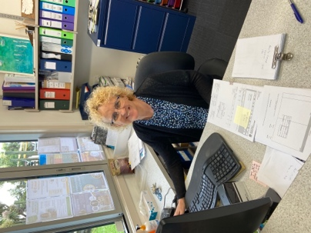
Congratulations
A big congratulations to Adelaide Conway on receiving a Very highly Commended in her first tap dancing competition at the weekend. Adelaide performed to the song Roar by Katy Perry. Well done, Adelaide, keep it up.

Room Three Camp
Well done to all of the children who attended Room Three’s camp at Tirohanga earlier in the week. This camp is designed as a bridge between the junior classes Big Day Out and the senior classes camps at places like Berwick, Stewart Island and Central Otago. One of the big aims of the camp is help and support the children to develop independence. This can be as simple as knowing where their socks or tooth brush are to getting themselves ready in the morning, and then fully taking part in the days activities. The personal resilience developed in these experiences can and does transfer to other learning experiences at school as it builds confidence and self-esteem, which is great for strengthening mental health and well-being. Thank you to all of the parents who were able to attend and support the programme.
I would also like to thank Michael, Lok and James up at Knox College for making the children feel welcome and really looking after them.
Thank you to Teresa for putting the programme together so that it was well balanced and meaningful for the age group.
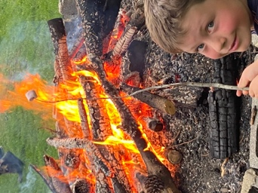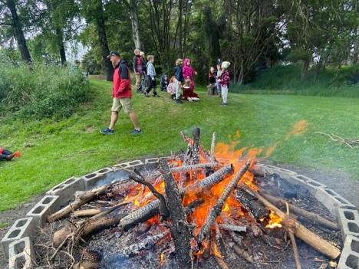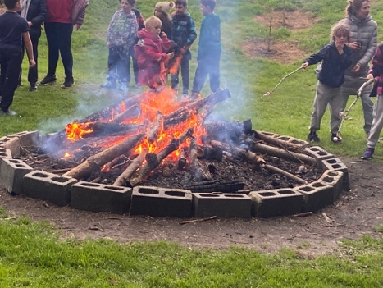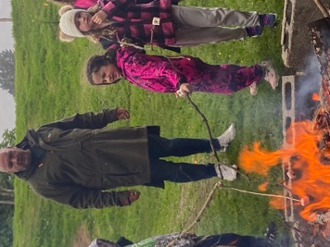
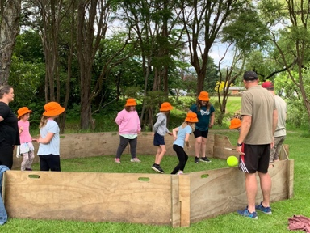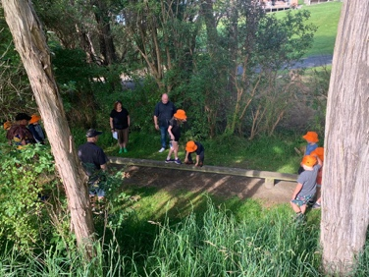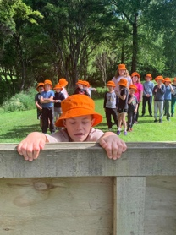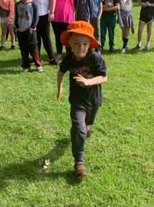
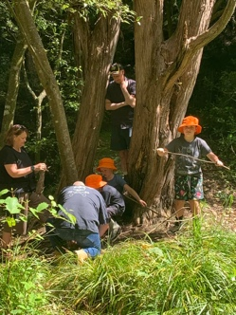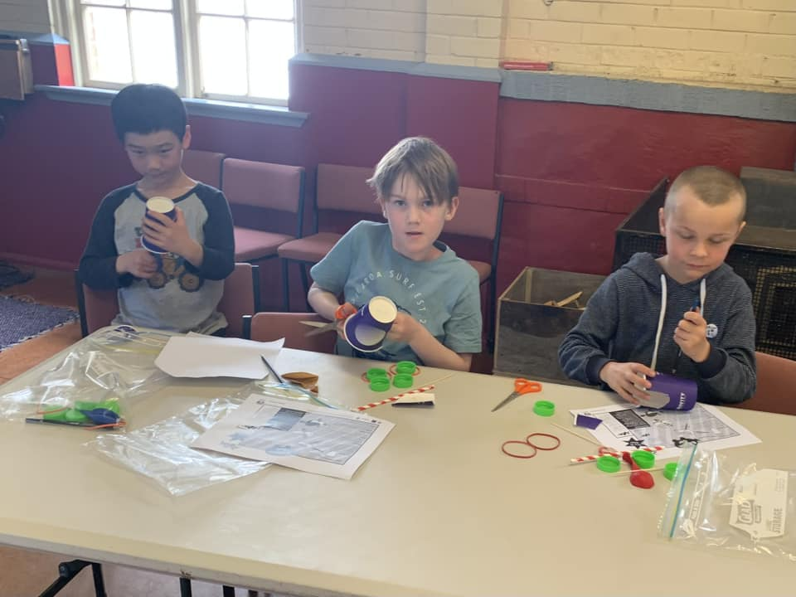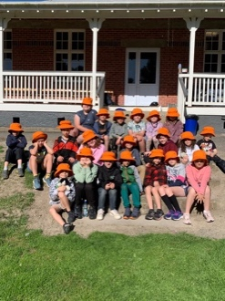
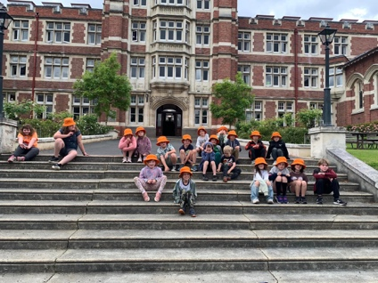
Futsal
Congratulations to Leo Henderson on earning Player of the Day for the Stingray, for an outstanding run down the line and narrowly missing out on scoring. Great stuff Leo.
An exhilarating 3 all draw and a wonderful performance from Kad Hancock saw him earn Player of the Day, outstanding Kade.
The Big Rock Sharks had a hard fought 1-0 victory, with a goal disallowed. Well done Scarlett Hancock on earning Player of the Day for a great all-round performance, attack and defence.
There is no futsal next week for any teams. The Edgar Centre is hosting the National Volleyball Championships.
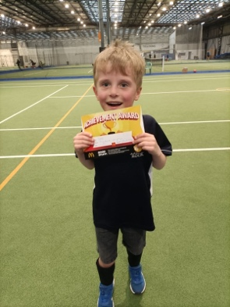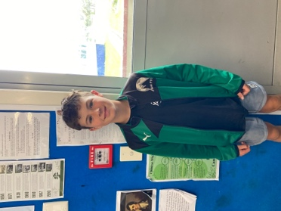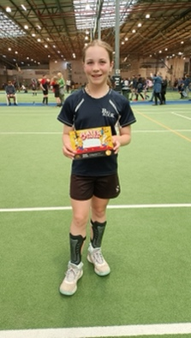
Pool Keys
Pool keys will be available on Wednesday for school families only at this stage. Please remember that school accounts must be up to date.
Can we please insist that families respect the ‘rules’ surrounding pool keys. Please do not lend them to friends etc and ensure that when your children are using the pool, they are supervised by someone 18 years old or over. Also, people without a key do not have free access, any more than they would at Moana Pool. This might sound a bit grumpy, but it is important to us that Big Rock children have a good facility and that people who pay for a key have access to a good facility.
The pool is designed for primary school aged children and is a resource primarily for the children of Big Rock Primary. The Board has spent a good amount of money refreshing the pool and pool area with more work planned.
On a lighter note, you know that the pool is popular when on the school Facebook page, even after all of the great things the children have achieved and got up to this year, news of the pool opening has the most likes. Go figure.
End of Year Prize Giving
Our end of year celebration will be at the Brighton Hall on Wednesday 13th December at 4:30pm.
Can we please have the remaining trophies back asap please.
The last day of school for the year is Thursday 14th December. School will close at 1:00pm
Room Four Camp
I am away on the Room Four Camp to Berwick next week. There is little to no cell phone coverage. If you need anything please contact either Lisa Lamb or Kelly, or in the first instance your child’s teacher.
Have a great weekend.
David Grant
Principal

