8th September 2023
Sadness
You will have noticed that sadly, the flag has been at half-mast this week. It is to acknowledge the passing of Wallace Russell, a longtime friend of the school, grandad of former pupil Amber Egan, and grandad of Emma Egan, dad of Lisa and father-in-law of Board member Graeme. Our thoughts and sympathy are with you at this time.
Congratulations
Last Friday we headed off to the Otago Cross Country Championships, an event that all runners must qualify for at their zonal event, ours being the Greater Green Island event. Our runners to qualify were Isaac Lucking, Leith Conway, Addison Johnston (Couldn’t run on the day), Kade Hancock, Scarlett Hancock, Kiptyn Garner, Leo Douglas and James Patterson. All runners gave it their all in very tough races. A special well done to Leith Conway (17th) Kade Hancock (17th) and Kiptyn Garner (19th). Anything in the top 20 in these events is great, as most races have around 80 runners.
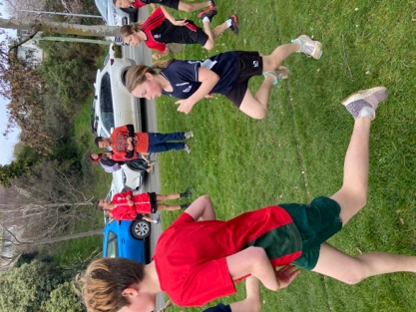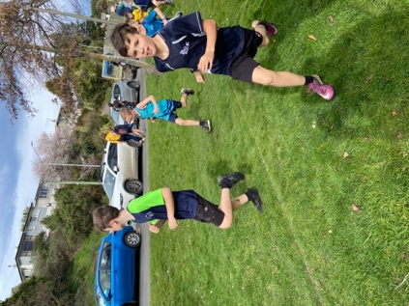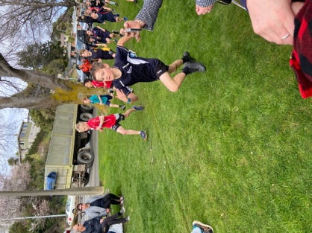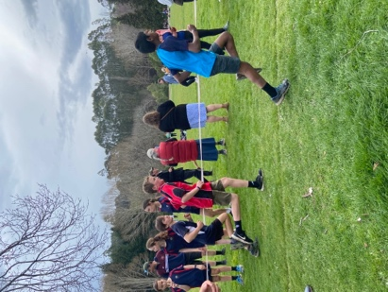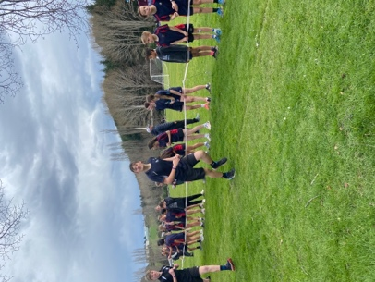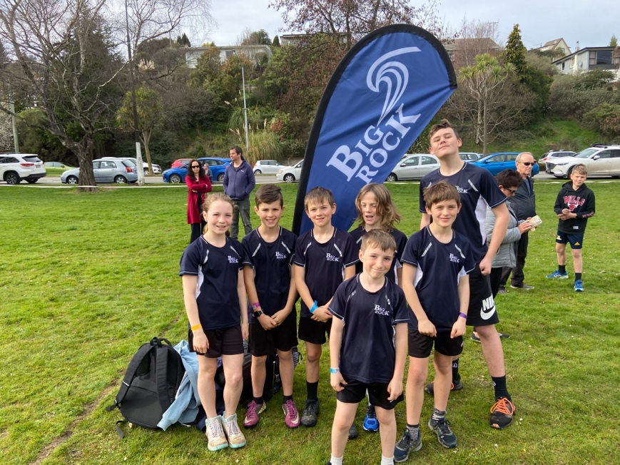

Kapa Haka and the Otago Polyfest
On Wednesday next week the Big Rock Kapa Haka Rõpu will be taking part in the Otago Polyfest. They are performing on Wednesday at 1:20 at the Edgar Centre. The children have been working hard, they are being led by Kimberley Maxwell, thank you Kimberley. They will be resplendent in their new uniforms. I believe that it is live streamed via Facebook or possibly Youtube.

Congratulations
Congratulations to Addison Johnston who finished second at the Hip Hop 2023 Nationals at the weekend in the Future Champions Cadet Crew division, with her crew Imperfectly Perfect from the Black and White Dance Studio. Very Cool. (I felt cool just saying it)
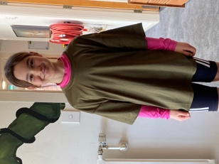
Mountain Biking at Big Rock
Yesterday was another great adventure for the TNT group at both Signal Hill and Redwoods. The Introductory Group have their next adventure next Friday.
We are currently developing a Junior Biking Programme, which we hope to begin implementing next term. Watch this space.
On the previous weekend the final parts of the City to Port Chalmers cycle way was officially opened by the mayor and former Revenue Minister David Parker. While all the dignitaries were there doing their thing, the strength of our MTB programme shown through as the opening required our bike trailer to get all of the officials bikes there Big Rock leading the way.
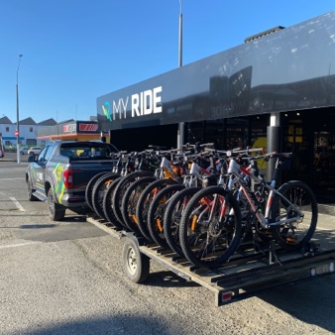
Weet Bix Tryathlon
Attention all parents of Big Rock Kids. On 3rd March next year we are hoping to have the BIGGEST number of kids from any Primary School across Otago attend the Sanitarium Weetbix Tryathlon. I realise it is a long way out but if you register this week, it is 25% off the normal price.
This is an incredibly well organised and fun event, you don't have to be a good runner, a great swimmer or a good rider, they cater for all levels and all abilities. Your kid/s will have the biggest smile and sense of achievement for finishing.
Below is a link to join the Big Rock School team.
https://urldefense.proofpoint.com/v2/url?u=https-3A__raceroster.com_registration_11382e68-2D66e7-2D481f-2Da1c3-2Ddd938e21ed6f_entry-3Fteam-3D563729&d=DwIFaQ&c=_Zm2Kb9yJrso4r0-N78Ezl-a6DfgMbIISn5tZXXqWk4&r=QtUPNs2KiRk3Ur5Ug3z1C1ISc1vQ4l5429nXMROj-Bk&m=QbtGxP59u15G4JA4pwkQ2Qoo2WX8_9ETA87IwCBydUZVtDjqC0HkQXhMHVqn8yiE&s=RjgmdEC5Lc81ZZ7M2Ph5Zy6oHsWYj3oj0Kdenyxrqic&e=


Library Books
Last week I wrote about a group going book shopping for the school library. This week two more groups got the opportunity. Firstly Courtney, Atiana, Taylor and Amelie went with Mrs Van and managed to spend just over $1000.00 which was great. Then on Wednesday I took Bella, Meadow, Jasmine-Rose, Esme, Addison, Emma and Dusty. They were given $1200 to spend. The books are obviously part of future literacy in the school, but without a calculator and at the first attempt, without UBS giving them a running total they said were done and the amount had spent--- $1190. Turned out to be a maths exercise as well, pretty remarkable I think.
More shopping to come with different children.
STEM Trax
Some of the Room 4 children have been working with Room 1 and 2 children on building race tracks with tunnel tracks and little remote control racers. I haven’t explained it very well, but it is very cool. Thank you, Leith Conway, Kaylyn TeNgahue, Faith Scoullar and Baily Jenkinson.
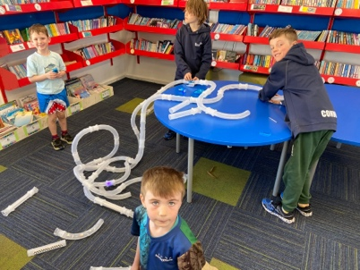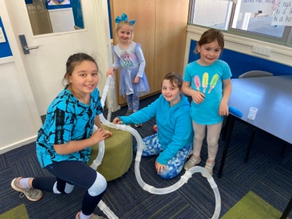

Skiing and Snowboarding
From what I have seen and heard, the recent ski and snowboard trip looked like a cracker, with incredible weather. Everyone seemed to have a great time.
Thanks, Shane, for organising this, I suspect it has set a great template for 2024.
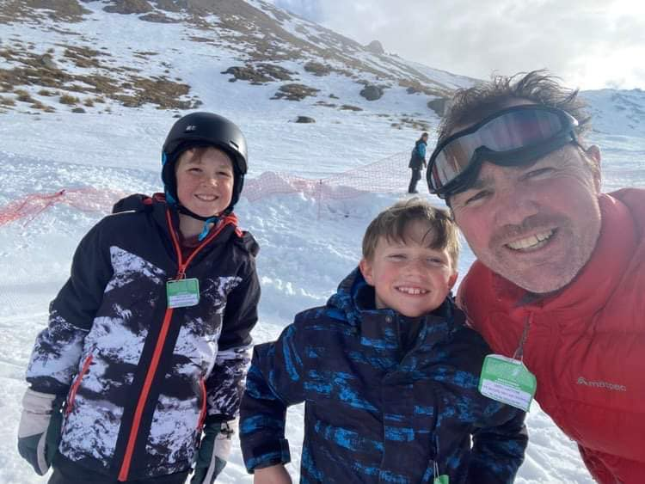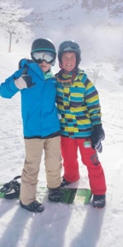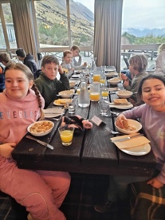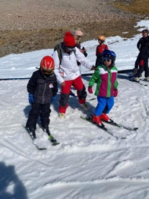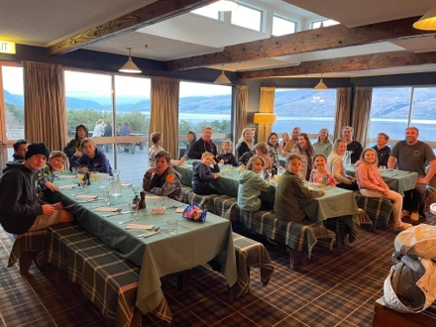
Dunedin Marathon
Good luck to everyone who is participating in this weekend’s Dunedin Marathon, Half marathon and 10km events, running and walking. We have staff and Board members out there this weekend, good luck Richard Murray, Su Keen, Scott Weatherall and Shane Turner.
Kelly Day
Thank you to everyone who was able to support our Kelly Day with the donation of groceries towards a hamper (Of which there was an incredible amount) and for dressing in blue. I know Kelly is incredibly grateful and a wee bit embarrassed with the generosity. Thank you.
Next Week
I am away for most of next week at the New Zealand Principal’s Conference in Queenstown. I promise it is not as exciting as it sounds. If for any reason you need to contact a staff member, please contact your child’s teacher in the first instance. After that if it involves the Junior School please contact Lisa Lamb and if it is the Senior School, please contact Richard Murray.
Have a great weekend
David Grant
Principal

