21st September 2023
Welcome
Welcome to the last day of Term Three and what a term it has been. Term Three is often the toughest one on the children with the cold weather, flus and bugs going around and days in a row without being able to get outside. This term, we seem to have been very fortunate in most areas, yes children have had the winter illnesses and we have been thankful that families have stayed home when ill, making it much easier on everyone else. The children also managed to engage in great learning opportunities, with trips to Orokonui, even a Nayv band, to planting and growing, learning about and understanding food webs and ecosystems, learning about trapping programmes in the local area (more to come on this), as well as outstanding results across the school in Literacy and Mathematics with 88% and 87% of all children achieving at or above expectation in Reading and Mathematics respectively. (This is considerably higher than the national average). We have also had a range of mountain bike adventures, children exploring the southern ocean via virtual reality and the Marine Biology Centre, great results at the Greater Green Island Cross Country Championships and later the Otago Championships, planting of native species occurred at the beach, a ski trip was squeezed in, children danced the night away at a tremendous school disco, we had 2 netball teams and three basketball teams competing in local competitions, all with great effort, attitude and results, the Big Rock Hoopsters being crowned Year 7-8 champions, we finished the term with a fun filled tabloid sports day, with the whole term being capped off with wonderful performances at the Otago Polyfest with the Big Rock Kapa Haka Rõpu. All in all a very busy and successful term.
Thank you to everyone for their support, encouragement and help. Like I said at the beginning, Term Three is often the hardest of the school year, this year it didn’t feel like it and that is a testimony to all of the children, families, staff, board and wider community working together.
Thank You
Kelly- Auctions for Olivia
A massive thank you to everyone who has donated to the auctions, which is everyone in the school, thank you to everyone who has made a bid and even just had a sneaky peek! It is also really appreciated by Kelly and her family and will make a massive difference. I have always argued (and won) that this community represents the very best of New Zealand and you have all proved me correct, again. Kelly will be away for the first half of next term and Kara Walters will be fulfilling some of her duties. I know that we all wish Kelly and Olivia safe travels and a speedy return.
Travel Well.
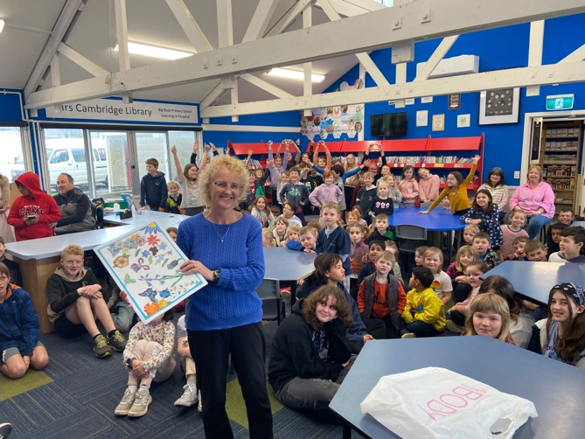
Congratulations
A massive congratulations to Addison Johnston who on the weekend finished fourth in the New Zealand Hip Hop Championships. A remarkable achievement, outstanding Addison!
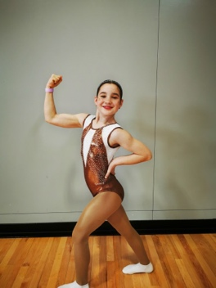
Futsal Next Term
Thank you to everyone who has registered and has now been placed in a team. Thank you to Tania Blanchard- Dolphins, Jo Henderson- Stingray, Shane Turner- Marlin, Cavan Jenkinson- Orca and Jo Henderson- Sharks for volunteering to manage/coach these teams. We still urgently need a manager/coach for the Big Rock Barracuda, if you can help please get in touch asap. Thank you
School Photos
Sadly, this year our local photography guru Justine Weatherall is unable to do our school photos. However, the person who is doing them comes highly recommended by Justine. School photos are on Tuesday 10th October. This is the second day back after the holidays, which means all of the children, most of the children, some of the children, a few children might be sporting school holiday haircuts ready for the photos.
Please see below with the information from the photographer:
Class photos are $20 each

Individual photo options are:

Pair of 6x4 inch (same image) $14
Single 6x9 inch $14
Single 8x12 inch $25
Digital file $25

We will provide a set of printed proofs of the classes to display at the school for parents to view.
Order envelopes will be given to teachers to hand out to students, they have individual proofs of each student on the back so only the parent views these.
We will also provide spare order envelopes in case families need more.

Order envelopes are to be handed back to the school by a due date (to be confirmed) but we take order payments directly (either by cash in the envelope or credit card details on a slip in the envelope). If parents don’t want to put their credit card details in the envelope they can pop in and see us with their order at 85 Great King St where we will have eftpos available (we are open Tuesdays till Fridays 9am-5pm).
Structured Literacy and Financial Literacy
There has been some talk during the election campaign and political party policies and things for education. Two that have come up are making Structured Literacy compulsory in schools. At Big Rock this has been our approach to Literacy for two years. This has been led by Lisa Lamb and her knowledge and expertise and now Rooms 1-4 are immersed in this approach, with Ms Keen, Mrs Grant and Mrs Van all operating at a high level of understanding and delivery.
Financial Literacy is already part of the senior class Maths programme, thank you Mr Murray.
Big Rock ahead of the game? You better believe it!
Next Term
Next term is traditionally my favourite (are you allowed favourites) and not because it is the last one. It is because of the fun of going into summer, the pool opening up, summer trips and camps, new sunhats (Yes! We have new sunhats for all of the children next term, all at no cost to families and whanau), the children getting excited as we approach the summer holidays.
Looking at the dates below you will see it is going to be a very busy term (again) and more things are likely to be added.
10th October School Photos
16-20 October Senior Class camp Stewart Island
24th October Room Four Highlanders Health Programme
25th October St John Kids Programme (All classes)
30th October Rooms 1 and 2 Bike Day
13-15 November Room 3 Camp
Have a great break
David Grant
Principal

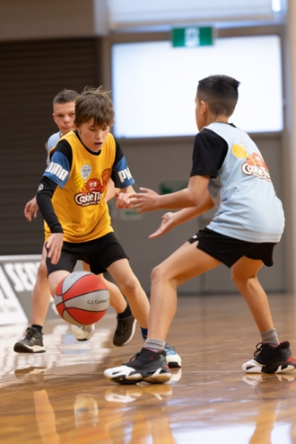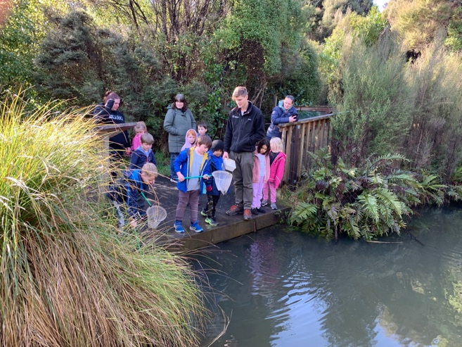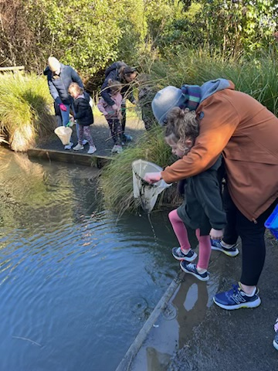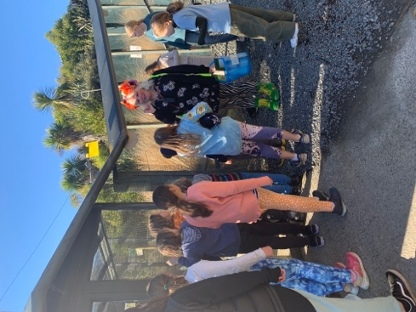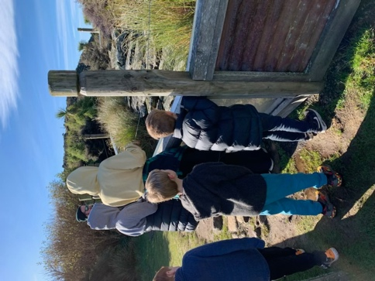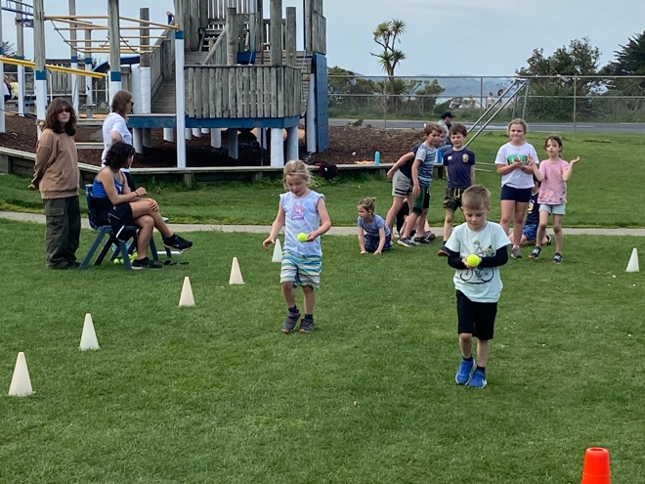
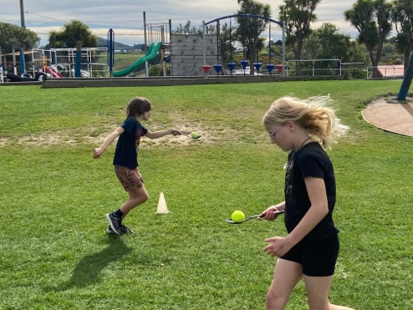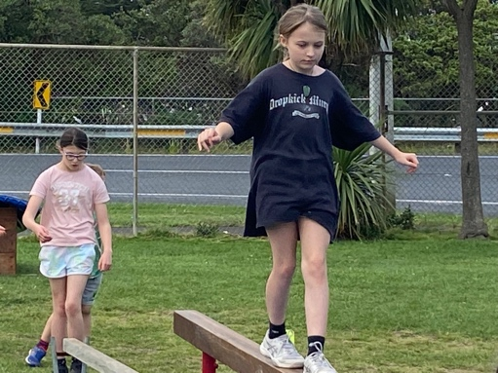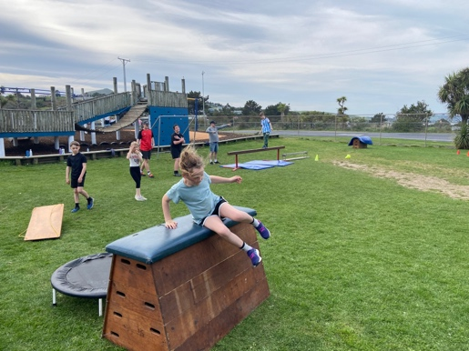
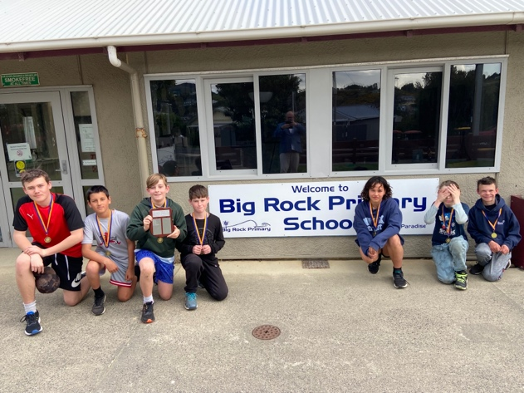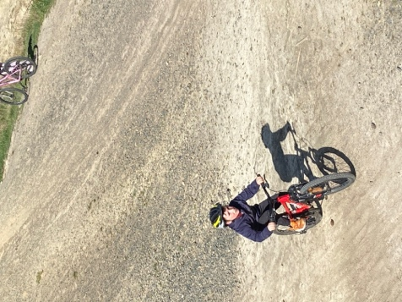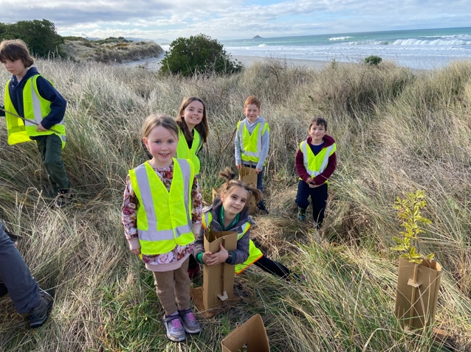
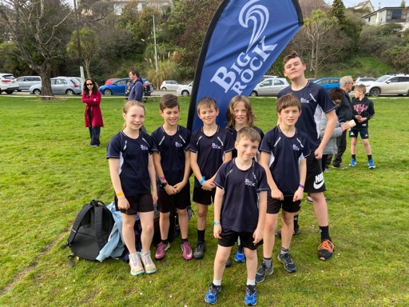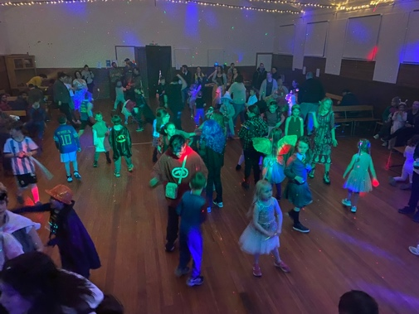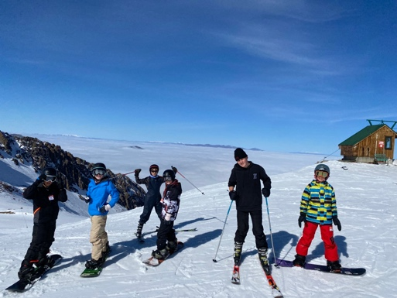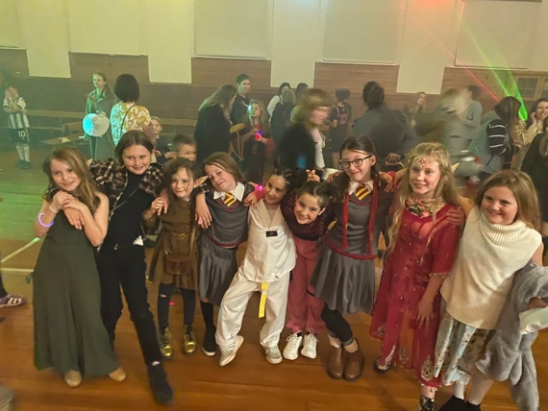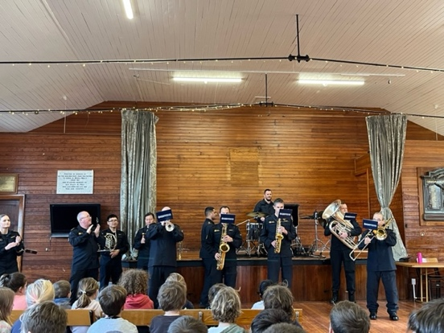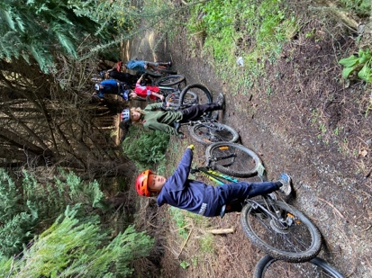

What amazing children

