15th September 2023
Kapa Haka and Polyfest
Congratulations to all of the tamariki who performed so well, with great enthusiasm and energy at the Otago Polyfest on Wednesday afternoon. It was wonderful to see the smiles (and a wee bit of nerves) which were quickly overcome as they got started. As with any performance, whether it be the arts or sport, the toughest bit can be the waiting as everyone wants to get into it. Keeping nerves and excitement under control is difficult, so a brilliant effort all round.
Thank you to the staff who supported the practices and new learning, thank you to Promo X for helping us out with our new Kapa Haka uniforms, and thank you to Kelly, who against the odds secured us a bus and thank you to all of the parents for their support live and online - unreal.
Thank you , Kimberley, for taking on the leadership role, for organising the waiata and haka, for bringing your energy, ability and enthusiasm that resulted in incredible results, we are all very grateful. He mihi nui ki a koe, he rawe to kaiarahi, he pai te mahi.

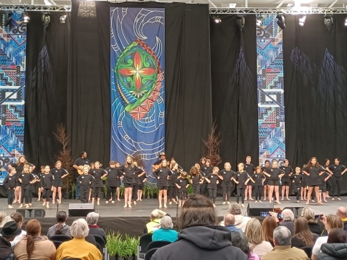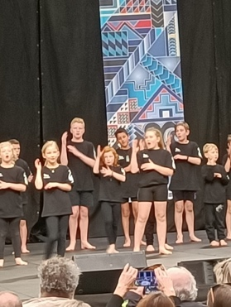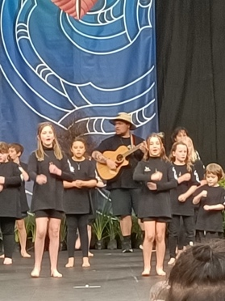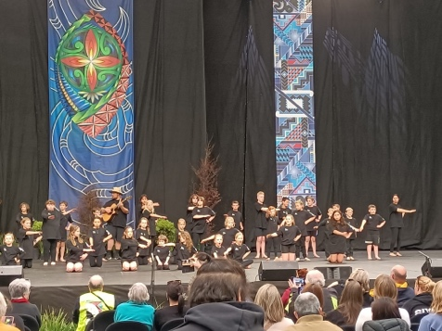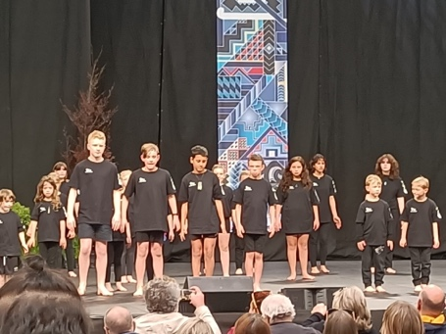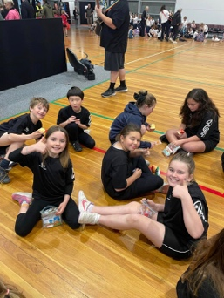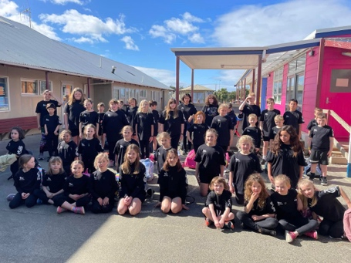
Congratulations
Well done to Libby Mooyman on earning her first dog training/handling certificate with her dog Dexter. I know that Libby puts a lot of time into exercising Dexter and working on commands and handling drills. If she is anything like her sister Pipa, she will be amazing. Outstanding Libby.

Tabloid Sports Day
Next Wednesday we are having a Tabloid Sports Day. This where all of the children will work their way around a number of different games. The games will include things like:
- Three legged races
- Egg and spoon races (Without actual eggs)
- Sort of High Jump
- Sort of Discus
- Teaspoon and cup water fill
These are just some examples. It is aimed at being a bit of fun in hopefully warm spring weather to end the term. The different games and activities will be at school and on the domain led by staff and senior students. It is not a serious event but one aimed at being fun and everyone having a go. If the weather is no good it will be on next term.
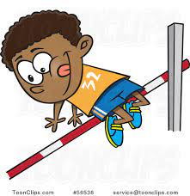
Futsal
Thank you to everyone who has registered their child for futsal. Registrations are now closed and the teams are full. Some teams do require coaches and managers. Information regarding your child’s team will come home before the end of term.

New Zealand Principal’s Federation Conference Queenstown
Earlier this week I was lucky enough to be at the above event where I had the privilege of listening to some excellent keynote speakers, have some really insightful conversations with other principals from around New Zealand, yes there was some socialising, but more importantly there was a lot of reflection and learning. One of the many things that I came away with having listened and talked to a wide range of principals of different size schools, as well as catching up with people who trained with was, how lucky I am to work in the community I do, with the children and staff I do and with the Board that I do. I do not say that lightly, but above everything else, I came away very grateful. Thank you.

Traffic and Road Crossing After School
Can we please ask that all parents and children crossing the road after school use the crossing not just somewhere near the crossing. We are trying to teach the children good road safety habits, particularly with road crossing and traffic awareness. Also please remember that is a 30km zone.We greatly appreciate your support with this.
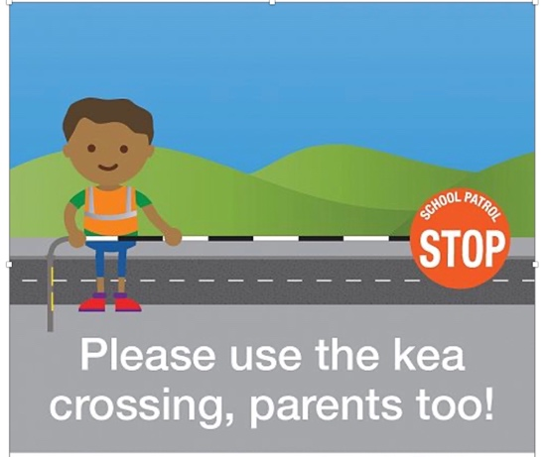
Rugby World Cup Competition
As you are probably aware, the Rugby World Cup started last Saturday. We are running a little competition with some prizes up for grabs. All we need families to do is have a think about what four teams they think will make the semi-finals, write them down on a piece of paper, write their family name on it and hand them in at the office. One entry per family please.
PLEASE BE AWARE, THEY MUST BE ON A PIECE OF PAPER, CLEARLY NAMED.
THEY CANNOT BE TEXTED, EMAILED OR PUT ON THE FACEBOOK PAGE.
Have a great weekend.
David Grant
Principal

