13th October 2023
Welcome Back
It is great to be back, and as I said at the end of last term, Term Four is my favourite, not because it is the last one, but the joy of coming out of winter and into the sunshine. Even in the playground this week, the vibe is great, it is usually good, but it is very noticeable. I am not poetic enough to link the enthusiasm to boisterous spring lambs, but I’m sure you get my drift.
As usual, the term will be very busy with trips, end of year stuff, as well as end of year assessments and report writing. As I mentioned in the weekend message we will not be having a Teacher Only Day in November, other schools are we are not. We will carry out the same stuff at our January Teacher Only Days. For effectiveness and we understand how challenging another day off school can be for families.
Welcome
I would like to offer a big welcome to Eva Verhoef and her family who have joined us. Eva comes to us from the Netherlands via a few years in Norway. It is great to have you and your family join us.
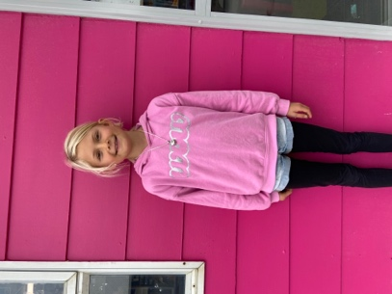
Auction for Olivia and the Adie Family
On behalf of Kelly and the Adie Family, wow, what an incredible and humbling thing. Our thanks to everyone who donated to the auction, who made bids and of course those who won. The generosity has been immense and overwhelming. A special thank you to Jo Henderson for leading the project, thank you to all of your team as well. I know it has meant a lot of hard work, and we are very thankful.
Olivia’s recovery is going well, and thank you for the many kind messages.
From Jo Henderson:
Right the final total… drum roll please!!!!
Together we have raised $19,535 for Olivia and her family!! Thank you Thank you Thank you!!
This is more than we could ever have dreamed of! Massive thanks to all those who donated items and to all those who bid! Fantastic result!

From me: I always say that this community represents the best that New Zealand Aotearoa has to offer, and you have again proved me correct. Well done and thank you to you all.
Congratulations
It is very cool to start the new term with congratulatory messages. Firstly, congratulations to Stevie Kahui and Leo Douglas who have applied for and have been accepted in to the Marine Science Primary Extension Programme, Science and the Sea! This is a wonderful achievement. The programme is run by the NZ Marine Studies Centre as part of the University of Otago. Also well done to Emma Egan who has been invited to join the one day programme. Outstanding, all three of you.
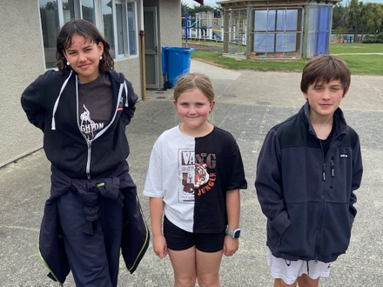
I would like to congratulate Leo Douglas again for his performances in the Playhouse production of the Wizard of Oz during the school holidays. Lots of work goes into this throughout the term. Top work Leo.
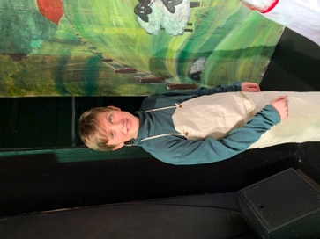
Well done George Weatherall on earning a bronze in the family section at the recent Naseby 12 Hour Mountain Bike Event. Top work!
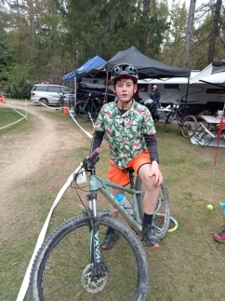
Also well done to Emma Egan, who completed both Levels One and Two in Artistic Gymnastics and Level One in Rhythmic Gymnastics. A great achievement, well done.
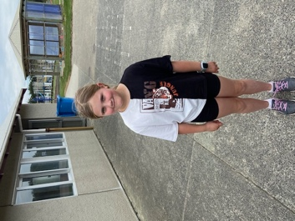
Science Badges
Last term all of Room 5 and some children in Room 4 began the Science Badges programme. This is a Science programme where the children undertake independent science projects to earn badges. The programme has been put together by New Zealand Secondary School Science teachers. So far the work that I have seen and evaluated has been excellent. Impressive stuff.
Weetbix Tryathlon
Are you thinking about your child doing the Weetbix Tryathlon in February? This is a great event. Shane Turner is organising a team from Big Rock and if you use the attached link to register your child, it will be at a discounted rate. The more entries the school team has the greater chance of winning great prizes. Get into it!
https://urldefense.proofpoint.com/v2/url?u=https-3A__raceroster.com_registration_11382e68-2D66e7-2D481f-2Da1c3-2Ddd938e21ed6f_entry-3Fteam-3D563729&d=DwIFaQ&c=_Zm2Kb9yJrso4r0-N78Ezl-a6DfgMbIISn5tZXXqWk4&r=QtUPNs2KiRk3Ur5Ug3z1C1ISc1vQ4l5429nXMROj-Bk&m=QbtGxP59u15G4JA4pwkQ2Qoo2WX8_9ETA87IwCBydUZVtDjqC0HkQXhMHVqn8yiE&s=RjgmdEC5Lc81ZZ7M2Ph5Zy6oHsWYj3oj0Kdenyxrqic&e=

Futsal
All futsal games start next week, sports shirts have gone home today. While I have not received the draw yet, as soon as I do I will post it on Facebook and Skool Loop. Many thanks to all of the parents for putting their hands up to manage our six futsal teams. (The most ever!)
Dolphins | Tania Blanchard
Stingray | Jo Henderson
Marlin | Shane Turner
Baracuda | Lauren Mooyman
Orca | Cavan Jenkinson
Sharks | Jo Henderson
All players must have long socks and shin pads please. Also, if your child is unable to play can you please let your child’s coach know in advance and can all players please courtside, ready to play 10 minutes before kick-off.
Stewart Island
I will be away next week on Room 5’s camp to Stewart Island. I know, it’s a tough job, but someone has to do it. Mrs Lamb will be acting in my stead, if you any problems contact her, or in the first instance your child’s teacher.
Big Weekend
This is going to be a big weekend in our country’s future. I imagine that we are all hoping for the same thing, a similar outcome at least. There will be some who are hoping for a different outcome, and that’s fine. However, in our heart of hearts, we know that the best thing can happen is a good strong win for the All Blacks.
Also, the school is a polling station this weekend.
Have a great weekend

David Grant
Principal

