31st May 2024
Welcome
A big Big Rock welcome to Alby McNab, who joins his sister Billie with us at. At last you have joined us Alby, very cool to have you on board.
I would also like to offer a big Big Rock welcome to Avalon Why who joined us and her big sister Sol. It is wonderful to welcome you Avalon.
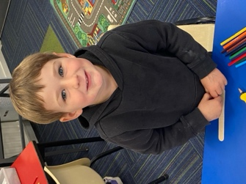
Congratulations
A massive congratulations to Aliza Johnston on winning the Dunedin Gymnastics’ Association competition at the weekend that included gymnasts from as far afield as Twizel, Balclutha and Oamaru as well of course Dunedin-wide. Great stuff Aliza.
Well done to Courtney McNair on earning Player of the Day for her Green Island Emerald’s football team.
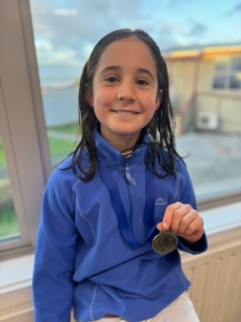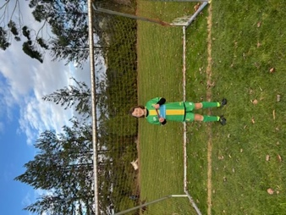
Netball
On Tuesday evening the Big Rock Hurricanes had their first hit out of the season with a ‘skills session’ followed by a short game against Kaikorai. The team advised me very enthusiastically that they played well and got a great result.
Basketball
Yesterday we had the unusual occurrence of two of our basketball teams being drawn to play each other. The Big Rock Shooters taking on the Big Rock Coasters (and vice versa). To save everyone a journey the game was played at school. The two teams fought out an entertaining 20 all draw. Congratulations to Cecil Williams of the Coasters and Jaxon Skerratt of the Shooters on earning Player of the Day for their respective teams.
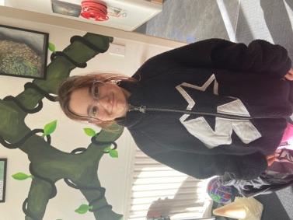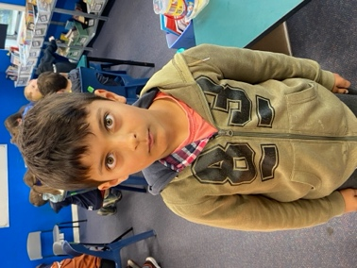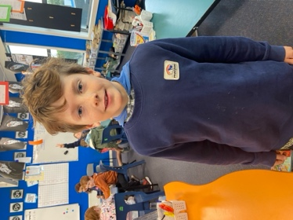

Room Three Dunedin Walking Tour
On Wednesday I had the privilege of tagging along with Room Three on their Dunedin Walking Tour of historic buildings. Sadly, the awful weather made the actual tour a bit more abbreviated than we would have liked. The children gave it their best shot and worked their way through it. This was all topped off with lunch in the Meridian Food Court, followed by lots of fun at TimeZone. Many thanks to Colin Driver, Marina Conway, Anar Khan, Kerri King, Sally Scott, Blair Judd, Sasha Turner, Carrie Graham and Pedro McMurdo on helping with transport and leading groups. Also thank you to the Brighton Club for helping us out with transport.
Thank you, Teresa Grant for putting it all together.
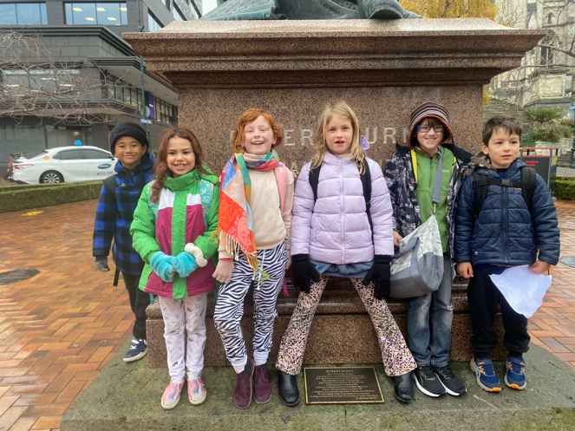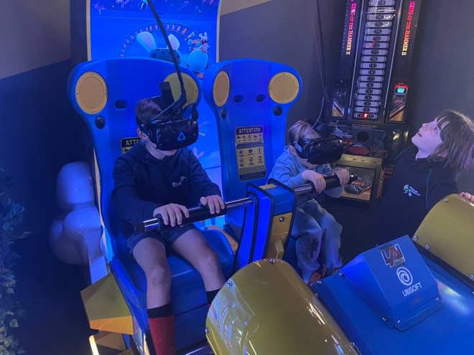
King’s Birthday Weekend
A reminder that school is closed on Monday as it is a public holiday. Many schools in the surrounding area are closed on the Tuesday for a Teacher Only Day. Big Rock is not we will be open on Tuesday.
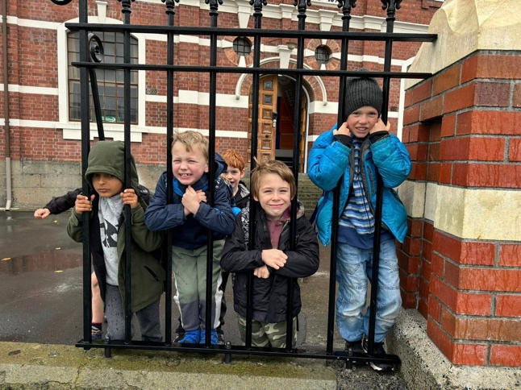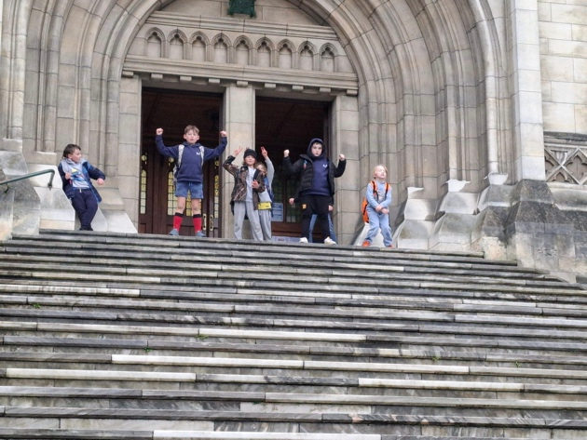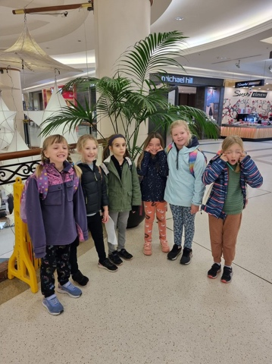
Mountain Biking
Yesterday the second Tracks n Trails Mountain Bike group had their first adventure, heading off to Forrester Park in North East Valley. Judging by the smiles and feedback from the children, it was another epic day out in the Big Rock calendar. Watching the children develop their skill and confidence over the years this programme has been running is very rewarding from an educators point of view. Thanks to Scott Weatherall and Ange Hancock for giving up your time to lead this adventure, also thank you to Craig Scott and Max Skerratt for helping out, much appreciated.
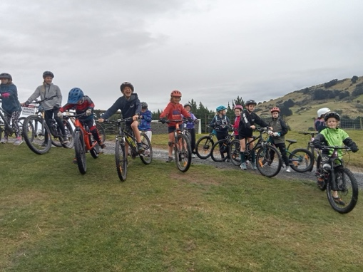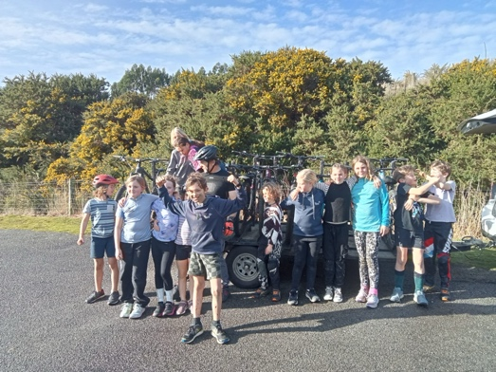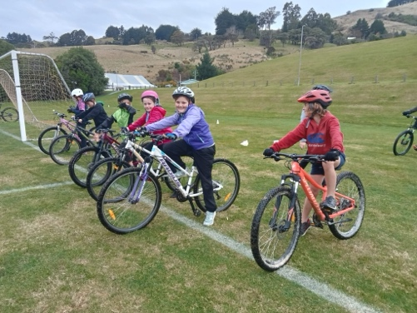
Toys and Stuff at School
Can we please ask that the children leave their toys etc at home. It can and does cause unescessary heart ache and frustration. Sadly things get broken, lost etc as well as being swapped for things and then they want to ‘swap back’ and only one does and so it goes on. Usually ending in tears, angry parents or both. Can we please keep them at home.
Thank you
Attendance
As you are hopefully aware, over the last few years New Zealand schools have faced a bit of an attendance crisis. There are many different reasons for this. While we are extremely happy with the levels of attendance at your school, I received an information brochure from the collective of schools in the Central Otago and Lakes area and thought it would be a good idea to share it with everyone.

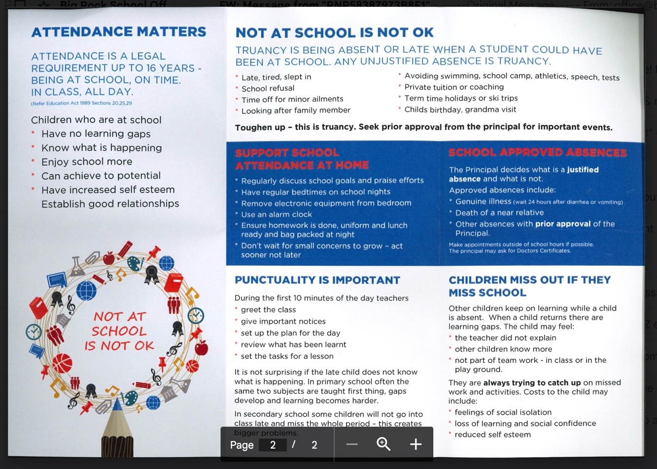
Enjoy the long weekend, if you are travelling away, travel safe.
David Grant
Principal

