24th May 2024
Welcome
On behalf of everyone involved with the school I would like to offer a big Big Rock welcome to Evie Hollands who joined us on Monday. Evie joins her big brother Quinn as a Big Rocker! Welcome Evie, you finally got to join us
Equally, I would like to offer another big Big Rock welcome to Paige Topping, who joined us on Tuesday. Like Evie, it is wonderful to have you finally join us. Paige joins her big sis Maddie as a Big Rocker!
Also, last week we missed Oakley Morton-Lowe’s photo.
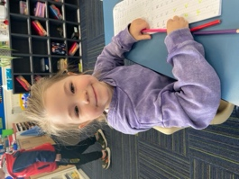
Sports Round-Up
Basketball
Well done to George Weatherall on earning Player of the Day for the Big Rock Hoopsters in their 46-8 victory over Liberton. It was an excellent all round team effort.
Congratulations to Lily Scott on earning Player of the Day for the Big Rock Shooters in their 34-0 victory over Wakari. Great stuff Lily.
Bravo to Braxton Parata-Walters on earning Player of the Day in for the Big Rock Coasters 10 all draw. All done with a player short. Outstanding stuff.
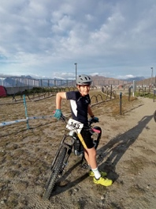
Football
Last weekend Green Island Football Club held their annual 7 aside tournament, which is a massive event. Congratulations firstly to Kiptyn Garner and his Mosgiel side on winning the 11th Grade section and becoming the 2024 CHAMPIONS. Excellent stuff Kiptyn.
Also on the winner’s podium, congratulations to Fin Ramsay and his 9th Grade team on winning the 9th Grade Social section and becoming CHAMPIONS!
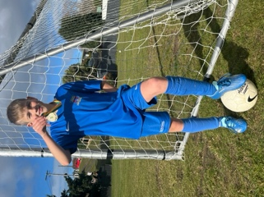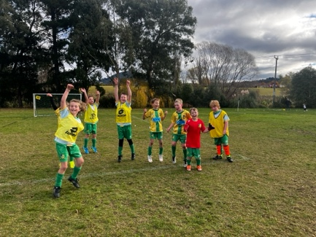
Rugby
Well done to the following Brighton Rugby Club players on earning Player of the Day for their teams:
Mini Gulls- Ollie McNair
Red Gulls- Jed Grey
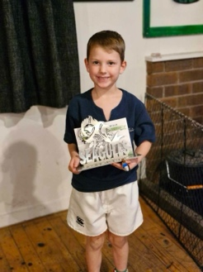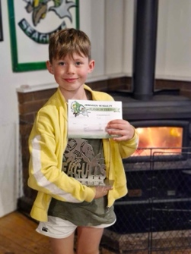
Matariki and Aotearoa New Zealand History
Hopefully, everyone received an information sheet yesterday on our upcoming Matariki evening, shared meal and children’s work.
Can we please ask that if anyone’s cultural background is something that we might not be aware of, can you please let us know, as we like to fly the flags on the night of everyone within our school community.
Our Matariki evening is easily one of my favourites on the school calendar and dare I say it, one that I personally, am immensely proud of.
Olveston
On Wednesday, our two senior classes visited Olveston, the grand old historical house in the city rise area along from Moana Pool. It is a truly incredible former home that was gifted to the city and is a genuine glimpse into the past. Many thanks to Mel and Richard for organising this and to the parents who were able to attend and help with transport.
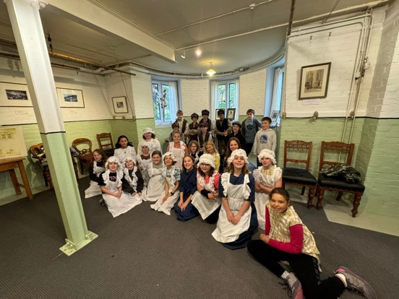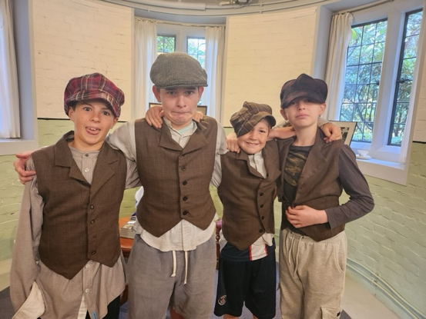
Mountain Biking
Yesterday our school Mountain Biking Programme got under way for the year, with our senior girls ‘T n T’ group heading up to Redwoods in what could only be described as a bitterly cold morning. However that did not cool the enthusiasm and off they went, full of smiles and excited chatter. Four and half hours later they returned to school still full of smiles and excited chatter, but this time covered in mud! Outstanding stuff.
Many thanks to Scott Weatherall for leading this and to Kara Walters for her help and support yesterday. This is such a powerful part of the school programme, not just the biking, but the building of their personal and physical resilience, building their confidence and supporting mental health, all of which aids all parts of school and home life.
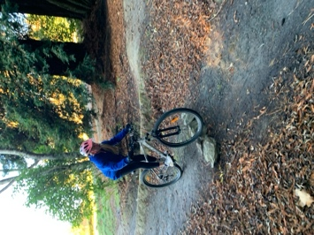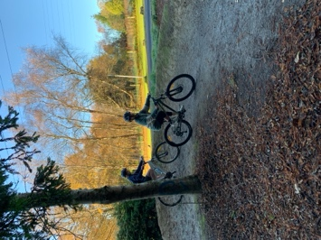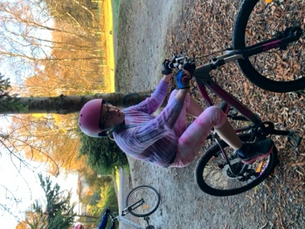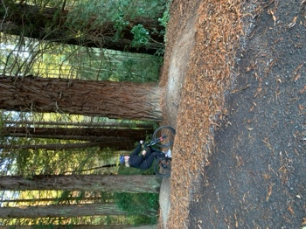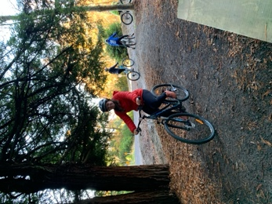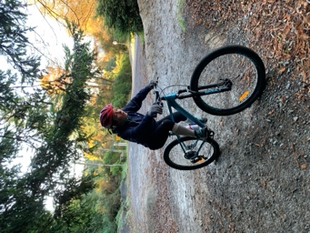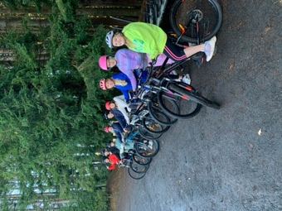
Earlier today, the Advanced group had their first adventure for the year, on what was again a very cold morning and like yesterday’s group the weather did not dampen spirits one little bit.
Many thanks to Scott and Ange Hancock for leading this intrepid group of riders.
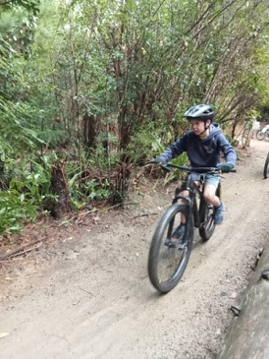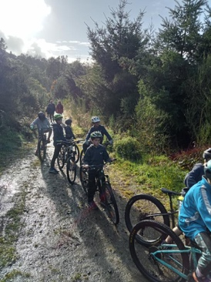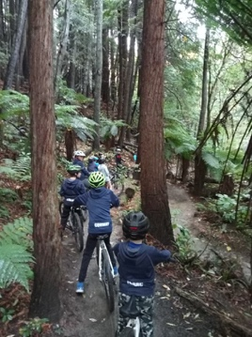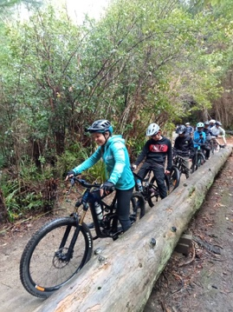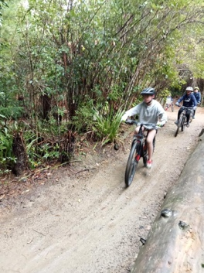
Have a great weekend
David Grant
Principal

