17th May 2024
Welcome
On behalf of everyone here at Big Rock I would like to offer a big Big Rock welcome to Oakley Morton-Lowe and his family as they join us. It is fantastic to have you on board. (Photo to come)
I would also like to give a big Big Rock welcome to Sol Why and her family. It is fantastic to have you join us.
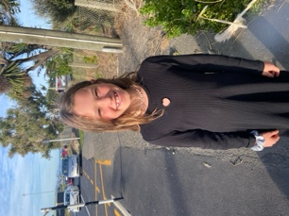
Sad News
Sadly, at the end of last term I received our amazing After School Care supervisor Sue Weir’s resignation, and more sadly I had to accept it. Sue has been a remarkable staff member in her time here. Not only doing a superb job with After School Care where the numbers have grown considerably. Also, at times in her capacity as a teacher aide supporting the children in their learning. As well as during the staffing crisis and chaos that were the Covid years, coming to our aid and allowing us to stay open. Thank you Sue for everything. Sue will finish with us at the end of the term.
Congratulations
Basketball
Congratulations to Addison Johnston on earning Player of the Day for the mighty Big Rock Hoopsters in the great team victory over Kaikorai Valley College 40-25.
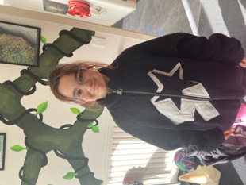
Well done to the following players on earning Player of the Day for their respective Brighton and Pirates rugby teams.
Baby Gulls – Kenny Keki
Mini Gulls – Lewis Vorgers
Red Gulls – Quinn Hollands
Pirates – Stella Brown
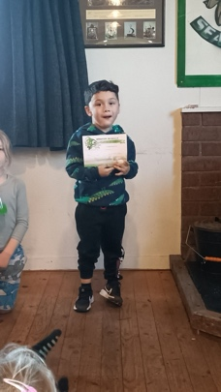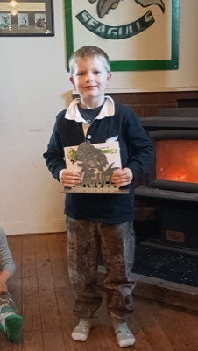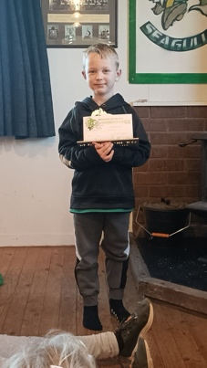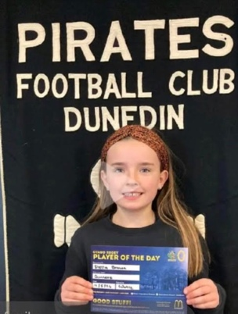
Thank you to Jude van Aalst, Teresa Grant, George Grant and Fiona and Max Skerratt for coaching the school basketball and netball teams, and to all of the people coaching or managing football, rugby or hockey teams. Without you, children’s sport wouldn’t exist. Can I please urge all parents to support their children’s coaches, not criticise. It can be a tough gig and they are volunteers. To be blunt, if you thought you could do better, you probably had the chance to volunteer.
Top work coaches.
Thank You
A big thank you to Lisa Russell and daughters on sorting a lot of lost property out, with lots going home this week. Can we please ask, that where possible that parents and caregivers name their children’s clothes, it makes it a lot easier when dealing with lost property.
Winter Illnesses
As we enter the winter months and the increase in winter bugs, colds and flus etc, can we please ask that children who are ill stay home. Snotty/runny noses, wet coughs, achy etc.
Also, can we also ask that children who may have nits or even worms please stay home until they have treated. These things can spread like wildfires. Thank you, we really appreciate it.
Further Congratulations
In an earlier newsletter we congratulated former pupil and a Year 8 here last year, on finishing 3rd at Kings High School in the University of Otago Junior Mathematics competition. This week we have heard that Riley has now qualified for the next round that includes only the top 15% of students across the whole country. Outstanding work Riley. An outstanding young man and mathematician.
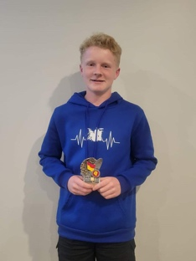
Room One and Two History Detectives
Earlier today I had the pleasure of tagging along with Rooms One and Two as the headed off to the Otago Museum to have a History Detective experience. They were provided with a book of photos and armed with their detectives magnifying glass, they had to locate 25 different things on display. From what I could see, they had lots of fun and managed to get lots of detecting going on. Many thanks to all of the parents who were able to come along and help each group in their role as ‘Lead Detective’.
A massive thank you to Lisa Lamb, Su Keen, Benji Keen and Hannah Wickens.
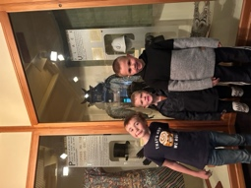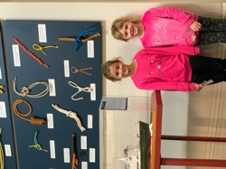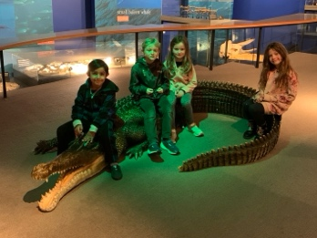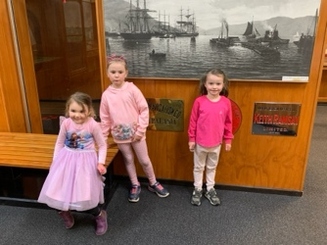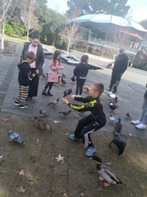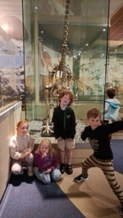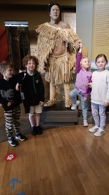
If any parents from today’s trip have any photos, can you please either send a couple to 021 2134316 or principal@bigrock.school.nz. Please do not post on Facebook or other forms of social media.
Sorry
My apologies, I missed last week’s Aotearoa New Zealand History quiz questions. They are linked to Mother’s Day. (Tentatively)
- Which former Finance Minister was responsible for the ‘Mother of all budgets!’?
- Who was the former television presenter that was sometimes referred to as the Mother of the Nation?
- Who, recently on a television ad, hinted at being the new Mother of the Nation? (Clue: There might be a sale soon!)
- What was unique about former Prime Minister Jacinda Ardern and her daughter Eve?
- Mrs Barrett is the mother of how many New Zealand sports representatives?
Have a great weekend.
Kind regards
David Grant
Principal

