7th June 2024
Job Vacancy at School
As you are aware, our wonderful After School Care supervisor Sue Weir is retiring at the end of the term. As such we have a vacancy.
The position is Monday to Friday, 2:45 until 5:45. If you are interested, please see me for a job description and any questions you may have.
At this stage, we are flexible, if people wish to do less days. i.e. If we had two excellent people who preferred to work two and three days each. Flexibility in days is a possibility.
While the position is term time only, there is capacity for the new supervisor to run a holiday programme, should they wish.
Also, full training will be provided, as well as first aid training, and ideally a week with Sue, learning the ropes.
Please get in touch, if you would like the opportunity to work with amazing children and their families.

Matariki and Aotearoa New Zealand History- Celebration and Shared Meal.
It is not far away now, just under three weeks until the big day. If anyone has any questions, please do not hesitate to contact the school directly. In a nutshell:
- We celebrate Matariki via the children’s Aotearoa New Zealand History work
- We enjoy a range of foods
- Enjoy each other’s company in a pretty cool part of the world.
- The school is providing 2 lambs on a spit, whitebait patties, vegetarian curry (professionally made) and a sausage sizzle.
- Families and whanau bring a plate of food to share and their own plates and cutlery.


Sports Round-Up
Netball
Congratulations to Meadow Hamilton on earning Player of the Day for the Big Rock Hurricanes in their 15-1 victory over Macandrew Bay. Outstanding Meadow.
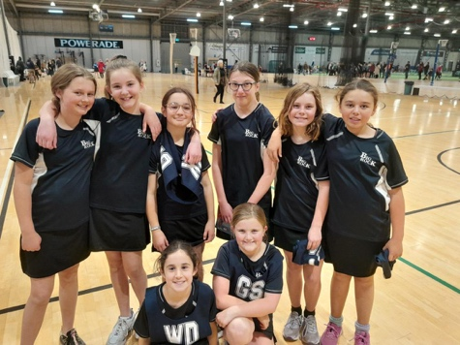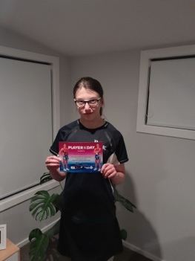
Basketball
Well done to Flynn Blanchard on earning Player of the Day for the Big Rock Shooters in the 9-3 win against Abbotsford.
The Big Rock Coasters were a bit light on numbers this week but still put in a great effort. Well done to Zachary Nielsen and Brianna Jones on sharing Player of the Day.
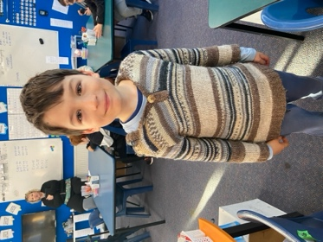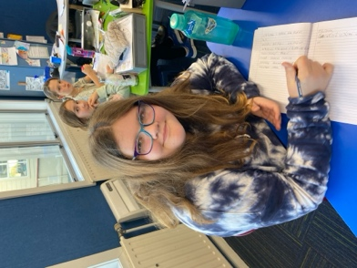
Brighton Rugby
Bravo to the following players on earning Player of the Day for their respective teams.
Georgia Smeaton - Baby Gulls
Ivar Elliot-Tressler – Red Gulls
Ollie McNair- Brighton Seagulls
Korbyn Parata-Walters- Brighton Seagulls
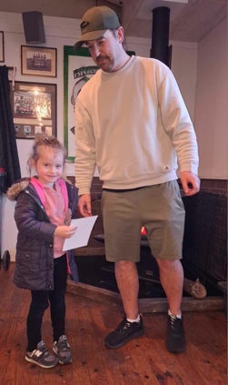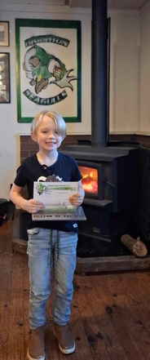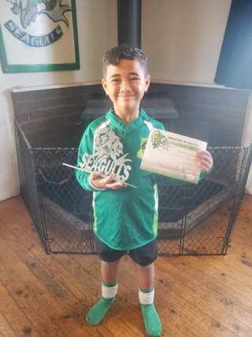

Former Students
I would like to offer my congratulations to former Big Rock Year 8 student, Thomas Weatherall on winning the Otago Secondary Schools Cross Country (Under 15’s). That is a mammoth achievement. Good luck at the ‘Nationals’.
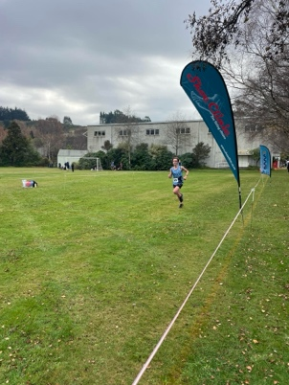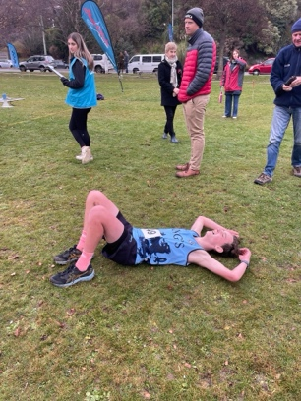

Aotearoa New Zealand History Quiz Questions
- Name at least three members of the band When the Cat’s Away?
- What was the name of the New Zealand reggae band with the hit songs ‘Sensitive to a Smile’ and ‘Long Ago’
- What prominent New Zealand band has it’s roots in Geraldine?
- What was the name of the indie label famed for the ‘Dunedin Sound’?
- What Dunedin suburb did Shayne Carter, former lead singer of Strait Jacket Fits, Dimmer, Bored Games and the Double Happys, and New Zealand Music Hall of Fame inductee grow up in?
Have a great weekend

David Grant
Principal

