June 14th 2024
Matariki Celebration and Aotearoa New Zealand History (ANZH) Shared Meal
This massive and important night on the Big Rock calendar is fast approaching. In fact it is a mere 12 days away. The event is on 26th June at the Brighton Hall, with a six o’clock kick-off.
As you are aware (I hope), the school is providing two lambs on a spit (Mein host roasters), whitebait patty sandwiches, a sausage sizzle and a vegetarian curry. There will also be children’s work on ANZH on display for you to enjoy. There will be an ANZH quiz for people to take part in if they wish.
What we ask for from families and whanau:
- A plate of food to share - enough for four people. This could be something that is culturally significant to your family or something that your family and whanau enjoy on special occasions
- Please bring your own plates and cutlery etc
Over the last few years we have sought your views on the 4 greatest New Zealanders, in case new Zealand were to have its own MT Rushmore. We have also asked for New Zealand’s four best songs. This year we are looking for New Zealand’s five greatest sporting achievements. To kick things off I will give you mine. (In no particular order)
- Dunedin’s Danyon Loder two Olympic Gold medals in swimming (200m and 400m freestyle) at the Atlanta Olympic Games 1996
- Sarah Ulmer setting a world record to win the Olympic Gold medal in Individual Pursuit Track cycling gold medal
- Michael Campbell winning the US Open golf in 1995, seeing off a certain Tiger Woods
- Peter Snell - three Olympic Gold medals in 800m and 1500m across the 1960 and 1964 Olympic Games
- Kiwi winning the 1983 Melbourne Cup, coming from nowhere to win. It still gives me goosebumps.
We have one more request. Upon entry, you will be asked what the Number one song was on the day you were born. We will not record your name or date of birth (People can be funny about that). It is easy to find out, simply google ‘Number one song on YOUR BIRTHDATE’

Sports-Round Up
Netball
Congratulations to Kaylyn TeNgahue on earning Player of the Day for the Big Rock Hurricanes netball team in their quite astounding victory on Tuesday night. Outstanding Kaylyn.
Basketball
Bravo to Lexie Brown on earning Player of the Day for the Big Rock Hoopsters in their hard fought victory against Arthur Street, finally coming away 32-16.
Well done to Brianna Jones and Korbyn Parata-Walters for their great performances in the Big Rock Coasters 34-17 victory.
The Big Rock Shooters had a hard fought but entertaining 10 all draw, with Jed ‘Swish’ Grey earning Player of the Day.
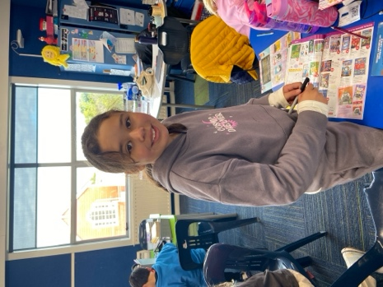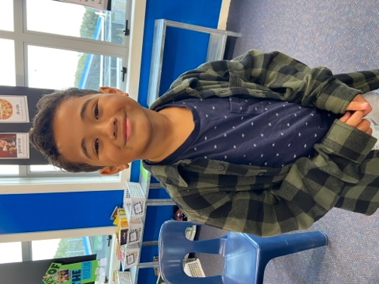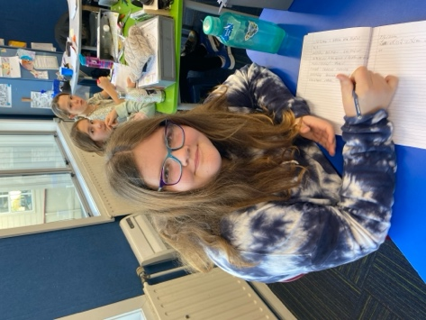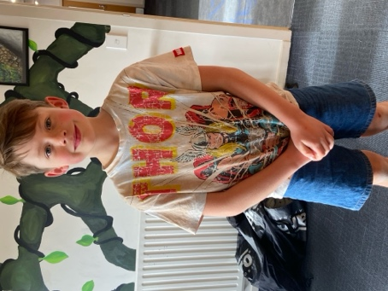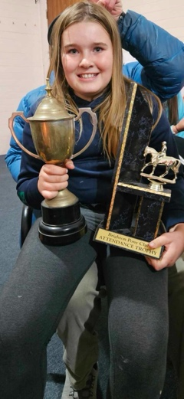
Rugby
A great performance earned Josh de Thierry Player of the Day for his Brighton Seagulls team. Great stuff Josh.
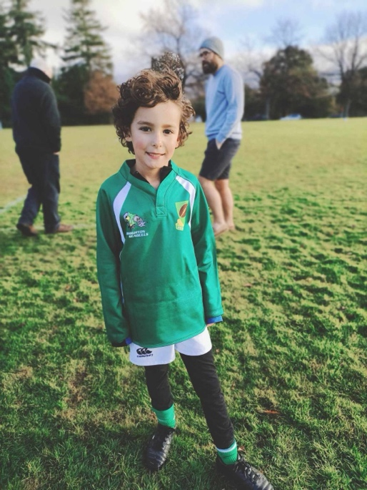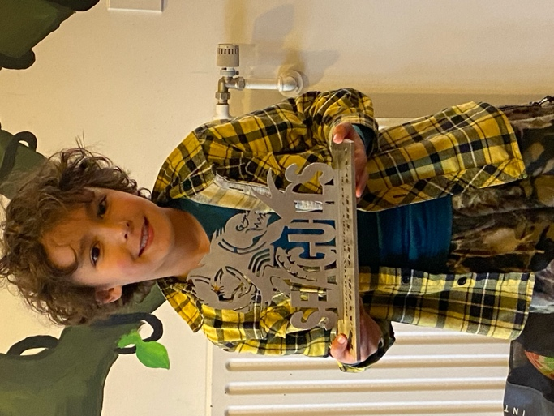

Congratulations
A massive congratulations to Leo Garth who won a Kea Kid’s News t-shirt for his work on designing a new meerkats ‘security lookout’. Outstanding work Leo.
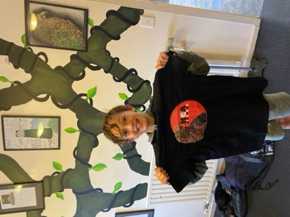
Which leads me to tell you of a new lunch time activity we are trialling that Leo and myself have put together. Not everyone wants to play ball games, ride scooters etc at lunchtimes. Some want to do other things, sometimes. Leo and I had a few chats about it and I managed to source some STEM (Science Technology Engineering Maths) project kits. Leo along with Baily Jenkinson and Andy Zhang (unaided) put them together with a few boo boos along the way, but it worked really well. As such, we bought another 30 different kinds of these kits and small groups of children are having a go at them in the library at break times. The challenges gradually become, well more challenging and intricate, with the ultimate goal being designing/building their own models from scratch, and adding lights, electric motors, buzzers etc.
The first group have made ‘pop pop’ boats, and will be racing them on Monday. I am really chuffed that Leo and I have worked on this together and have involved other children, and am fascinated to see where it ends.
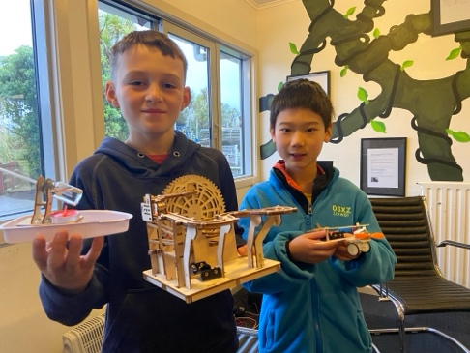
Art or Chemical Spill
If anyone was walking past Room Three yesterday, you may have had a wee panic and thought there was some sort of ‘outbreak’. As everyone was in hazmat suits. But no, it was art in readiness for the Matariki Shared Meal and Mrs Grant was just ensuring the children’s clothes were protected!

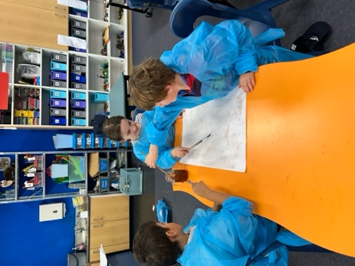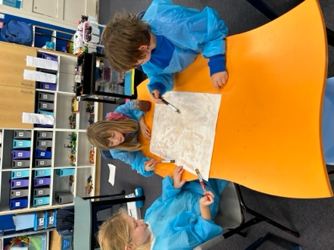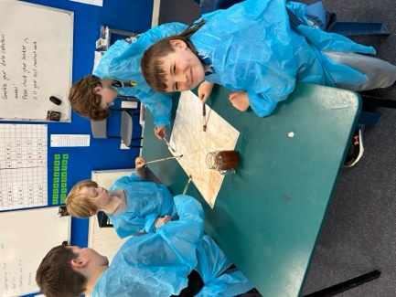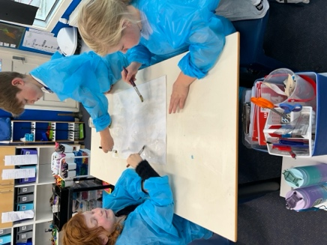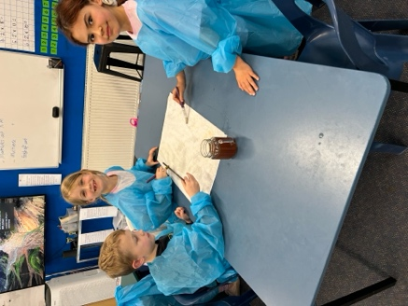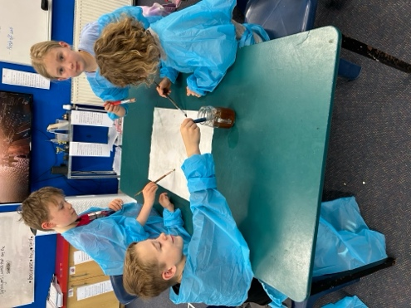
Aotearoa New Zealand History Quiz Questions
- What New Zealander, do some believe, had controlled flight before the Wright brothers at Kittyhawk?
- Who or what was nicknamed the ‘Washdyke Wonder’ ?
- What sank off Barrett’s Reef?
- What is significant about the song ‘In the Year 2525’? (Consider our upcoming Matariki evening)
- What is New Zealand’s most successful film at the box office (In New Zealand)?
Have a wonderful weekend
David Grant
Principal

