8th December 2023
Welcome
I would like to an extend a massive Big Rock welcome to Leo Zhang who joined Room 1 this week. Leo joins his older brother Andy. Fantastic to have you join us Leo.

End of Year
On Wednesday we will be having our End of Year Prizegiving at the Brighton Hall. The prizegiving is now on at 1:00pm due to futsal being played in the last week of term.
The prizegiving is a chance to celebrate all of the children’s achievement, present some awards, bid some people farewell and thank a great many others. We hope to see as many families as possible.
Sports Uniforms and Library Books
Can all sports uniforms please be returned asap. We understand that many will still be being used for futsal next week. Can we also please ask that parents check for black school shorts and return these as well. Also we still have some outstanding netball uniforms.
Can all outstanding library books please be returned, please check as we still have a considerable amount to be returned.
Thank you, we greatly appreciate it.
School Closure and School Re-opening
School will close for the year on Thursday at 1:00pm. After School Care will finish on Wednesday.
Big Rock Primary School will re-open on Wednesday 31st January. Monday 29th and Tuesday 30th January are Teacher Only Days.
On Sunday the 21st January we will again be selling whitebait patty sandwiches at the Brighton Gala Day. This has become quite a tradition, and we have people coming especially to buy them. I will put a request out for helpers a bit nearer the time. Please have a think about helping. It is fun and usually busy, and we only usually need people for 30-45 minutes.
Futsal
Congratulations to Lewis Vorgers on earning Player of the Day for the Big Rock Stingray. Top work Lewis.
Bravo to Rowan Patterson on earning Player of the Day for the Big Rock Dolphins. Great photo Rowan.
Outstanding work from Magenta Grant saw her earn Player of the Day for the Big Rock Barracuda. Keep it up Magenta.
A great all round game saw Zach Turner earn Player of the Day for the Big Rock Marlin. Well played Zach a great all-round game at both ends of the court.
A comprehensive victory 6-3 for the Orca with Courtney McNair earning Player of the Day. Great stuff Courtney.
A very impressive team performance against Dunedin North Intermediate had the Sharks winning 13-0. This week Leo Douglas and Troy Twinning both earned Player of the Day. Well done lads.
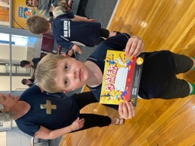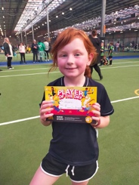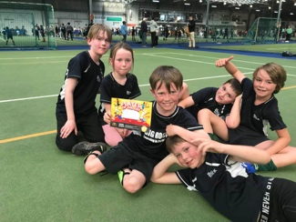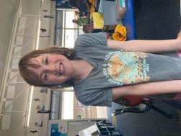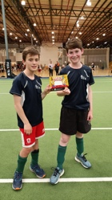
Taieri Mouth Boat Trip
Yesterday was an absolute belter. An incredible day on the Taieri River as part of our end of year package for our Year 8s. A boat trip up the river, jet skis and biscuit riding. The canyons echoed with laughter and the odd squeal, and an occasional loud splash followed by laughter. If that wasn’t enough, crayfish on the barbeque for lunch! I don’t know of any other school that could even dream of such an adventure, all 100% safe. This, like so many of our adventures in EOTC was possible through the enthusiasm and generosity of our school families. In this case a massive thank you to Paddy Patterson who was ably assisted by Bevan Duke, Richard Murray and Lauren Mooyman. Learning in Paradise anyone?
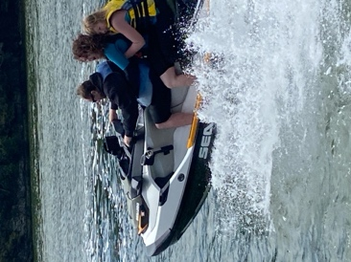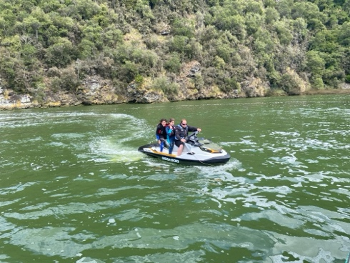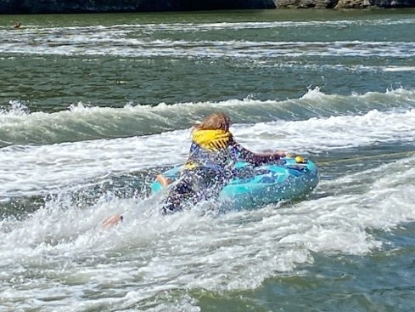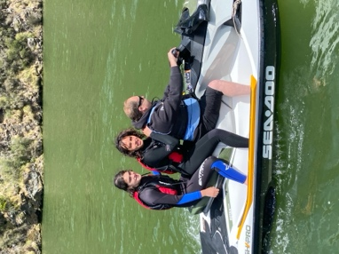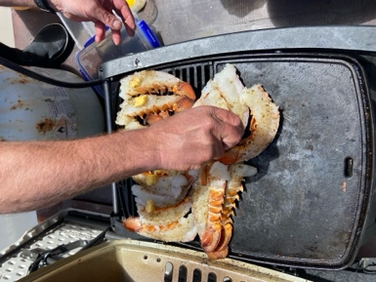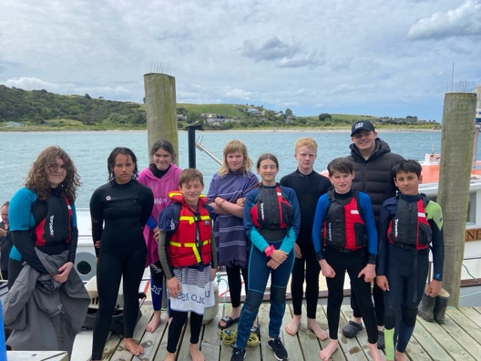

Principal’s Report
The Big Rock School Board has asked me to share my final Principal’s report of the year with you. (It follows below)
Have a great weekend.
David Grant
Principal

Board of Trustees
Principal’s Report 4th December 2023
End of Year Report
Curriculum
2023 has been a very positive year for curriculum and curriculum development. Some of the key components include:
- Achievement and Attendance Levels
- Literacy Development, Structured Literacy and IDEAL
- Aotearoa New Zealand History
- Development of Personal and Physical Resilience Programme
- Full Implementation of EOTC programme
- Extension of MTB programmes
- Living World
Achievement and Attendance Levels
It won’t come as any great surprise that when attendance levels are high, achievement levels have a greater chance of being high. Our Mid-Year achievement results in the core learning areas of Literacy and Mathematics were very pleasing, and I look forward to confirming our End of Year Results. Our attendance levels have also been very high.
There are number of reasons for this, but put simply, quality teachers and teaching with meaningful and engaging programmes, supportive parents and enthusiastic happy children. Throw our EOTC programme into the mix, things like Pet Day, Tabloid sports day etc, it is a very exciting and happy place to be and learn. It is indeed learning in paradise.
Literacy Development
The upskilling of staff in Structured Literacy has been excellent. The work being lead by Lisa Lamb with support from Teresa Grant is being well received by all staff and will continue to make a positive difference for all children across the school. Teachers attended professional development on this with Liz Kane (Specialist). This was followed up with Lisa and Teresa visiting Holy Family School in Wanaka for further professional development. Lisa and Teresa are now working on a plan of further implementation in 2024.
Aotearoa New Zealand History (ANZH)
While this is a new component of the New Zealand Curriculum, the progress that we have made is excellent and is now a key part of our school calendar. The classroom work following our topic Based Integrated Model of Investigate, Explain and Present (IEP) allowed children to learn and understand NZ History, as well as following their only learning direction (Student agency). This work was also supported by EOTC experiences and adventures based on age, from History Detectives to Amazing Races. All of this work culminated in our ANZH and Matariki Celebration, with whanau enjoying children’s work, sharing food, all under the flags of our varied cultures while celebrating those cultures as well as acknowledging and celebrating Tangata Whenua. It was a body of work to be proud of.

Development of Personal and Physical Resilience Programme
While it has been a bit slower in the development stages than we would have liked, it has given a better understanding of what causes anxiety, nervousness in the children a Big Rock through sessions with the children at. The children’s voice gave us a very good insight and understanding. It will also help us to eradicate some of the anxieties as well as giving the children the tools to help deal with some in the future.
The development of the programme has involved professional readings, group collaboration, personal experiences and observations, as well as consultation with the children.
The plan is to fully implement in Term One 2024.
Full Implementation of the EOTC Programme
Through the usage of newsletters, facebook etc our parents and whanau have a greater understanding of EOTC at Big Rock. Firstly, that it is not just surfboards and mountain bikes, but that it also includes all learning outside the classroom, things like; Orokonui trips, Amazing Races (ANZH), History Detectives, water testing on the Otokia etc and why they are important to a meaningful learning programme.
I also think that we have telegraphed the message that a key component of EOTC is developing and building self-esteem and personal confidence and resilience that supports mental health and brings more confidence to learning areas in the classroom. We are now seeing evidence of this. The growth in confidence of children on Survivor Camp, who only 18 months ago were anxious about trying anything new, are now ripping into it.
MTB Extension Programmes
From meagre beginnings. This has been an unmitigated success and is the envy of a number of schools. Starting with a class trip to the Rail Trail a number of years ago, to now having a Rail Trail class trip, a Goldfields class trip, Harbour ride class trip, three different MTB groups, Introductory, Tracks N Trails and Advanced and now with the Te Manuawa funding we will be able to implement a Junior Biking programme. Like our EOTC plan, this is having incredible positive outcomes across the school.
Living World
The learning programmes delivered in Term Three as well as the achievement results linked to our Integrated Topic Based Model were very good, and the programme included lots of EOTC which was also very pleasing. However, the other reason it was so important is that it was a direct link to community consultation and showed that as staff and a Board were listening to the responses and acting when and where we could.
Property
2023 has been an interesting year for Property and Property Developments. Some of the key areas of 2023 include:
Switchboard replacement
- Library and Outdoor Learning Area
- Painting
- Swimming Pool
Switchboard Replacement
In the middle of the year the school switchboard was replaced. It was a big job and a necessary job, but with the best will in the world, not a very exciting one. We now have a modern switchboard.
Library and Outdoor Learning Area
This project is underway, and we are expecting big progress being made while school is closed. Again, there have been a number of issues with suppliers and builders. Kara is again keeping the pressure on. It is very frustrating. With a bit (Lots!) of luck we should have an exciting new area in the new school year.
Painting
Rooms Three and Four were painted rather vibrant colours which have made a positive difference. I understand that the next body of work will be Rooms One and Two, and the office block.
The changing rooms and the bathroom at the swimming pool were also painted. The painting work was completed quickly and efficiently by Blayr Findlay of iPaint. Blayr was great to deal with and put in some big hours and weekends to get it done for us. It was incredibly refreshing.
Community Partnership and Engagement
Community Partnership and Engagement is very important if we are going to deliver a real and meaningful Localised Curriculum. It has been very positive in 2023. Some of the evidence of this includes:
- ANZH Evening
- Parent Survey
- Pet Day Extravaganza and Tabloid Sports day
- Social Media feedback
- Support of Staff
ANZH Matariki Evening
I alluded to this earlier, but this was a staggeringly great evening. To have 95% of our families fully engaged in the evening is remarkable. I am unsure what else we could do to improve without a bigger facility and a massive budget. The evening did the following things:
- Shared and celebrated children’s work on ANZH and Matariki
- Celebrated and acknowledged local Tangata Whenua
- Celebrated and acknowledged all of the different cultures and nationalities within our school community.
- Shared food from all families
- School provided lamb on a spit, venison bbq, vegan dishes
- Family and whanau enjoyed each other’s company
- Consulted with whanau
To be honest, it was almost a perfect example of education in action and our school pedagogy.
Parent Survey
While this took a wee bit of time to get the framework correct, it was worth it. As a Board and as a staff we have acted on a lot of the suggestions and thoughts, many of which followed a similar trend (Pool, Living World, painting, sports day).
Pet Day Extravaganza and Tabloid Sports Day
Along with ANZH Evening, our Pet Day and Tabloid Sports Day provides the opportunity for whanau to come along to school and engage with the children in a range of fun activities. These days are also really important for the children’s development as they are pretty independent for a chunk of the day and can choose what activities they are going to be involved in at their discretion. This is truer for Pet Day. Both days also provide the opportunities for younger and older children to work together.
Like a number of things we do at Big Rock, other schools are envious but are not prepared to have a go. Which saddens me as while they are fun, they are also important. It is of great help that we have such supportive and engaged parents and whanau.
Social Media Feedback
The feedback for school events and adventures is always very positive, admittedly a limited number of people actually write feedback but there is a lot of thumbs up etc. While I take social media with a grain of salt, it does provide us with an opportunity to share many of the children’s adventures. The tone is always positive.
Support of Staff
On the whole, the community has been very supportive of staff, which has been very pleasing but is the right thing to do. I would hope that the community recognise the extra distance the teachers go to ensure quality programmes, high engagement and good achievement levels. The fact that we have always tried to manage strike days, Teacher Only Days in a way that families were not battered must have been viewed positively and comes back to school and home working together.
Summary
Overall, a very positive year, when the media was negative about schools in general, particularly attendance and achievement levels. Ours were both strong and somewhat against a negative trend. I believe that the effort and ability of both staff and Board are major contributors and that our curriculum and events create a special learning environment, and we should be collectively proud of that. We also need to acknowledge the support and encouragement of our families and whanau as they make up the powerful triumvirate that creates success in a school. Children, whanau and school, working together.
The school vision states that we aim to ‘Create independent, resilient lifelong learners with inquiring minds by providing all of our students with rock solid foundations in Numeracy and Literacy.’ I would argue that together we are doing that. Learning in paradise is a reality.
Thank you to everyone for everything you do for the children in your school. I wish you and your families a happy, restful, exciting holiday and I will see you all at Gala Day if not before.
David Grant
Principal

