15th December 2023
Congratulations
Congratulations and well done to Isaac Lucking on his performances in the Mosgiel Fire Station Theatre’s performance of The Life and Adventures of Santa Claus. With all of the rehearsals, and more rehearsals, followed up with six shows. That is a mammoth effort at any time of year, but to do all of that on top of school, futsal and everything else at this time of the year is quite remarkable. Outstanding Isaac.
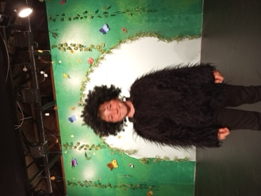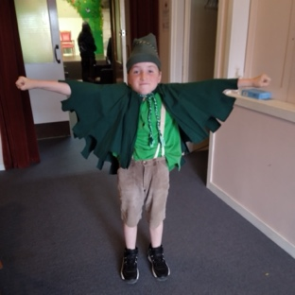
Also, a big congratulations to Chloe Knights on earning a Merit award in a recent writing competition run and organised by the Otago Literacy Competition. Chloe wrote beautifully in the section ‘If I could change one thing about our school for well-being’.
Brilliant work Chloe.
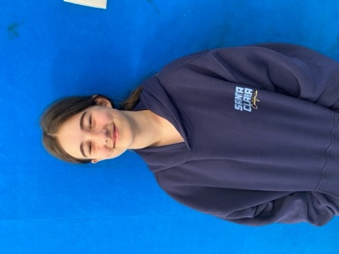
Futsal
Firstly, a massive thank you to Jo Henderson, Cavan Jenkinson, Tania Blanchard, Shane Turner and Lauren Mooyman for your commitment to coaching our six futsal teams. It is massively appreciated.
Well done to Adelaide Conway on earning Player of the Day for the Big Rock Stingray.
Bravo to Bryn Little on earning Player of the Day for the Big Rock Barracuda.
Outstanding work from the whole Marlin team saw them all earn Player of the Day.
A great final game saw Leo Garth earn Player of the Day for the Big Rock Orca.
Congratulations to Benja Gonzalez Montenegro on earning Player of the Day for the mighty Big Rock Sharks. In their final, they beat Fairfield 9-2, a team that they lost to in round robin play. Ben, as goal keeper decided to dribble the ball out, beat one, then two before dribbling past the whole team and slotting the ball in the goal. Great work Benja!
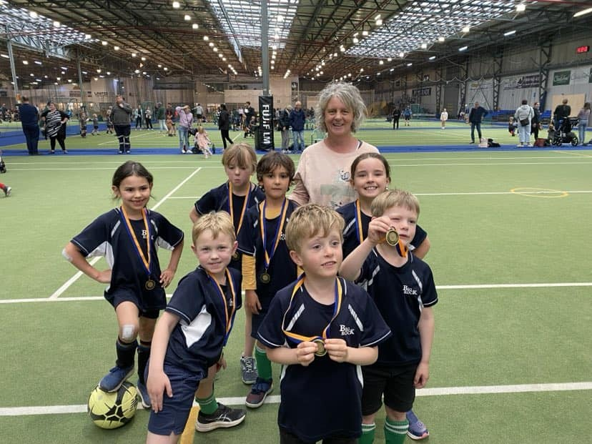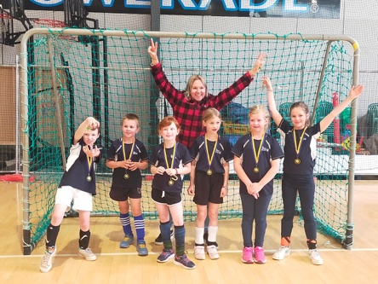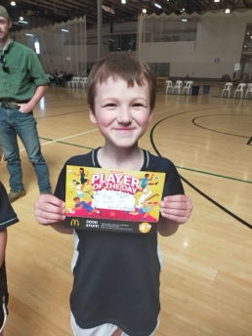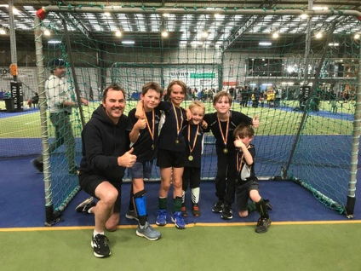
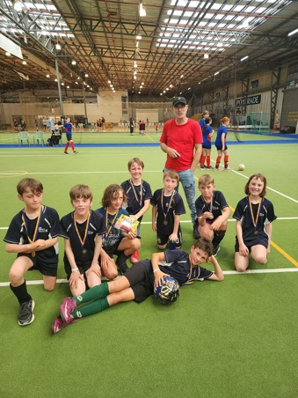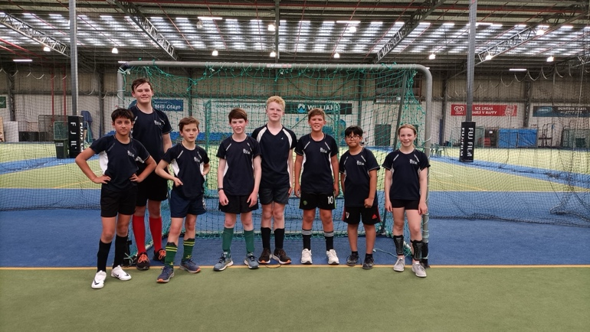
Thank you
I would like to offer a massive thank you to Lauren Mooyman, Katie Little, Morgan Skerrat and Gayle Woodford for doing an amazing job at After School Care, when we had a genuine staffing emergency. The work you did, was extraordinary under very short notice. Thank you.
Another Thank You
Thank you to everyone who has made this year another great year, the attendance rates, the achievement rates and the happy children prove it. Thank you to Kelly, Kara, Sue Kerry and Debbie, our amazing support staff. Thank you to Kim Maxwell for your wonderful work with Kapa Haka, thank you Lisa Russell for the thankless task of sorting the lost property, thank you Tania Blanchard, Shane Turner, Joe and Ange Hancock, Sophie Wheeler, Cavan Jenkinson, Scott Weatherall, Lisa Russell, Graeme Egan, Jo Henderson, Jasmine McNabb, Marina Conway and others who helped coach our different sports teams, thank you to the great teachers who make a difference every day, thank you to our wonderful families for the faith and support, thank you to our wonderful Board of Trustees, Scott, Graeme, Jo, Shane, Kara and Lisa for everything, and lastly and most importantly, thank you to every single child for your hard work and enthusiasm and for not only making Big Rock rock, but ensuring it continues to be Learning and Working in Paradise.

Goodbye
Enjoy your richly deserved retirement Debbie, your contribution has been much appreciated.
To all of the children moving on, Lucy, Daisy, Mia and CC, all the very best, it has been a huge honour and a privilege to have been a part of your education journey.
Lastly, to our Year Eights, all the very best wishes, Armani, Chloe K, Chloe V, Stevie, James, Ayshe, Leo, Riley, Libby and Troy. Keep on rocking, Big Rocking that is.
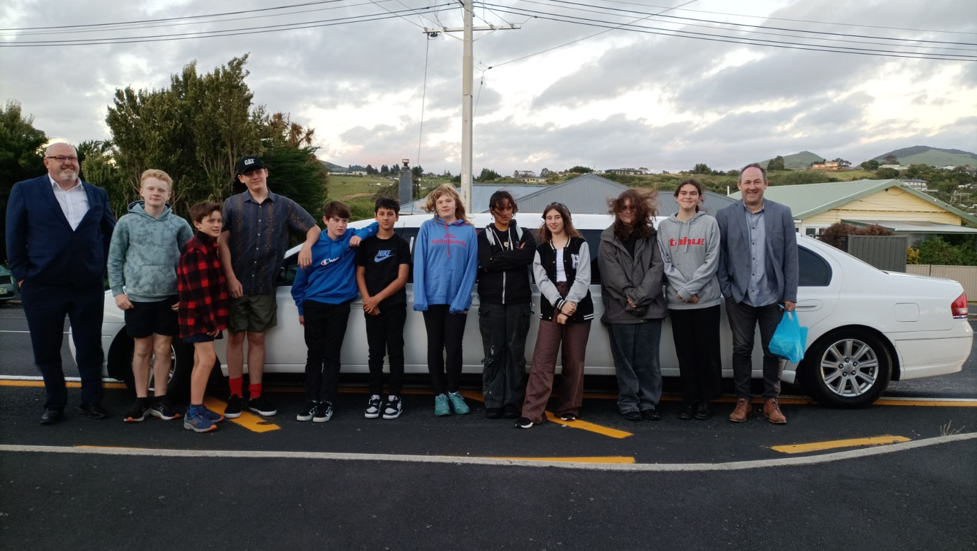
On behalf of everyone at Big Rock, I would like to wish everyone a safe, happy and enjoyable summer. I hope everyone gets the opportunity to do what they and to avoid the things that don’t want.
Take care and we will see you in the New Year when we will welcome a lot of new families and Learning in Paradise will resume.
Ka kite
David Grant
Principal

