31st August 2023
Tree Planting
On Tuesday we had an excellent tree planting session down at ‘back beach’ in Brighton. The children planted a range of native grasses and trees. It was a very cool experience, with clearing, digging, planting, putting down matting, stakes and windbreaks, all wrapped up beautifully with a lovely karakia by Stevie Kahui. A massive thank you to Claire Laing and Viktoria Kahui for giving us the opportunity but also for leading the way. “We should all plant a tree that someone else can sit under”
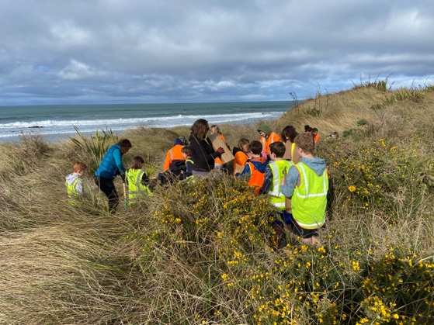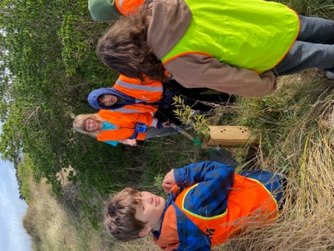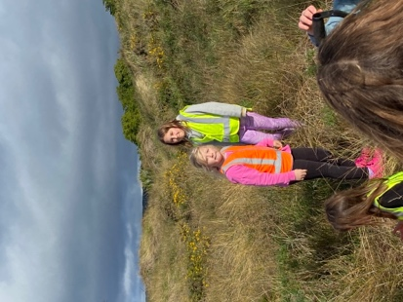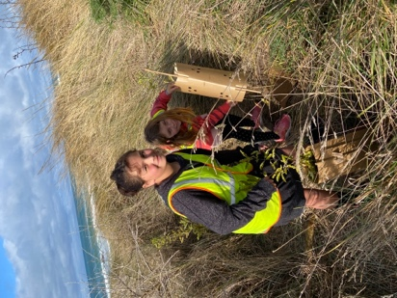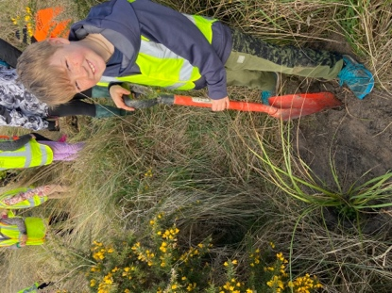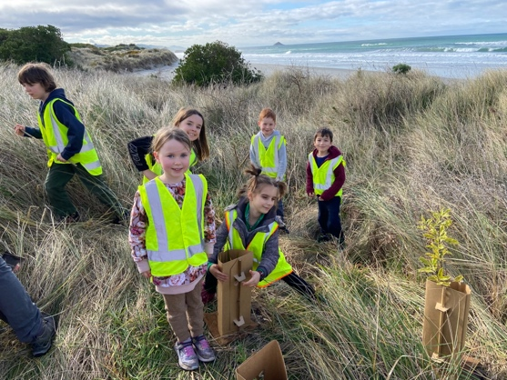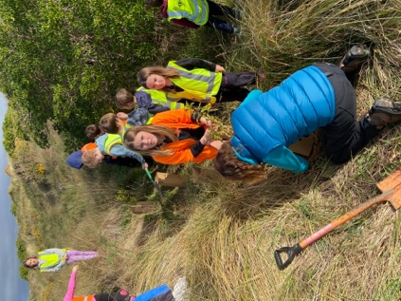
Honey Fundraiser
Thank you to everyone who was able to get on board with the honey fundraiser. Thank you to Tania McIlroy, Kelly and the team for all of the work. Much appreciated. The honey is available for pick-up after school today.
School Disco
From all the feedback I have received from children and parents, last Friday’s disco was a wonderful success for young and old. The costumes looked amazing. Well done for all the effort that went into them.
Thanks, Shane, for getting it going, I know lots of people helped but it takes that one person to get it all underway and keeping it underway. Nice one. It even made some money, which is great is great because the goal was breaking even.
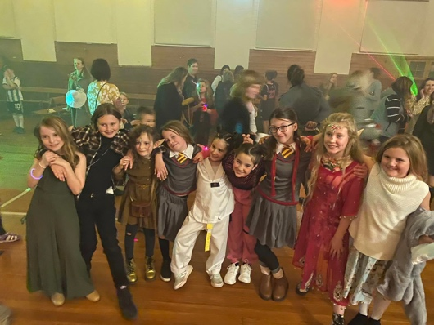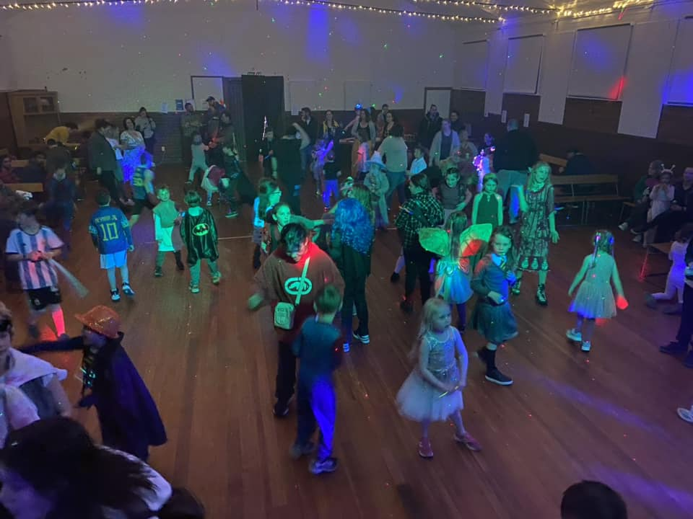
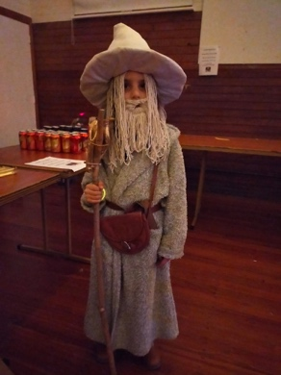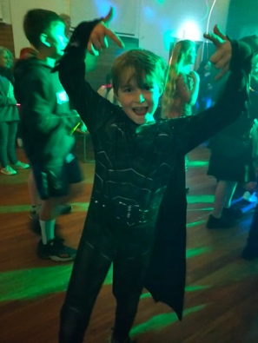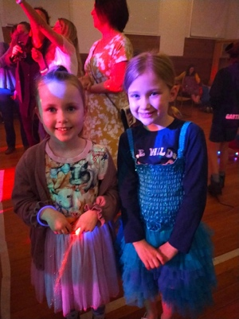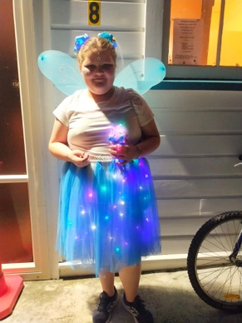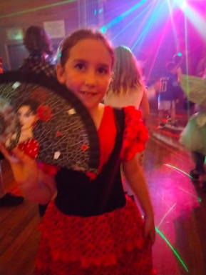
Library Books
It is sad when you read that schools are getting rid of their libraries, tragic really. There is nothing that attracts children to the benefits and joys of reading like books do. Yes, you can read them on a tablet or kindle etc but it’s not the same. Saying tablets and kindles are better than books is bit like saying you’d rather watch a movie on your phone than see it at the movies. Anyhow, earlier today I had the pleasure of going book shopping with Cameron Walters, Chloe Knights and Scarlett Hancock. We have $4000 to spend and these girls got us off to a great start ($1100). More books will be purchased in the next week or so with different shoppers. Keep an eye out.
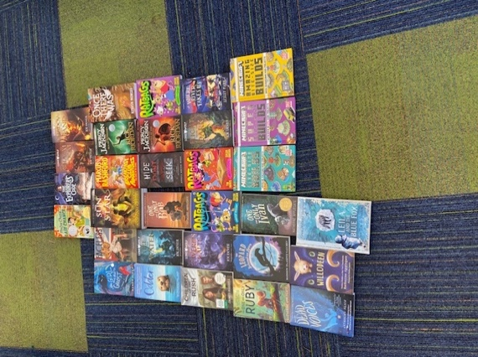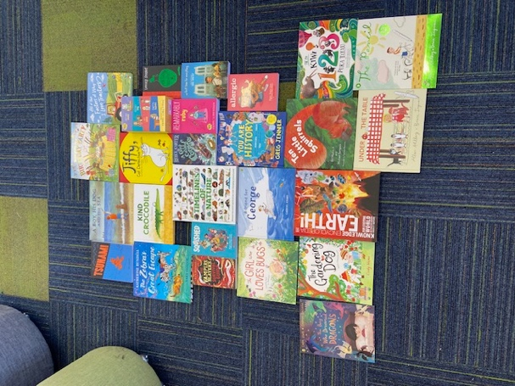
Futsal
A reminder that we are currently taking names for futsal. We will need these all in by next Friday, 8th September please. Years 1-4 play on a Tuesday and Years 5-8 on a Wednesday, both at the Edgar Centre. Also if you are keen to manage/coach a team, please let us know.
Car Wash
Does your car need a bit of a spruce up after all of the winter muck? Get yourself and your car over to the Brighton Rugby Club carpark where this is a carwash fundraiser on Saturday.

Otago Cross Country Champs
Good luck to Leith Conway , Isaac Lucking, George Weatherall, Kade Hancock, Scarlett Hancock, Kiptyn Garner, James Patterson and Leo Douglas as they compete in the Otago Cross Country Champs tomorrow.

Brighton Seagulls End of Season Prizegiving
On Saturday the local rugby club had it’s prizegiving. Congratulations to the following players whose efforts were recognised.
Most Diligent Player- Stella Brown, Most Improved- Charlie Hughes, Lewis Vorgers- Presidents Trophy for Perseverance, Bryn Little- Most Promising, Fin Ramsay- Best and Fairest, Greyson Farquhar- Most Promising, Daisy Brownlie-Best and Fairest, Rhys Shayler and Quinn Hollands- Most Improved.
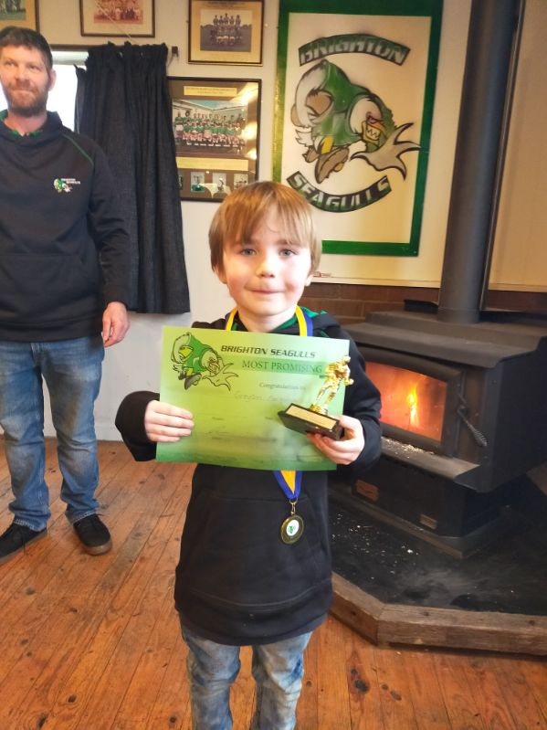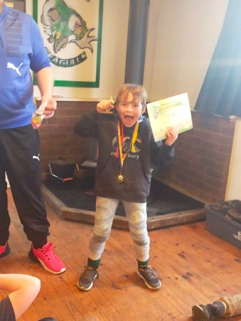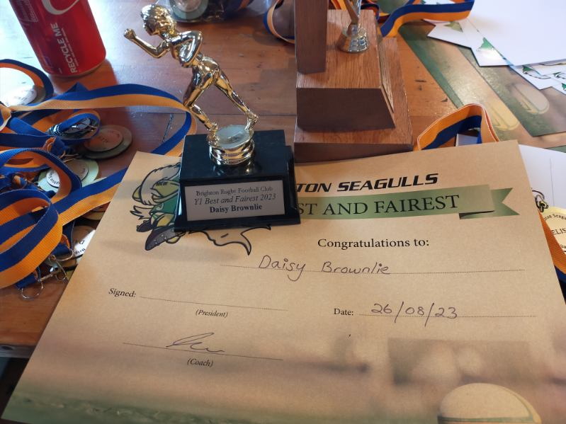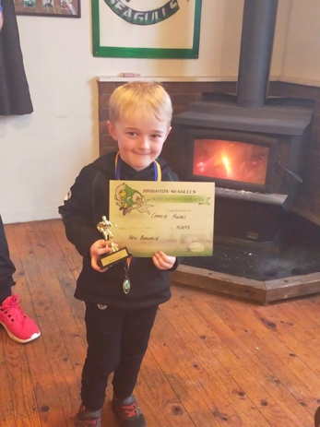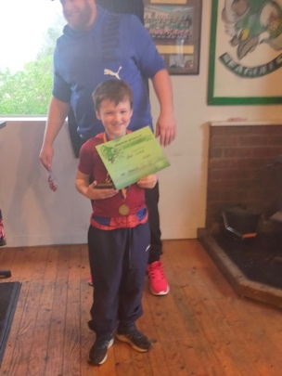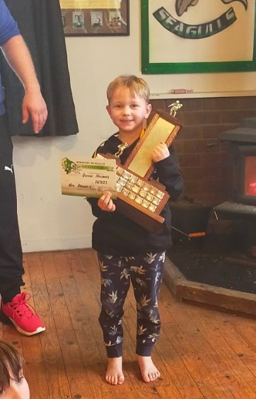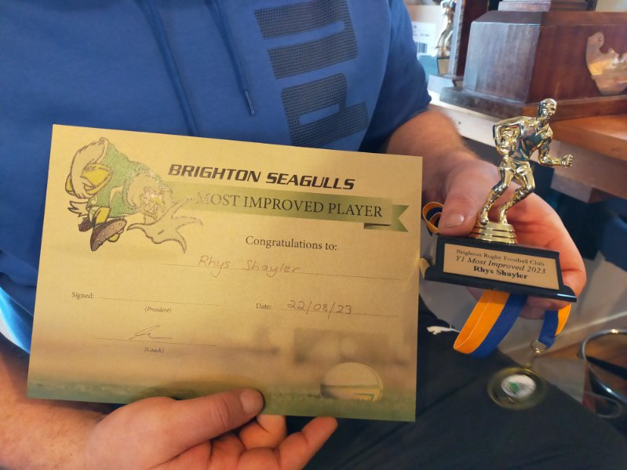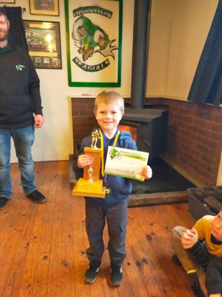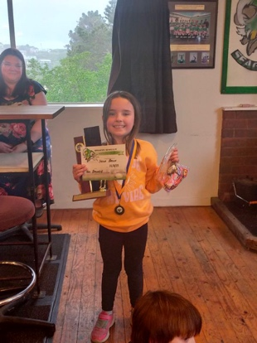
Have a great weekend
David Grant
Principal

