25th August 2023
Big Rock School Disco
The time is now. It has been a number of years (You can probably guess why) since we have had a school disco and you easily forget how much the children look forward to it. Thank you, Shane, for getting it up and running again. The drinks are cooling, the treats are being bagged up, the prizes are being wrapped, the lights are flashing, the playlist is being finalised, and the final sound check will be happening a little bit later.
Doors open at 5:55pm and close at 8:00pm. The entry fee is $2. All of the treats for sale are either $1 or $2. This time the disco is only for Big Rock children and pre-schoolers of Big Rock children. Children 7 and under will need an adult with them or an adult who is responsible for them. The aim is for the children to have some fun, but we do need to ensure the safety of all of the children which is why the ‘discoers’ will not be permitted to leave the hall until the end or they are leaving to go home. Historically there have been unfortunate incidents outside and down the back of the hall.

Congratulations
Congratulations to Riley ‘Sticks’ Henderson who made his gig debut at the weekend playing drums in a band with his brother Ruben and father Mark. It wasn’t a cameo performance, Riley played the whole gig, 19 songs to a very good sized crowd. I can see you Riley becoming one of the greats alongside Keith Moon, John Bonzo Bonham, Ringo Starr, Chachi Aicola or even Gonzo.
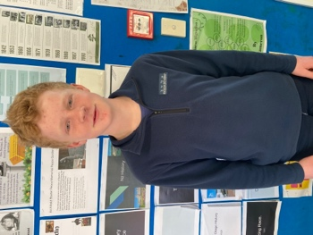

Virtual Reality
On Wednesday Rooms Four and Five were visited by Hannah Drury a Professional Practice Fellow at the NZ Marine Studies Centre. Hannah ran two sessions on ocean ecosystems, pollution, challenges facing the oceans, what we can do about it. It was taught in a very interactive way that had the children hooked (sorry!). It was supported by incredible 360º Virtual Reality goggles that took the children under the ocean with the sea life, whales, dolphins, snapper, spider crabs, sea sponges to name a few. It was very cool and meaningful. I think of when I was at school we might have coloured in a fish!
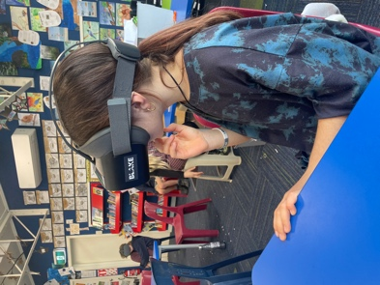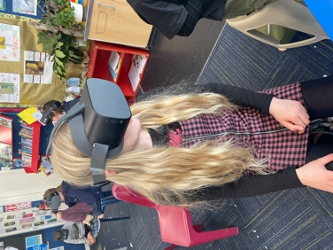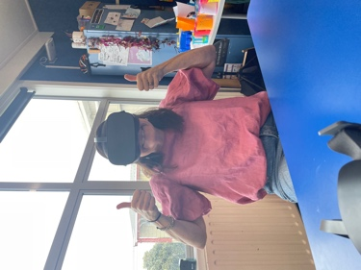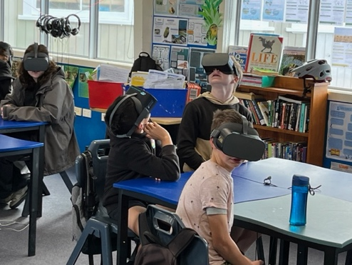
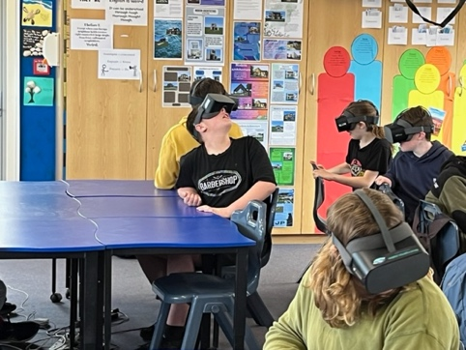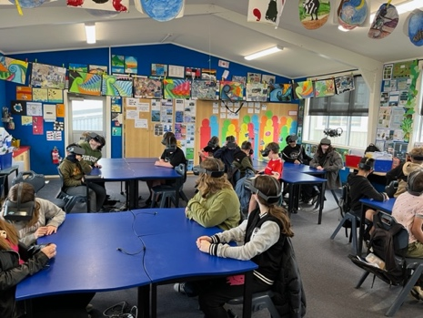
Futsal
It is that time again, if your child is interested in playing futsal next term can you please let us know. Year 1-4 children play on a Tuesday and Years 5-8 play on a Wednesday. Also if you are keen to manage a team can you please let us know as well. I will need all player registrations by 7th September so that we can enter teams.
Mountain Biking
Yesterday I had the privilege of joining the Advanced MTB group on their adventure. They were riding the tracks of Whare Flat, with some pretty steep inclines. No problem for them though. I was impressed with effort and attitude, as I always seem to be. Many thanks to Angie and Scott for leading this and making it challenging but achievable.
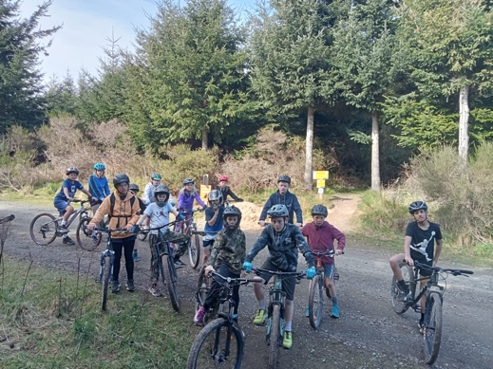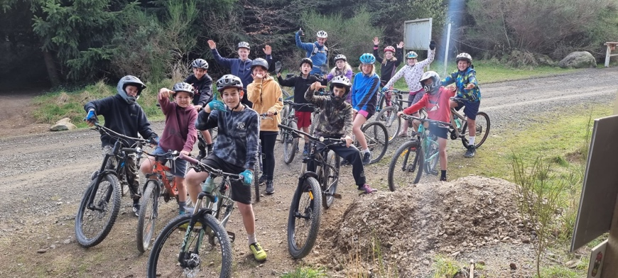
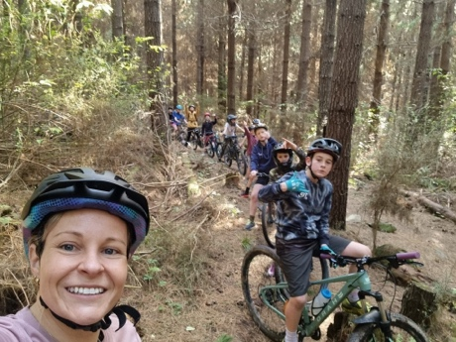
School Honey Fundraiser
Many thanks to everyone who was involved in our honey fundraiser, it is greatly appreciated and needed in these expensive times.
The honey will be available to be picked up on Thursday here at school from 3:00pm.

Have a great weekend.
David Grant
Principal

