9th August 2024
Mid-Year Achievement Results
Please find below a table showing baseline data for our Mid-Year achievement results in Reading and Mathematics. Assessment is carried out using formal assessment tools, as well as bookwork and other samples of work. (A statutory requirement for all New Zealand schools to present these twice a year.)
I am pleased with these results, knowing that they will improve by the end of the year. Both Reading and Mathematics are considerably (Over 25%) than results nationwide.
 | Girls | Boys
Reading | 91% achieving at or above expected level for age | 84% achieving at or above expected level for age
Mathematics | 85% achieving at or above expected level for age | 91% achieving at or above expected level for age

The timing seems appropriate as there has been a lot of talk, information and misinformation about mathematics in the media this week. One of the alarming statistics was that a mere 28% of Year 8 students across the country are achieving in mathematics, I would dispute that. Please see the table below that shows the achievement levels of Big Rock Year 8 students in mathematics in the last three years.
2022 | 2023 | 2024
97% of Big Rock Year 8 children achieving at or above the expected level for their age in mathematics | 93% of Big Rock Year 8 children achieving at or above the expected level for their age in mathematics | 100% of Big Rock Year 8 children achieving at or above the expected level for their age in mathematics

As well as bookwork and non-formal tests, assessment is carried out using the Progressive Achievement Tests (PATs) that the Minister of Education requires all schools to use as of 2025 (we have been using it for 10 years plus). The Big Rock statistics are further enhanced by those students at high school with NCEA excellence and being in Maths extension classes at Kings, Queens, Otago Boys, Otago Girls, Bayfield and Logan Park High Schools. Similar data goes back more than 6 years. It is not for me to say who is underperforming at Year 8 or earlier but the data tells our story. All the full primary schools I have spoken to in the last week report similar results.

Congratulations and Sports Round-Up
The Big Rock Hoopsters had a hard fought 19-16 victory with several players out through illness etc. They worked hard together and found a way to get a good result. Well done Malaika Patton on earning Player of the Day.
On Tuesday night I had the privilege of watching the Big Rock Hurricanes netballers play George Street. Again, they had several players out with illness etc. Again, they worked hard together to get a great 14-6 victory. Well done Bella Yeoman on earning Player of the Day, richly deserved I might add.
Bravo to Lily Scott on earning Player of the Day for the Big Rock Shooters in their 18-8 victory.
Another excellent performance, full of energy and enthusiasm saw Annabel Free earn Player of the Day for the Big Rock Coasters in their narrow 1-point defeat.
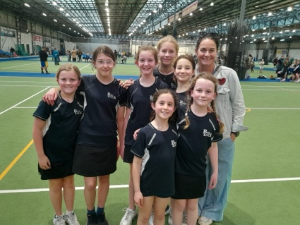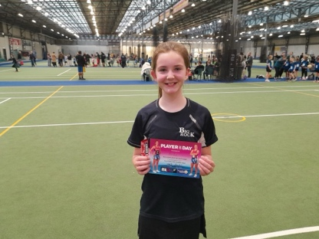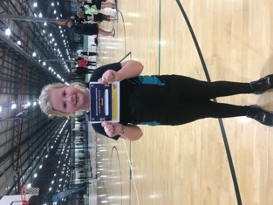

Players of the Day
Well done to the following people on earning Player of the Day for their football and rugby teams.
Leith Conway Green Island Football Club
Leo Henderson. Brighton Seagulls – Mini Gulls
Jed Grey Brighton Seagulls
Courtney McNair Green Island Football Club
Stella Brown Pirates Rugby Club

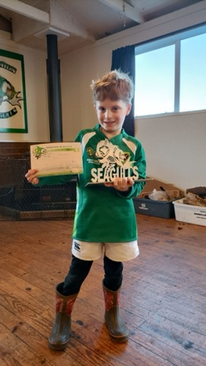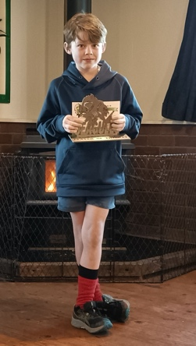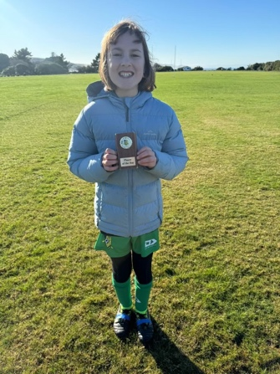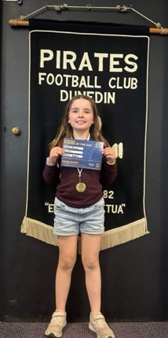

Ski and Snowboard Trip
Earlier this week a group of enthusiastic skiers and snowboarders, made a 5:15 departure and headed off to Ohau for a couple of days on the mountain. From all of the reports, photos and videos, everybody had a great time. How could you not? Many thanks to Su Keen for leading it and to Shane Turner for getting it underway. Many thanks to all of the parents for helping with transport, supervision and pastoral care.
The plan at this stage is for Coronet Peak in 2025, staying in Arrowtown.
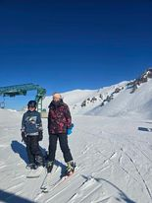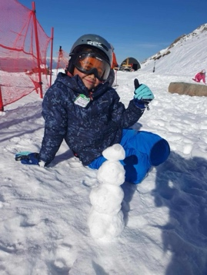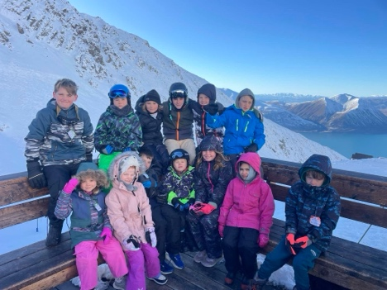
Steven Adams Basketball Camp
Yesterday at the Edgar Centre, New Zealand NBA star Steven Adams, supported by great coaches from Otago and around the country ran two, two-hour training camps. There were just over 200 places available, you had to apply to win. I have been reliably informed, over 4000 people applied. The Big Rock Hoopsters, bar one due to illness, got to attend. I am not 100% sure why they won, but I am pretty sure it was a combination of on-court attitude and the parents and whanau off-court attitude. We also had a few younger ones attending. It was an incredible experience for all the children lucky enough to be involved. Massive thanks to Annette Hogg, Kara Walters and Rowan Newman for helping on the day. Also, a massive thank you to the people at Basketball Otago (Rebecca Moon and James Ranson) Alf Arlidge and Meadowfresh for making it happen. Of course, the big man himself, Steven Adams and his team. Legends all of you.
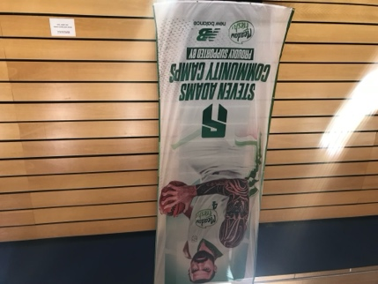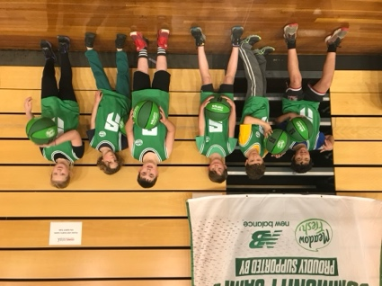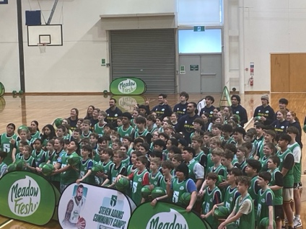
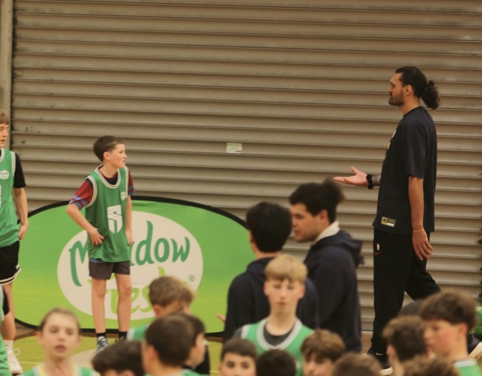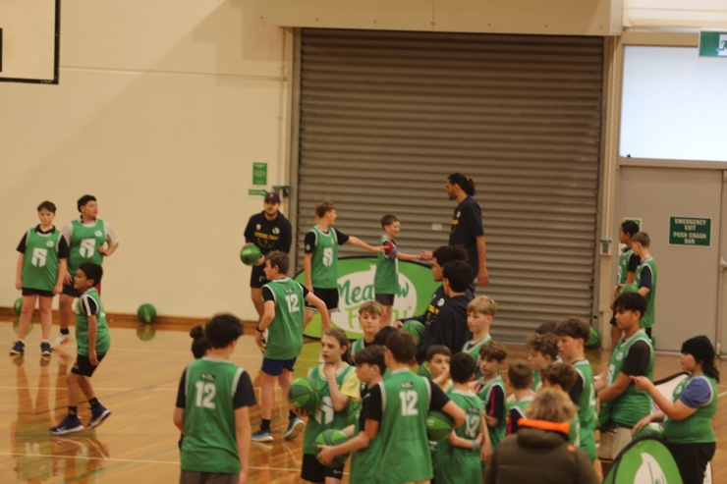
When Steven met Beau!

Year Seven-Eight Information Evening
On Wednesday night, we have our Year Seven-Eight Information evening. I initially sent an invite to all of the parents of Year 5-6. So as to inform them what happens at Big Rock and why. If anyone else would like to attend, please you are very welcome. It is on Wednesday 14th August at 6:15 in the senior class. If you have any questions, please don’t hesitate to contact me directly.
Art Extravaganza
Please remember to pencil in the date - Wednesday 25th September. The hall will be open from 4:00pm until 6:00pm, and again on Thursday from 10:00 -1:00 for the wider community.
Rest assured, the Arts are an important part of the Big Rock School Curriculum. The arts are important to everyone, whether it be humming along to a song, to playing music, singing and performing, or painting and sculpture or all of the above. Our Art Extravaganza encourages the children to understand art, art history and most importantly, to be creative. Creativity is not just about the arts, it is also about literacy, mathematics, problem solving, science, storytelling, sport and games. It helps us all be more interesting, happy and kind humans.
The children’s work will prove that. I promise.
Toi mo nga mahi toi Ars Gratia Arti Art for art’s sake
Have a great weekend
David Grant
Principal

