8th November 2024
2025 Announcements
While there is still a wee way to go in the 2024 school year, it seems like a great time to make some announcements for 2025.
2025 promises to be an exciting one culturally and within the wonderful world of the arts. Firstly, I am delighted to advise you that we will be back on stage at Polyfest 2025. We are aiming to have two performances to celebrate our Pasifika students and our Māori students with a Pasifika performance and a Kapa Haka performance. While it is still early days, if you are keen to help with costumes, performance etc, please have a think and let me know.
I am equally delighted to let you know that planning for our 2025 musical production is underway. I can advise you now that Big Rock Primary will proudly present Alice the Musical (Alice in Wonderland)
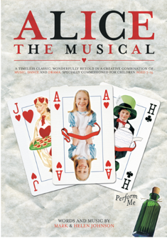

As with Polyfest, if you think you can help with costumes, music, lighting etc, please have a think and let us know.
Science and Nature School
Our school has a strong focus on Education Outside the Classroom particularly at the older end of the school. For two main reasons, it is important for social development as apart from curriculum benefits, it is also proven to support mental-health, self-esteem and leads to positive impact on other curriculum areas and it’s fun. As part of this we have loosely followed a philosophy based on ‘Learning In, Learning About and Learning for the Environment’ with the knowledge that children who love their environment through experience, are more likely to care about it. Actions not just words.
As of 2025, we are formalising the programme, by trialling a new Big Rock initiative that we have put together that will see the senior class (At first) experiencing our very own Science and Nature School every second Friday. It will take place all over Dunedin and the wider area, (Blueskin Bay, Fraser’s Gully, Akatore, Taieri Mouth, and the Brighton beach and wetlands area), Year 6’s will be involved once a term. I want to thank Jessica Garth for helping me put the programme together and for the encouragement. It is going to be amazing. If anyone would like to see it, please call in.
Futsal
Congratulations to the following players on earning Player of the Day for their respective futsal teams:
Big Rock Dolphins -- Greyson Farquhar
Big Rock Stingray – Elise Blanchard
Big Rock Barracuda – Zachary Nielsen
Big Rock Orca – Fynn Blanchard
Big Rock Sharks – Malachi Turner (a massive 12-3 victory over Dunedin North intermediate)
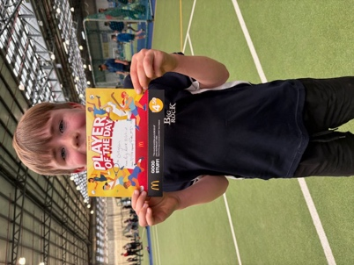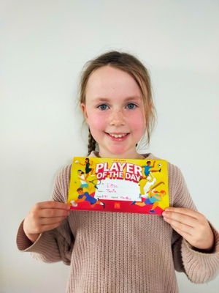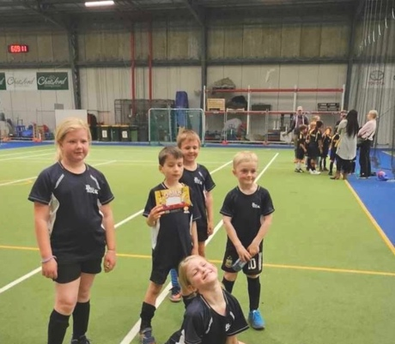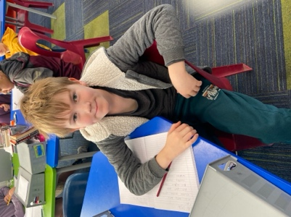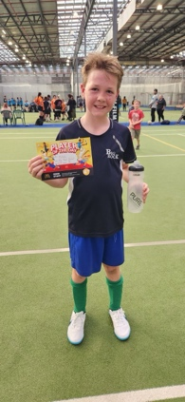
Athletics
I would like to offer our congratulations to the following athletes on their stand-out results at the recent Greater Green Island Athletics, George Weatherall 2nd Discus, 2nd Hurdles, 3rd Long Jump, 3rd Shot Put, Kade Hancock 3rd 800m, 2nd High Jump, Ruben van Tonder 3rd Discus, the boys finished 2nd Senior boys relay, Scarlett Hancock 3rd Long Jump, 2nd Hurdles and 3rd Senior Girls relay. Well done to these athletes and all of the team.
Pool Keys
Pool keys will be available to school families as of Wednesday at a lower cost than last year. They are $65 plus $15 deposit (total $80). To purchase pool keys, school accounts must be up to date.
Dunedin Symphony Orchestra
On Tuesday we were treated to a visit by members of the Dunedin Symphony Orchestra and it was brilliant, as were the children. It would be easy to think that primary school children might lose interest after a bit with an orchestra (I know it crossed my mind) but the children were attentive, engaged and responded superbly. The standard of musicianship was unreal. The musicians involved the children in the music, talked about their instruments, took questions and asked questions. Some of the children stayed behind afterwards to ask more questions. I am delighted to add that I used to teach the percussionist, and even more pleased that he was pleased to see me!
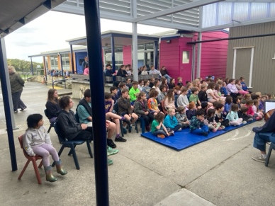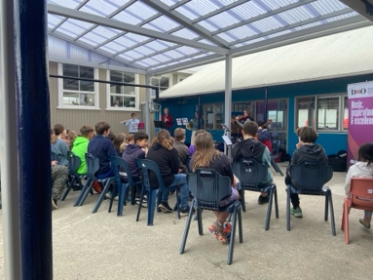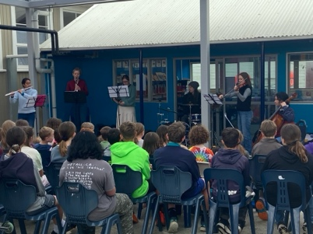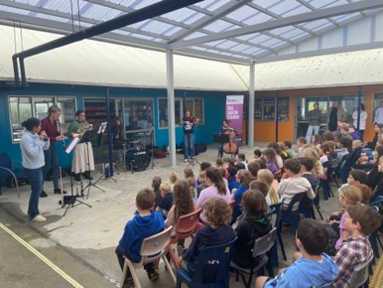
Playground Observation from the Outside
Yesterday was a stunning day, the weather was warm and sunny, and we had an education advisor at school. They were outside at morning tea and commented to me that it would make a great photo/video showing a perfect playground setting, if it wasn’t real you would think it was staged for an advertisement. Along with the perfect weather, everywhere you looked children were playing happily, laughing and smiling, two games of volleyball, all the playground equipment being used, music playing, children dancing and singing, balls being kicked, basketballs bounced. You know what? They were correct. Yes, sometimes negative things happen in the playground, but they are quite rare. Sadly, the advisor was not here at lunch time, because it got better because then the pool was open, and it was a truly stunning scene.
When the pool was open and some Room Three and Four children were using it at lunchtime, playing on floaties etc some of our youngest children looked in. It was priceless, they didn’t know that the school had a pool, and with the floaties etc their eyes were like saucers. It was very cool to see that absolute excitement.
Have a great weekend everyone.
David Grant
Principal

