8th March 2024
Taieri Mouth Adventure
If a picture paints a thousand words, I would think that all the photos that were shared on Facebook painted a million words. What a day. A massive thank you to all the parents who were able to attend and help on the day, whether it was in the water or on the shore. It is greatly appreciated, and I am sure you enjoyed it too. Thank you, Ange Hancock, Scott Weatherall, Tania Blanchard, Pete Conway and Alex Ramsay for all of your help in the water, a big effort being in the water all day and it helped make the day special.
Thank you, Paddy Patterson and Brayden Mitchell for your time and generosity in sharing the boat with the children, travelling up and down the river all day and refusing to take any money. Incredibly kind fellas and the children had a blast.
Thank you, Kaikorai Valley College for helping us out with a trailer load of kayaks, and for understanding what working together is all about.
Thank you to the staff for making it all work and for having the flexibility to adapt and adjust.
Lastly, thank you to all of the amazing children who were keen and willing to have a go and encourage each other. Your enthusiasm and grit mean that it is possible to have events like that and to build on it.
Days like our Taieri Mouth Adventure are so important and are a key ingredient in our school curriculum, one that others look on in wonderment and envy, that is certainly the feedback I get.
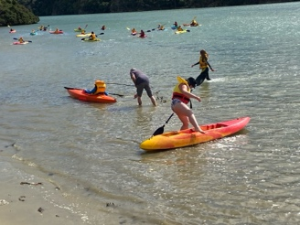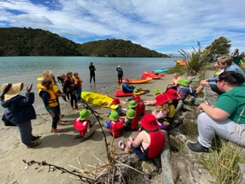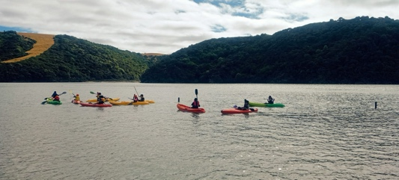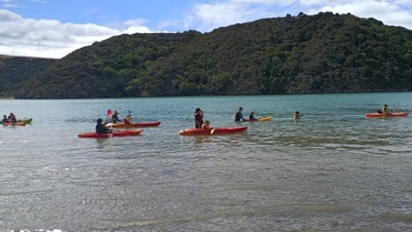
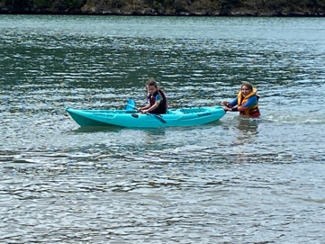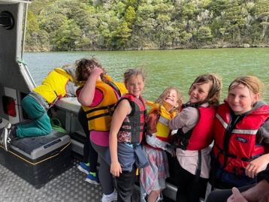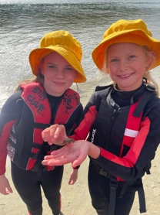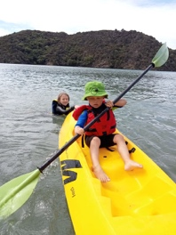
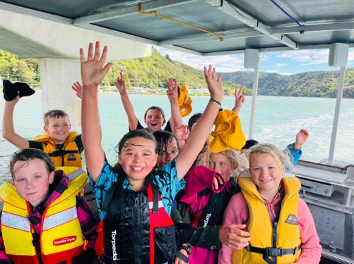
PTA and Fundraising
Thank you to everyone who was able to attend the first meeting or has shown a willingness to be involved in the school PTA. In the coming weeks there will be a school fundraiser. This is not directly linked to the PTA (but it sort of is). I have been asked by Jo Henderson to (try) and explain that the PTA is not yet an official incorporated group so fundraising at this stage is through the school per se. Everyone who has shown willingness, opportunities to be involved will be coming soon.
Road Crossing
After school can everyone, please use the crossing with their children and not just cross anywhere. We are trying to model safe practice and we really need parent support on this. I know sometimes it might be quicker but…

Covid and the Flu
Can we please insist that if your child tests positive or has the following symptoms, runny nose, sore throat, coughing, achy, etc that they please stay home until the symptoms have gone. Covid does seem to be doing the rounds again and although I have no expertise at all, I suspect that this become more common as we enter winter. We greatly appreciate your help with this.
Futsal
Congratulations to the following players who earning Player of the Day for their respective futsal teams.
Big Rock Dolphins – Elise Blanchard
Big Rock Starfish --- Cecil Williams
Big Rock Stingray – Zach Turner
Big Rock Orca – Aliza Johnston
Big Rock Sharks—Scarlett Hancock
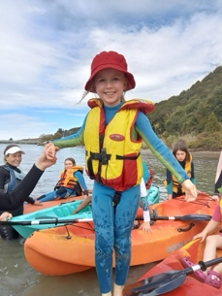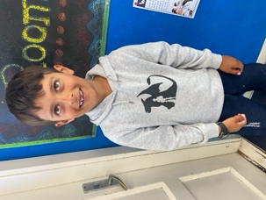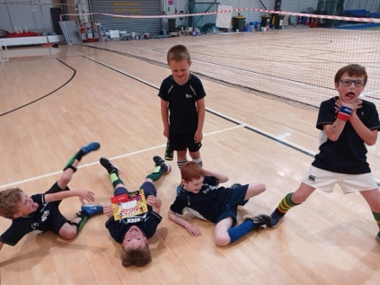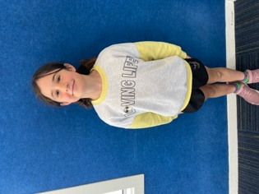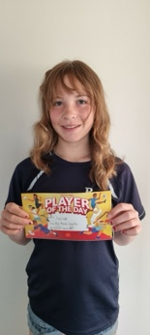
Have a great weekend
David Grant
Principal

