8th February 2024
Meet the Teacher Chats
Bookings are now available via the Skool Loop app. If you are having any trouble booking a time, please contact either the office or me, and we will be able to help.
These chats at the start of the year, while reasonably informal, are still important for the family, child and the teacher and help form a positive learning bond between home and school.
If the interview time is not long enough and conversations go over time, teachers are more than happy to arrange another time to meet, with more time.
Attendance
At the end of last year, I congratulated the children and their families for their high attendance rates, almost 35% higher than national averages. As a teacher, I cannot stress how important attendance is. It is not hard to work out that everyone is more likely to achieve, if at first you turn up. It is also important for knowing what is happening in classes and being part of it all. When children do not know routines or what is happening etc it can and does lead to anxiety. Good attendance is also important for friendships and social development, being with and engaging with their friends. All important things in children as they develop, learn and grow. Good attendance also demonstrates to the children that their parents value education and schooling, but more importantly, value their child’s education and schooling. If the parents don’t value it, the children won’t and achievement and social development levels do falter.
So, well done on getting the children to school and valuing their education.
Good Luck
All the best to George Weatherall, as he heads off to Christchurch with Brighton Surf Lifesaving Club to compete in the South Island Championships and then a week later the National’s in Mount Maunganui. Outstanding stuff.
On behalf of everyone, I’m sure, I would like to wish our Board Chair, Scott Weatherall all the best as he competes in the Coast to Coast this weekend. Scott is competing in the gruelling event to raise the profile for the I am Hope Foundation. A pretty gutsy and challenging thing to do. Go well.


Literacy and Mathematics
You may or may not be aware of changes made by the new Minister of Education, and that schools are now required to teach one hour of Reading, Writing and Mathematics per day. Obviously there will be days where this is not possible because of things like class trips, Pet Day, camps etc.
However, I am pleased to advise you that traditionally at Big Rock we have already being doing this and have considered it good practice for more than a decade. Quality Reading, Writing and Mathematics come in different forms, and it is important that different forms and strategies are utilised to keep the learning meaningful and vibrant. Sometimes we find an hour a day on each is not enough.
On top of more traditional instruction methods, here at Big Rock we also utilise what we call our Integrated Topic Based Learning model. What this means that if we are focusing on a particular topic, for example Aotearoa New Zealand History, or the Living World, to use two examples from 2023, we will utilise that topic as part of Reading and Writing programmes (and when it fits, maths). We do this as we know that it adds meaningfulness and relevance to the children’s learning. This model also allows children some freedom of choice or student agency in teacher language. For example, with work on Aotearoa New Zealand History, the children’s Reading and Writing work will have a research component, which the children will be able to choose or follow their own path of interest. Last year for example, some children researched and presented on New Zealand’s Natural Disasters, others Pre-European Aotearoa, or the Great Migration, to the 81 Springbok Tour. Equally, with the Living World some children investigated and presented on local environments and food chains while others explored challenges of the future for our environment and possible strategies to address these challenges. This method gets broader as the children progress through the school. Part of this is, in essence, the journey from Learning to Read - Reading to Learn.
It is also expected that New Zealand schools teach Literacy using the Structured Literacy approach. I am pleased to advise that this has been used in the Junior (Room 1 and 2) classes lead by Mrs Lamb for 18 months, Room 3 since mid 2023, and our senior classes are coming on board in 2024.
Another key part of our progress in Reading is a well-stocked library, that is refreshed and restocked every year, with big input from the most important people of all, the children. When the building work is completed, we will have a very exciting library and outdoor learning area.
Please find below our achievement results in Reading and Mathematics for 2023. While they are pleasing, and considerably higher than national averages we will continue to strive to raise them higher.
The attitude of the children to their learning, and the support and encouragement from home can never be underestimated. The children’s attitude and your support are amazing. Thank you.
If you have any questions, please talk to your child’s teacher at next weeks ‘Meet the Teacher Chats’ or call in and see me.
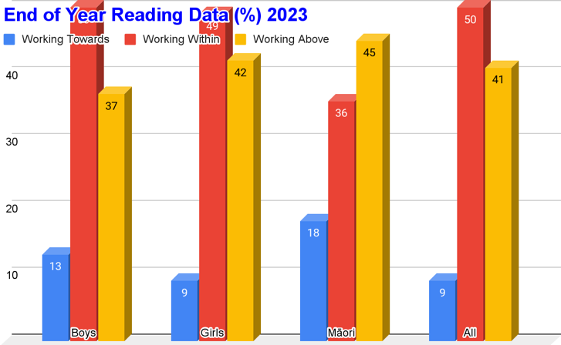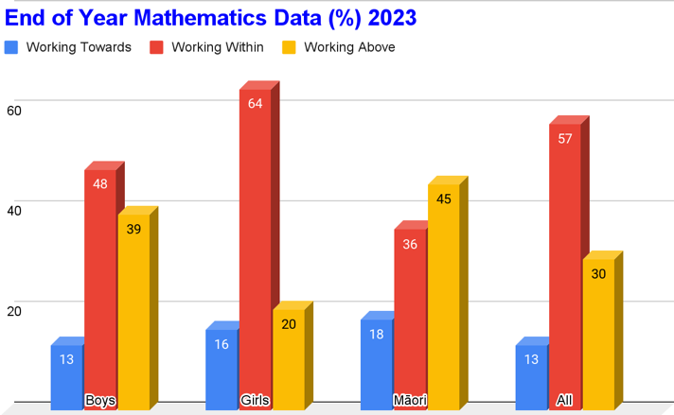
It is important to note that due to the relatively low number of children identifying as Māori the above percentages are somewhat negatively skewed when in fact Māori achievement levels at Big Rock are comparable with non-Māori.

Master’s Games
Well done to Mrs Lamb and Mr Murray on competing over the weekend in the Master’s Games in and around Dunedin. Mrs Lamb in netball and Mr Murray in football. Mr Murray’s team coming away as gold medalists in the Premier A Men’s section.
Weetbix Tryathlon
If you are planning on your child registering for the Weetbix Tryathlon (And I urge you to do so, pretty cool event) Please use the link below as it will put the school in with a chance of winning great prizes. Board member Shane Turner is helping with this and believes we can win as last year the winning school had very few entries. So, if you’re keen, or child is, get into it. Thank you, Shane, for leading this. I am not 100% sure, but I think the school van and bike trailer will be available.
https://www.facebook.com/events/375382257354594/?__cft__[0]=AZW6uajuyCRQzcP0EyeixhIcS2qAXCt68OapxS75bkZbYlJiXPjQX-y1KQ652gw3sFbOiFiagI2B0xE8veKf2RrnKWM64Va1dEc5AeLFC0SF5RS10y_rX320zkRdIxUmoiv8b5xMBVWtqoEvLwGcNoiBLQ2H3NNEGb2UtQ5rs06sRbZCK5fRTeCJOfOZ5QHy2rs&__tn__=-UK-R
Update School Records
Can anyone who has changed their mailing address, phone number or email address, since last year, please advise the office so that we up to date details please.
Also, if your child’s school account is split between two different parents etc can you please let the office know asap to avoid confusion. Many thanks.
Pet Day Extravaganza
Less than two weeks until the big day. Our big event is on Wednesday 21st February. Loads of new games and prizes. Please don’t forget the baking competition and the homework challenge. Parents and pre-schoolers are more than welcome. Pre-schoolers are able to take part in all of the games, bouncy castle etc. We will ensure that the games are made age friendly and that only other pre-schoolers are on the bouncy castle at that time.
If any parents can help on the day, please let me know.
We are all, looking forward to the first school week of the year next week. Remember bbq on Wednesday.
Have a great weekend
David Grant
Principal

