8th August 2025
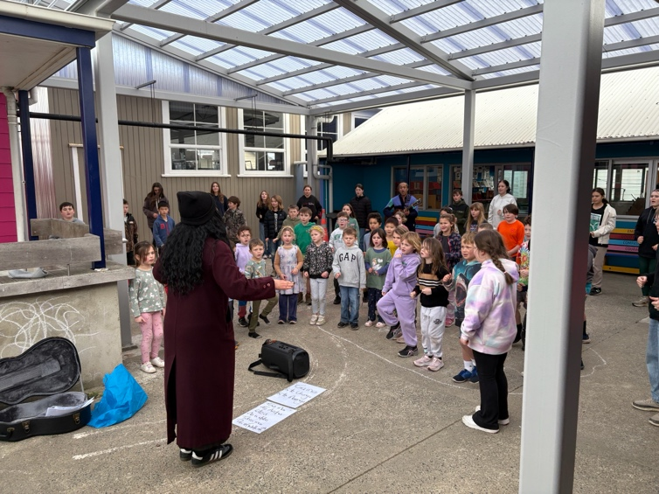
Polyfest practice in full swing
Congratulations and Thank You
Firstly, I would like to thank and acknowledge the new members of our Board of Trustees. Thank you, Colin Driver, Lisa Daniels and Aaron Hollands, for putting your name forward. It is fantastic to have you join us and I look forward to working with you all. I would also like to thank and welcome back on to the Board, Jo Henderson and Kara Walters. It takes some courage to put your name forward, in this instance we have not needed an election, which makes it simpler and less challenging for all concerned, including voters.
I would also like to acknowledge and thank two departing Board members who have both made a hugely positive difference and contributed plenty to the school, through sound governance and a willingness to share their thoughts and ideas.
Shane Turner has made a big contribution to the school in the last three years, with insight at meetings, support of staff and lots of ideas for the betterment of the school and community in general. Some highlights for me have been school discos, running a ski trip (which saved me a lot of time), organising a school ‘team’ for the Weetbix Tryathlon, that resulted in winning new sports gear for the school. I have enjoyed and benefitted from our 1-1 chats. Shane has also been incredibly supportive of the extra opportunities that the school provides, such as surfing, mountain biking and curriculum developments. That support has been much appreciated. Shane’s next project is the Brighton Pump Track, I sincerely hope that the community get behind it, it will be an amazing asset for the community. Thank you Shane.
Scott Weatherall has been on the Board for nine years and has served the last six as the Chair. Many will recognise Scott’s contribution in supporting and leading parts of our Education Outside The Classroom (E.O.T.C.) programme, especially the mountain bike component, and along with Angie Hancock not only led many adventures helped me with the writing of the school programme. This has also led to the tightening of our Health and Safety policies and practices, particularly for E.O.T.C. ensuring that they are first rate. Another key contribution Scott has made is the Taieri Mouth Adventure. At first I was a little apprehensive having so many children in, on and near the water at the same time. Scott talked me around and it is now a key part on the school calendar, weather permitting. Scott has also led some wonderful fundraising opportunities, including the Backyard Ultra, as well as with guidance for grants, particularly through Sport Otago.
On a personal note, I will miss Scott’s support of myself and the staff. It is probably no great surprise that working in a school comes with some mental challenges and stresses. Scott’s support and expertise has always helped, as they say, keep things real.
Scott and Shane, your contribution has been immense. Thank you. To Colin, Lisa and Aaron- no pressure.
Congratulations
Well done to the following people on earning Payer of the Day for their respective school teams.
Big Rock Dolphins—Eva Verhoef
Big Rock Coasters— Braxton Parata-Walters
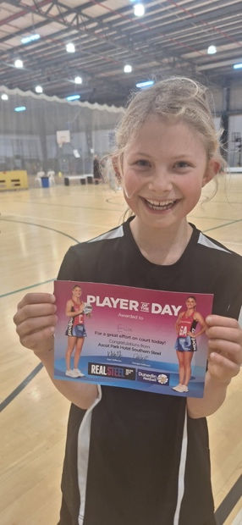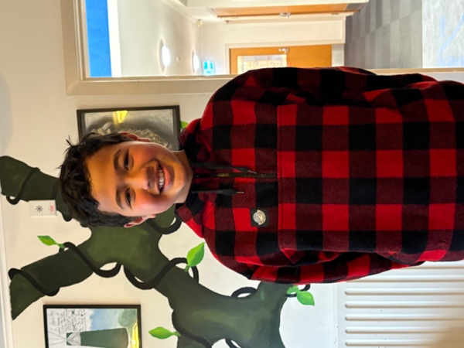
Mountain Biking
Yesterday, Angie Hancock and Mr Murray, and our Advanced Mountain Bike group headed off to Forrester Park and Bethune’s Gully for their next adventure. Lots of sweat, tired legs, a bit muddy, as well as lots of thrills and spills, but mainly plenty of smiles. While the whole group was excellent, I would like to single out Eva Verhoef and Jaxon Skerratt who were on their first outing with the Advanced Group, and Malaika Paton who took on a leadership role and ensured the new riders were doing ok, with lots of encouragement and support.
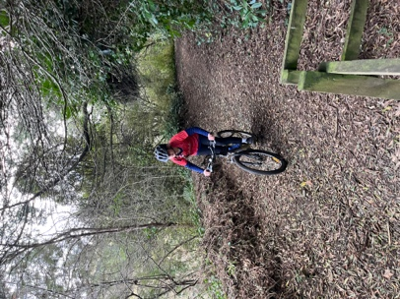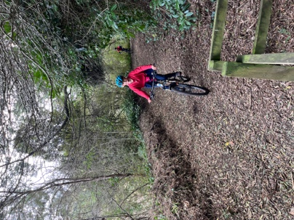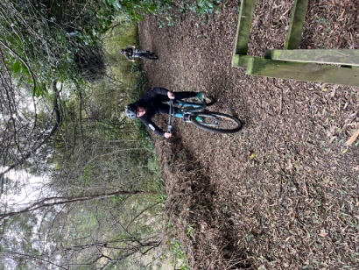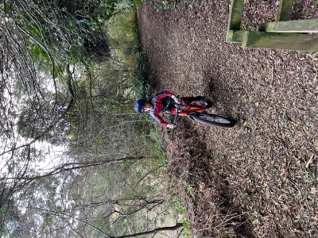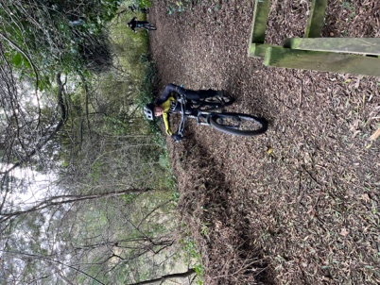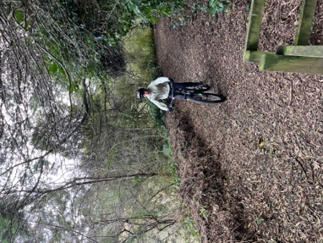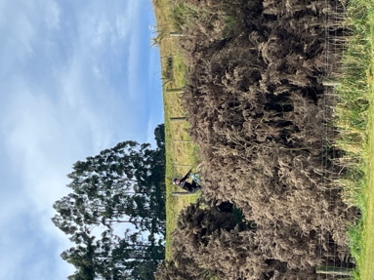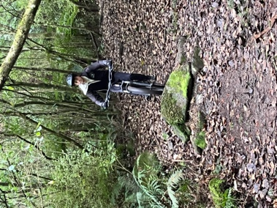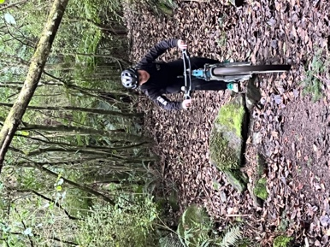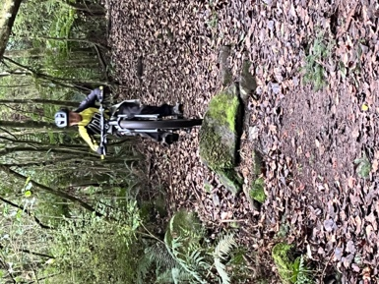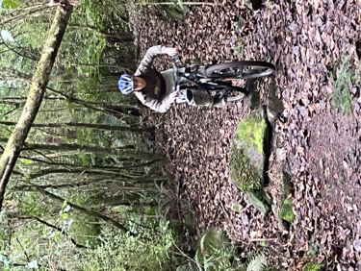
Science Badges Programme
A couple of weeks ago I mentioned that we were introducing the Science Badges programme into the Year 5-8 programme. It is going brilliantly. The range of work and the quality is excellent. From designing and building periscopes, water cycles, volcanoes, forensic science, psychology, building catapults, models of the Space Station, birdfeeders, electrical experiments (Safe), designing and building weight bearing bridges, food chains and much much more.

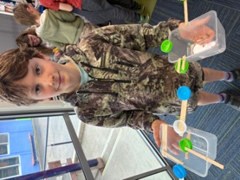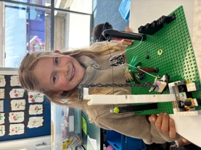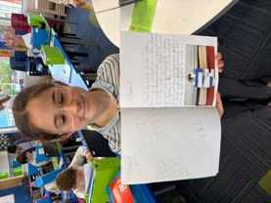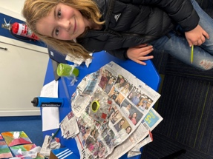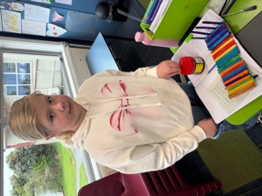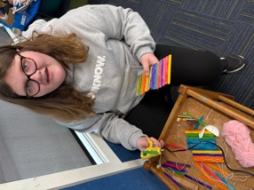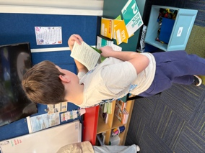
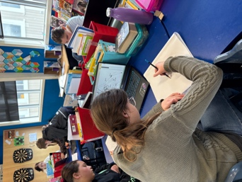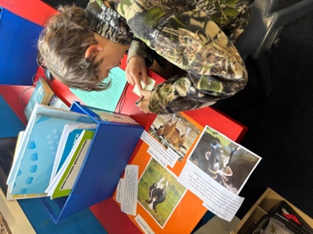
Well done to Atiana Reihana (Year 7) and Malaika Paton (Year 8) who are the first to earn their Senior Science badge. Atiana in the scientific field of Geology and Malaika in the scientific field of Forensics. An outstanding effort.

Gastronaut Programme
Yesterday in Room Five, the Gastronauts made Macaroni Cheese. Pretty straightforward, but this was part of learning to make sauces, and in particular what are called in French cuisine, the 5 Mother Sauces. These are bechamel, velouté, tomato, hollandaise and espagnole. All based on a roux. Yesterday they made bechamel, before making a cheese sauce. The other sauces will be made in the coming weeks.
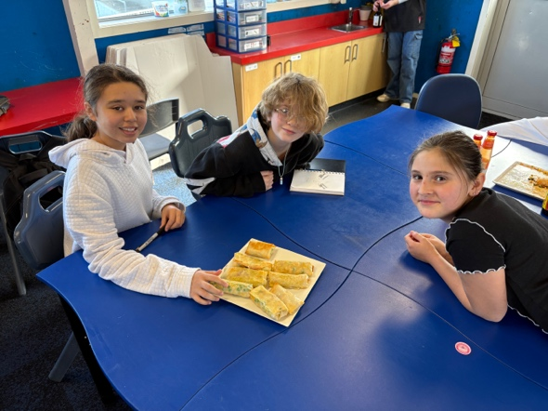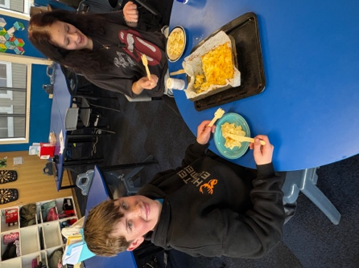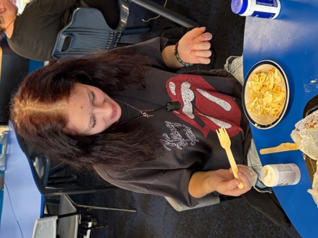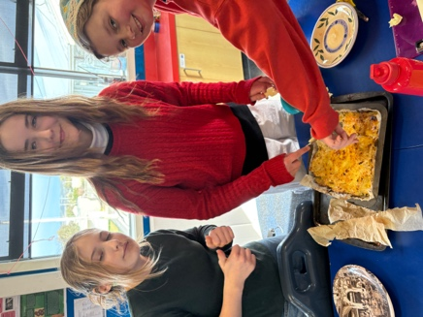
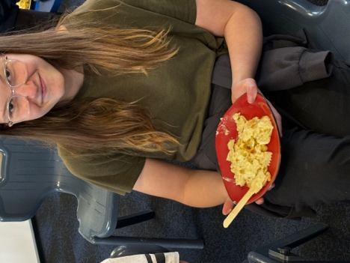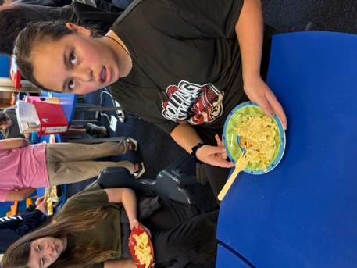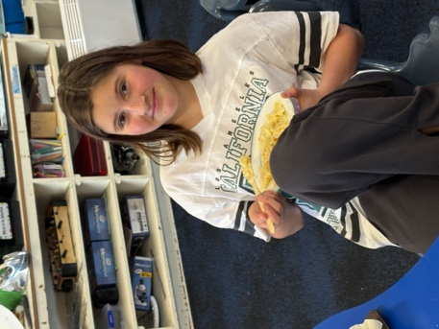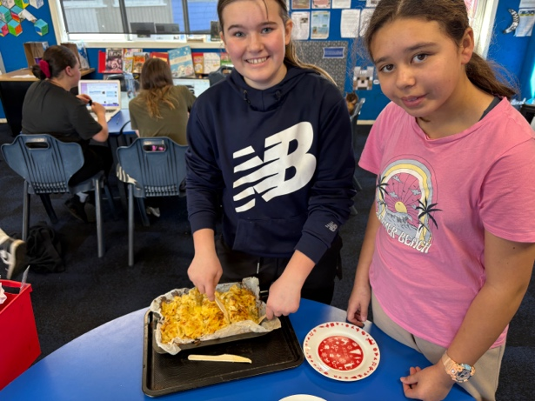
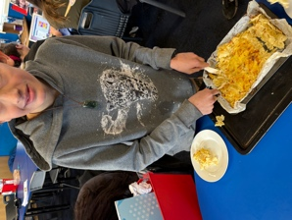
Have a great weekend
David Grant
Principal

