7th November 2025
Welcome
I would like to offer a big Big Rock welcome to Ella Coory. Ella joins her older sister Mieka and their mum Lisa, our Board Chair. Outstanding to have you with us Ella.
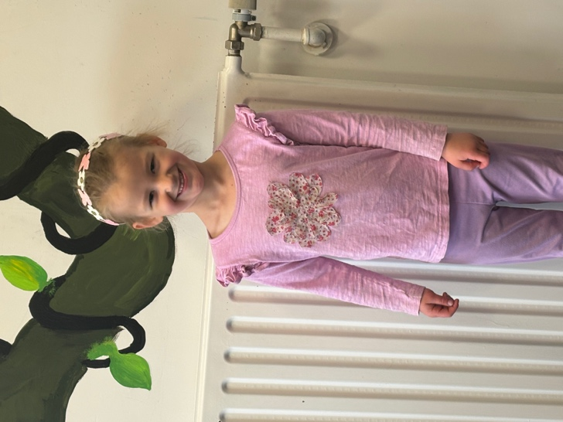
Swimming Pool Update (Upgrade)
We are working on having the pool open in the next two weeks. I understand that it is a bit later than usual, but the work is taking time. A lot of the work you will probably not notice, but it is being done. Unfortunately, swimming pools are expensive to fix and maintain and we do not receive any additional Ministry of Education funding. So there are plenty of financial challenges involved.
We have (or are doing):
- Repairing the masonry work on the pool itself
- The shower is now hot water
- The building’s interior is receiving an industrial level spring clean (It is a real challenge with mould and algae growth)
- We will be installing a brand-new water heater
- The pool itself will be painted at the end of the season (The humid environment in the pool area makes it difficult for the paint to adhere and dry properly, so it needs to be done in the cooler months)
We appreciate your patience, but we want to ensure that we future proof your pool for families of today and the future, at a time when school pools across the country are closing.

PTA Fundraising Committee Meeting
On Wednesday at 7:00 in the school library there is a PTA meeting for anyone who is keen to be involved and help us raise some much-needed funds that will always be used to benefit all the children.

Congratulations
Well done to the following players on earning Player of the Day for their respective futsal teams.
Big Rock Dolphins – Ari Isaksson
Big Rock Stingray – Korbyn Parata-Walters
Big Rock Orca – Cecil Williams
Big Rock Sharks –
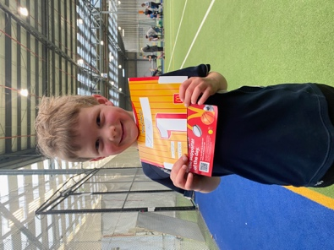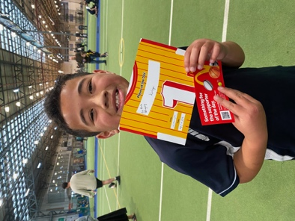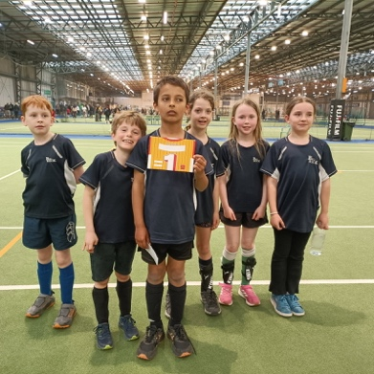
I would like to offer my congratulations to Lexie and Stella Brown who had a successful event at the recent Outram Cowboy Challenge. Stella coming away as Reserve Champion in her group and Lexie winning a haul of ribbons.
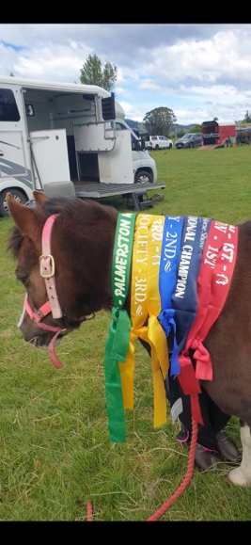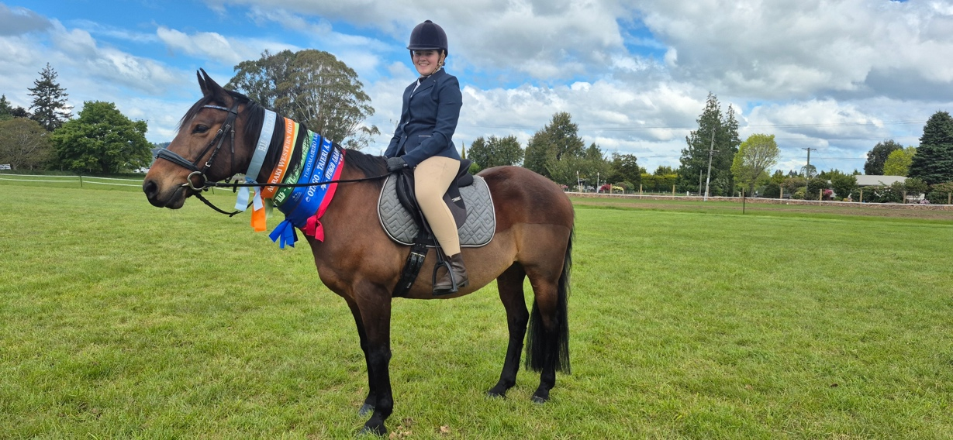
Rising Star
Our second rising star is senior student Malachi Turner, again a football enthusiast like Kade last week. During the last school holidays, Malachi travelled to the Gold Coast with his family. While there Malachi was fortunate enough and good enough to attend the George Cowie Football Camp. This is an academy-based programme that is connected to West Ham Football Club in the English Premier League. 400 children were involved from all over Australia and New Zealand. Malachi was recognised for his high level of sportsmanship and good play and was awarded a West Ham badge by one of the West Ham coaching staff. Malachi has since been invited to attend another West Ham camp, this time at West Ham in East London. A great achievement Malachi, well done.
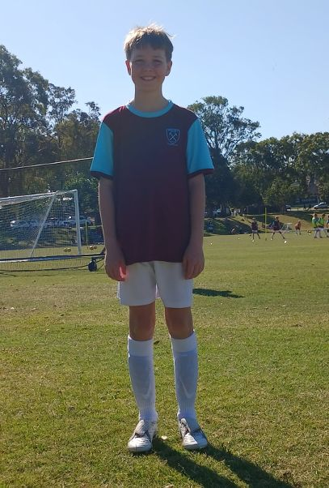

Thank You
Thank you to the team of boys, Kade Hancock. Leon Skerratt, Jed Grey, Fin Ramsay, Malachi Turner and Beau Mansfield who created an obstacle course on the bottom field using gym equipment and bench seats. It proved immediately popular with all ages and abilities. It was particularly nice to see so many children’s confidence grow after every lap.
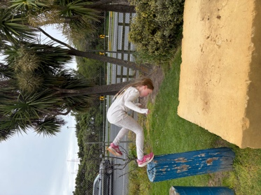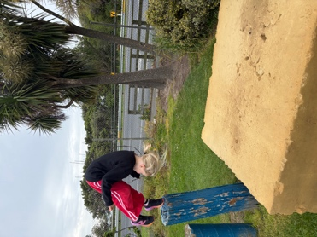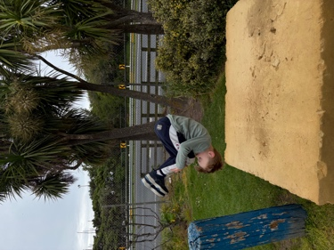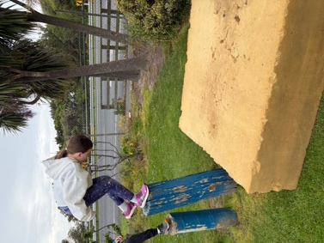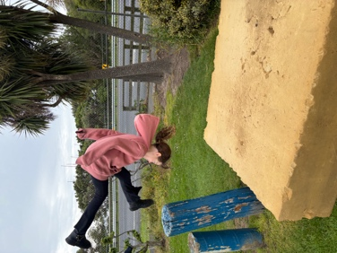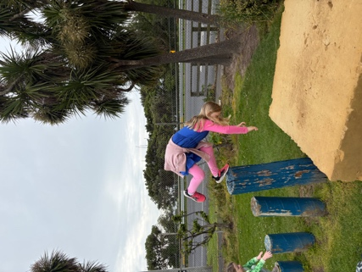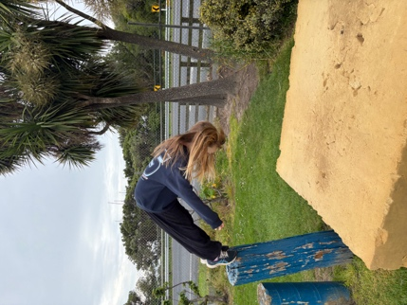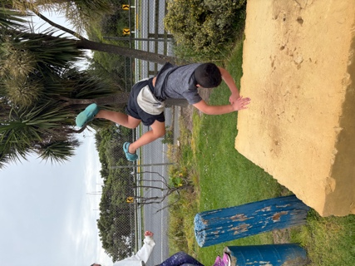
Homework Heroes
A few photos from last week’s Homework Heroes Prize Draw
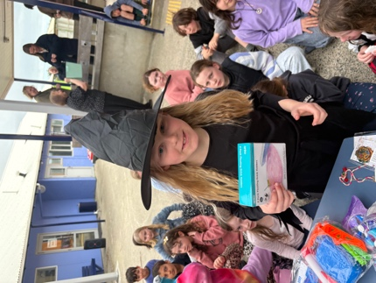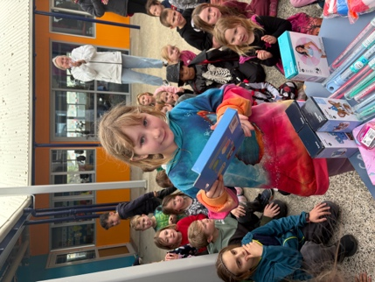
Have a great weekend
David Grant
Principal

