7th March 2024
Welcome
I would like to offer a big welcome to Asti O’Brien, to Big Rock. Number three of the ‘Beastie Girls’ has joined her big sisters Penny and Willow. Fantastic to have you join us Asti.


Congratulations
Congratulations to the following players on earning Player of the Day for their respective futsal teams:
Big Rock Barracuda- Korbyn Parata-Walters
Big Rock Stingray- Millie Scoullar
Big Rock Sharks- Baily Jenkinson
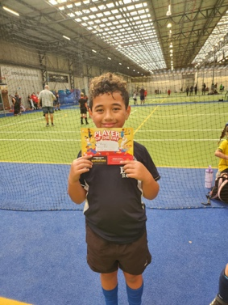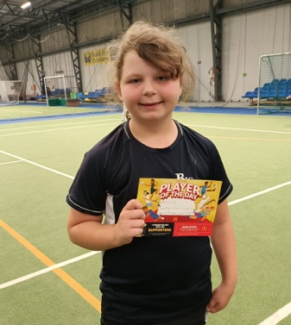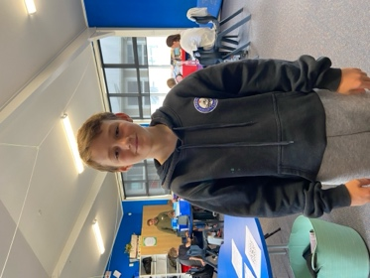
Taieri Mouth Adventure
We are all set for our Taieri Mouth Adventure on Tuesday.
Thank you to everyone who has volunteered to help, both in and out of the water. We need you all. Also thank you to everyone who has kindly offered the usage of their kayaks. Much appreciated and valued.

On the day the children (and adults) will require:
- Lunch and a refillable drink bottle
- Towel and swimming gear
- Wetsuit (If they have one or access to one)
- Lifejacket (If they have one or access to one) We do have a limited supply
- A sunhat. They can wear their school one but if they would like to wear their own that will be fine.
- There will be a sausage sizzle, and children will be provided with popsicles. All dietary requirements will be taken care of.
Room Three, Four and Five children need to be at school by 8:40, ready to go please.
All of the children will be travelling by bus and school van.
At the moment, the weather forecast is pretty average, fingers crossed for an improvement.
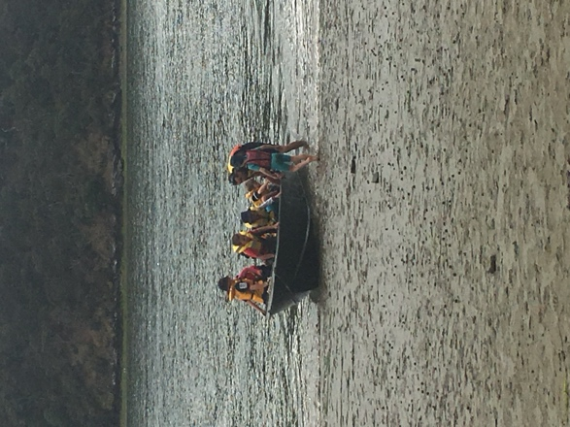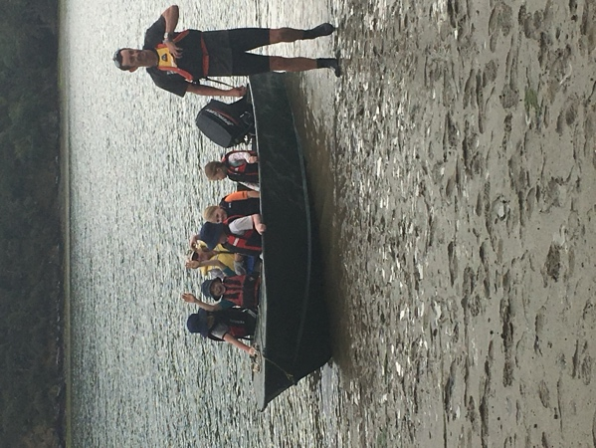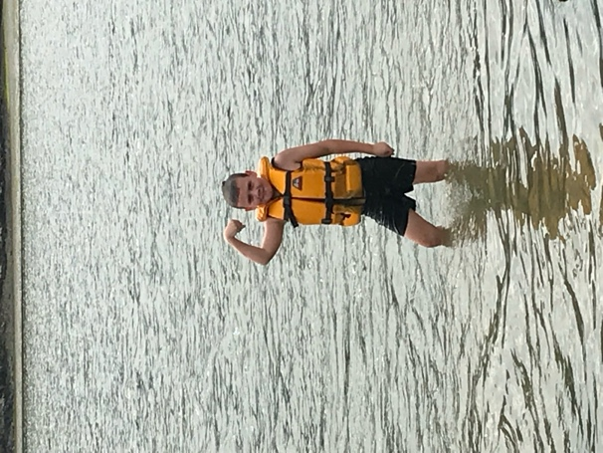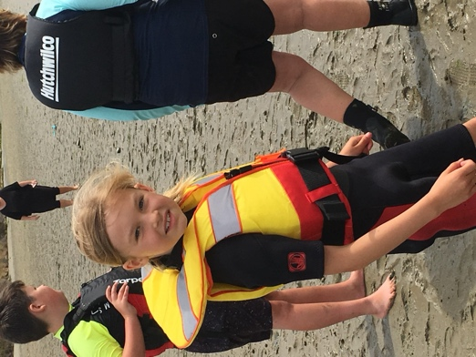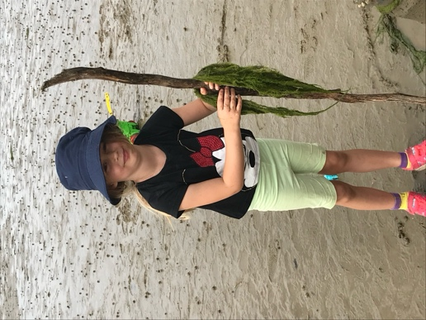
Weet-bix Tryathlon
Congratulations to the fourteen athletes who took part in the Weet-bix Tryathlon at the weekend. It is plain to see by the smiles on the faces the satisfaction and enjoy. Also, well done the parents and whanau for getting the athletes their and all of the encouragement. Thank you, Shane Turner, for really driving this. The effort resulted in the school winning $300.00 of sports equipment, and to add to the success, Adelaide Conway won a bike. Fantastic.
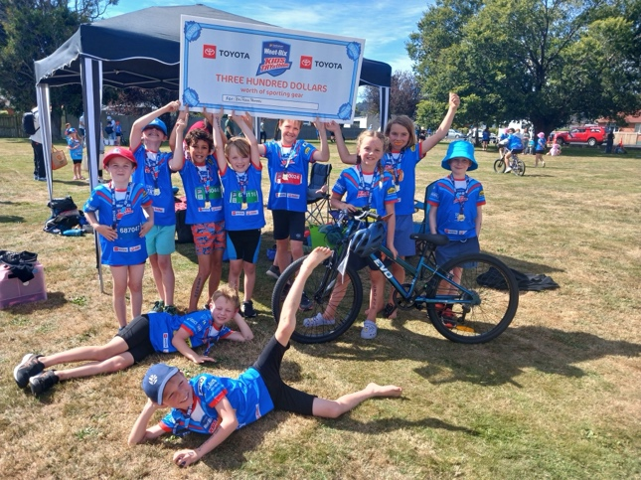
Room Three Harbour Bike Ride
On Tuesday Room Three and a number of hardy parents, grandparents and staff rode down the new(ish) Harbour track from the rowing club behind the stadium down to Roseneath and back. A few toughies carried on over the hill into Port Chalmers, while the rest of us rested and ate jelly snakes. The other riders were provided with jelly snakes upon their return. Everybody completed more than we expected. It must be said that the return was into the wind, and this age group have smaller bikes with smaller wheels. I was genuinely impressed with their effort. Thank you, Rufus O’Brien, Jo Henderson, Jana Dorana, Hamish Graham, Clarke McNab, Kimberley Maxwell, Maxine and Trev Harstonge, as well of course as Teresa Grant and Livi Wells.
A boring fact about the new track, when it was officially opened, the dignitaries doing all the official stuff had to borrow our bike trailer to transport their bikes.
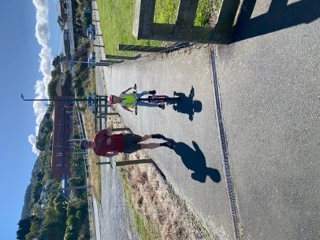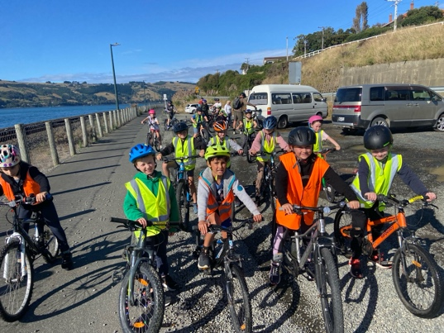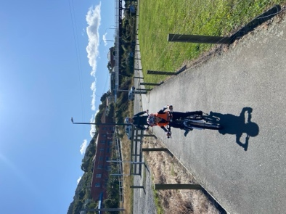

Pet Day Extravaganza
Our Pet Day Extravaganza is fast approaching, and like our Taieri Mouth Adventure, this is a very important and much-loved day on the school calendar.
On the day:
GAMES | PET INFORMATION | FOOD INFORMATION
^{Pet Day Pong} | All dogs need to be tethered to the fence on the bottom field, please provide them with a water bowl. Dogs need to be collected by 11:00 please | Free Sausage Sizzle  (All dietary requirements catered for)
^{Fruit Salad} | All dogs must be registered with the DCC | Popcorn for everyone
^{Darts} | No dangerous or aggressive breeds or dogs please | Fruit Kebabs on the go
^{Treasure island} | All caged and tanked animals in the library please | Family baking competition- Sweet, Savoury and Decorated
^{Head Basketball} | Farmyard animals on top court please | 
^{Mini golf} | All dogs need to be tethered to the fence on the bottom field, please provide them with a water bowl. Dogs need to be collected by 11:00 please
^{Croquet Bowling} | All dogs must be registered with the DCC
^{Corn Hole} | 
^{BOUNCY CASTLE}

Senior Students Science
Earlier today the senior class, as part of their Science and Nature School, carried out a couple of basic experiments with the Room One Children. There was a variation of the baking soda/vinegar classic, as well as the Dancing Pop Corn experiment. (Warm water 2/3, vinegar 1/3, baking soda and dry popcorn in a sealed jar). It was great seeing the oldest working with the youngest. (More photos on Facebook)
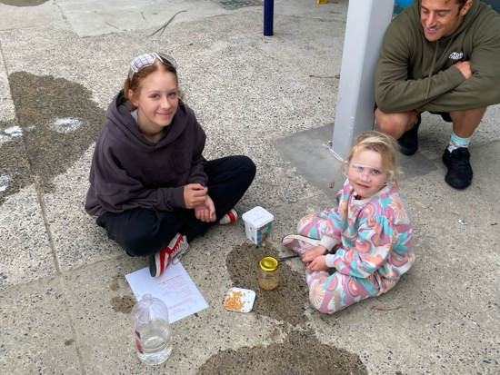
HOT OFF THE PRESS (I minute ago)
Congratulations to former Big Rocker, Thomas Weatherall who just won bronze at the New Zealand Surf Lifesaving Championships 2km Under 15 beach run. Top effort Thomas.
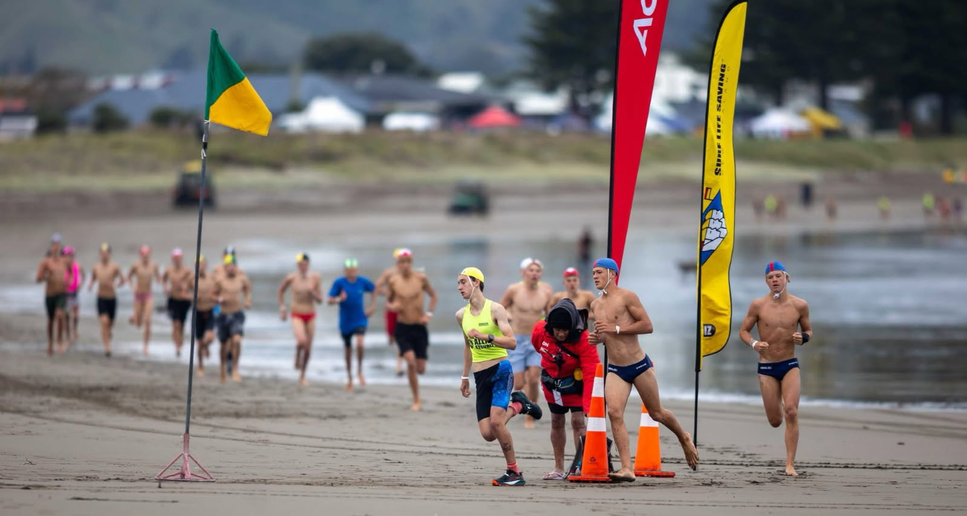
Have a great weekend
David Grant
Principal

