7th February 2025
I would like to offer on behalf of everyone a big Big Rock welcome to Octavia Whelan (photo to come), Ari Gilbert and Caia Worth who joined us this week. It is fantastic to have you, and your families join us. Exciting times ahead.
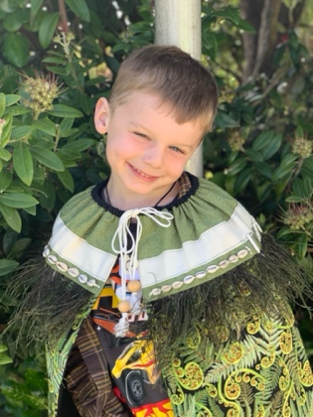
It is also important that I welcome to the staff for Term One, Tara McGoff. It is always very cool when you have the opportunity to welcome former students back, in any capacity, to have a former student come back as a member of staff is especially cool. Tara was a ‘First Day’ student at Big Rock back in 2008 when the school first formed after the merger of Brighton and Ocean View schools and her dad was on the Board of Trustees, and her mum helped us out in the office for a bit due to staff illness.. Tara will be working in Room’s 1, 2 and 4.
Reminder
The Meet the Teacher meetings are on Tuesday and Wednesday next week. If you haven’t made an appointment yet and want to, please go on to the Skool Loop app. If you are not having any luck, contact Kelly on Monday and she’ll be able to help you out.
Equally, if you would like an appointment, but the days and times don’t work, get in touch with your child’s teacher and they will be able to help.
Futsal
I need all names of futsal players for Term One by Monday please. After that I will not be able to guarantee a place in a team. Years 1-4 play on Tuesdays at the Edgar Centre and Years 5-8 play on a Wednesday. The first games are on the week of February 18th. The school provides playing shirts and parents need to provide shin pads and long socks, and ideally black shorts.
Also, if you are keen to coach or manage it will be great to hear from you.

Congratulations and Thank you
It was great to hear that so many from Big Rock, past and present, took part in the South Island Regional Surf Lifesaving Championships held at Warrington Beach. It takes a lot of effort to compete, and to compete in the South Island championships is a whole new challenge. Well done to you all.
As part of that, I would like to thank and acknowledge the lifeguards who patrol Brighton and other popular beaches all summer, doing an amazing job. Thank you.

Weet-Bix Tryathlon
In a few weeks’ time, the Weet-bix Tryathlon will again be on. If you haven’t already, and you are thinking about it, get into it. The children, especially after they have completed it, have a genuine sense of pride and achievement and wear their medals proudly. Shane Turner has organised a Big Rock team. The information is on the school Facebook page. There are also 2 free passes to give away, Shane has information about that on the FB page as well.
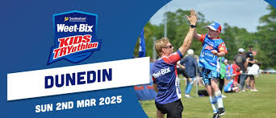
Good Luck
All the best to our Board Chair, Scott Weatherall and our Assistant Principal, Richard Murray as they compete in the Coast to Coast. Inspiring stuff and as I understand it is for the I am Hope Foundation.
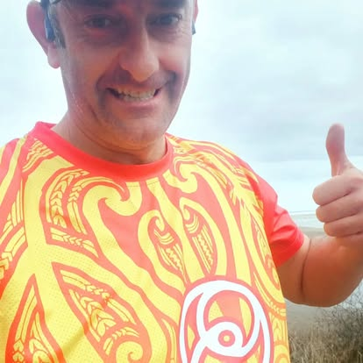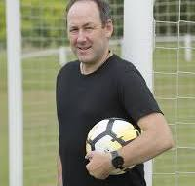
Have a great weekend
David Grant
Principal

