6th September 2024
Thank You
Now that the winter sports season seems to be officially over for the year, I would like to firstly say a big well done to all the children who gave their all in their chosen sport(s), whether it was netball, rugby, basketball, football, gymnastics, indoor bowls, hockey, bmx, or go karting, to name but a few. Good on you!
A massive thank you to all the legends who coached or managed a team, for school or club. It is great fun and ultimately rewarding, but it is also a massive commitment and too often thankless. Thank you to our school coaches, Jude van Aalst, Teresa Grant, Fiona Skerratt and George Grant for your commitment to our netball and basketball teams and the wonderful success they enjoyed. (Smiles are the best measure of success I believe). Also thank you to all the parents who supported all the players all season and helped out when required. Brilliant, players, coaches and whanau, wonderful ambassadors for your school and the wider community. I for one, salute you!
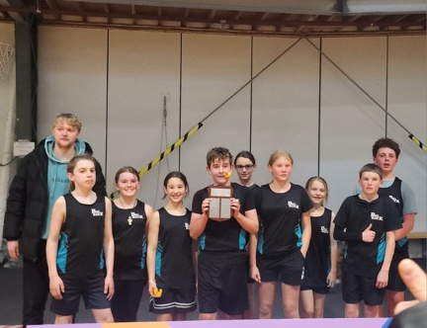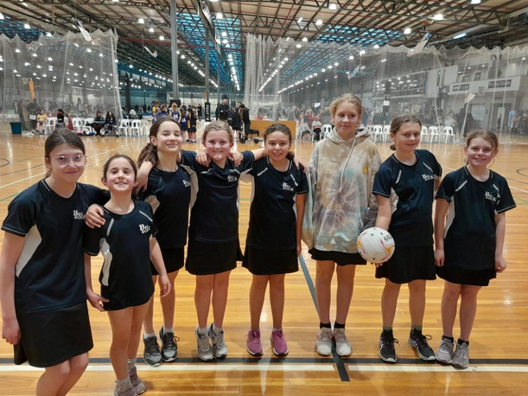
100% winning record 95% winning record
Outstanding effort Hoopsters and Hurricanes (If it wasn’t for flu they would both be 100%
We are still collecting names for futsal. Regrettably, we have not yet heard from Southern Football with the season details. Please keep the names coming in, especially in the Year 4-6 age group.
A massive thank you to Janette at John Swan Engravers for helping us out with medals for Netball, Basketball and Cross Country. Janette is a former Board Chair and great supporter of the school.
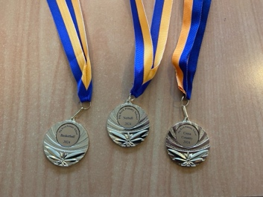

Good Luck
All the best to Kade Hancock, Malachi Turner, Taylor Matthews and Leith Conway as they compete in the Otago Championship Cross Country. A big and incredibly challenging event. I know that they will give it their all today.
HOT OFF THE PRESS: All the runners ran their hearts out. While we are waiting for confirmation of placings, we can advise that Kade Hancock got a very commendable 12th out of nearly 100 runners.
Also, best wishes and the best of luck to Aliza Johnston as she competes in the South Island Gymnastics Championships this weekend. Last year, as you should recall, Aliza was/is the reigning South Island Champion. Go Aliza!

Lunch Orders
Can we please remind people if you are putting a lunch order in at the shop for your child, can you please do so. When you forget it causes chaos and real upset in the children.
Big Rock Children Supporting the Local Environment
Earlier yesterday a lucky group of Room Four children continued with the Otokia Creek and Marshland planting. Many thanks to Loveday Why and the team for getting us involved.
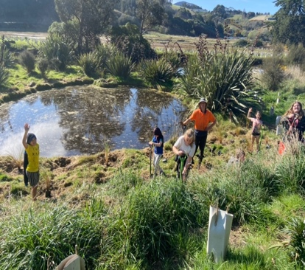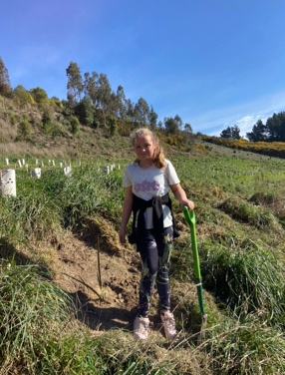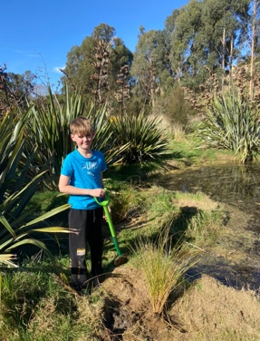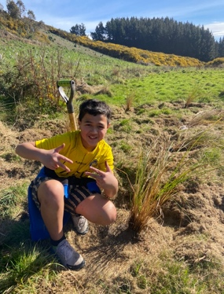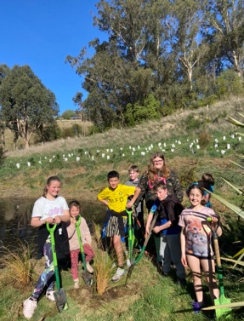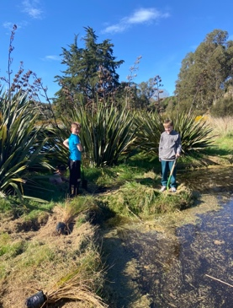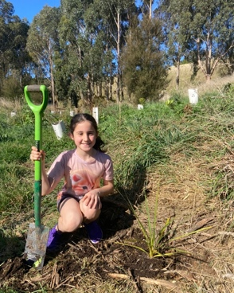

Big Rock’s Got Talent
Yes, the rumours are true, Shane Turner is playing impresario and bringing to you Big Rock’s Got Talent. The date is set, the theatre (Brighton Hall) is booked, all we need now are the stars. Entry forms are in the office, with all of the relevant information. Show day is Thursday November 21st.


Seed Library
Spring is in the air, the days are longer and everything is covered in pollen. You may have noticed a fabulously painted box at the gate. This is our new Seed Library, like a Lilliput Library only with seeds. Many thanks to Annie-Kate Williams for putting this together for us. Also thank you to Bella Yeoman, Esme Grey, Addison Johnston and Jasmine-Rose MacFarlane Pearson for decorating and bringing it to life.
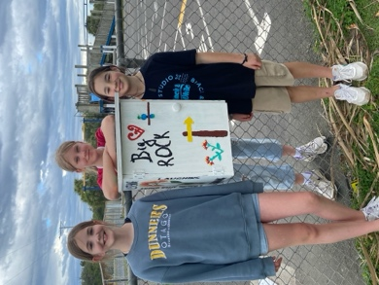
Have a great weekend
David Grant
Principal

