6th June 2025
Congratulations
I always like to have someone or someone’s to congratulate publicly in the school newsletter, or to give a shout out to as the modern parlance seems to be. Whether I hear from the child, their family, a staff member or I witness it myself. On Monday afternoon as I was writing my reminder message for Skool Loop etc, I received a rather special email from Darin Smith- Deputy Rector at Kings High School inviting me and Mr Murray to a Year 9 Scholarship Assembly.
Kings presents 20 scholarships across Academia, Sport and Culture. The reason Mr Murray and I were invited was to celebrate not one of last years Year 8s, but two, have been awarded Academic Scholarships. As a former ‘Kingsman’ himself, Mr Murray advised me of the significance of these awards.
I would like to offer our congratulations to former Big Rock Year 8s Ruben van Tonder (Dunedin Old Boys Academic Award) and Seth Elliot-Tressler (Bob Glass Academic Award) on earning academic scholarships. I am delighted for you both and proud of your achievement and that your talent and hard work is getting the recognition it deserves. Outstanding for you and our school. I feel like a man who got run over by a train- chuffed to bits!
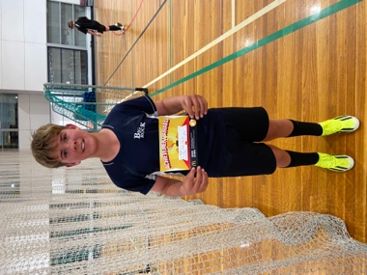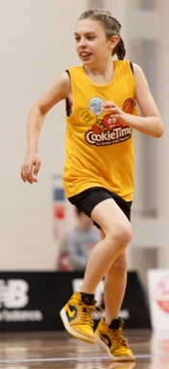
Sports Round-Up
Congratulations firstly to Elise Blanchard on earning Player of the Day for the Big Rock Dolphins Netballers. I would also like to congratulate Bryn Little on earning Player of the Day for the Big Rock Coasters.
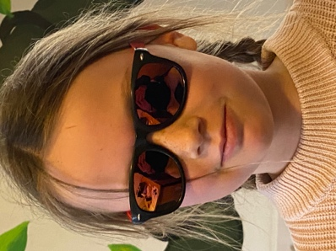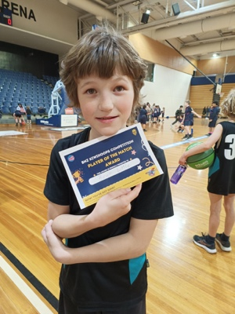

Celebrating Samoan Culture
As part of Samoan Language, Room One student Kendrick Keki brought along some very cool Samoan treasures to share with his class. As well as that he also shared some of the language. Talova lava- hello, Tofa- good bye, and fa’afetai- thank you. Kendrick spoke and shared magnificently as well as with great pride.
Earlier today, with the very able support of Malaika Patton, Esme Grey and Bella Yeoman, Room One continued to celebrate Samoan culture by making banana panikeke with me. They were great and brought back some childhood memories for me.
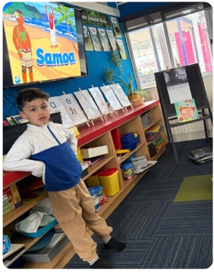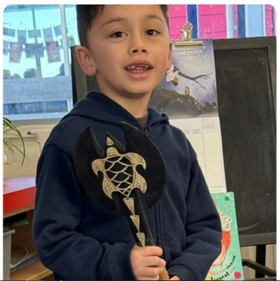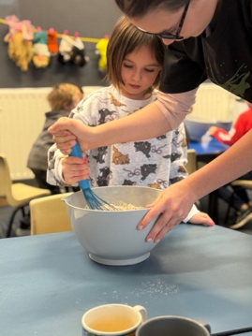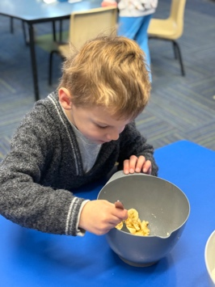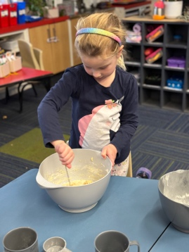
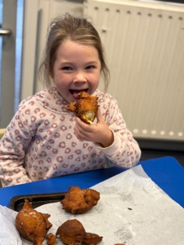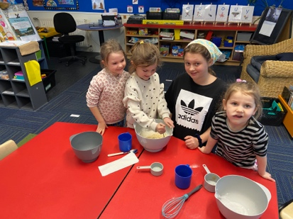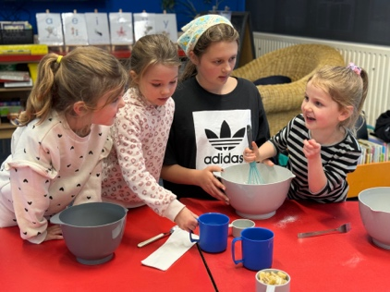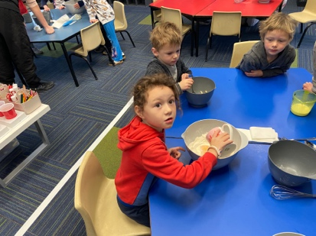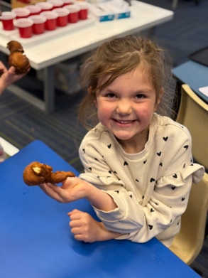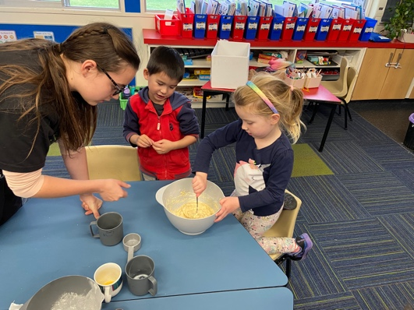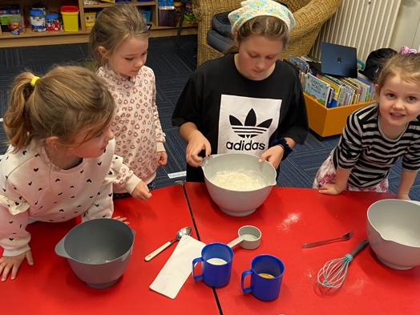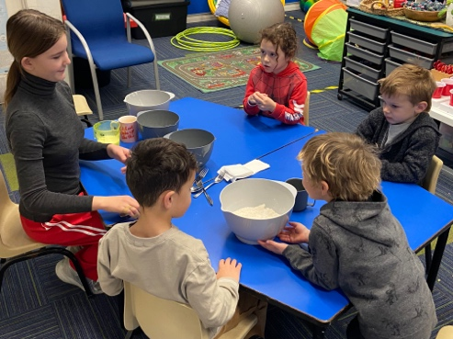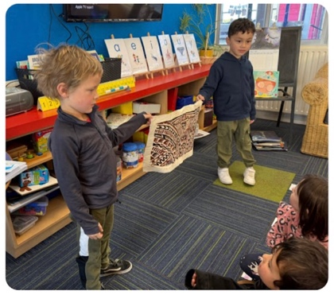
History Spies
On Tuesday Big Rock’s own History Spies or secret agents, were out in force rescuing taonga and treasure from the nasty Peter Porker and Freddy Fish, as well as being out and about amongst Dunedin Landmarks. After which they enjoyed lunch at the Meridian Food Court. I am not sure, but as top secret agents their drinks were shaken, not stirred. The whole thing was designed to be a fun introduction to history as well as being out and about. Many thanks to Mr Murray for making the Secret Agent ID cards, to Pearl Mansfield and Aliza Johnston for putting the kits together for me and not spilling the beans. Thank you to the spy masters in the field- Clarke McNab, Jo Henderson, Kimberley Maxwell, Blair Judd, Tania Blanchard and Pete Conway for keeping our agents safe in the field. Thank you to Mrs Grant and Miss Wells for believing in the mission. Lastly, thank you to all the secret agents- thank you for not blowing your cover, for sticking to the mission, showing immense courage and in the end succeeding in a mission that many deemed ‘impossibile’.
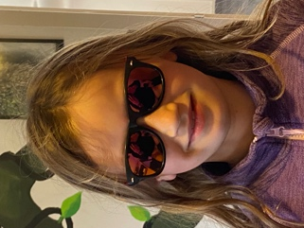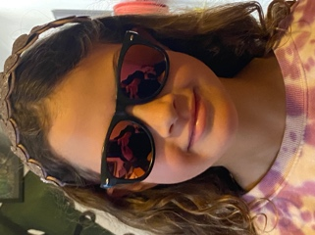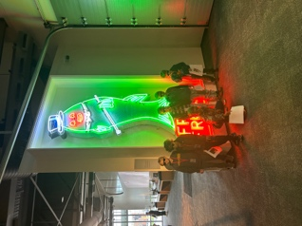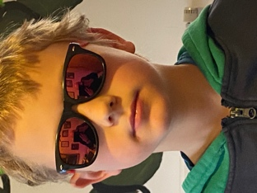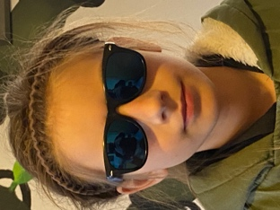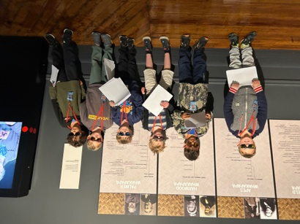
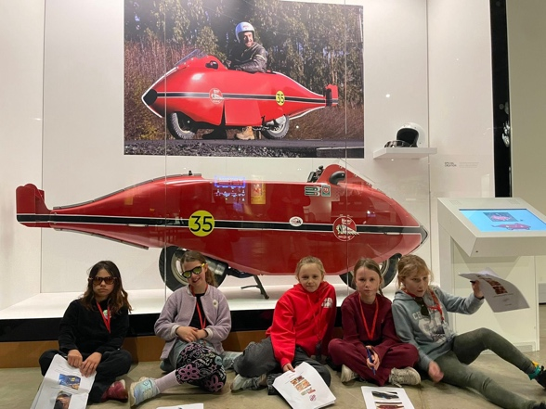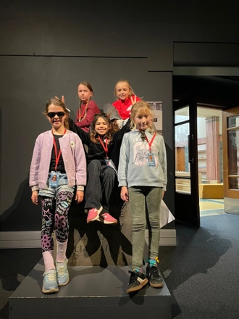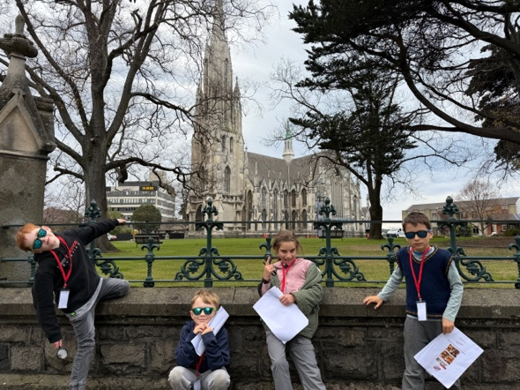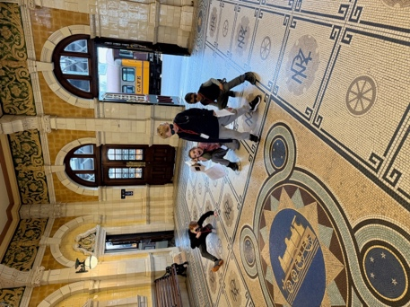
Thank You
I would like to offer my sincere thanks to Dr Lisa Daniels on her delivery of an entertaining and informative evening on children’s nutrition, and the dreaded school lunch box. Ideas on how to keep them healthy, fun and varied. What the different food groups are, how they interact, what children need and how it supports and helps their learning and development. Thank you for giving up your time and expertise- we know you are busy. Thank you, Scott, for setting it all up.
Here are a couple of links from Dr Daniels that will be of use to all parents and whanau.
https://mykidslickthebowl.com/whole-food-lunch-box-ideas/
https://nutritionfoundation.org.nz/lunchbox-ideas/
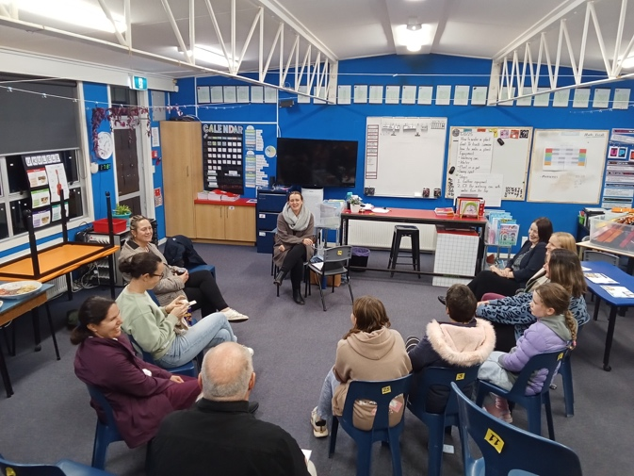
Covid and Winter Illness
I have been advised that there has been a sudden spike in Covid in the Dunedin area. As we are now in the winter months, where illnesses seem to be more prevalent like colds’ flus and the dreaded covid. Can we please ask that if your child is displaying any of the usual symptoms, snotty nose (green), persistent cough, fever, lethargic etc that they stay home, as it does seem to spread very quickly. The school and the other families and whanau, appreciate your support on this.
Good Luck
All the very best to the Parata-Walters whanau as they compete in the NZ Kukkiwon Cup in Taekwondo this weekend. Good luck to you.
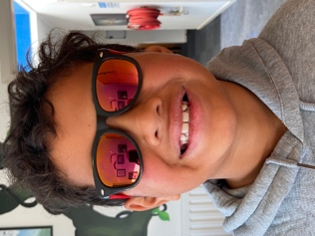
Have a great weekend and try and stay warm.
David Grant
Principal

