5th December 2024
The Big Day Out
Today was the day that Room’s One and Two have been looking forward to for what to them would seem agggggges, but it arrived. The excitement began when they arrived this morning, ready for action. The bus arrived on time and the excitement continued. Straight to Rialto for an advanced screening of Paddington in Peru, advanced screening! It is released to the public of New Zealand until boxing day. After which there was a brief snack and off to Leap to quote Mrs Lamb ‘Jumping and bouncing, flipping and flopping’. Back on the bus and home. Thank you to Mrs Lamb and Ms Keen on organising this epic event and to the Board for subsidising it so as to help our families with costs.
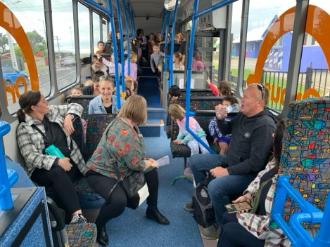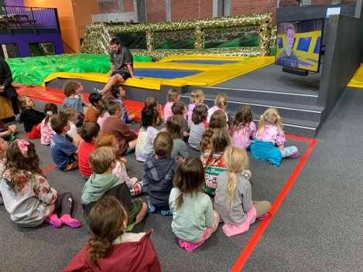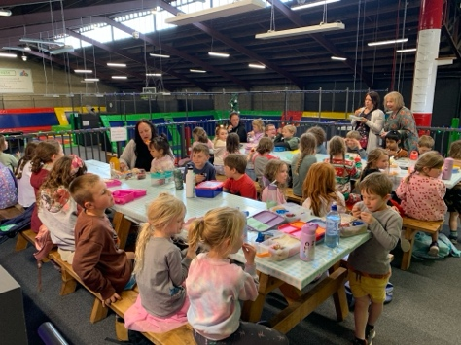
Prizegiving
Our prizegiving is on Wednesday 11th December at 4:00pm. The prizegiving will include:
- A long list of thank you
- Sad farewells to a few
- School sports presentations
- Class merit and achievement awards
- School community trophies (Good Egg and Newsletter Reader of the Year)
- School trophies
- Year 8 Personal acknowledgements and farewells
It is a time for reflection, sadness, but mainly a celebration of all the children’s many achievements.
Futsal
This week saw the last round of games for 2024. Well done to all of the children who played, whether it was your first season or your 8th season. Thank you to all the coaches and parents for the support and encouragement, and while I shouldn’t need to say it, for the great attitude from the sideline.
Congratulations to the following players on earning Player of the Day this week.
Big Rock Dolphins -- Leo Henderson
Big Rock Orca – Leith Conway (2-2)
Big Rock Sharks – Kade Hancock (4-4 v Port Chalmers)
Well done to the mighty Big Rock Sharks on winning the Year 7-8 mixed grade (Division 1) and becoming the 2024 Champions. In an extremely close game that finished 4-4. The mighty Sharks won the penalty shoot-out 4-2 with hero of the hour Malachi Turner saving the penalties. Congratulations Ruben Van Tonder, Kade Hancock, Malachi Turner, Scarlett Hancock and Cameron Walters. Wonderful stuff, even after Survivor Camp.
What that means is Big Rock won the Year 7-8 mixed grade basketball undefeated, won the Year 7-8 mixed grade futsal (P 8, W7) all with children from the same class and nobody played both. Throw in the fact that the senior netball team only dropped one game, I reckon that is a pretty impressive record across 3 different sports.
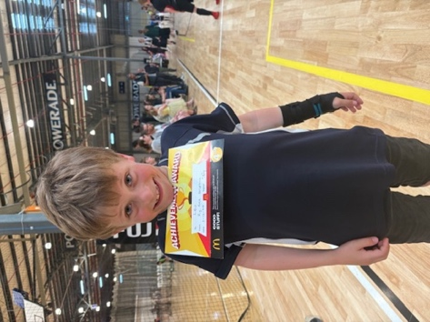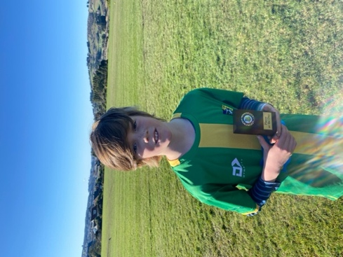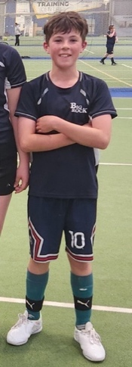
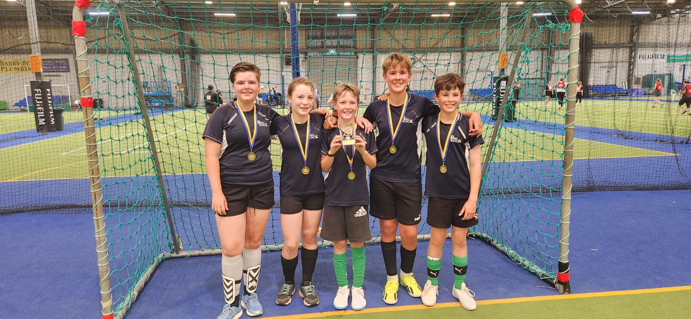
Cameron Walters, Scarlett Hancock, Malachi Turner, Ruben Van Tonder, Kade Hancock
Absent; Coach- Urita Van Tonder
Room Three Camp
Well done to all of the Room Three stars for ensuring your camp was a success. For many of you it was your first and that can be a bit daunting, but from the stories I have heard and the photos I have seen, you were awesome.
Such an important part of our EOTC programme. Having witnessed many children go through the programme, the progress and confidence is quite astonishing.
Thank you to all the Room Three parents who were able to attend, support and encourage the children and make sure they were fed, well fed!
Thank you, Teresa, for having the courage and confidence in the children to take a Year 3-4 class on camp. It makes a massive difference.
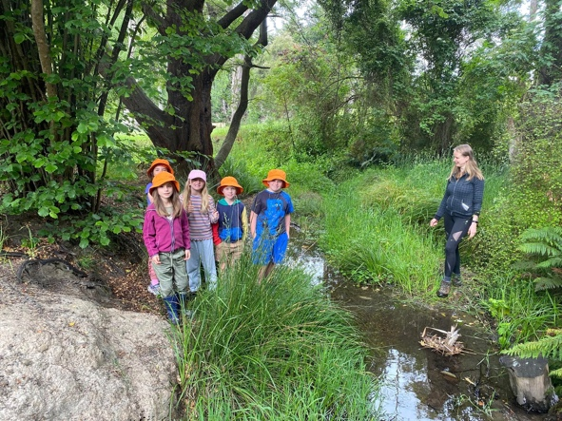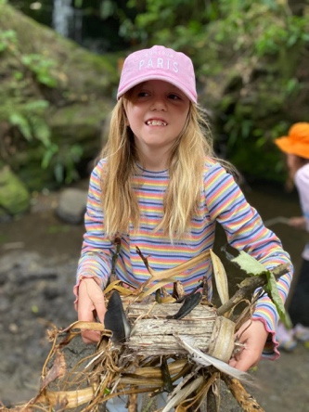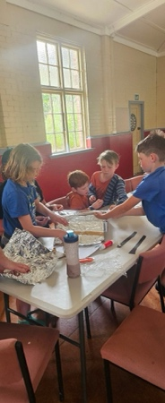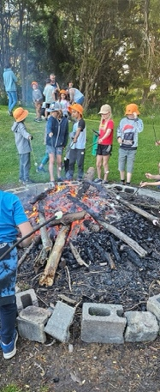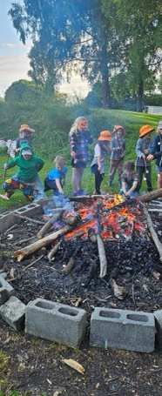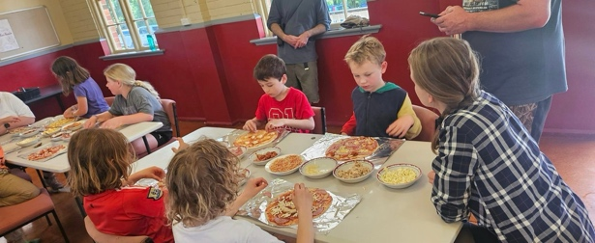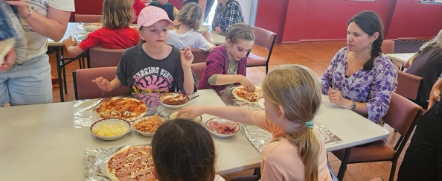
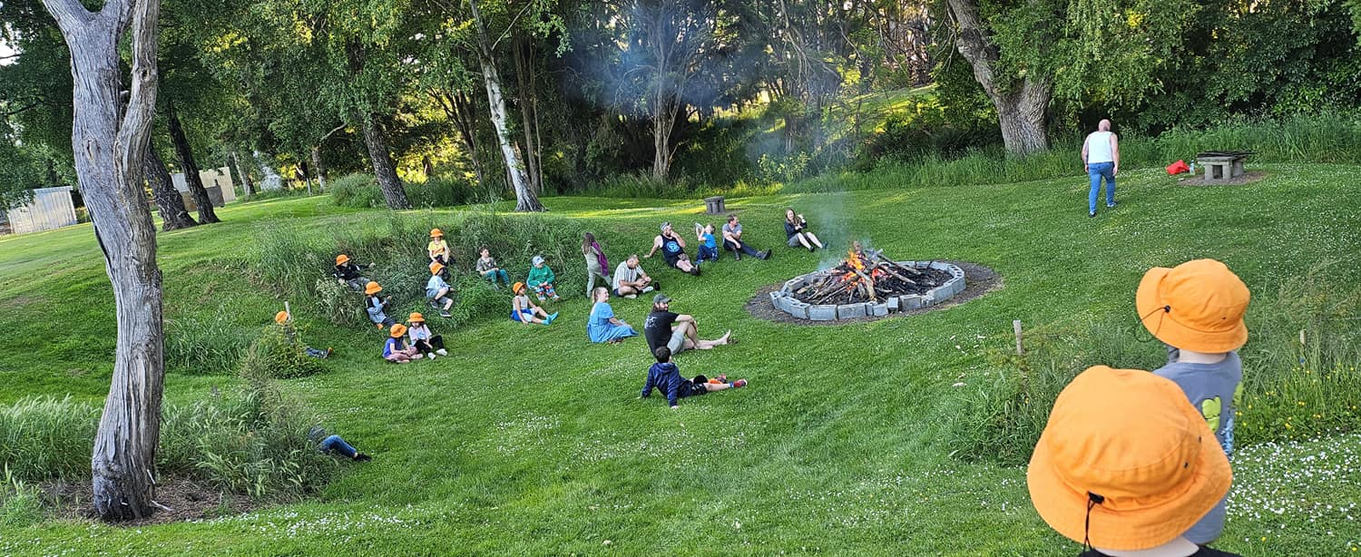

Survivor Camp
While the Room Three folk were having their first or second camp, the senior class were surviving their end of year Survivor Camp. A real tradition now.
In essence they plan the camp themselves, the Year 8s take the Year 7s hostage (sort of), they are driven to a mystery location blindfolded, led into the bush blindfolded, abandoned for 1 minute and reunite and they all survive together having fun by cooking and camping in this beautiful country.
Thank you, Racheal, Justine, Kara and Jude, for all of your help in helping the children survive.
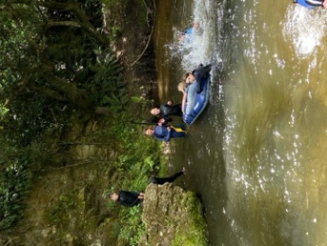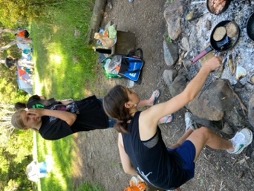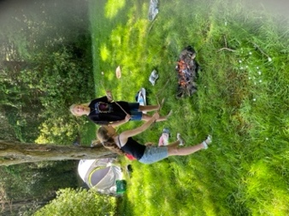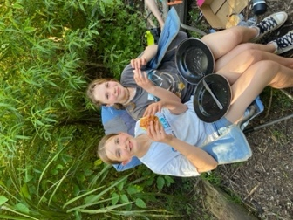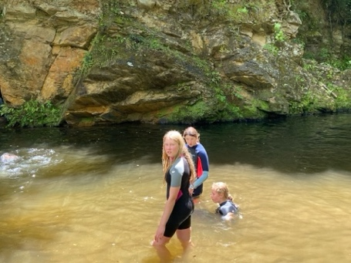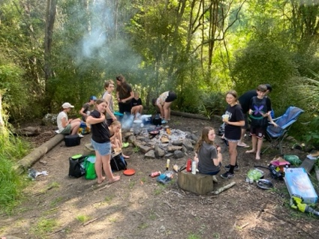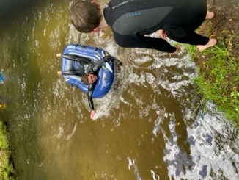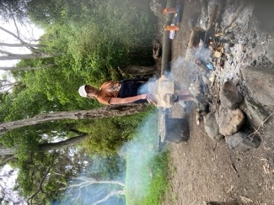
Last TNT Group
Earlier today, the last Tracks n Trails (TNT) group of the year ventured up to Redwoods. As usual they showed great enthusiasm and a fast-developing skill set. With a bit of luck, they will practice and build on their skills and bike fitness so that they are more than ready for the new challenges in 2025. Thank you Scott and George for your efforts again today.
I would like to thank Scott Weatherall and Angie Hancock for their incredible efforts over the year with all of our MTB groups, from the TNT groups to Advanced, as well as the famous Naseby Nightriders. Thank you to the parents for your support.
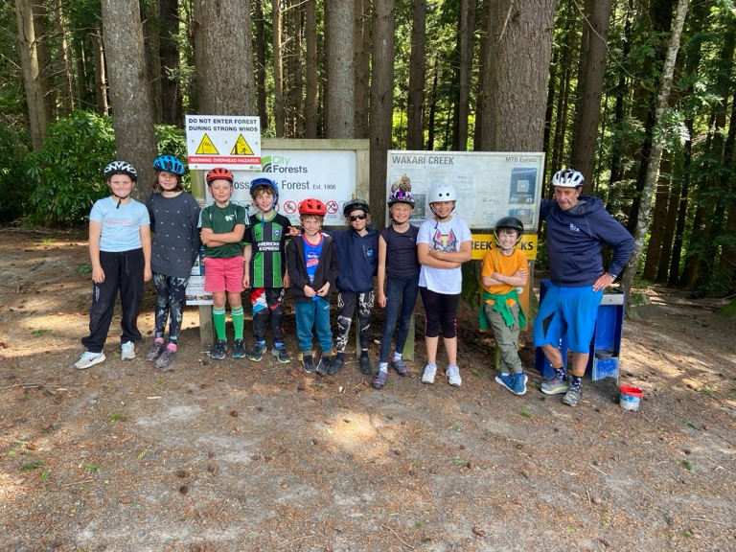
Have a great weekend
David Grant
Principal


