5th September 2025
Congratulations
Tino Pai, Malo lelei, Malo lava and bravo to all our performers this morning at the Otago Polyfest. There was a lot of excitement as well as a lot of nervous energy. I couldn’t have been prouder of them all. Their patience before and after the performance was exceptional as well. We had quite a wait for the bus, but they all hung in there. A massive malo to Dennis Kahui and Litea Ikahihifo for your support, teaching and guidance. Thank you to Kara for your work on the uniforms, especially the lavava. Thank you, Su, Jude and Rachael, for your help at rehearsals and today, fantastic. A massive thank you to Pip Laufiso and all of her team that put together this incredible event. Fa’afatai
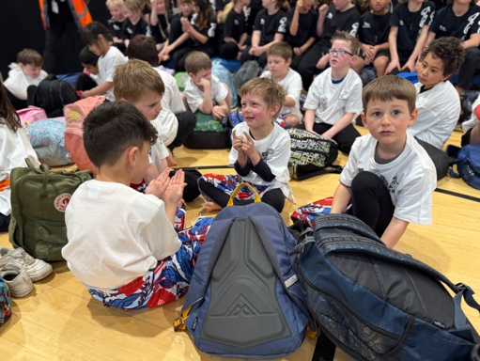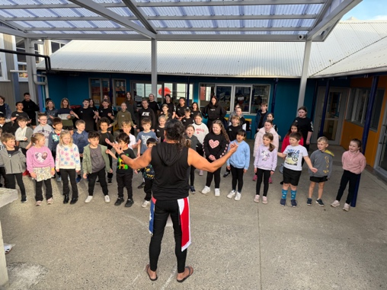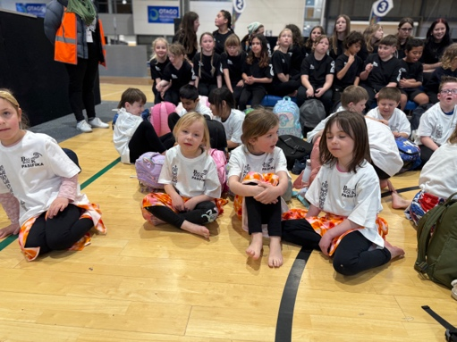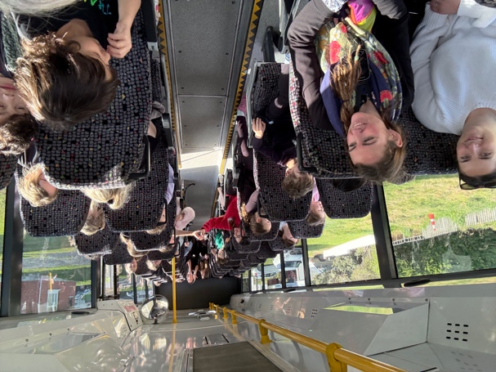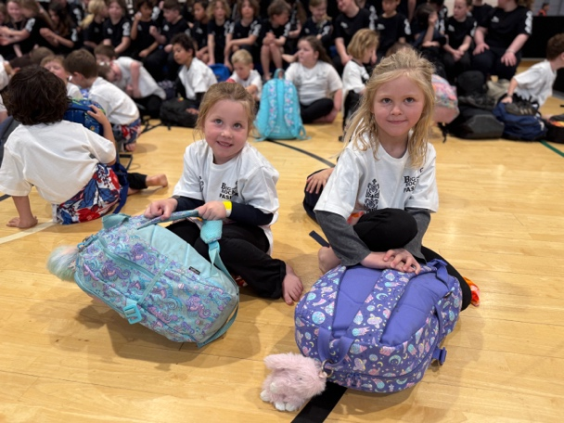
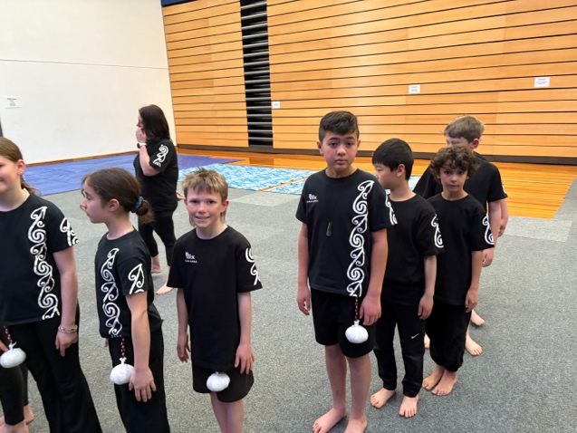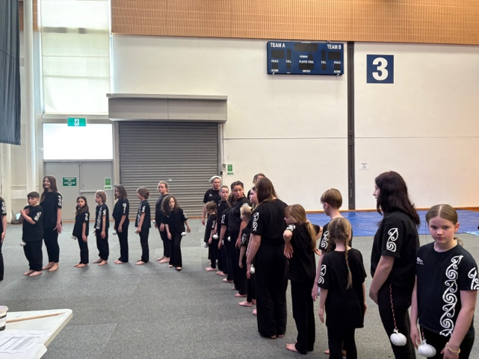
Cross Country
Meanwhile on the other side of town, Jaxon Skerratt and Eva Verhoef were competing in the Otago Cross Country Championships at Kaikorai Valley College in very challenging conditions. A wet boggy track and warm cross country weather. At this stage, places have not been confirmed but I have it on good authority that it is likely 9th and 14th respectively, in fields of over 60. Well done Eva and Jaxon.

School Lunches
Next term we will be introducing sushi for lunch on Wednesdays. These will be ordered online through the lunches-on-line app by parents. The sushi will then be delivered to the school office in time for lunch. There will be cut off times etc. I will send all the information home before the start of next term. It is important to note that the school has no part in the process apart from handing the lunches out. The sushi come from a sushi place in Mosgiel. We had the children vote and sushi got 80% of the vote. Keep an eye out for ordering information coming home soon.

Futsal
We are now taking names of children interested in playing futsal. At this stage it looks like Year 1-4 will be playing on Tuesdays and Year 5-8 will be playing on Wednesdays. If your child is keen, can you please register at the office. We try to keep teams to seven players so that everyone gets plenty of gametime and there is some room for illness etc. Also, if you can help manage team, we need you, please let the office know.
Alice the Musical
Thank you to everyone who has picked up their tickets. Please come and collect these asap as they are running out fast and we have limited seats.
Have a great weekend
David Grant
Principal

