5th July 2024
Good Luck and Wow!
Firstly, good luck to Addison Johnston as she heads off to Christchurch in the holidays to compete in the New Zealand Hip Hop Nationals. All the best, Addie, we know you will be amazing.
Secondly, on behalf of us all I would like to wish Bella Yeoman the best of luck as she heads off to Auckland to sing and compete in the WORLD Choir Championships. Truly remarkable Bella, and like Addie, we know you will WOW everyone.
All the very best to both of you.
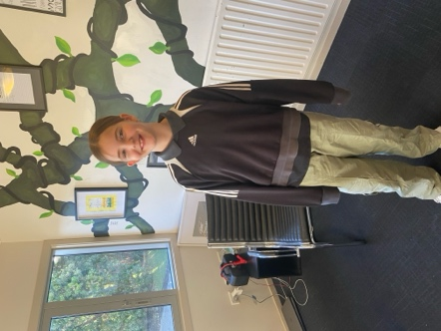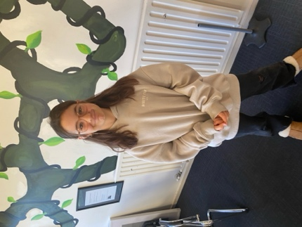
Reports and Parent Interviews
This afternoon your child’s Mid-Year report will be delivered by email. These are a snap shot of your child’s progress and achievement levels. As you would expect they focus mainly on Literacy and Mathematics, they also include other important information from other curriculum areas.
On the Tuesday and Wednesday of the first week back we will be hosting Parent-Teacher meetings. Booking times will become available this afternoon, via the Skool Loop app. If you have any problems please email the office.
School Accounts
As we are mid-way through the year, can we please ask that all school accounts be settled quickly. If you have any questions or think that there are any errors, please contact Kelly. We do endeavour to keep any charges as low as possible. We greatly appreciate your support with this.
Sports Round-Up
No rugby, football or senior basketball this week.

Netball
The Big Rock Hurricanes put in another excellent all round performance for a hard fought win over Anderson’s Bay, who in a conversation I had with them, were very complimentary. Well done Hurricanes.
Congratulations to Aliza Johnston on earning Player of the Day for a great all round performance. Thank you to Jude van Aalst for coaching the team, and to Susannah Yeoman, Dallas Hamilton and Poppy for fulfilling the score keeping and umpiring commitments.
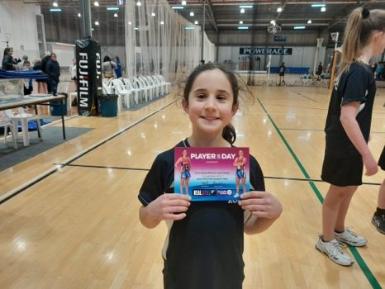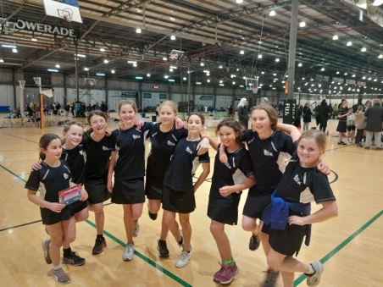
Thursday Basketball
Congratulations to Fin Ramsay on earning Player of the Day for the Big Rock Shooters, great work young man.
Also, well done to Brianna Jones on earning Player of the Day for the Big Rock Coasters. Excellent stuff Briana.
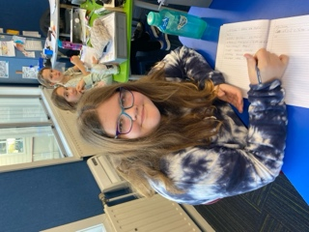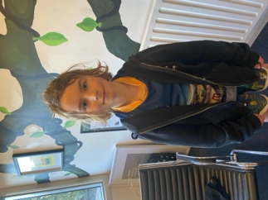

Tree Planting and STEM
Many thanks to Loveday Why and Viktoria Kahui for getting half of Room Four up to the Otokia Reserve to plant some trees. Actually forty five trees as part of replanting programme. Last year we had a group planting in the dunes towards Big Stone Road. Very cool for the children to be involved in and to support the work of the Otokia Trust team.
At the same time, the other half of the class were taking part in STEM (Science Technology Engineering and Mathematics) work. Being supported and led by Leo Garth, Isaac Lucking, Andy Zhang and Leith Conway. This is a trial programme and the trial will continue in Term Three, possibly with a Science Badge component.
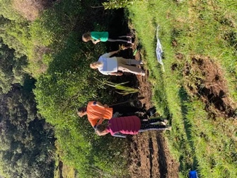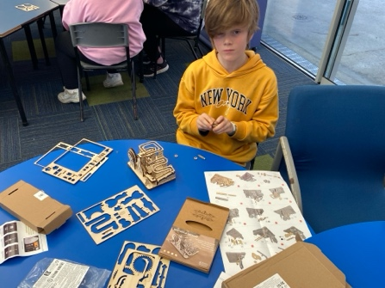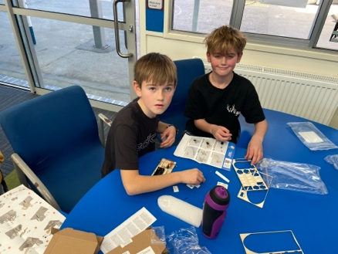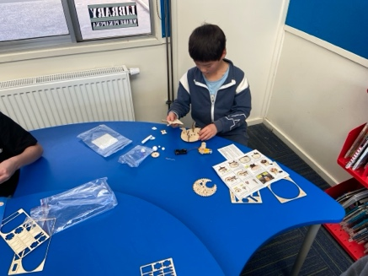
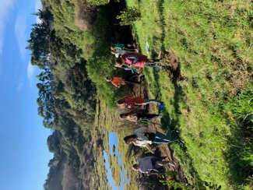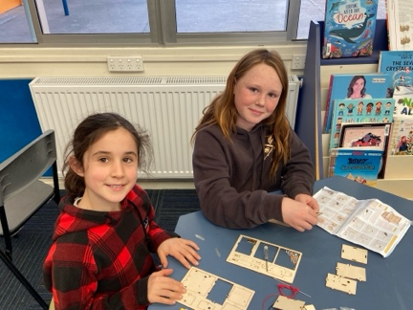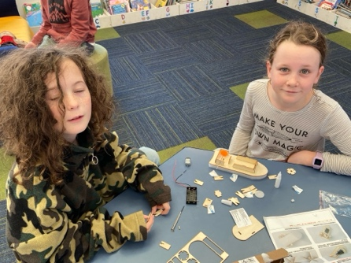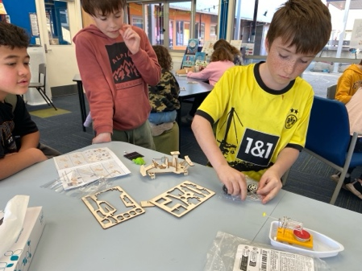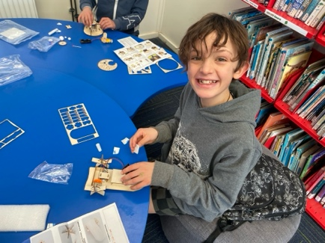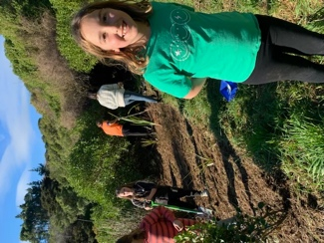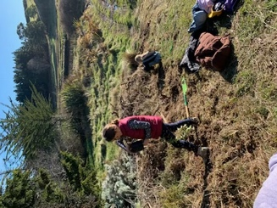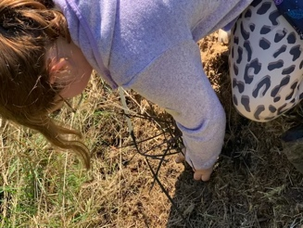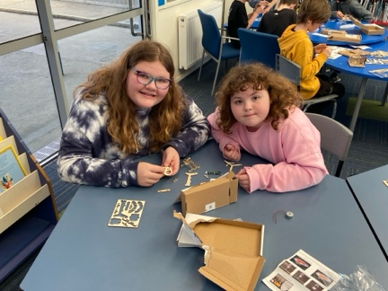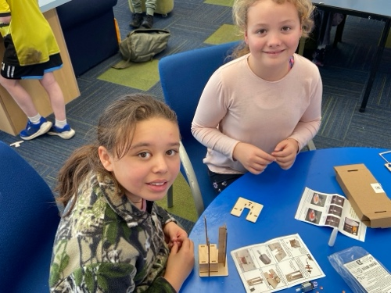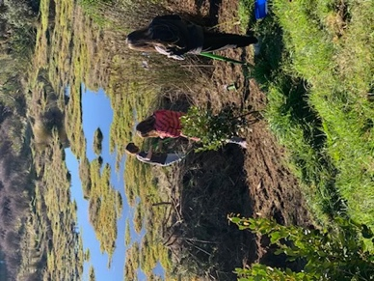
End of Term Summary
It has been another busy and ultimately successful term, and all of the children need to be congratulated for their hard work and endeavour over what is traditionally the toughest term as we head into the cold heart of winter and everything that goes with it, cold weather cold symptoms, bugs, dark mornings and dark before tea time. It all affects us. However, the Big Rock children powered through it. Some of the highlights include Room One and Two’s visit to the museum as History Detectives, Room Three’s rain affected but not fun affected walking tour of Dunedin ending at Time Zone, or Room Four and Five visiting the historical and glamourous Olveston, Dunedin’s Downton Abbey.
Equally I was delighted that our mountain bike groups got underway, at the moment we have an Advanced group and two Tracks n Trails (TNT) groups. This is a huge commitment from both Scott and Ange, to have the combination of their ability and their enthusiasm is immense. So a big thank you.
Also for the first time as part of our Year Seven Eight programme, we were delighted to be able to offer a swimming extension programme that is available to all of our Year Seven-Eight’s at no cost to families. This is now a permanent part of the school programme.
The biggest event was of course our Matariki Celebration and Aotearoa New Zealand History celebration and shared meal. Of course not just the event itself but all of the work and learning the children undertook, and shared some of it with you. It is one of the many things about your school that I take great pride in telling others about, especially other principals who think it can’t be done. They of course don’t know the wonderful Big Rock community. It is something, I believe that the whole school community should be proud of, because the whole school community made it a success.
All of this was on top of quality Reading, Writing and Mathematics programmes, with very high levels of achievement.
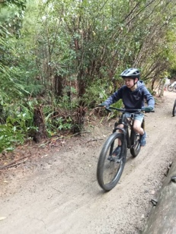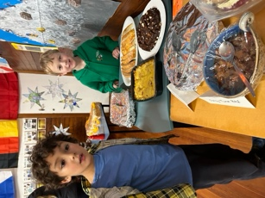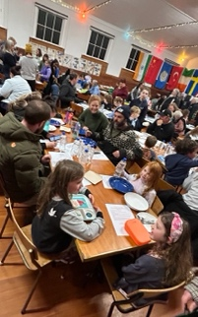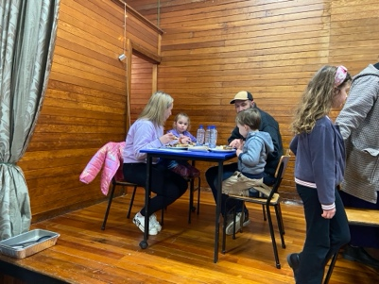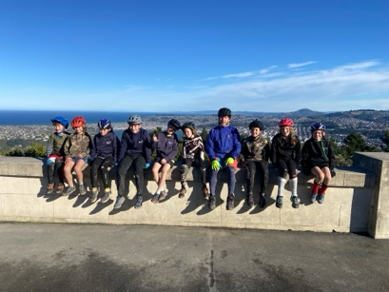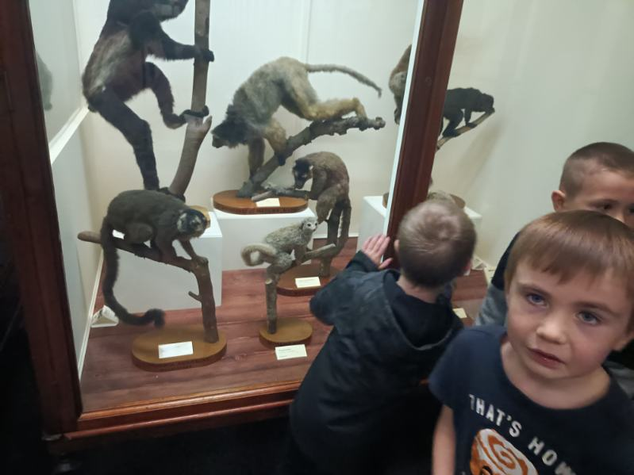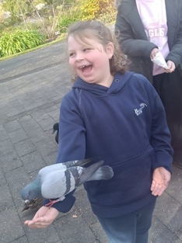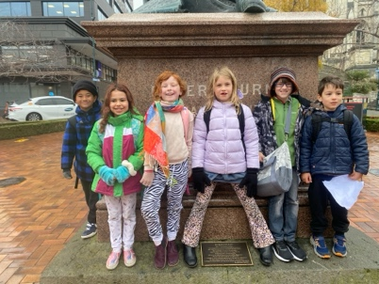
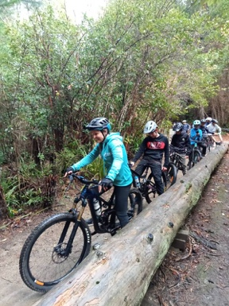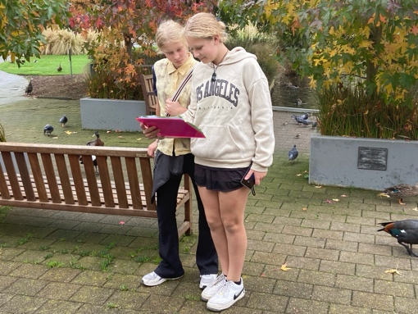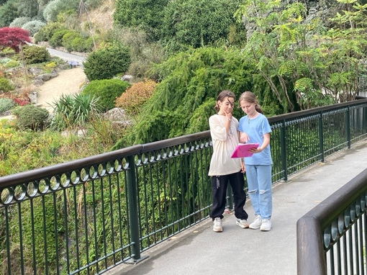
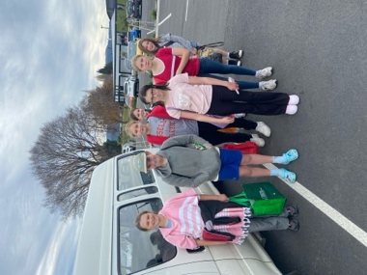
Congratulations
Congratulations to the Hancock family on winning this year’s Aotearoa New Zealand Quiz with a score of 21. Well done. Your prize will be available after school today.
Next Term
Next term promises to be another busy term, and if you have got to this part of what is a very long newsletter, well done.
As well as continuing with robust Literacy and Mathematics programmes in all classrooms, there will be a major focus on Visual Art, both in a creative way and an academic way, building on the children’s art skills and their understanding of art, significant art pieces and renowned artists. This will culminate in the Big Rock Art Extravaganza where the children’s work will be on display for everyone to enjoy, parents and whanau will be encouraged to attend the temporary gallery at the Brighton Hall, all the while enjoying **** and cheese (a throwback to Aotearoa New Zealand History), where once again the Big Rock children will be the stars.
We will also be seeking expressions of interest for children to be involved in the Introductory Mountain Bike group.
As the term progresses, more learning experiences will be added.
However for now, we hope you enjoy the much needed break and we look forward to seeing everyone next term as we work our way towards spring and then summer.
Have a happy and safe holiday.
Kind regards

David Grant
Principal

