5th December 2025
END OF YEAR PRIZEGIVING
A reminder that our end of Year Prizegiving is on Tuesday 9th at 4:15 at the Brighton Hall.
After School Care children will taken along to the hall.
Thank you
Congratulations
Well done to Evie Hollands who performed on stage with her ballet group’s Christmas show last weekend. The excitement she showed when telling me that she was going to be ‘on the stage’ was incredibly endearing and infectious. Magnificent stuff Evie!
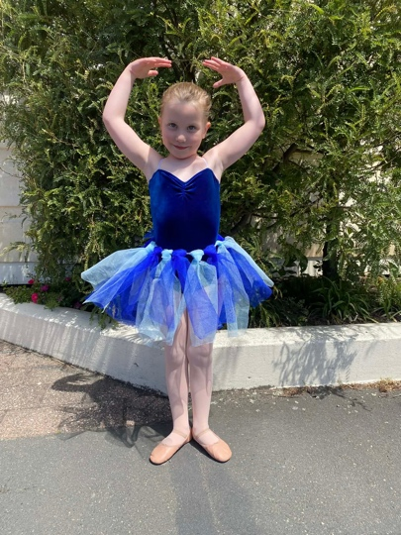
Also, at the weekend a few of our children were competing in a surf lifesaving event at Warrington. Here are a couple of action shots of Leon and Jaxon Skerrat in full flight!
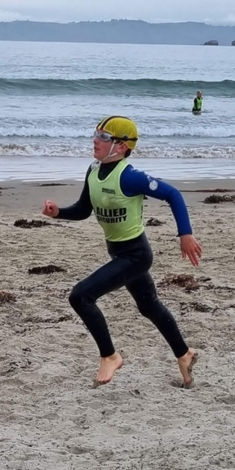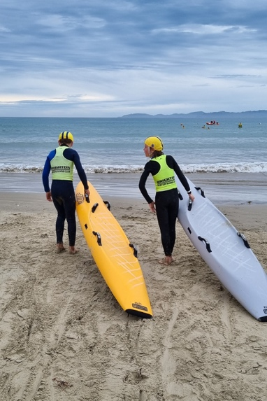
I love hearing about what the children get up to in the weekend and outside of school. The range is amazing. Ballet, surf lifesaving, bmx, equestrian, hip hop, tae kwon do, karate, surfing, singing, cello, drumming, guitar, piano, modern jazz dance, mountain biking, football, rugby, swimming, cultural groups, and I have probably missed a few. We love sharing of their successes in the newsletter.
Futsal
Congratulations to the people who earned Player of the Day in their last game of futsal for the season.
Big Rock Dolphins-Fletcher Cockburn
Big Rock Stingray- Zachary Nielsen
Big Rock- Orca- Max Ashton
Big Rock-Sharks- Fin Ramsay
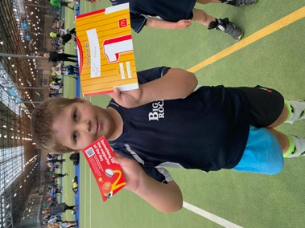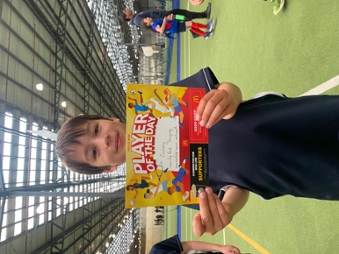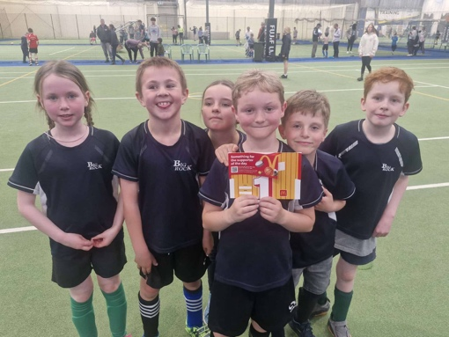
Also, a very heartfelt thank you to Jo Henderson, Nina Daniels, James Gilbert, Lauren Mooyman, Tania Blanchard and Alex Ramsay for your hard work and commitment to coaching these teams.
Survivor Camp
Over the last two days, our Year Seven and Eights have been on their annual Survivor Camp in the bush. This camp is the culmination of our Education Outside the Classroom programme. In brief, they plan the camp themselves in teams of 2-3. The arrange tents, meals and cooking equipment. They are taken ‘hostage’ and survive a night in the bush, cook their meals over open fires, swim in a river, waterslide, explore the creek.
Lots of fun was had, and the good news is, they all survived.
A big thank you to Ange Hancock, Scott Garth, Shea Davie for helping the hostages survive and for surviving yourselves. Thank you Kara Walter for helping transport all of the survivors.
A big thank you to Mr Murray of course.
It is always a sad camp, as it is the last one, we have with our Year Eights, after many adventures over the years, including two Survivor camps, Stewart Island, Central Otago, Berwick, Waiora, Tirohanga, Naseby and for some Ohau. As usual, they never let us down with their attitude and enthusiasm.
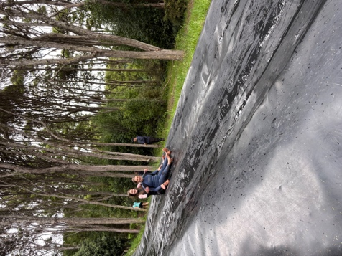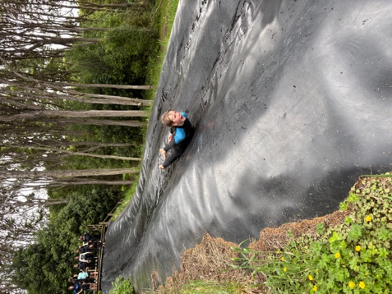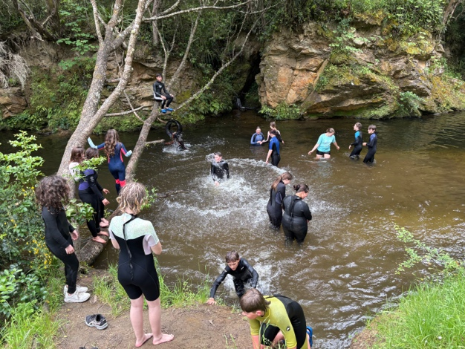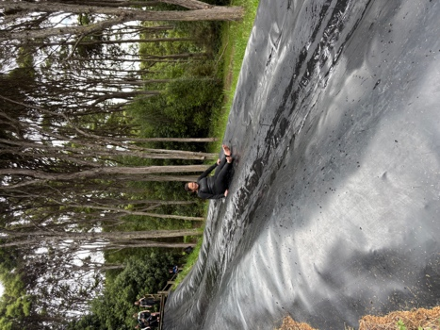

This year was particularly poignant, as it was our last camp with Ange Hancock. Ange and I have been on at least 12 camps together, and many EOTC events including kayaking, surfing, mountain biking, Amazing Races etc. Ange has taken on many leadership roles, and with her knowledge, experience and enthusiasm, has made everything so much easier for staff and better for the children. Thank you Ange, your contribution has been immense.
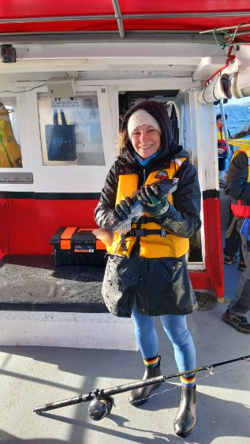
Have a great weekend
David Grant
Principal

