4th August 2023
Welcome
On behalf of everyone I would like to welcome Ruben van Tonder to Room 5 and Big Rock, it is great to have you join us and be a part of the school.
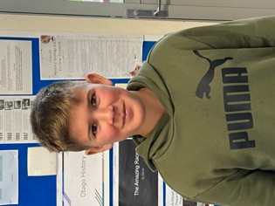
Congratulations
Congratulations to George Weatherall who along with his guinea pigs Maggie and Pebbles won the New Zealand Online Guinea Pig Show at the weekend. George (and Maggie and Pebbles) claimed First Place in the Family section, 3rd place in the MS section, Fave Food 3rd place, Fave Food 2nd place (2 different guinea pigs), 2nd place Junior Smooth Coat and 3rd place Junior Long Coat. Well done George.

Southern Hoiho
Thank you to the parents and the children for getting involved and supporting the Southern Hoiho on Sunday. A pretty cool opportunity, to not only do the honour guard/tunnel but to get a few minutes on the main court with the seats down.
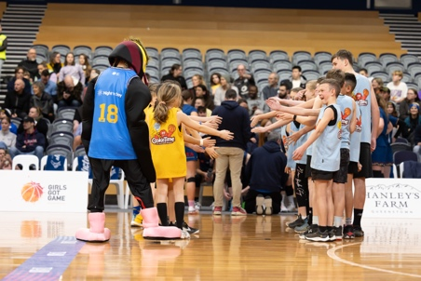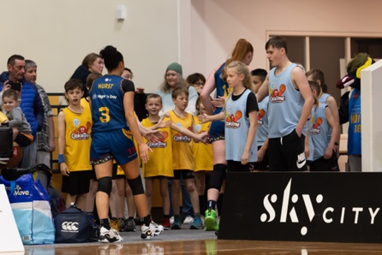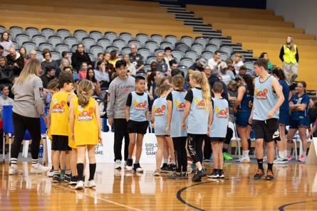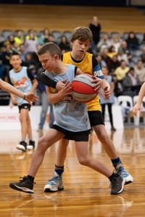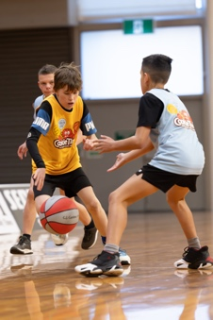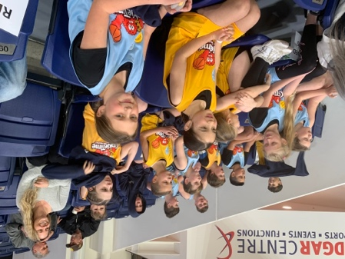
Orokonui Eco- Sanctuary
Last week, Rooms One, Two and Five had an amazing day at Orokonui, which is a pretty cool place and fits in perfectly with our Term Three topic. On Monday Rooms Three and Four got their turn. Both groups were incredibly fortunate with the weather. Stunning weather in a stunning place. Many thanks to the wonderful team up at Orokonui. It is awesome to be able to offer this experience to all of the children, even more so at no cost to families in these challenging times.
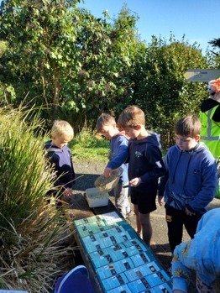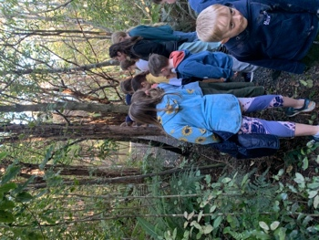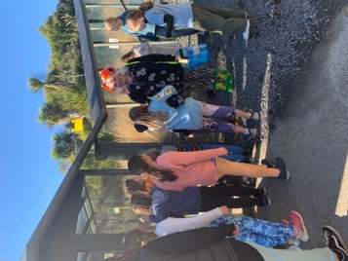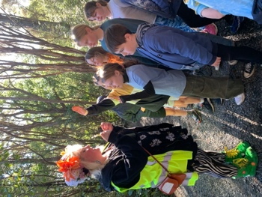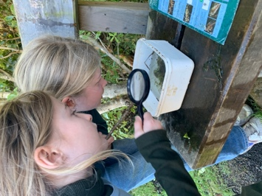
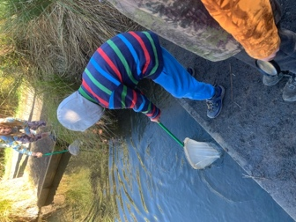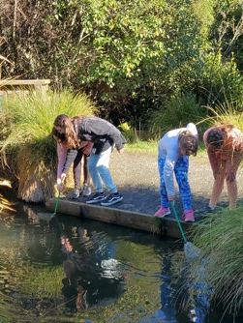
School Disco
On Friday 25th August there is a disco at the Brighton Hall. The disco will run from 6:00-8:00. There is a $2 entry fee. On the night there will be drinks, lollies and glow sticks for sale. As well as music, there will be games with prizes, as well as even more prizes for the best dressed. The categories are Superheroes, Wizards and Fairies for the junior, and favourite actor/actress for the senior children. Although I am sure it will not be against the rules if anyone got out of their lane and went with a different age group dress up theme.
There has been a wee competition to design a poster. Please see the winners below.
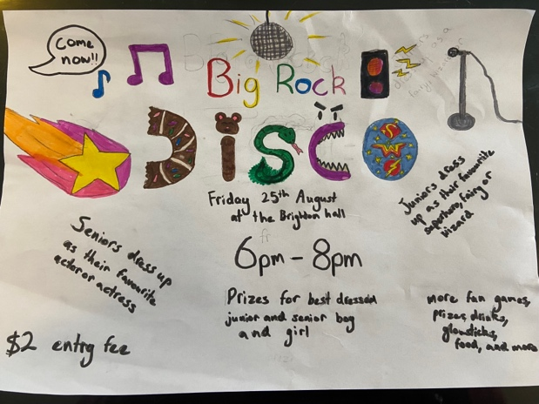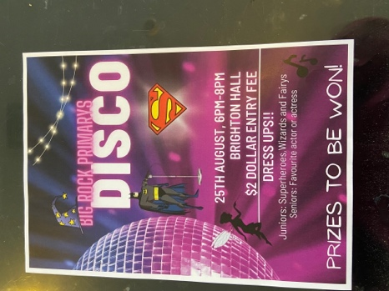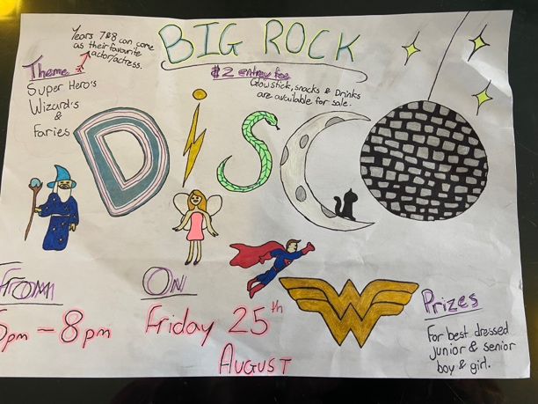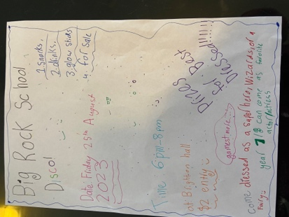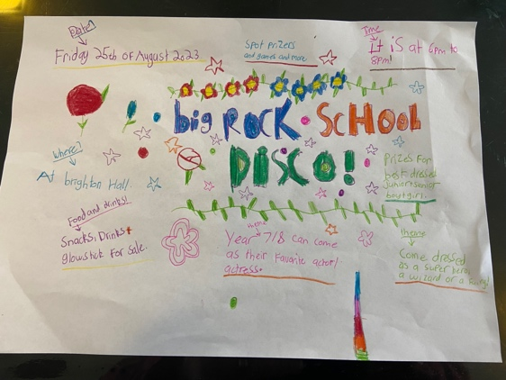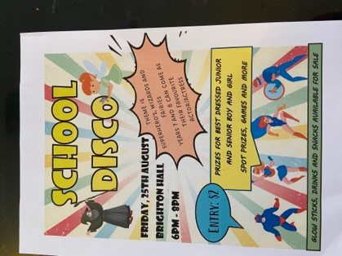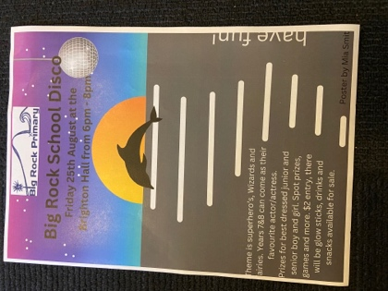
Congratulations to Bella Yeoman, Addison Johnston, Scarlett Hancock, Lilly Hamilton, Meadow Hamilton, Ella Dorana and Mia Smith. Your prizes will be available on Monday.
Sports Round Up
On Monday night the Hoopsters had a close game with Abbotsford. Congratulations to Seth Elliott-Tressler on earning MVP.
The Coasters battled hard in their game against Opoho, just missing out. It was a sterling effort as due to illness they had no subs. A lot of running was required, but they gave it their all and you can’t ask for more than that. MVP went to the famous five of Dusty, Jasmine-Rose, Beau, Isaac and Addison.
A lot of tough games this week, and the Shooters were no exception. Bravo Flynn Blanchard on earning MVP in a very tight contest. Keep it up dude.
No game for the Big Rock Dolphins this week.
Congratulations to Esme Grey and Meadow Hamilton on earning Player of the Day for the Big Rock Rockets on Tuesday night.
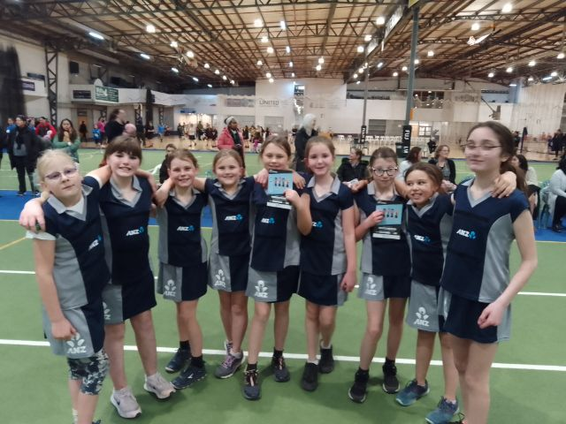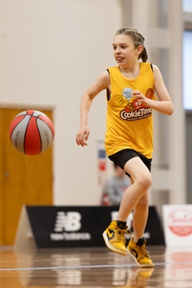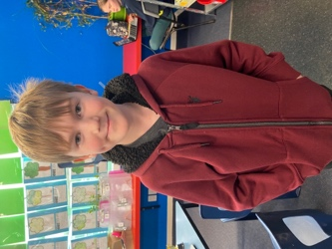
Brighton Seagulls
Well done to Dion Mooyman on earning Player of the Day for his Brighton Seagulls team. Also well done to Leo Henderson on earning player of the Day for his Seagulls team and to Lewis Vorgers for earning Most Improved.
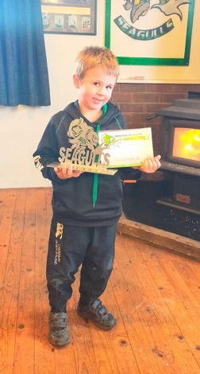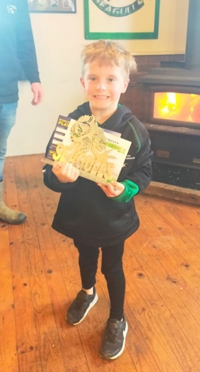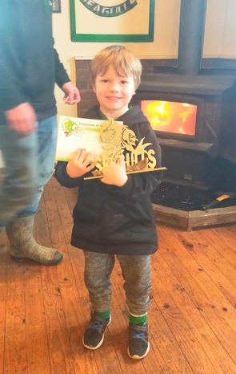
Have a great weekend.
David Grant
Principal

