4th April 2025
After School Care
Thank you to everyone who supports and uses our After School Care programme. As we near the end of the term I need to remind everyone of After School Care expectations. We have been having some areas that need tightening up.
Cancelled Bookings
If your child is booked in and for any reason, no longer needs to go to After School Care, can you please ensure to let Maree know in good time. We have a limited number of spaces available and other families may need the space. It is also a safety concern, as when children who are booked in don’t turn up, we need to locate them to see what is happening. We can’t just assume they are not attending, we need to hear it from parents please. Non-attendees can also lead to an oversupply of food.
Even if your child is of sick, can you please let Maree know, as the office does not always know who is booked in as Maree deals with that.
Please remember, that we do not charge when children booked in don’t turn up. Most do. We understand that things happen, all we ask is that you let us know.
Late Bookings
Please be aware that late bookings are not always possible as we have a set number of places so as to maintain safe ratios. If we get enough notice, we can arrange extra staff. Again, we do understand that things happen and we will always do our best to accommodate families.
Signing Out
Children need to be signed out by a parent or an adult that is responsible for them and that we are aware of.
We can’t have children signing themselves out. Again, this is a safety issue.
We appreciate your support with all of the above.
After School Care Phone Number- 021 082 50863
Congratulations
Congratulations to all of the players who earned Player of the Day for their respective futsal teams. Bravo to:
Big Rock Stingray- Leo Henderson
Big Rock Barracuda- Georgia Stewart
Big Rock Sharks- Baily Jenkinson
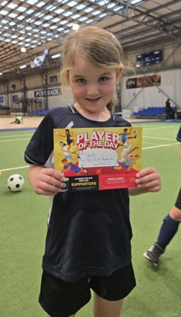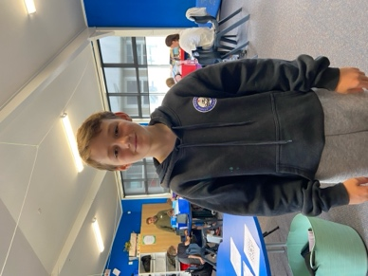
Well done to Lexie and Stella Brown who both finished third in their different age groups at the recent West Harbour Gymkhana. Well done girls.
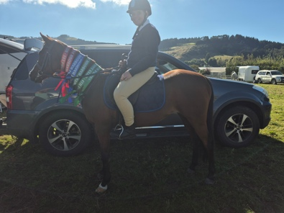
Brighton Trail Ride
A massive thank you to everyone from the school, rugby club and fire brigade for giving up your time to make this event happen. The work that Aaron Hollands and his team of volunteers have done is quite astounding. The setting up of the course, the making of markers, the organising of prizes, getting everyone working together, the logistics and documentation alone are quite staggering. I will endeavour to thank everyone eventually by name next week, I would also like to acknowledge all of the work done by Nina Daniels and Hamish Graham as well. Also thank you to Ross McLeary and his farming colleagues for allowing their farms to be used.
It is going to be amazing tomorrow. Thank you everyone.

Hungerball (Or in action the Hunger Games)
The Hungerball games were a massive hit this week, with all of the children involved in a variety of games, with balls flying, lots of shrieking and laughing. While it wasn’t necessarily planned, it connected very well with our Personal and Physical Resilience plan. It is not always easy to develop resilience and things like this help out immensely and make it very real for the young people. It is beneficial, even if they don’t always understand.
Many thanks to Jake from Hungerball for helping us out with a great deal, and thanks to Annette Hogg for organising it for us.
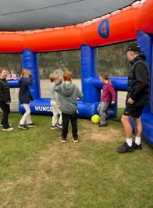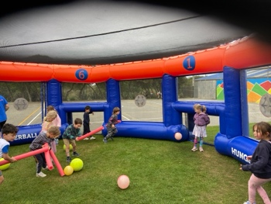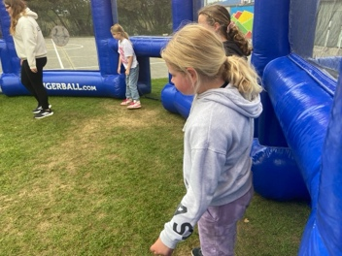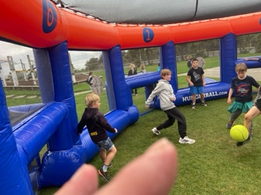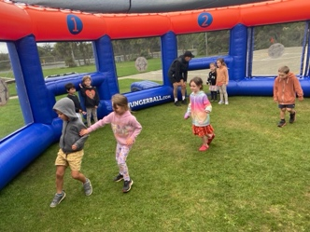
Swimming Pool
The school pool will close to key holders on Sunday 6th April. Thank you to everyone who used and looked after the pool this season. We are planning on some upgrades- some structural work, a new pool heater and possibly painting the pool. Can all keys please be returned asap.
As is the tradition at Big Rock. We will celebrate the end of the season with class pool parties. These will include sweet treats and drinks. If you do not want your child to partake can you please let me know in advance. Children with different dietary requirements will be catered for. It is always a bit of fun. The pool parties will be on Tuesday and Thursday. They will begin with Rooms, 1, 2 and 3 on Tuesday and Rooms 4 and 5 on Thursday. As the t-shirt says…


Have a great weekend
David Grant
Principal

