3rd May 2024
Welcome
A massive welcome to Big Rock to Kendrick Keki and Ruiha Louisa Kelly-Matthews (Photo to come). It is fantastic to have you and your families join us.
It is fantastic to be back after a wee break. Term Two is always exciting as we delve into Aotearoa New Zealand History as a key focus. This is of course on top of the core curriculum areas of Reading, Writing and Mathematics, which where appropriate will integrate with our Aotearoa New Zealand History teaching and learning.
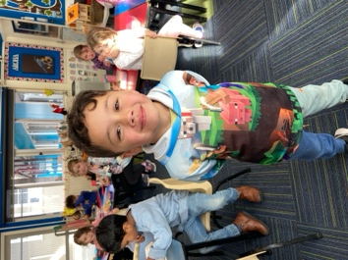
Congratulations
A massive congratulations to former Big Rock student and a Year 8 here last year, Riley Henderson. Riley finished 3rd in the top extension Mathematics class at Kings High school in the University of Otago Junior Mathematics competition. He also won Most Promising Male Lifeguard for Brighton Surf Lifesaving Club. An academic star and sporting achievement, is that a result of the wonderful broad and rich programmes at Big Rock I hear you ask? Maybe, but it is testament to Riley’s hard work and determination. Top work Riley, you’re a top man!
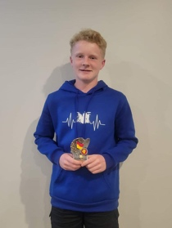
Morning Drop-Offs
As we are now coming into the winter terms when it is colder and darker, can we please ask that all children dropped off between 8:00 and 8:30 go straight to the library. Also, if children are going to be dropped off at 8:00 can you please let us know. If it is a one off or every now and then, please. Before 8:00 is a bit early and we can’t guarantee that there will be staff members here.

Big Rock Basketball
Basketball tips off next week, with the Big Rock Hoopsters playing on Monday night and the Big Rock Coasters on Thursday night.
The draw
Big Rock Hoopsters v Outram on court 6 at 4:50 (Monday)
Big Rock Coasters v Anderson’s Bay at 5:50 on court 4A. (Thursday)
The Coasters still require a coach/manager please.
All players require a mouthguard. All players must have correct uniform to take the court. (School singlet and black shorts or leggings). Can all players be courtside 10 minutes before tip off.
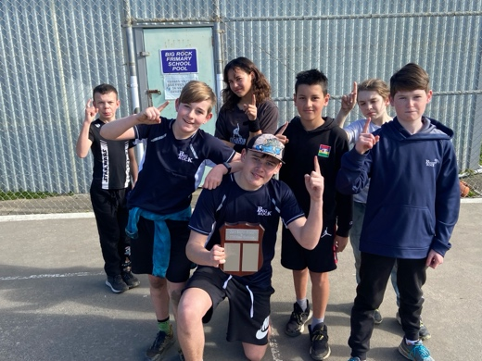
2023 Championship winning Big Rock Hoopsters
Otago Hockey
Earlier today we had Otago Hockey working with four of the classes (Room Three were at the University). This programme will run on Fridays for the next few weeks. Many thanks to Jolene and all the team at Otago Hockey.
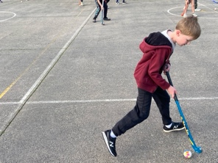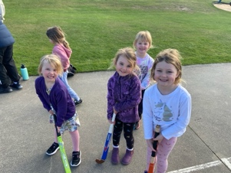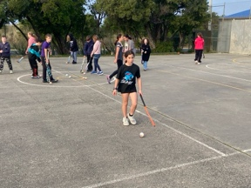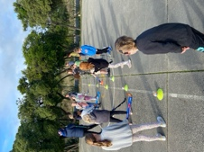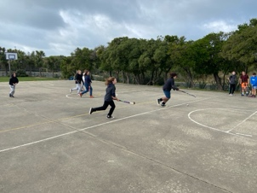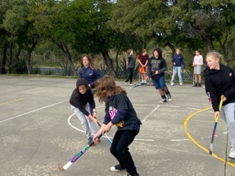
Sports Equipment
You may recall that last term, we received some funding ($3000) from the Bendigo Valley Charity Trust for sports equipment. Next week we will be collecting basketballs, netballs, footballs, hockey gear, croquet sets, pickle ball gear, amongst other things. A massive thank you Mike at Bendigo, as well as Brent at the Otago Sports Depot for helping us out with great pricing and service. It always pays to support local.

Room Three attending the University of Otago
Earlier today Mrs Grant and a team of parents all headed off to university. I know these children are pretty sharp, but that seemed a bit over the top. In fact, as part of their Aotearoa New Zealand History focus they were off to the Dunedin icon that is the University of Otago Clocktower. This is not a place you can just pop-in. Many thanks to Annette Hogg for organising tis for us, really appreciated. Thank you to all of the parents who were able to help with transport.
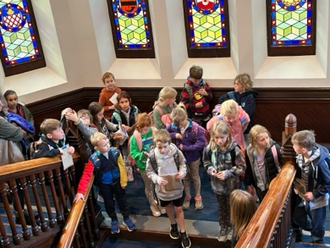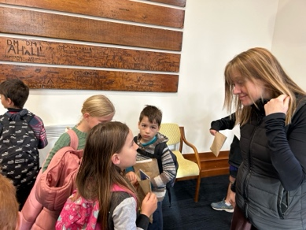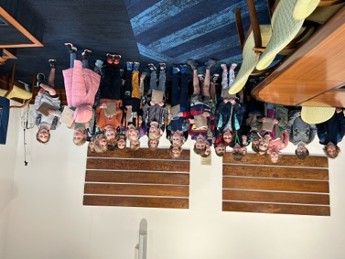
Aotearoa New Zealand History
Last year, at our Matariki Aotearoa New Zealand History Celebration we had a wee quiz and asked for Aotearoa New Zealand’s five greatest song, the year before we asked for our 4 greatest New Zealanders (New Zealand’s Mount Rushmore). This year we are looking for New Zealand’s five greatest sporting achievements. So, get thinking. Below are 5 NZ sporting questions to get you started.
- In what year did Michael Campbell win the U.S. Open?
- What was unusual about the first try scored at the first men’s Rugby World Cup in 1987?
- Who is the most capped Silver Fern?
- Who is the only New Zealand athlete to win an Olympic Gold medal in cycling?
- What and where are Cook’s Gardens?

Have a great weekend.
David Grant

Principal

