Good afternoon Big Rock families/whānau.
Sad Farewell
As we come to the end of the term, we say a fond farewell to Miss Low. Although she has only been with us for the past two terms, she has made a genuine and lasting contribution to our school community. Her kindness, enthusiasm, and commitment to our students has been greatly appreciated by staff, students, and whānau alike.
Thank you, Miss Low for the care and positivity you have brought to our school. We are grateful for the difference you have made in such a short time and wish you every success and happiness in your next adventure. You will always be welcome back at Big Rock Primary, and we hope our paths cross again in the future.
What’s Been Happening Around the School?
The major highlight of this week was our Matariki Celebration. Wow, every year I am more impressed than the year before. Firstly, thank you to all of the parents and whanau for not only attending and making it work, but also for the incredible amount and quality of the food. (I have been bragging to colleagues in other schools), thank you to all the children for their efforts in the build-up and on the night.
Thank you to all the staff for your commitment to such an important night on the school and national calendar.
There are a few people who I want to single out for thanks, thank you Kara and Blayr Findlay for the hanging of the flags, a bigger job than it looks, thank you Matt Whelan and Bill De la Mare for carving the lamb, thank you to Colin Driver and Craig Scott on the sausages and all the parents who made the clean-up so much easier.
Thank you to the Room 5 children for setting and packing up the hall and helping with the food prep with the younger classes.
A big shout out to Baily Jenkinson and Pearl Mansfield on your massive input in cooking, prepping and cleaning- you were immense.
Lastly thank you to Atiana Reihana, wahine toa for leading our karakia.
It is a wonderful night and one that we are immensely proud of, the bringing together of people to share food and enjoy each other’s company is a positive force.
If anyone has a couple of photos from the night, could they forward them to me please at principal@bigrock.school.nz

Food for Thought
‘The purpose of education is to turn mirrors into windows’ Sydney J Harris
Listening, Laughing, Learning and Looking After Others
Some Big Rock students who were ‘caught’ displaying our school values this week were –
Bryn Little- helping the younger ones on the Big Fort
Baily Jenkinson – helping younger children in their football game
Leo Garth -- helping younger children in their football game
Maple Wilson- helping her injured friend
School Reports
Your child’s achievement and progress report comes out later this afternoon. We will be holding interviews early in the new term as well as discussing next learning steps.
Sports Roundup
Congratulations to the following Players of the Day
Arlo Pfyl- Kaikorai Demons
Dion Mooyman- Green Island Football
Braxton Parata-Walters – Big Rock Hoopsters Basketball
I would also like to congratulate Meika Coory and Evie Hollands who competed in the Dunedin Gymnastics Academy recreational competition at the weekend. They competed in the Orange Rainbow section. Top work.
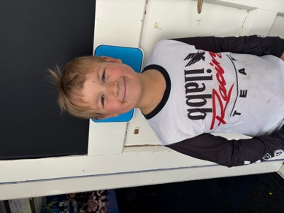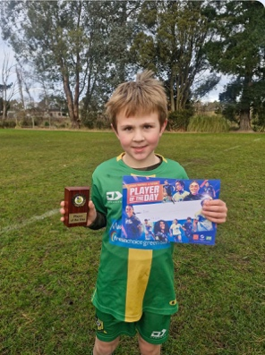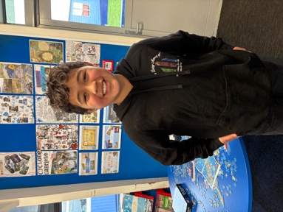
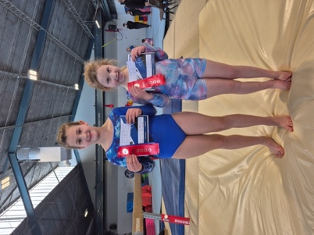
Good luck to Korbyn and Braxton Parata-Walters who are competing in the regional Tae Kwondo championship in Christchurch.
Lastly, good luck to Mr Murray as competes in the Gold Coast Marathon this weekend, as attempts to complete all the worlds ‘classic’ marathons.
Thank you
It is great to be back. I must admit that I felt like what it must feel like for a 5 year old on their first day of school, a wee bit nervous and excited. However, all the children were welcoming and seemed pleased to see me, which was incredible. All the parents and school whanau were welcoming too. I have always said that this school and the community it serves, is a very special place, and I believe it is a wonderful example of New Zealand at its best.
A big thank you to the staff for their wonderful work over the last two terms and for graciously welcoming me back.
Lastly, I want to thank and acknowledge the work, leadership and management of Lisa Lamb. Bein principal has its challenges and rewards. Being in acting position is much more difficult, as it is human nature to think what would the other guy do, am I doing it right, even What do I do? I feel privileged in coming back to your school and that it is thriving. That has made my return much easier. Thank you Lisa, you have left me big boots to fill.
The research I undertook on my sabbatical is now complete and was very successful. I feel very blessed that I had the opportunity to do it and to have so much support. Thank you.
Room Three making sushi
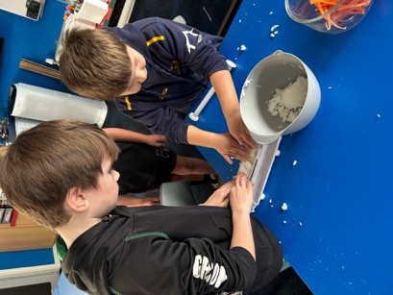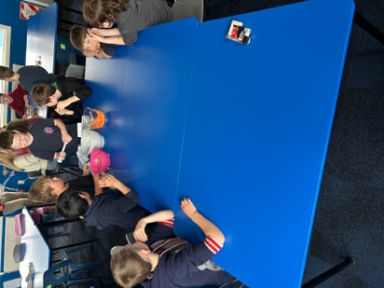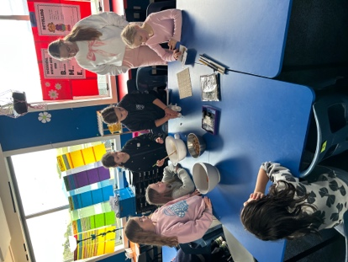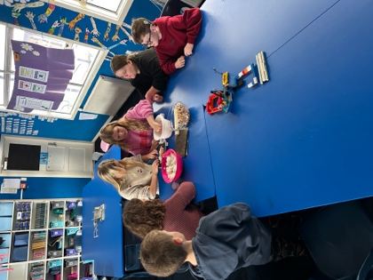
Next Term
Term Three promises to be an exciting one. Our curriculum focus (aside from Literacy and Mathematics) is on Science and Technology. We will share more about that in the new term.
Even more exciting, we are opening a new classroom (sort of) that will be known as 2b. This is to ensure that we are able to offer the best teaching we can in the Junior school, especially in the areas of Literacy and Mathematics. I am delighted to advise you that Room 2 b will be led by Rachael Ward. Exciting times ahead.
We will also have a visit from the Education Review Office, an we look forward to sharing with them the wonderful that has been happening across the school, particularly in Literacy and Mathematics, and the embrace of Structured Literacy, Science of Learning and Explicit teaching- all key components of the Revised New Zealand Curriculum-Te Mataiaho.
It’s great to be back
Have a safe and happy break
David Grant
Principal
Upcoming Events
End of Term – Friday, July 3rd.
First Day of Term 3 – Monday, July 20th.
Year 6, 7 and 8 Bike Trip – Date to be advised.
School Accounts
With it being the end of term, it would be appreciated if any outstanding school accounts could be paid in
full or a direct credit set up to clear these please.
If you wish to start a direct credit to pay your school account, the school bank account details are – Big Rock
School – 02 0900 0000225 00
Please let Kelly know if you do start a direct credit payment.

Keith from Project Excavation Landscape is responsible for our school looking so smart. If you have any
landscaping or excavation projects we highly recommend using his services.
Reminders
Sushi
Sushi is available for lunch every second Wednesday. You can order this by using the Kindo/Ezlunch app.
Term 3 sushi.
Wednesday 22 nd July. 5 th , 19 th August. 2 nd , 16 th September.
Knowing if your child is well enough to go to school — guidance for parents and caregivers.
If you are not sure if your child is well enough to go to school, the Ministry of Health have a quick guide where you can check your child’s symptoms to make an informed decision.
Google – knowing if your child is well enough to go to school.
After School Care
Bookings or cancellations for After School Care can be made by texting 021 082 50863 or by emailing
asc@bigrock.school.nz.
Office Hours
Monday and Wednesday – 8.45am – 3.15pm
Tuesday, Thursday and Friday – 8.45am – 12.15pm
Kelly is only in the office between these hours.
Please note that if your call goes to the answer phone, leave us a message. Staff may not be able to answer the phone at that timebut will check the machine as soon as they can.
Lunch Orders
These can be made at the shop on a Friday or dropped at the school office before 9.00am.
Lost Property
This is located in the library.
2 Bath St • Brighton • Dunedin 9035
Ph 03 481 1781
email: office@bigrock.school.nz
Absences
Thank you for getting your absences and late notifications in before 8.50am on Skool Loop.
It saves us a lot of time if we don’t have to chase these up.
The new Stepped Attendance Response Regulations from the Ministry of Education and what they mean.
An automatic email will be sent from EDGE, as per Ministry requirements, when absences reach 4.5 half days
in a term.
Any absence must be recorded in accordance with the Ministry of Education attendance guidelines.
You can find further information about this on the Big Rock Primary School website under policies.

David Grant
principal@bigrock.school.nz

