31st October 2025
Welcome
On behalf of everyone, I would like to give a massive Big Rock welcome to Jackson Gulliver and his family. It is fantastic to have you on board.

Assembly
On Wednesday 12th November, we are reintroducing Assemblies. We have been bullied, harassed, persuaded, encouraged and challenged to start these up again. Our first assembly will be at 2:10 on Wednesday 12th November outside the library. Some children will share work, certificates will be presented, and other things may or may not happen. We weren’t really bullied and harassed
There will be another assembly on Wednesday December 3rd which will also include a Homework Heroes Superdraw.
(Unfortunately, due to Fridays being booked with other things happening, we have had to have assemblies on Wednesdays.)
Congratulations
Well done to the following players on earning Player of the Day for their respective futsal teams. (The Dolphins had two games this week.)
Big Rock Dolphins- Ari Gilbert
Big Rock Dolphins – Kendrick Keki
Big Rock Orca – Elise Blanchard
Big Rock Stingray – Millie Scoullar
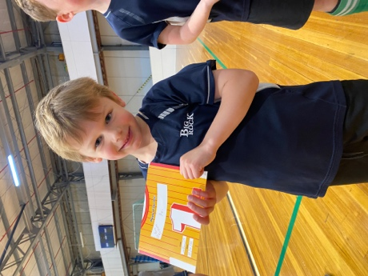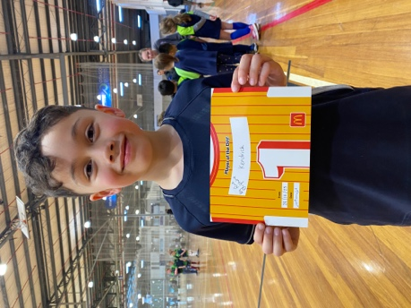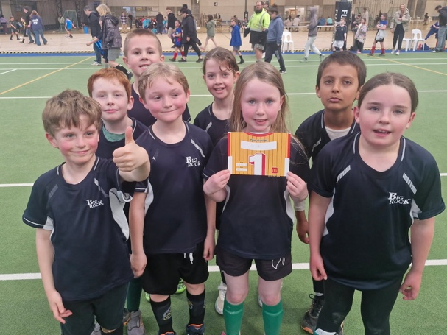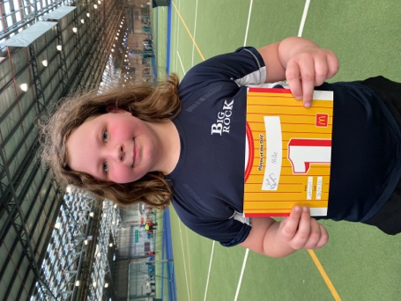
Rising Stars Series
Over the next few weeks, I will be sharing with you, stories and experiences of Big Rock stars who are shining not only locally but also internationally.
Our first rising star is Year 8 student Kade Hancock, a talented footballer and all-round top student. Kade has recently returned from Australia where he was representing what amounted to a New Zealand selection team, coached by former All White player and coach Ricky Herbert. The team is made up of players from academies all over New Zealand. The competition was based in Melbourne, with teams from New Zealand, Australia and other parts of the world. Kade’s team were the eventual winners of the tournament and the Shepparton Cup. Winning all their games, scoring 25 goals and conceding just 1. Kade played in the centre of midfield as the midfield general, directing attack and defence. Kade scored 5 goals and created 10. Which means that Kade was heavily involved in 60% of his team’s goals. (Including a personal hat trick).
Congratulations Kade, an incredible effort, and for the humble way you behave. A rising star for sure.
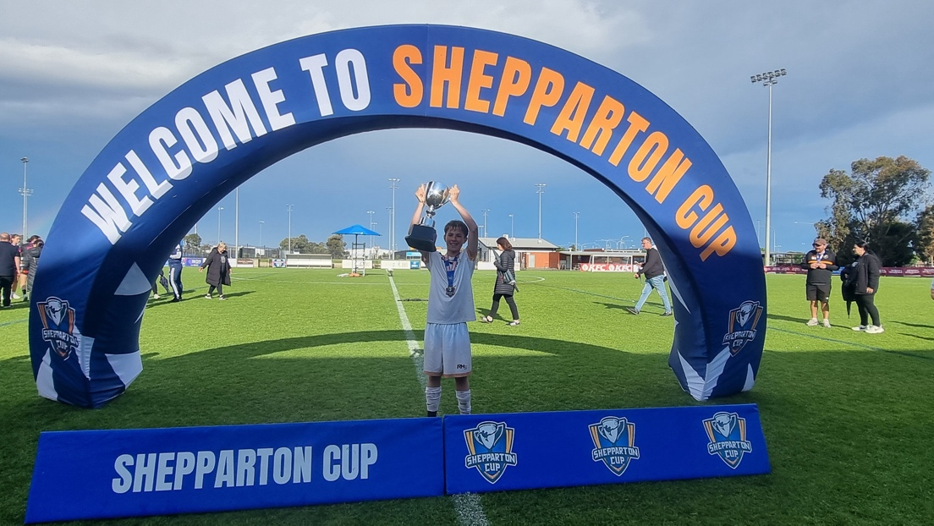
Next week another rising football star, with links to West Ham. More next week.
Greater Green Island Athletics
This year we sent a small but enthusiastic team out to Mosgiel. Regrettably this year our preparation was not what we would have liked due to the wild weather, it was either raining, blowing a gale or both. However, the children gave it their all with a smile (while chasing their hats). Honourable mentions to Jaxon Skerratt (Year 5) high jump and 800m, Leon Skerratt high jump, both with PBs on high jump. Lexie Brown on shot put and Eva Verhoeff on winning her high jump event with a 100% rate of clearance.
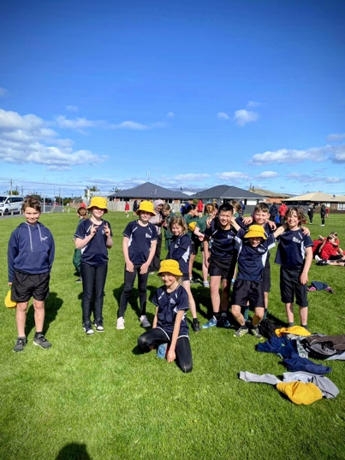
Have a great weekend
David Grant
Principal

A Message from our new Board Chair/Presiding Member, Dr Lisa Daniels.
Kia ora koutou
Our school board met this week to discuss a range of updates and upcoming initiatives.
Recently, our new board members attended the New Zealand School Board Association
training, which was a valuable opportunity to refine our roles and connect with other
boards.
We appreciate those who have supported our reminder about safe school drop-offs and
pick-ups. However, we are still noticing some unsafe practices. Please do not stop or drop
children off on the yellow lines, as this blocks visibility at the road crossing.
Brighton Gala Day is coming up soon (18 January), and we’ll need plenty of help to make this
important school fundraiser a success. Please save the date! We’ll also be establishing a PTA
shortly and will be calling for members to join. At least 10 members are needed for it to
proceed.
The Board also reviewed the school’s “Appropriate Clothing” policy. A reminder that all
school policies are available on our school website
(https://www.bigrock.school.nz/policies/). Please take a moment to re-familiarise yourself
with them.
If you’d like to learn more about what the school board does, here’s a great summary:
https://www.schoolboardelections.org.nz/assets/Community-member-guide-to-the-role-of-
the-board-of-trustees_SEPT20_SAM_web.pdf
Our next Board meeting will be held on Monday, 1 December at 3:30 pm, in the staffroom.
Ngā mihi nui
Lisa Daniels (Presiding Member)

