30th June 2023
Thank You
A massive thank you to Lauren Mooyman and Jo Henderson for organising the Senior Class Bingo Fundraiser on Wednesday night at Green Island Rugby Club. I also want to make a special mention of Katie Little who gave up a ton of her time to help and doesn’t have a child in the class! It was not only a splendid night but also an immensely successful one. A big thank you to all the wonderful sponsors whose generosity helped make the night successful. Thank you to everyone who was able to attend, it is much appreciated. Lastly, thank you to the Room 5 children who attended and helped sell raffles. Top work.
Congratulations to Kimberley Maxwell, Lisa and Emma Egan and Team Yeoman on winning the Matariki Night Quiz. The prizes were designed to be Kiwiana Care packs wrapped as old-fashioned Fish and Chips.
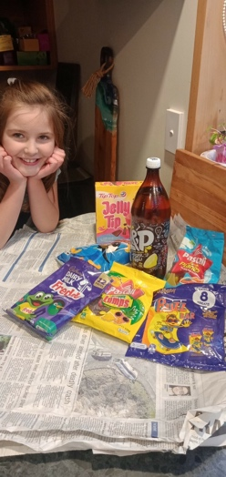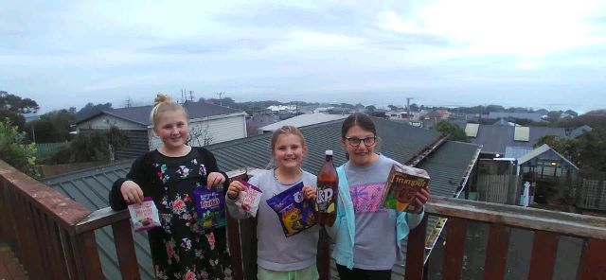
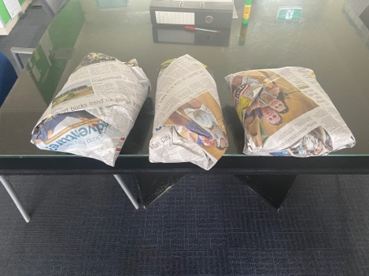
School Reports
Mid-Year reports will be emailed out today. We are having Parent-Teacher interviews in Week 2 of next Term. On-line bookings should be available as of today.

Sports Round-Up
Netball
Bravo Adelaide Conway on earning Player of the Day for the Big Rock Dolphins, top work Adelaide.
Congratulations to CC Walker on earning Player of the Day for the Big Rock Rockets in their 10-0 victory. This team is tracking very well. Well done to all of you.
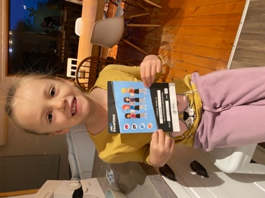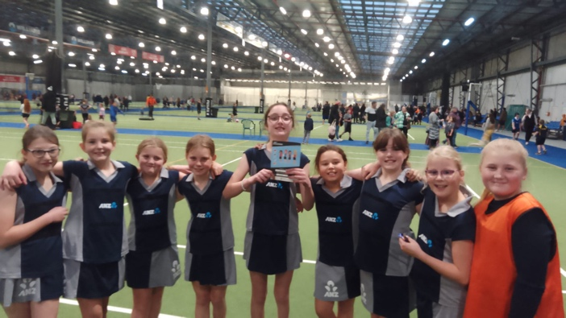
Basketball
Congratulations to Seth Elliot’ Tressler on earning MVP for the Big Rock Hoopsters in their 34-10 victory over Kaikorai Valley College.
Great work Bentley Marsh on earning MVP for the Big Rock Shooters in their game this week.
Well done Jasmine-Rose MacFarlane-Pearson on earning MVP for the Big Rock Coasters in their hard fought defeat against a very sharp Abbotsford team.
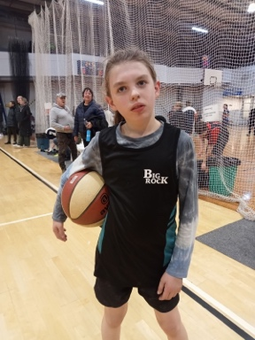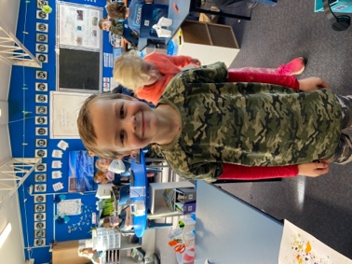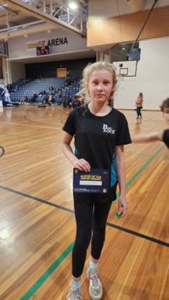
Rugby
Congratulations Greyson Farquar on earning Player of the Day for the mighty Seagulls. Equally well done Fletcher Graham on earning Player of the Day for his Seagulls team. Top work Elise Blanchard on being named Most Improved.
On the subject of rugby, well done Lexie Brown on earning Player of the Day for her Alhambra Brumbies team.
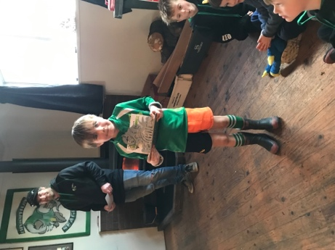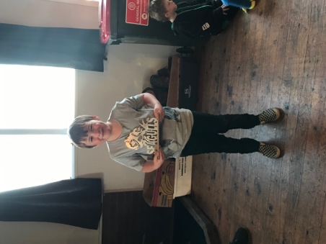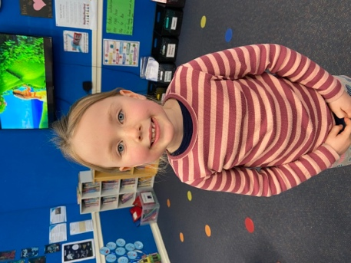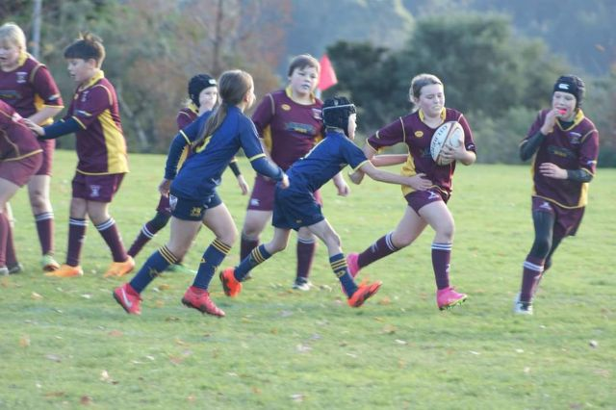
Gym and Gymkhana
Well done to Vienna Garth on achieving her Stage One Gymnastics badge. Great work Vienna.
Also well done to Lexie Brown on winning a handful of trophies at the recent Green Island Pony Club prize giving. Outstanding Lexie.
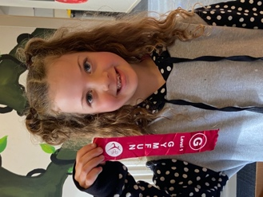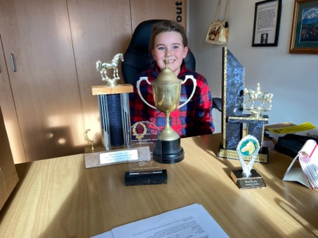
End of Term, Bring on the New Term!
Thank you to everyone for their support throughout the term, Term Two is always a challenging one, as we descend in to winter and the days get darker and colder. I couldn’t have been happier with the way our Aotearoa New Zealand Histories work went, obviously culminating in last weeks celebration. The classroom learning and work from the children has been excellent, and they are developing a deeper insight into our country’s history than I was ever offered at school. The class trips and adventures all proved beneficial and fun, not a bad combo.
The different bike groups are well underway, and next terms dates have been established.
Next term our major Topic Based Learning Focus is the Living World. The children will be exploring and learning about:
- Planting and Growing
- Ecosystems and Biomes
- Tracking and Trapping pests and predators
- Environmental Issues (Air pollution, Land pollution, Water pollution etc Climate Chane
- Food Chains and webs
Where possible we will be linking learning to our local environment with the different beaches, the Otokia Wetlands and even everyone’s backyard.
We have booked trips for every class to the Orokonui Ecosanctuary for end of the second week back and start of the first. However, as part of this we were (note were!) going to take the classes by bus. This is no longer possible as the cost for a buses is just under $1800.00, which is just too expensive for us. We will be working on a different plan.
At the end of next term we are also holding two tabloid athletics days for all of the children to be involved in.
Next Terms Key Dates (Thus far)
School Starts Back Monday 17th July
Advanced Mountain Bike Group Thursday 27th July
Orokonui Visits Friday 28th July and Monday 31st July
Year 7-8 Open Night Wednesday 9th August 6:00pm
TnT Mountain Bike group Friday 11th August
Intro MTB Group Tuesday 15th August
GGI Cross Country Friday 18th August
NZ Navy Band Friday 18th August
V R Underwater World (R 4 and 5) Wednesday 23rd August
Advanced MTB Thursday 24th August
Intro MTB Tuesday 5th September
TnT MTB Thursday 7th September
Tabloid Athletics 19th and 20th September
As you can see the dates are filling up quick. There will be more additions as the term progresses.
Aside from the bus disappointment, we are excited about next term, as well as looking forward to a wee break. Thank you everyone for continuing to support our school. Have an enjoyable break.
David Grant
Principal

