30/01/2025
Welcome Back
A massive welcome back to everyone and a massive welcome to our new children, their families and whanau.
I would like to welcome Livi Wells to Big Rock. Livi is a final year Teacher’s College student, and after having had a placement here in 2024, elected to come back for her final year. Livi will be based in Room Three and for all intents and purposes will be treated and act as a member of staff. Great to have you here Livi.

I hope that everyone had an enjoyable break over the festive season and beyond. Despite the weather, which does seem to be on the improve.
As I said on the Facebook and Skool Loop post, please keep a lookout for notices in paper form and via Facebook and Skool Loop. All information will be sent home via one or more of these methods, but it will always be sent.
Attendance Reporting
As of 2025 all schools must report attendance to them daily. In the morning and the afternoon. Please be advised that:
- The morning roll is taken before 9:10 and afternoon straight after lunch
- If we have not been advised of a child’s absence it will automatically be logged as Truant
- Lateness is also recorded via the new system, if children arrive after 9:10.
Our attendance has always been consistently very high, however that is not the case across the country and all schools have no choice but to be part of the new Attendance Reporting System.
Thank You
Firstly, I want to thank all of the staff, parents and whanau members who were able to come and help with our whitebait and burger stall at the Brighton Gala Day. Everything being sold out by just after 1:30, and we were busy from 9:30 cooking and selling. There was slight lull about 12:15, then we were away again with 3 bbqs in full flight.
Special thank you to Cavan Jenkinson for the wonderful Brighton Gold eggs, Jasmine and Clarke McNabb for the venison, Cass Morton-Lowe and Quality Bakers for the generous bread donation, Barkers of Geraldine for the range of sauces and the Brighton Club for your help. Your generosity is much appreciated.
I want to thank four of our Year 8 girls who put in a shift on the burgers, Meadow Hamilton, Esme Grey, Bella Yeoman and Lexie Brown, and Jed Grey for helping cook the whitebait.
While the obvious goal is to raise money at the gala day. It has always been important to us that we do so with a quality product at a good price. The feedback and level of sales suggest that we do that, which we are very happy with.
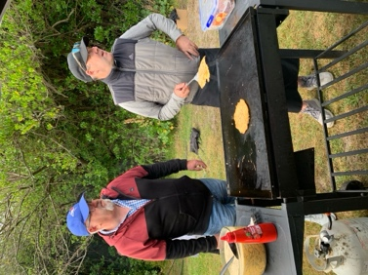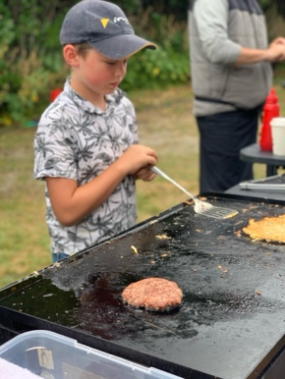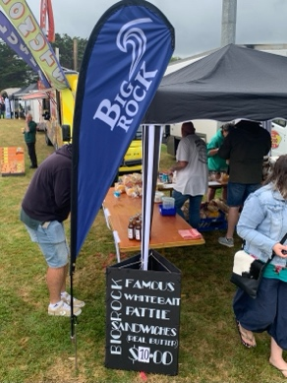
Meet the Teacher Meetings
Meet the teacher meetings are scheduled for Tuesday 11th and Wednesday 12th February. These meetings are a chance for the teachers to give an outline of expectations, the year ahead etc as well a chance for parents and whanau to ask any questions. Booking for these appointments will become available tomorrow via the Skool Loop app.
Skool Loop app
Can we please ask everyone to update the Skool Loop app on their phone. Many of you will need to update your child’s classroom. If you need any help or are unsure, please call in, we will be able to help.
Lost Property
We still have a considerable amount of lost property. On Monday it will be put out in front of the library. Please come and see if there is anything belonging to your child. After that, anything left will have to go to the clothing bin, we just don’t have the space.
Please see below for a list of dates for upcoming events:
- February 6th Waitangi Day School Closed
- February 11th and February 12th Meet the Teacher meetings
- February 20th Room Five class bike trip (Parent help required please)
- February 26th Room Four class bike trip Rail Trail. (Parent help required please)
- March 4th Room Three class bike trip Harbour Ride (Parent help required please)
- March 7th Year 5-8 Greater Green Island Triathlon
- March 11th Taieri Mouth Adventure (Whole school) (Parent help required please)
- March 18th Pet Day Extravaganza
- March 21st Otago Anniversary Day School Closed
- 2nd and 3rd April End of Season Pool Parties
It’s great to be back
David Grant
Principal

