3rd November 2023
End of Year and Prize Giving
School will finish at 1:00pm on Thursday 14th December at 1:00pm. After School Care finishes on Wednesday 13th December.
On Wednesday 13th December we will be having our end of year prize giving, it is scheduled for a 4:30 start. We are not sure of a venue yet as the hall is closed for use, for most of the term. I will keep you posted.
Can all school trophies please be returned to school asap. These are the two sports people of the year, Dux, The Arts, Boys and Girls Empathy Trophy, Mānakitanga, Citizenship and two futsal trophies. Individual futsal, netball and basketball trophies are keepers. Thanks
Room 1 and Room 2 Bike Day
On Monday I had a cracking day out with Room 1 and 2 on their bikes and scooters. The day started with a wee safety briefing and skills session here at school. That was just a chance to see what they could do, and they could do plenty. We then headed off to Malow Park (Dinosaur Park) to make the most of the great facilities there.
The children had lots of fun, I think, there was the odd crash and spill, as well as one riding without stabilisers for the first time. It was great to be a part of. The children were great, a bit of work to be done on road rules (Red means stop but apart from that, excellent.
These wee bike adventures with the younger children in the build-up to bigger bike adventures in latter years at Big Rock. They are also a key part of our Physical Education programme and MTB programme. I am hoping to have a positive announcement on that in the very near future.
Many thanks to Su Keen and all the parents for ensuring Monday was a success.
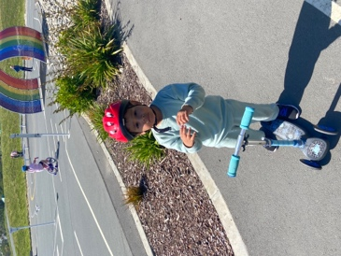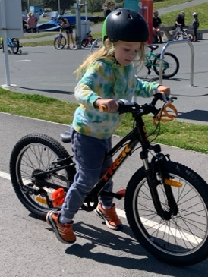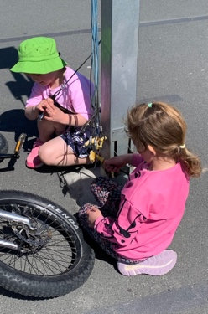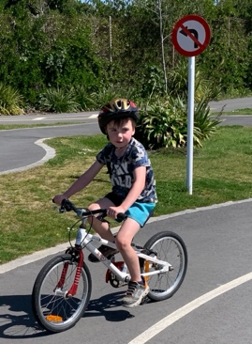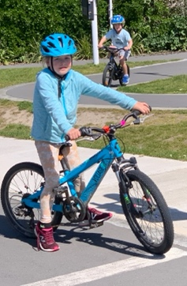

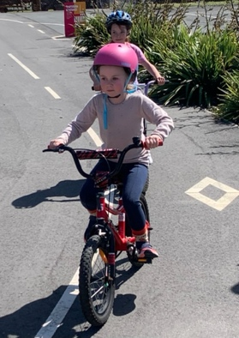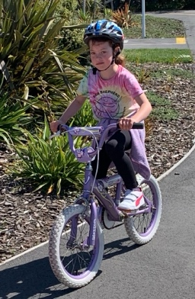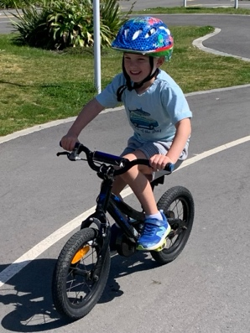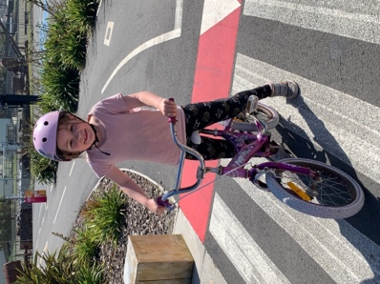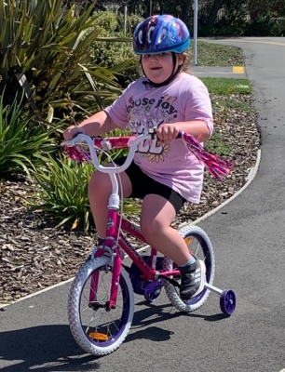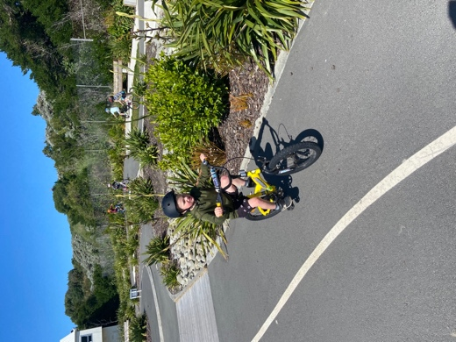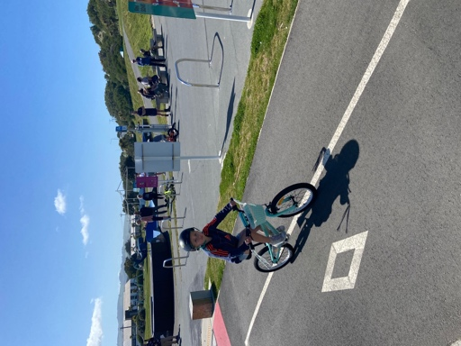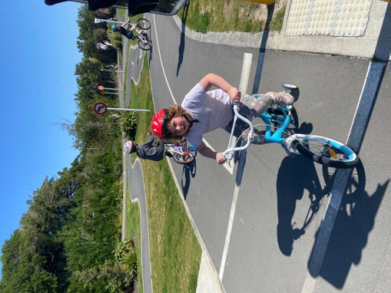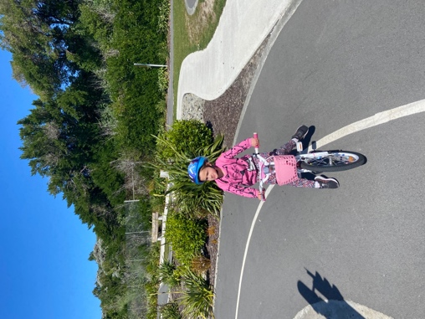
Futsal
Bravo to Rhys Shayler on earning Player of the Day for the Dolphins, top work Rhys! A shout out to Elise Blanchard for scoring the winning goal. Great stuff Dolphins.
Congratulations Adelaide Conway on earning Player of the Day for the Stingray. Keep it up Adelaide!
Well done to Pearl Mansfield on earning Player of the Day for the Barracuda. Second week in a row for Pearl. Brilliant Pearl, you are a star.
Congrats to Jed Grey on earning Player of the Day for the Marlin for saving three goals in the 5-3 victory. Keep that up Jed.
A great performance in a 4-0 victory saw Baily Jenkinson earn Player of the Day for the Big rock Orca. Top man Baily.
Last, but by no means least, well done to Troy Twinning on earning Player of The Day for the mighty Sharks in their 1-1 draw. Troy, you must have the best smile of any player of the day, ever
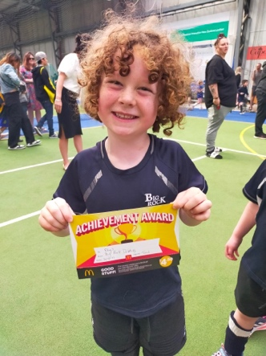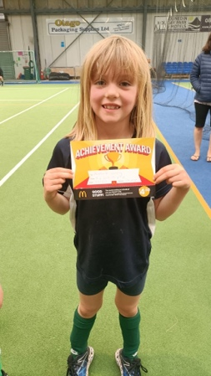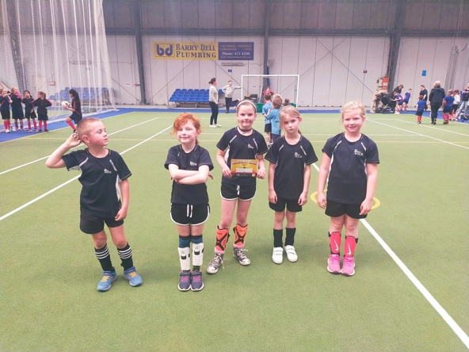
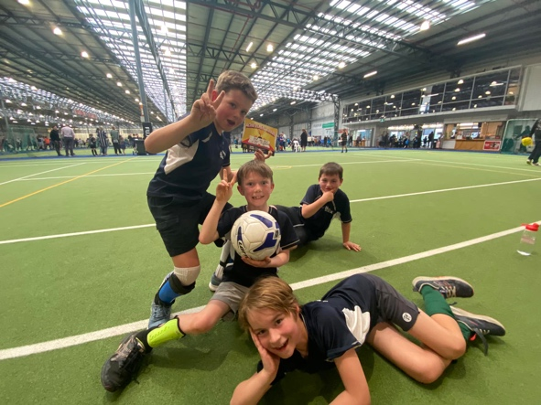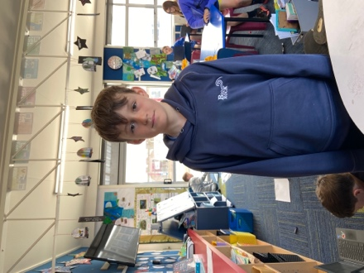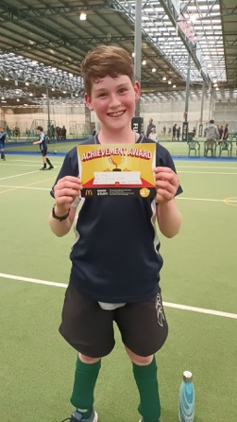
Congratulations
Well done to Libby Mooyman on earning the next stage certificate of Canine Training and Handling with her wee buddy Dexter. Top work Libby.
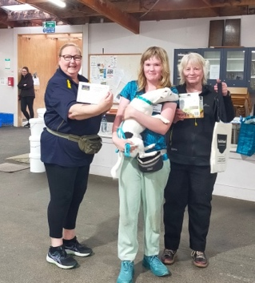
Dunedin Triathlon
As per my Facebook post yesterday, the school triathlon team of Malachi Turner, Leith Conway, Kade Hancock, George Weatherall put in an amazing effort, all competing in the individual event, a run, a bike and swim. It was pretty daunting as they were all in their first event, and up against children from most of the bi schools, including intermediates and colleges. All of our team finished in the top 20 for each age group. Leith Conway 6th (Year 5 Boys Individual) Malachi Turner 17th (Year 6 Boys Individual) Kade Hancock 9th (Year 6 Boys Individual), George Weatherall 5th (Year 7 Boys Individual) and drum roll please… Scarlett Hancock 3rd and a podium finish (Year 7 Girls Individual). Great work team.
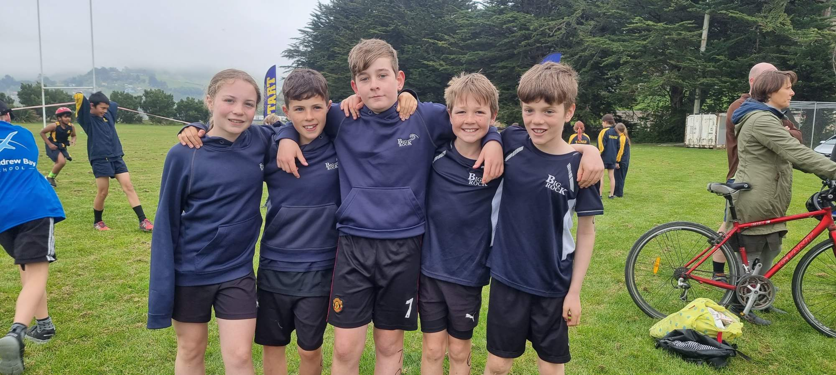
High Five Programme (Well-Being in Partnership with the Highlanders)
On Monday, Room 4 had a visit from Siale Tunoka as part of the High Five programme. This is a programme aimed at student well-being. The programme started in the classroom with a korero about the importance of well-being and then ended our session with some co-operative challenges and many opportunities to race around an awesome obstacle course. A magic start to the week.
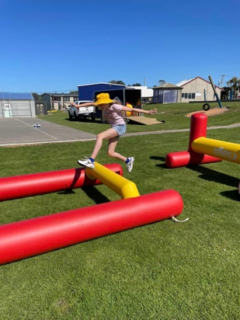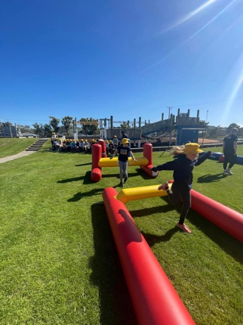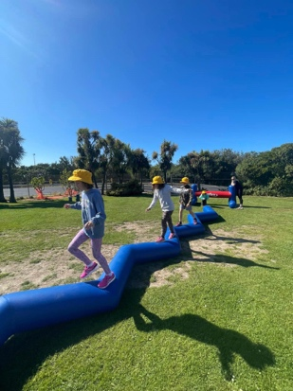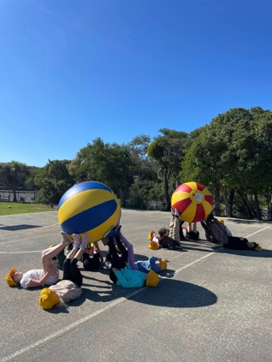
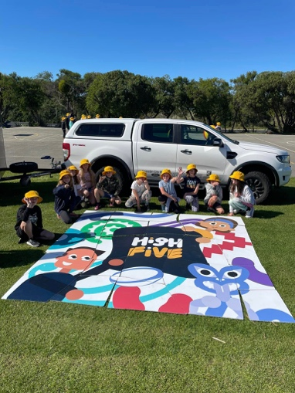
Swimming Pool
The swimming pool should be open next Thursday. We are just doing a final bit of tidying up and pre-season maintenance, including painting of changing rooms etc. Teachers will advise you of their swimming days. The children bring their swimming gear every day, just in case.
Pool keys will become available to the school families in mid to late November and community members in the first week of December.
Gumboot Day
We will be having a Gumboot Day fundraiser on Wednesday 29th November. We will be selling sausages for $2.00. All money collected will go directly to the I am Hope foundation. The people at I am Hope are making an incredible difference with their support for young people all over New Zealand. I have attached a link below with the I am Hope and Gumboot Day merchandise store, as another opportunity for people to support the programme.
https://store.iamhope.org.nz/
Have a great weekend.
David Grant
Principal

