2nd August 2024
Thank You
Thank you for all the very kind messages and supportive comments I received on ‘International Principal’s Day’. I have never heard of it and not sure that it should be a thing. To make anything work in a school it takes many people, and I have the privilege of working with amazing people everyday, children, teachers, parents, board members and wider community. As they say in rugby, it’s no good if you haven’t got the right cattle. While that sounds a bit disparaging, I hope you know what I mean. Anyway, thank you, very humbling and a bit embarrassing.
School Closures due to Weather
In the event that school has to close or have a delayed start due to weather. Things like snow, icy road conditions or even extreme rain. I will put the message out on Skool Loop and the school Facebook page as soon as I know. As you know, the weather in wider school community is often better than it is town and Mosgiel, and sometimes it may be that staff cannot get to work safely.
If you are ever in any doubt, please send me a text on 021 2134316.
Congratulations
Congratulations to George Weatherall on earning Player of the Day for the Big Rock Hoopsters win over Arthur Street. Last week it was Beau Mansfield who ran hot, this week it was George’s turn to shoot the lights out. Full credit to the team for working hard as a team to get him the ball and create space. (That is from the coach not me)
Sadly, the high-flying Hurricanes did not have a game this week due to opposition defaulting.
Bravo to Korbyn Parata-Walters on earning Player of the Day for the Big Rock Coasters. Great passing Korbyn.
Well done to Leon Skerratt on earning Player of the Day for the Big Rock Shooters in their victory. Top work Leon.
A fantastic all-round game saw Baily Jenkinson earn Player of the Day for his Green Island football team. Great stuff.
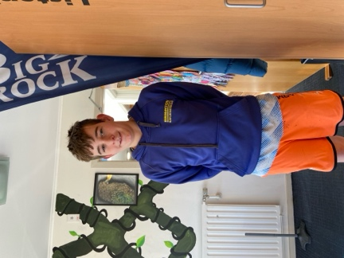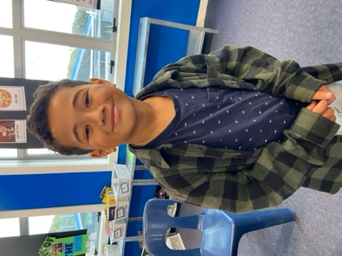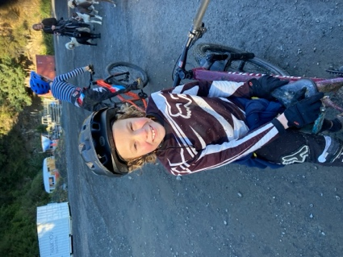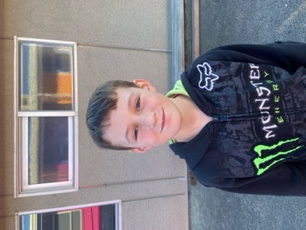
Former Staff
Yesterday when I was at the pool with some of our senior students, we had the pleasure of bumping into former staff member Holly Robinson. Holly had just finished a training session, before she heads off to Paris for the Para Olympics. Holly is competing in the shot put and the javelin. Holly is the current Olympic champion, winning gold at Tokyo in 2020. Sadly, at the time with Covid restrictions they were unable to have the normal medal ceremony. After the 2020 Olympics Holly came out to visit us, with her medal and we had a proper ceremony for her. Flag, national anthem, the works. Holly has promised to come out again after the Paris games.
Some photos from four years ago.
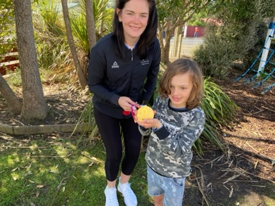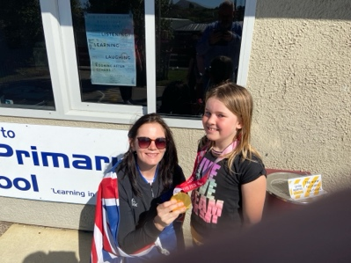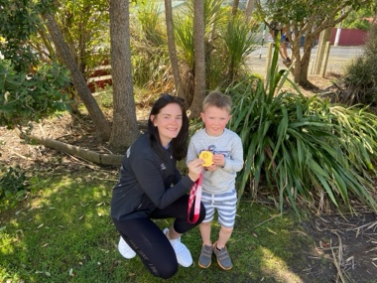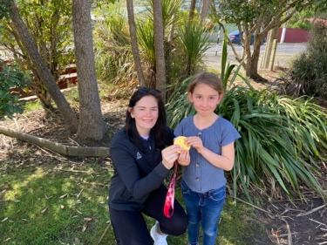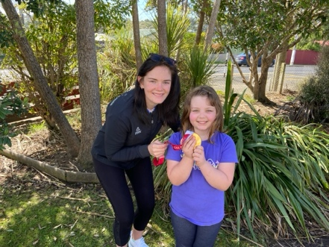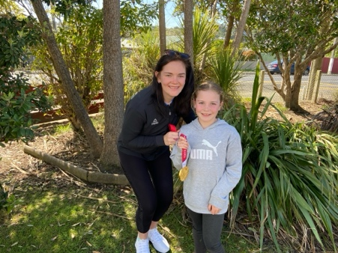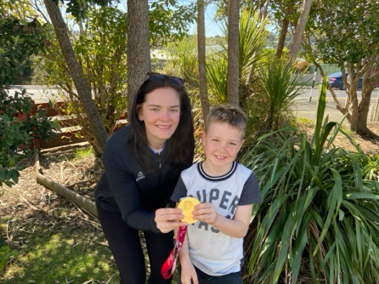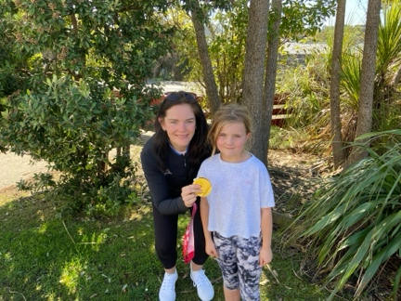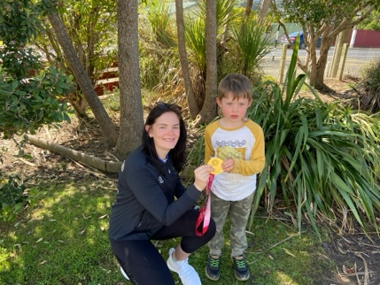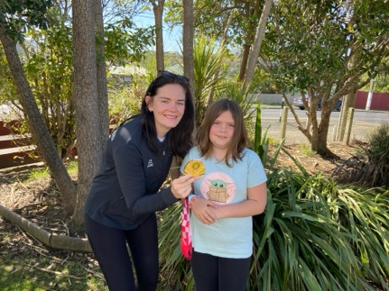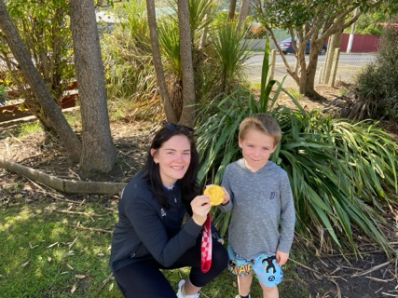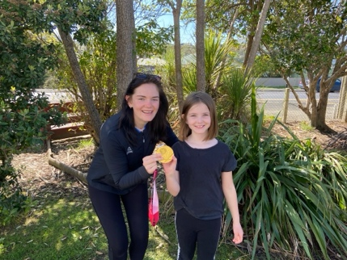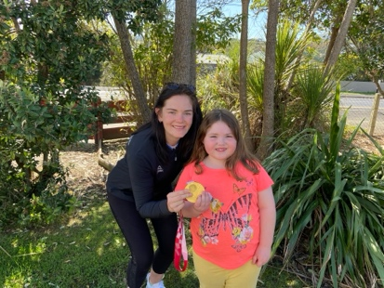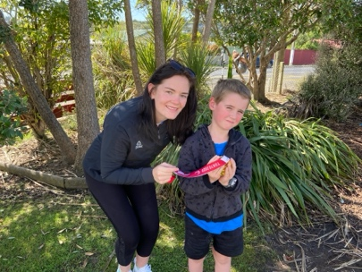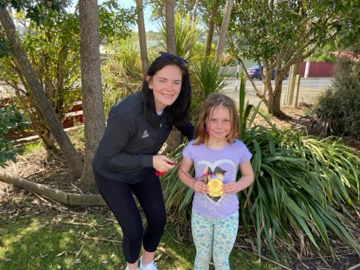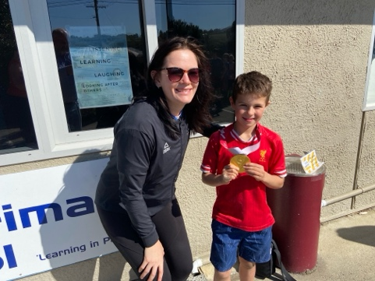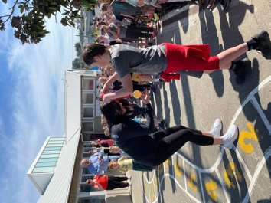
GOOD LUCK HOLLY
AA, NZ Police and the DCC
Earlier today we had a very exciting event happening at school. A partnership between the DCC, AA and NZ Police are trialling a road safety campaign around bike safety on our roads. As part of the programme front and rear bike lights are provided, that can be fitted on bikes and helmets, they require no batteries as they are charged with USB. The trial has been running in Canterbury. We are the first school in Otago to be part of it, which is pretty exciting, and ties in beautifully with all of our biking programmes.
All the children who were able to bring a bike to school today were gifted a light kit, a new bell and fluro bag cover.
Many thanks to Dallas Hamilton and Malcolm Budd of the AA, Ross Greer of the NZ Police, Aukje van Aalst of the DCC and Scott Weatherall representing the Community Board.
They gave me extra bike lights, which are available to children who require them. Regrettably, once I run out, I run out. They will be available on Monday. Please only come and get one if your child needs one.
Keep an eye on the ODT tomorrow, for the full story, photos, as well as video interviews with myself and Scott Weatherall. (As usual I forgot to take decent photos.)
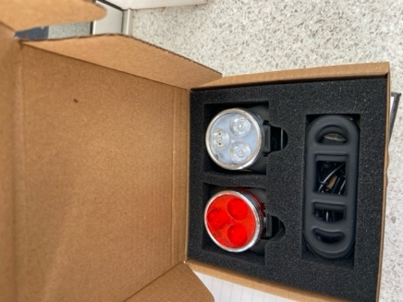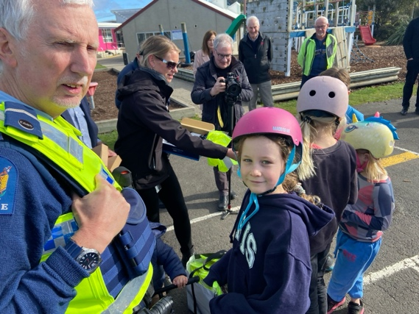
Have a great weekend
David Grant
Principal

Quick Update from the Board Table,

Hi All,

It has been a few newsletters since the Board of Trustees provided an update – but rest assured, we are alive and active. We continue to meet, discuss, and strive to support the governance of the school to the best of our abilities. With a diverse mix of skills, backgrounds, and perspectives among the parents and staff on the Board of Trustees, we ensure robust discussions and decisions that prioritise the well-being of our students and staff.

In addition to our ongoing review of policies and procedures (trust me, it's as exciting as it sounds), today's discussions included an important conversation on Health & Safety,
specifically regarding Education Outside the Classroom activities.

From beach walks and cross-country runs to museum trips and more adventurous activities like mountain biking, open water swimming, surfing, kayaking, and camps, we discussed the Board's role in ensuring thorough planning, adequate resources, and well-trained supervisors.

Under the Health, Safety, and Workplace Act, we have a significant responsibility in this regard.

Further considerations regarding Health & Safety encompass the school buildings, property, playground, pool, and infrastructure. As a responsible employer, we are significantly mindful of the physical, verbal, and psychological well-being of our staff and students. Instances of abusive behaviour towards our staff by parents are extremely rare but are deeply concerning and will not be tolerated. Should such behaviour persist, parents (and their support persons) will be summoned to a meeting, and disciplinary actions may follow, potentially including trespassing from school premises.

While this may seem intense, it underscores our commitment to the well-being of our staff and students.

Please feel free to reach out to me anytime,

Scott Weatherall
Chairperson, Big Rock Primary School
Phone: 027 4404 700

