Good afternoon Big Rock families/whānau.
We have come to the end of the first term for 2026 and what a term it has been! Beach Days, Pet Days, Pool Parties and surfing. As well as setting up classroom routines and programmes.
So far next term we have Harold visiting, bike trips for Rm 5, 4 and 3, wheels day and TNT Mountain bike trips.
The staff at Big Rock would like to wish everyone a safe and happy Easter and enjoy the holidays.

Upcoming Events
First day fo Term 2 – Monday 20th April
ANZAC Day school closed – Monday 27th April
BOT Meeting – Tuesday 5th May
Life Education – 6th, 7th, 8th May
Assembly – Wednesday 20th May
King’s Birthday school closed – Monday 1st June
BOT Meeting – Tuesday 9th June
Last Day of Term 2 – Friday 3rd July

Sports Roundup
Players of the Day
Big Rock Stingrays Big Rock Orcas Big Rock Dolphins Big Rock Sharks

Everyone! Greyson Farquhar and Kolton Haggerty-Walker Ari Gilbert and Evie Hollands. Everyone!

Congratulations to Zach Turner who picked up the Player of the Season for Green Island Junior Cricket.
Zach’s team also won the Most Successful Team award. They only lost one game all season!


2026 Season Brighton Rugby Club Registration
Registration is now open for the 2026 junior rugby season. First game is 9th May 2026.
This year will be easier as you will have entered your child's information last year, and that will carry over to this year's process.
If you go to https://xplorer.
rugby/ and log in with your credentials, it will then allow you to choose your child to start the registration process. It's pretty easy, very much a follow your nose situation. You can search for us using the club's postcode as well if you'd like to, which is 9035.
The one thing that will throw you is that it asks you to pay at the end. Oddly, you can safely click to pay, and it will complete the registration, and tell you that you've chosen to pay directly to the club. I don't know why it's like this, but I've tested it and it won't charge you.
If you want to know anything about the local club please email info@brightonrugby.co.nz

Listenting Laughing Learning Looking After Others
Some Big Rock students who were ‘caught’ displaying our school values this week were –
Oakley Morton-Lowe – having a go and stepping out of his comfort zone.
Asti O’Brien – focusing on her work and producing excellent handwriting.
Adelaide Conway – being a team player.

Reminders
After School Care
Bookings or cancellations for After School Care can be made by texting
021 082 50863 or by emailing asc@bigrock.school.nz.

Absences
Thank you for getting your absences and late notifications in before 8.50am on Skool Loop.
It saves us a lot of time if we don’t have to chase these up.

Office Hours
Monday and Wednesday – 8.45am – 3.15pm
Tuesday, Thursday and Friday – 8.45am – 12.15pm
Please note that if your call goes to the answer phone, leave a message. Staff may not be able to answer the phone at that time but will check the machine as soon as they can.

Sushi
Sushi is available for lunch on a Wednesday. You can order this by using the Kindo/Ezlunch app.

Lunch Orders
These can be made at the shop on a Friday or dropped at the school office before 9.00am.

Stepped Attendence Responce Regulations from the Ministry of Education and what they mean.
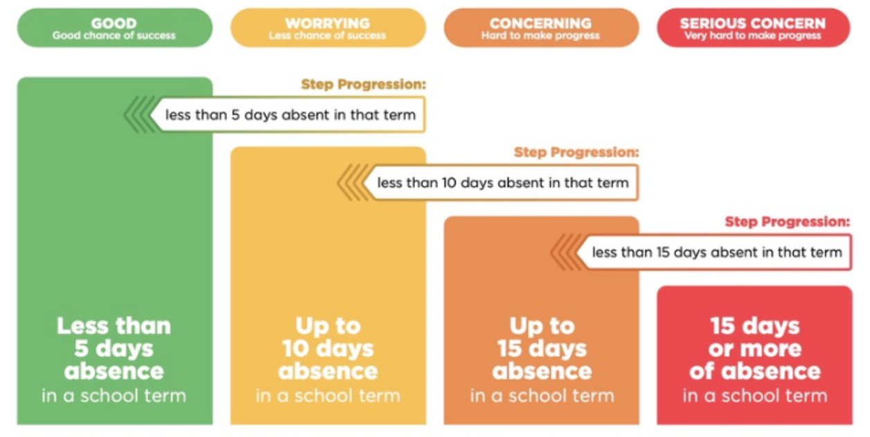

If you have any questions, please contact us.
Lisa Lamb
Acting Principal
actingprincipal@bigrock.school.nz

