30th August 2024
Signing In and Signing Out
We have a new signing in and out tool in the foyer. If your child is late on arrival for whatever reason, be it the doctor, dentist, or just one of those mornings that we all have from time to time. Can you please sign them on arrival with iPad in the foyer. Can we please ask that you do the same if you are picking your child up early. This links directly to our school and class administration systems and let’s teachers etc know where everyone is. Thank you.
Biking at Big Rock
As you may be aware, the school has a comprehensive Mountain Biking/Biking programme. Without bragging and just sticking to the facts, it is easy one of the best in the country. It offers great experiences with highly skilled and enthusiastic leaders and staff. We also have a good supply of mountain bikes and helmets when needed as well as specialty bike trailers. On Tuesday we added to the stock with a new trailer. Many thanks to Kelly in the office for doing all the arranging and purchasing and thank you to Shane Turner for picking it up and getting it registered and warranted. The funds came from the Tu Manawa Fund grant we received at the end of 2023.
On Tuesday the TnT Group had a blast at Redwoods with Scott Weatherall and Angie Hancock, ably supported by Alex Ramsay. Many thanks to you all.
Yesterday, another 18 riders (predominantly Year 2-4) joined the Introductory programme, which focuses on basic skills, safety and bike fitness.
I can’t stress enough how valuable this programme is to self-esteem and how crosses over into other areas of learning and development.
Our Vision at Big Rock Primary School is to create happy, independent, resilient lifelong learners with inquiring minds by providing all of our students with rock solid foundations in Numeracy and Literacy.
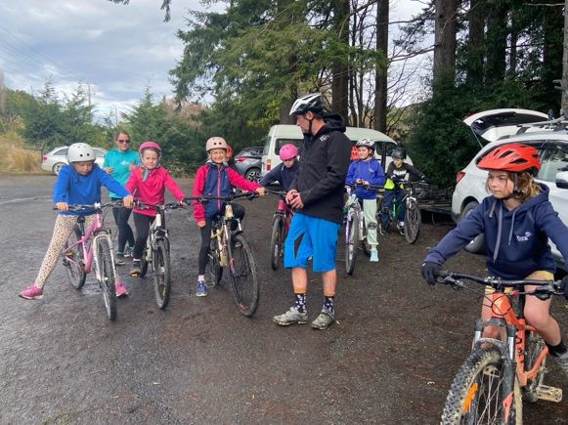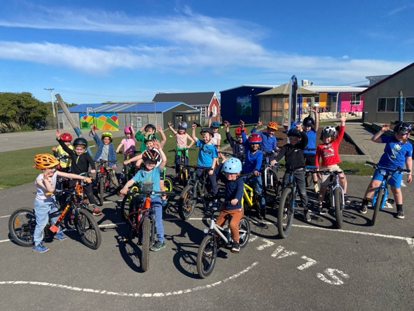

Congratulations
Congratulations to Courtney McNair who won the Fairplay Player of the Month for her Green Island Emerald’s football team for ‘Great play and sportsmanship every week’. Great stuff Courtney.
Also well done to rising Big Rock rugby star, Year seven Lexie Brown, who got to lead the Otago Spirit out at the weekend and play in an exhibition game at half-time. Great stuff.
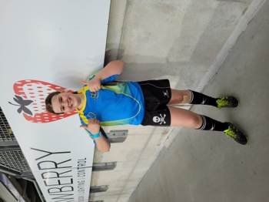
Futsal
Thank you to everyone who has signed up for futsal next term. Please keep the registrations coming in. Also, please let us know if you are keen to help coach/manage a team.
Art Extravaganza
Work in the classes is well underway to putting on an incredible show for all our whanau and any curious community members.
The work on show will feature a range of different artists and techniques and we are confident that you will enjoy it.
The Art Extravaganza is on Wednesday 25th September from 4:00pm until 6:30pm. Doors will be open again the following day from 10:00am until 1:00pm.
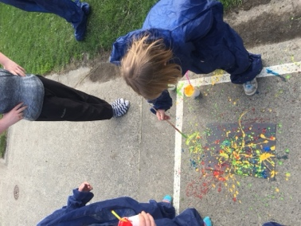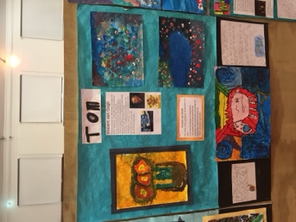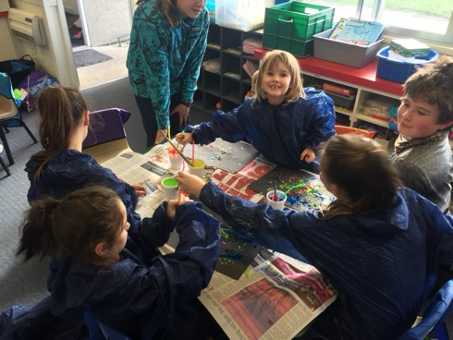
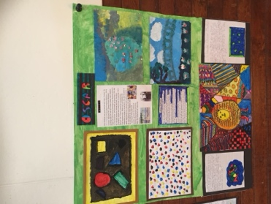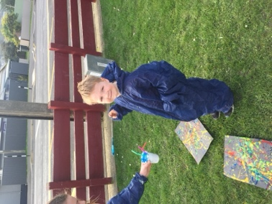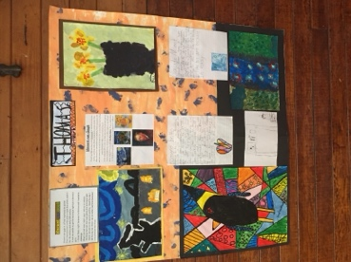
Art and artists from a few years back
Have a great weekend

