28th November 2025
Out and About
It has been a very busy week with four classes out and about.
Earlier today Room’s One and Two headed off on their Big Day Out. At 9:00 sharp(ish) they trooped onto the bus and headed with smiles like Christmas morning.
First stop was the movies in town. They watched Zootopia 2, I have no idea what that means but I am sure that they all enjoyed it. After that they were back on the bus and off to lunch in Green Island. After lunch they headed to Te Puna o Whakaehu for a swim in Mosgiel. I had a flying visit, and I witnessed a lot of smiling, happy children.
Many thanks to the parents who joined the adventure, James Gilbert, Mon Wilson, Stacy Smeaton, Brenda Nicolaou, Blair Judd, Lewis Worth and Amanda Pfyl.
Bih thank you to Lisa Lamb, Su Keen and Kara Walters for your work in making it happen.
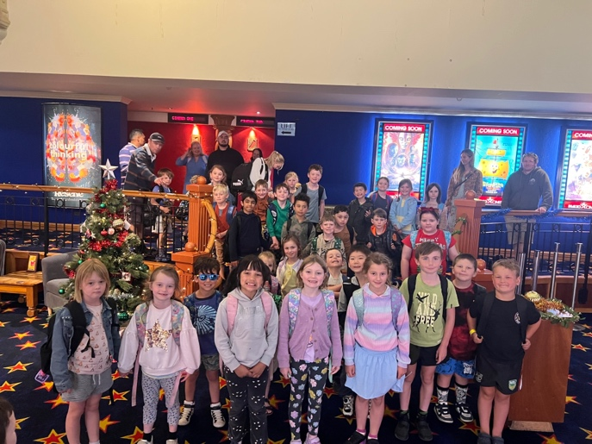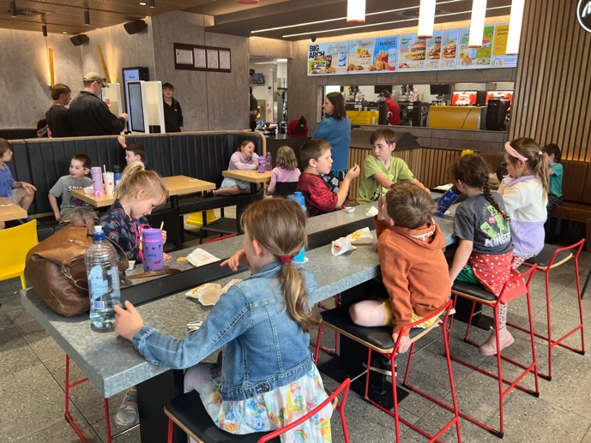
On Monday morning Room Three headed off to Tirohanga in North Taieri for the camp, and for many their first school camp experience.
On Tuesday, Room Four headed off to Berwick Lodge for their end of year camp.
Today Room’s One and Two have their Big Day Out.
Firstly, Teresa Grant, Room Three (Year 3-4) and a big team of parents excitedly packed up their mountain of gear and travelled to Tirohanga for their school camp adventure. While at camp they took part in a range of fun, age-based activities and experiences. Some of these included:
- Frisbee Golf
- Solar ovens
- Confidence Course and climbing wall
- Slip n Slide waterslide
- Bonfire with marshmallows
- Gaga Ball
- Raft Building
- Pizza making
- Scavenger Hunt
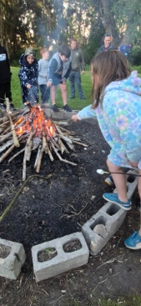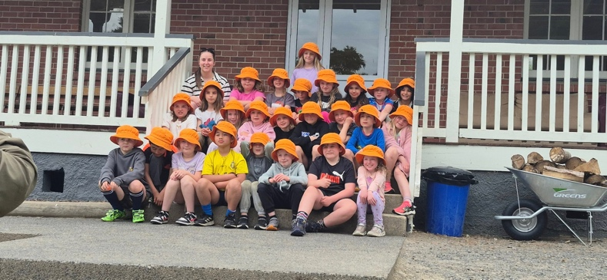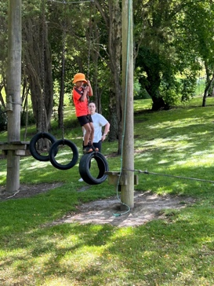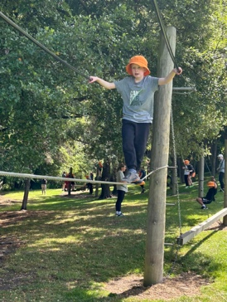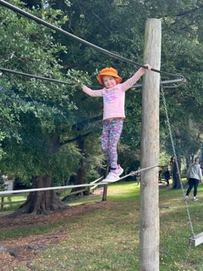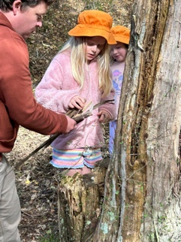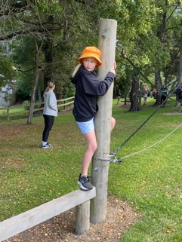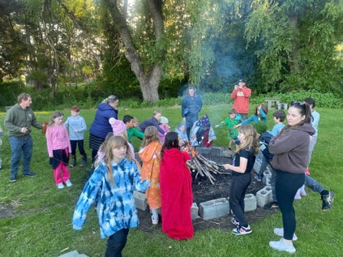
As you can see an action-packed adventure and an excellent introduction to school camp, so that they are ready as the progress through the school.
A massive thank you to all the children for their wonderful attitude and effort, thank you to all the parents for your help and support. Lastly a massive thank you to Teresa for all your hard work in planning and running, we know how much effort it takes.
Also on Monday morning, I had the pleasure of tagging along with Jude van Aalst and Room Four as they packed up and drove out to Berwick Lodge for their end of year camp. It was also an action packed few days with a wide range of activities and experiences that challenged the adventurers physically and mentally. To add to the challenge, it became extremely warm, probably too warm, especially the last day. The Room four adventurers enjoyed (some more than others):
- Confidence Course
- Shelter Building and the dreaded bucket test
- Flying Fox
- Kayaking
- Raft Building
- Radio Orienteering
- Archery
- Downhill push-carts
- Crazy Rope Swing
- Solved a crime in the sweltering heat.
A huge thank you to Fiona Skerratt, Kerri King, Wouter Verhoef, Colin Driver, Sasha Turner, Sarah Ramsay, Sally Scott and Tania McIlroy for all your help with transport, cooking (and cleaning) and on the activities, running and encouraging the adventurers. Congratulations to all the children for their effort, endeavour, behaviour and encouragement of each other. As I said to all the adventurers at the start of day two ‘Fear knocks at the door- you courage will answer at there will be no-one there!’ and you proved me to be correct.
Lastly, thank you to Jude van Aalst for all your hard work in planning, booking and running, excellent stuff, thank you.
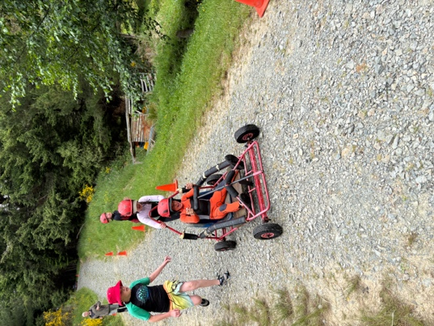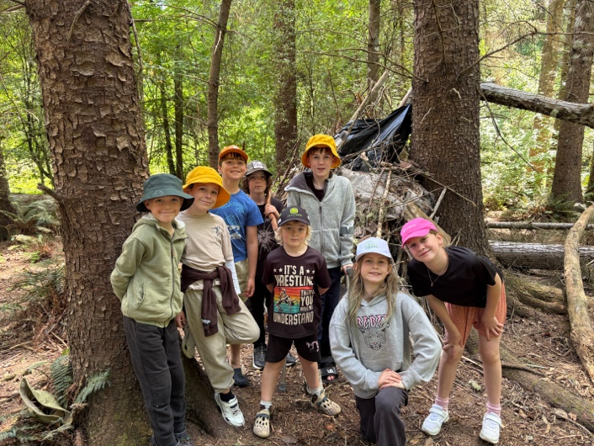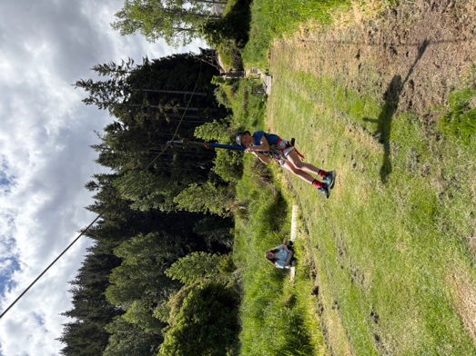
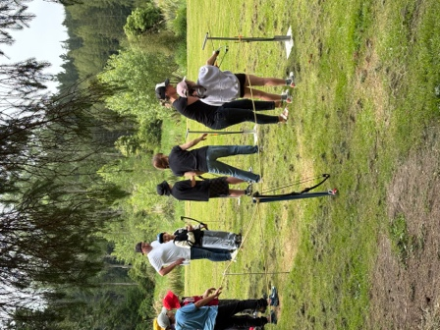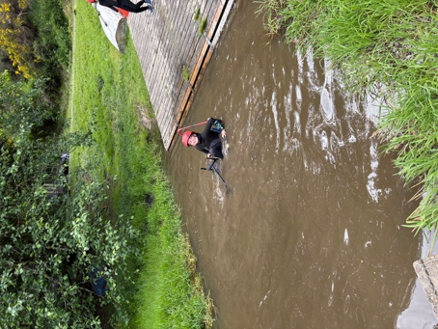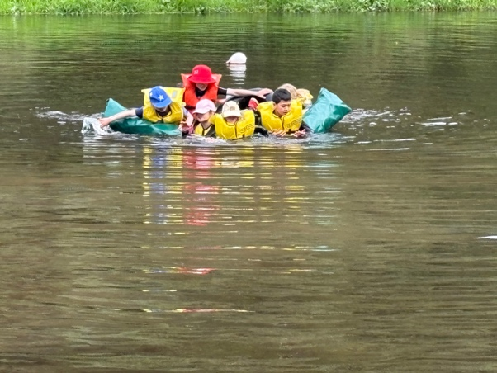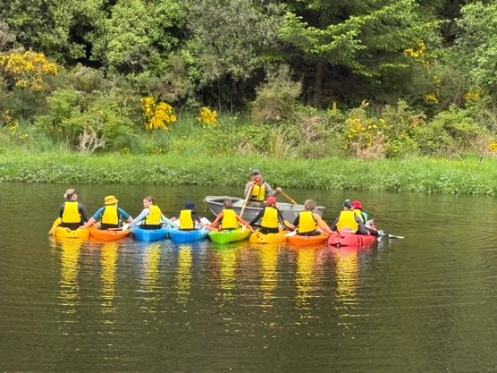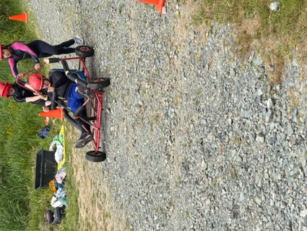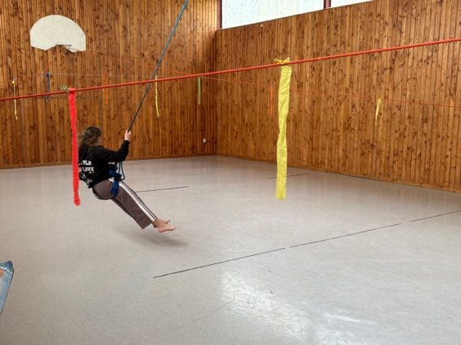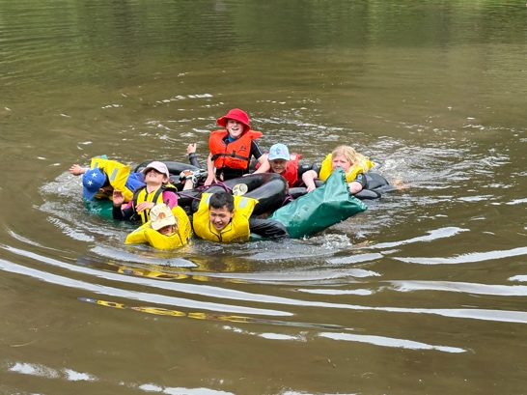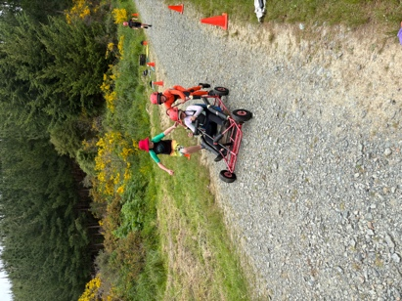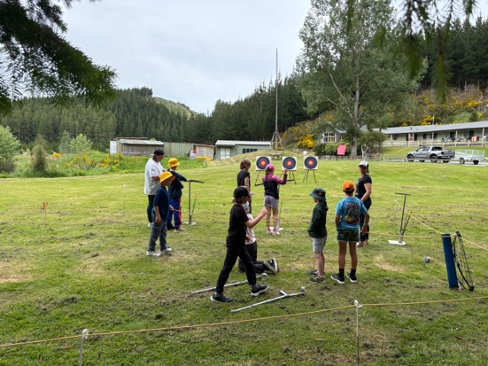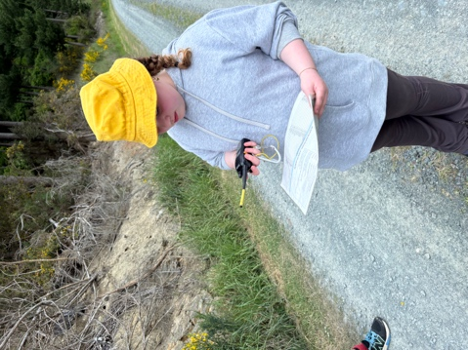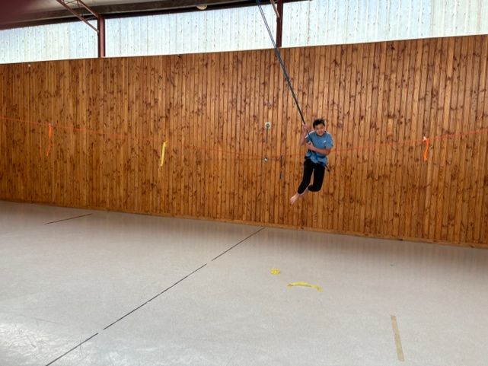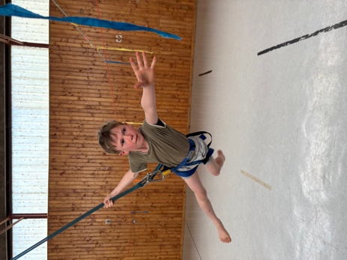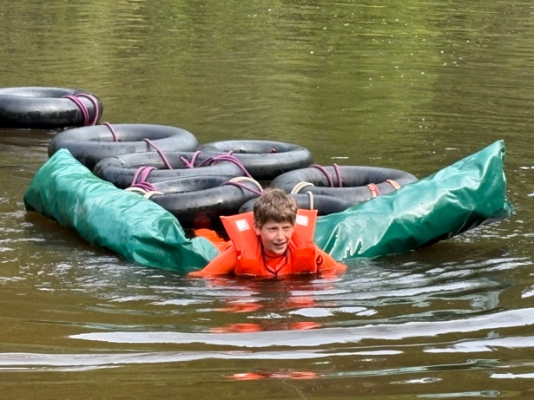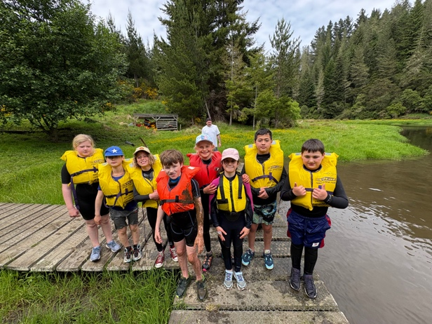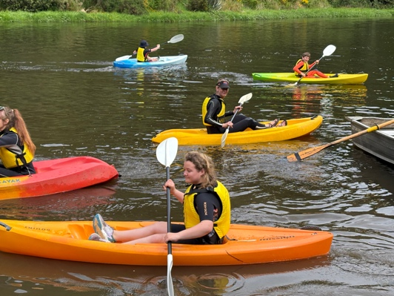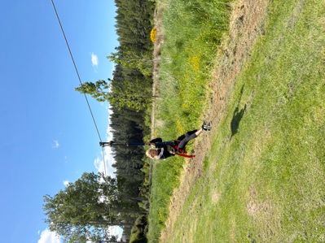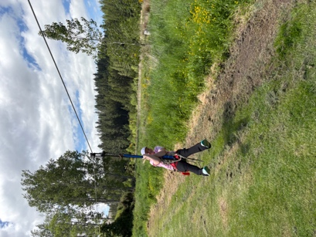
Room Five have their last EOTC adventure for the year next week, when they have Survivor Camp, where they have to ‘Survive’ in the bush for 24 hours. They plan their accommodation (tents), provide their own food and cook over open fires. It is very unique to Big Rock and always a great experience.
Swimming Pool
With the warm/hot weather this week you realise very quickly how lucky we are to have the pool. While it is great for swimming etc it is magnificent on those really warm days, where the children are hot, bothered and can get quite irritable (Can’t we all?). Having the pool as another option in the playground at lunchtimes acts as not only a leisure activity but a chance to freshen up.
Thank you, Kerry Turner for all your work in getting it up and running, along with Mike Smeaton and Jeff Chesney. The children and staff are very appreciative.

Thank You
Thank you to Colin Driver and Craig Scott for repairing a much-loved part of the playground. I’m not sure what it’s called, it is the standy uppy spinning round thing! Any way Colin and Craig repaired it and pleased the children and saved us money. Perfect!
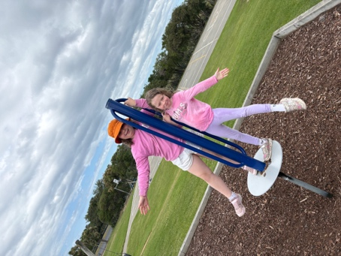
Futsal
Congratulations to the following players on earning Player of the Day for their respective teams.
Big Rock Dolphins – Leo de Thierry
Big Rock Orca --- Stella Brown
Big Rock Stingray --- Josh de Thierry
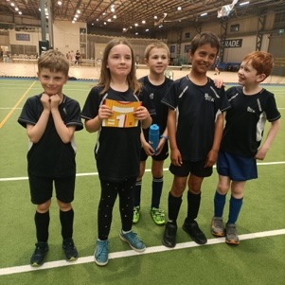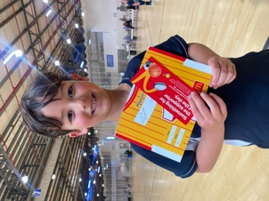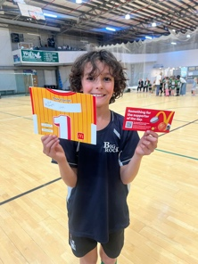
End of Year Prizegiving
Our End of Year Prizegiving is on Tuesday 9th December at the Brighton Hall, starting at 4:15 pm sharp. Children who are in After School Care will be taken along to the Brighton Hall.
At the prizegiving there will be:
- Children singing
- A performance from the school band (With a few cameos)
- Principal address
- Sports awards
- Class awards
- Principal Awards
- Community awards
- School Awards
- Farewells
School Closes for 2025
Big Rock Primary School closes at 1:30 on Friday 12th December. There is no After School Care on this day.
After School Care finishes on Thursday 11th December.
School Starts Back – 2026
Big Rock will reopen on Thursday 29th January. There will be two Teacher Only days on Tuesday 27th and Wednesday 28th. (Better than having them during term time)
Have a great weekend
David Grant
Principal

