28th March 2025
Welcome
On behalf of us all, I would like to offer a massive Big Rock welcome to Ari Isaksson who joined Room One this week. It is great to have you, and your family join Big Rock.
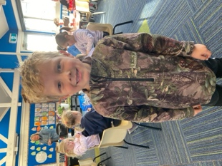
Congratulations
First of all I would like to offer my congratulations to the following players on earning Player of the Day for their respective futsal teams.
Big Rock Stingray- Rhys Shayler
Big Rock Barracuda- Zachary Neilsen
Big Rock Sharks- Fin Ramsay
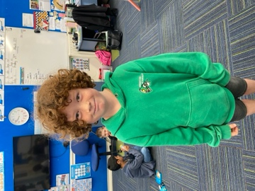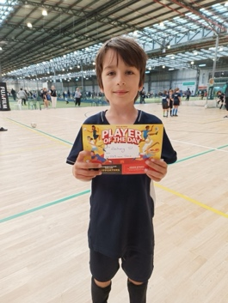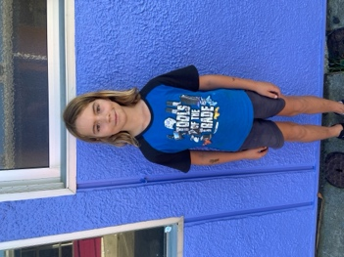
Bravo Greyson Farquhar, who at the Otago Athletics Children’s Championships at the weekend won the Vortex and finished 2nd in shot put and 3rd in the discus. Great work Greyson (0639)
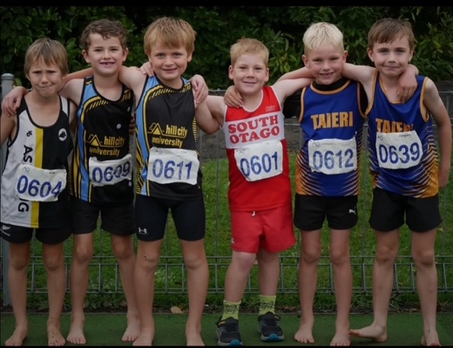
On Tuesday we had the Greater Green Island Triathlon at Memorial Park and Te Puna o Whakaehu in Mosgiel. It was a challenging run and bike on the wet Memorial Park. Our team represented themselves and school with great pride. Well done to the whole team, for many it was their first event of this nature and there were a few nerves. Special congratulations to Jaxon Skerratt 1st place individual (Year 5), Kade Hancock and Malachi Turner 2nd = (Senior Boys Individual), Aliza Johnston, Annabel Free, Kaylyn TeNgahue 2nd (Year 6 Girls team), Bella Yeoman, Meadow Hamilton, Malaika Patton and Lexie Brown, 2nd Place (Senior Girls team). I was impressed, not only with the effort but how they cheered and encouraged each other. Well done team.
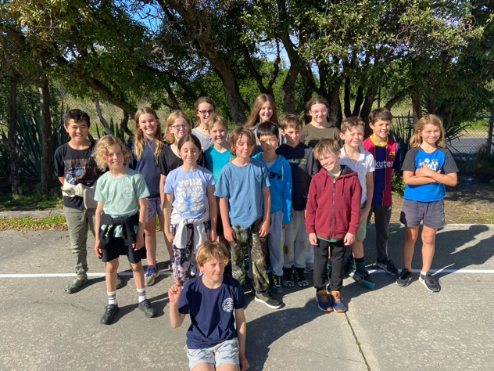
Basketball and Netball
Thank you to everyone who has registered for netball and basketball. We have three basketball teams and one netball team. There is capacity for a junior netball team (Room 1 and 2) but we need a few more players please. Team information will come out next week. If you are keen on coaching or managing a team, can you please let me know asap.
School Accounts
There is a lot in the media at the moment about back to school costs, things like uniforms, stationery, chromebooks, fees, laptops etc.
One thing I am really proud of is that we are able to provide all of that (except uniforms) for $60 as well as replacing stationery when need be. Also that the vast majority of our trips at no cost to our families. Education is for everybody not only for those who can afford it. The Board need to be acknowledged on this as well.
Blast from the Past
Earlier this morning I received a couple of photos from ten years ago of the Big Rock Rockets T-Ball team. That year the Rockets won the competition, undefeated and also won team of the year. The team was (From Left to right) CJ Edwards, George Grant, Liam Jackson, Kate Buchan, Jack Yeoman, Jack Coatsworth, Regan Buchan, Pipa Mooyman, Kamyn Hale-Pauley, Matilda Alcock and Rosie Maley. The team was undefeated for 3 years (6 seasons). 2 of the team went on to represent NZ in different sports (age group) as did two other team members, Breane and Cody Byck.
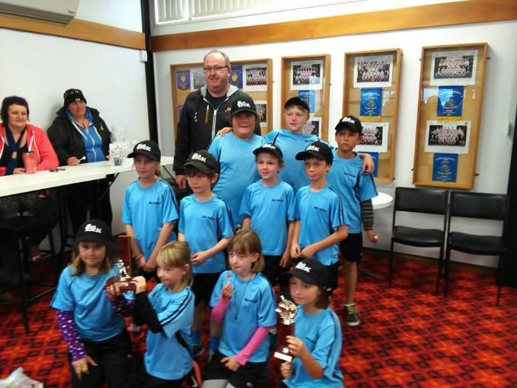
Brighton Rugby Club
The Brighton Rugby Club is having its registration day for the upcoming 2025 Junior Season on Saturday March 29th, from 10:00am to noon, at the clubrooms at The Domain.
This is for both new and returning players, and kit will be handed out at this time as well.
If you have any questions, email them at info@brightonrugby.co.nz or ask via their Facebook page.
Go Seagulls!
We had a visit from Hamish Graham from Brighton Rugby Club and Rooms Two and Three had the opportunity to enjoy some Rippa Rugby.
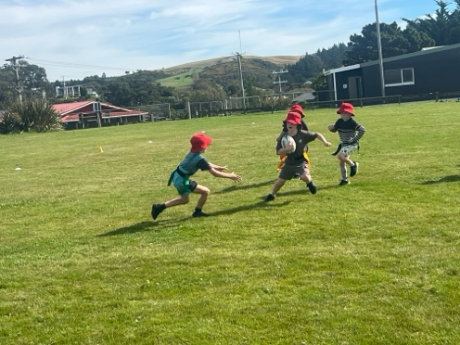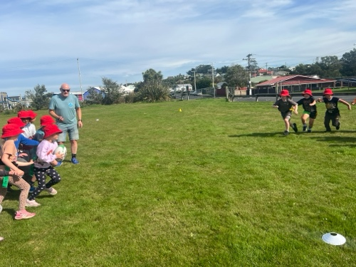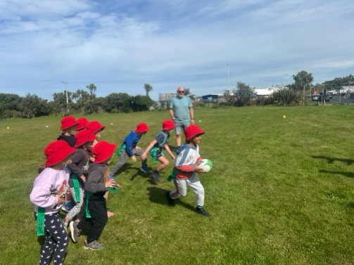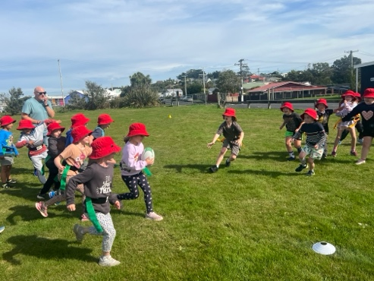
Brighton Trail Ride
Thank you to everyone who has kindly volunteered to help with this amazing fundraising opportunity and event. The event itself is on next Saturday. If you haven’t put your name down yet to help out, but would like to, please get in touch with Aaron Hollands on 021 195 5885 or me on 021 2134316. There is also a meeting for all volunteers at the Brighton Rugby Club at 6pm on Thursday 3rd April. We do need all volunteers there then please, so that we can provide more details on the roles people will have.
All of the funds that the school raises (our cut if you like) will be going towards pool upgrade and maintenance.


Next Week
On Monday -Wednesday, all of the classes will be involved with the Life Education Trust mobile classroom and Harold the Giraffe.
Also next week, we will be visited by Hungerball. This a sort of combination of a sports field and a bouncy castle. All of our classes will also get to have a go at this on Tuesday and Wednesday. Thank you to Annette Hogg for organising this for us.
Two very different learning experiences for the children.
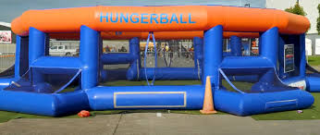
Have a great weekend

David Grant
Principal

