28th June 2024
Thank You
Further to our Facebook post yesterday, thank you to everyone who was able to attend and celebrate the children’s learning, Matariki, and the wonderful community you live in and we have the pleasure of working in.
Firstly, thank you to all of the children for their hard work and allowing it to be shared, thank you to the staff for continuing to inspire the children to producing great work, creatively presented, all on top of writing reports and assessing and compiling data. I couldn’t of been prouder. Thank you to all of our families and whanau for the amazing food, you stun me every year, thank you to Cass Morton-Lowe and Quality Bakers for helping us out with the bread, thank you to Richard, Shane Scott, Thomas and George on the bbq, thank you to Richard, Kara and Room Five for the set -up and clean-up, thank you to Kade, Esme, Bella and George for the whitebait. Thank you to Atiana Reihana for the beautiful karakia, I know you were nervous but no-one would have known, stunning.
Lastly, as an event I am really proud of the way the school community comes together and ensures our celebration is authentic and genuine.
Crikey, I almost forgot, Josh de Thierry, Lewis Vorgers and the Jackson/Big Rock 5, for their impromptu dance routine
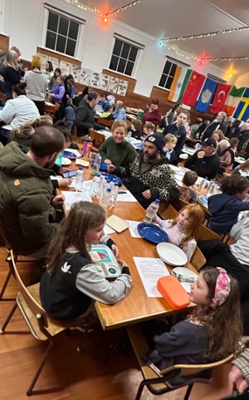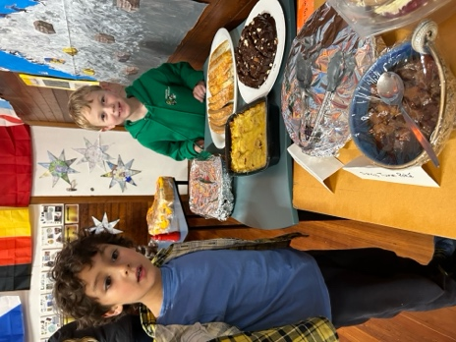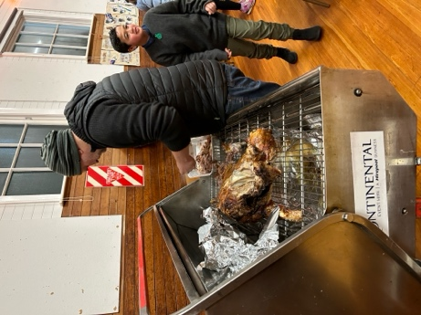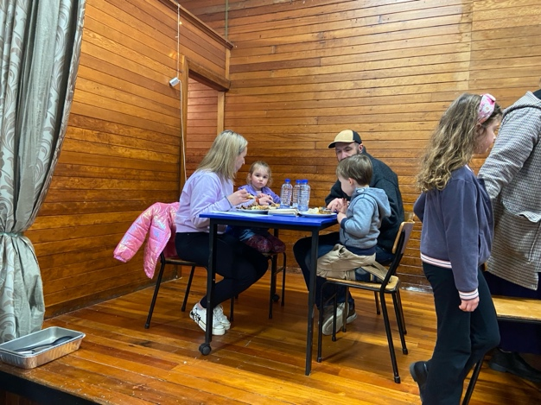
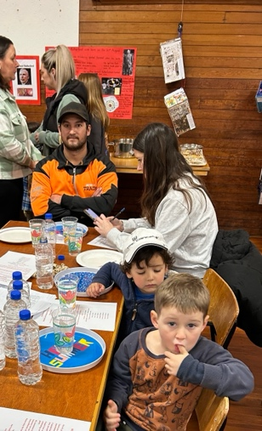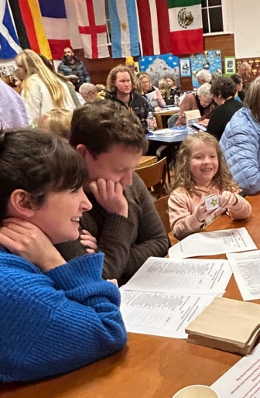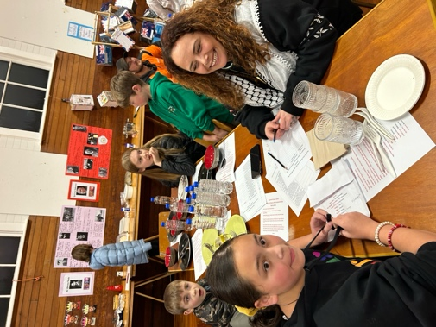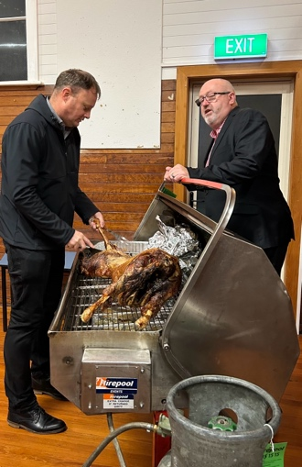
Sports Round-Up
A busy week on the courts this week.
On Monday night, due to illness and other unforeseeable circumstances the mighty Hoopsters were a bit light on numbers, four to be precise. The four of Seth, George, Lexie and Beau, played their hearts out, running up and down the court chasing every stray ball, passing, shooting. In the end came away with an incredible 39-19 victory. As a result of that, all four earned the right to be Player of the Day, and the looks on their faces said it all. Very proud.
Tuesday Netball
Congratulations to Araia Te Waiti on earning Player of the Day for the Big Rock Hurricanes in their victory. Also a special mention to Bella Yeoman for two stunning displays of genuine sportsmanship, without a second thought, pure class.
Thursday Basketball
Bravo to Quaye Driver on earning Player of the Day for the Big Rock Shooters in their victory. Thank you to Fin Ramsay for helping out.
Also Bravo to Braxton Parata-Walters on earning Player of the Day for the Big Rock Coasters in their hard fought game.
I need to congratulate these two young basketball teams on the progress they are making and their love of the game.
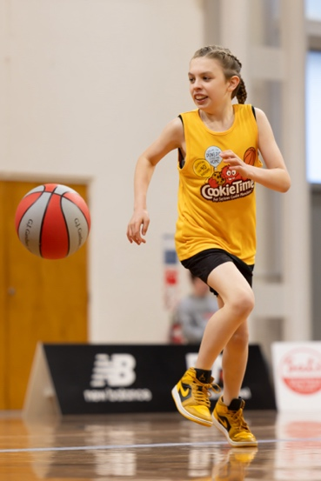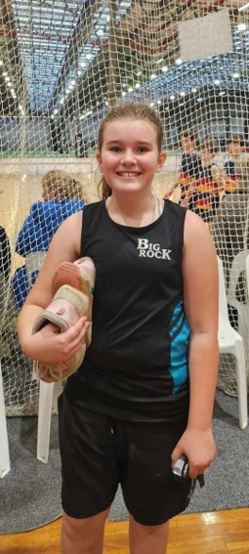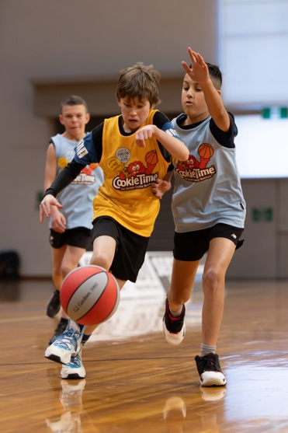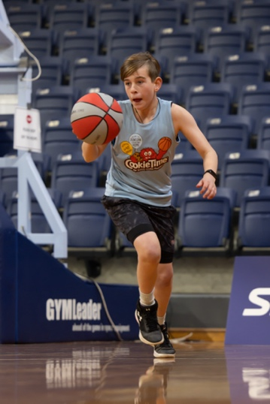
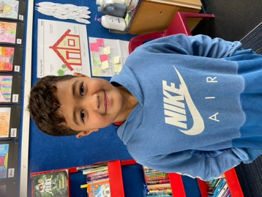

Next Week
Next week is the last week of term. Mid-year reports will be emailed on Friday, as long as there are no technical glitches.
Next Term
One of our major foci next term comes from the Cultural strand of our school curriculum and is Visual Art. This will conclude in our Art Extravaganza at the Brighton Hall. The work will not just focus on Visual Art but also the history of art, significant artists and famous pieces of art.
Aotearoa New Zealand History Quiz
Below you will find the answers to the quiz. I have accepted three different answers for the New Zealand movie question, as there is some debate about what constitutes a New Zealand made movie. All other answers are down to the judge, me
Winners will be announced early next week.
Thank you for recording all of the Number One songs on your birthdays, I am currently compiling a Big Rock Birthdays playlist on Spotify.

Big Rock Primary School
Matariki Celebration and Aotearoa New Zealand History (From the Newsletter, mostly)
Quiz
Ingoa whanau/Family name:
Question | Answer
What New Zealander, do some believe, had controlled flight before the Wright brothers at Kittyhawk? | Richard Pearse
Who or what was nicknamed the ‘Washdyke Wonder’ ? | Phar Lap
What sank off Barrett’s Reef? | The Wahine
What is significant about the song ‘In the Year 2525’? | It was the number one song when David Grant was born
What is New Zealand’s most successful film at the box office (In New Zealand)? | Hunt for the Wilderpeople  (Or any of the Lord of the Rings trilogy or Hobbit)
Name at least three members of the band When the Cat’s Away? | Annie Crummer, Kim Willoughby, Margret Ulrich, Debbie Harwood and Dianne Swan
What was the name of the New Zealand reggae band with the hit songs ‘Sensitive to a Smile’ and ‘Long Ago’ | Herbs
What prominent New Zealand band has its roots in Geraldine? | Dance Exponents/Exponents
What was the name of the indie label famed for the ‘Dunedin Sound’? | Flying Nun
What Dunedin suburb did Shayne Carter, former lead singer of Strait Jacket Fits, Dimmer, Bored Games and the Double Happys, and New Zealand Music Hall of Fame inductee grow up in? | Brockville
Which former Finance Minister was responsible for the ‘Mother of all budgets!’? | Ruth Richardson
Who was the former television presenter that was sometimes referred to as the Mother of the Nation? | Judy Baily
Who, recently on a television ad, hinted at being the new Mother of the Nation? (Clue: There might be a sale soon!) | Tammy from Briscoes
What was unique about former Prime Minister Jacinda Ardern and her daughter Eve? | First prime Minister to have a child while serving as Prime Minister
In what New Zealand province would you find Parihaka? | Taranaki
What New Zealand city would you be in if you visited Moutoa Gardens? | Whanganui
What was former New Zealand Premier/Prime Minister Richard Seddon’s nickname? | King Dick
What New Zealand cricket captain had the nickname ‘Hogan’? | Martin Crowe
Who was the first New Zealand cricketer and only test cricketer to climb Mt Everest? | Adam Parore
What products did these famous New Zealand ads advertise?
 | 
Crunchie | KFC
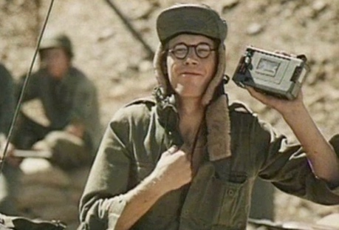 | 
BASF cassettes | Trumpets

Go to https://www.nzonscreen.com/title to check out some old New Zealand tv ads. It used to be said that we made better adverts than we made tv programmes.
Enjoy and celebrate the Matariki weekend
David Grant
Principal

