28th July 2023
A Massive Thank You
On Monday the staff were pleasantly surprised and overwhelmed to receive an amazing lunch courtesy of the Board of Trustees as a mid-year thank you. To top it off Shane and Graeme carried out lunch time duty for us. A wonderful and well received gesture (more than a gesture but you know what I mean). The food was amazing, so thank you to Gary and the team at the Food Room as well.
Thank you Scott, Shane, Graeme, Jo and Kara. Nice one.
Sports Round-Up
An immense effort from the Big Rock Hoopsters saw them defeat Outram on Monday night, with a 24-16 victory. The result was the other way in the first round. Congratulations to James Patterson on earning MVP for great all-round play but also demonstrating genuine sportsmanship to the opposition. Top Man JP
Well done to the Big Rock Dolphins netballers on their effort and performance on Tuesday night. Bravo to Lilly Hamilton and Billie McNabb on earning Player of the Day. Also, a special mention to Amazon King and Meadow Hamilton for helping out the opposition who were short of players. Well done.
Congratulations to Lucy Tapp who had a very well-earned Player of the Day in what was a particularly tough game, but the Rockets hung in there, and while they may not have got the result on the scoreboard, they showed genuine grit in a close loss.
Top work Fin Ramsay on earning MVP for the Big Rock Shooters last night in what was a hard fought, scoring frenzy, with a 17 all draw. Great work Fin
Well done Lexie Brown on earning MVP for the Big Rock Coasters in a tough 19-12 defeat, in what is described in sport as ‘one of those days’. It was like the hoop had a lid on it and the ball would just not drop. It happens in basketball. They hung in there and never gave up and that is all you can ask for. Also, a special mention to Beau Mansfield who drained his first 3!
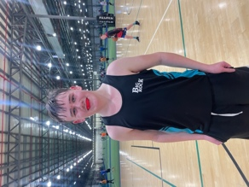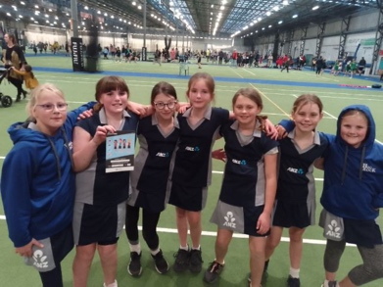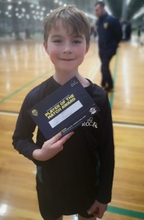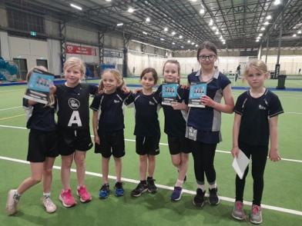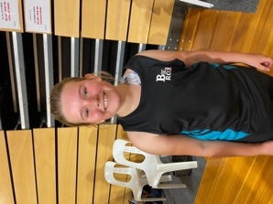
Brighton Seagulls
Congratulations to Jed Grey on earning Player of the Day on his return from injury, top stuff. Rumour has it that Dion Mooyman won muddiest player, excellent Dion, that’s the spirit. (No photo sadly of the mud sadly)
Bravo Elise Blanchard on earning Most Improved and well done Greyson Farquhar on earning Player of the Day.
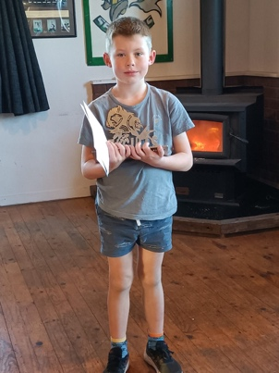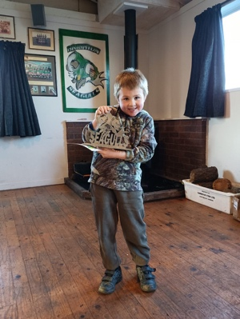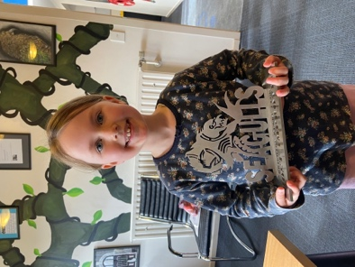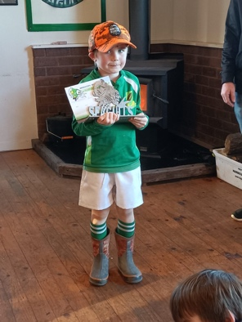

School Disco
On Friday 25th August there is going to be a School Disco at the Brighton Hall. It will run from 6:00pm-8:00pm. On the night there will be drinks, lollies and ‘glow products’ for sale. There will be a $2 entry fee. The disco will have a theme, this will come out with more information a wee bit nearer the time. There will also be prizes for games, best costume etc.
Parents of children 8 and under will either need to stay or have an adult identified as the designated carer for their child.
Thank you to the group of parents who are organising this, it is much appreciated, and the children will love it.
More information will come out soon.
Orokonui Ecosanctuary
Earlier today Rooms 1, 2 and 5 visited the Orokonui Ecosanctuary. This is a key part of our work on the Living World, particularly local environment, endangered and local species as well as all of our roles in being guardians of our own environment. One of the philosophies of our teaching and learning at Big Rock is teaching the children, In the Environment (EOTC, biking, surfing, Taieri Mouth Day etc), For the Environment (Anti-pollution, rubbish and waste, Climate Change, endangered species, trapping and predator control etc) and About the Environment (Planting and Growing, Ecosystems and Food webs, Local ecosystems, local flora and fauna). Put simply, the goal is that when knowing, understanding and enjoying their local environments the children will love their environments and are more likely to look after something they love and understand. Thank you, Mrs Lamb, Ms Keen and Kara, as well as all of the parents for making it work. Thank you Mrs Van, for booking it. Room 3 and 4 are away on Monday.
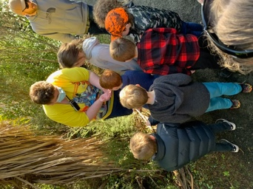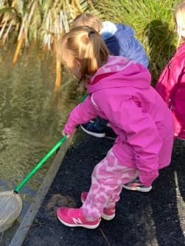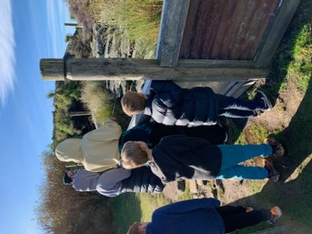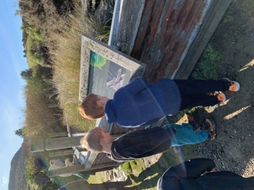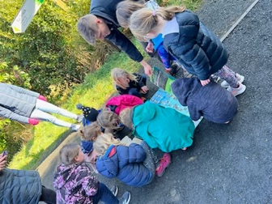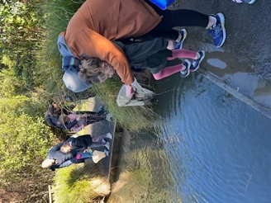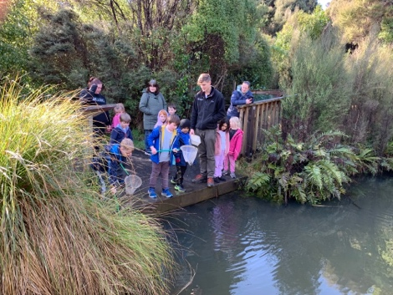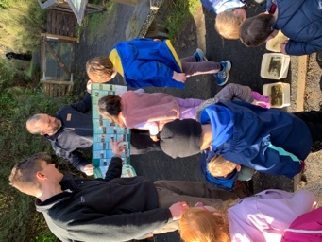
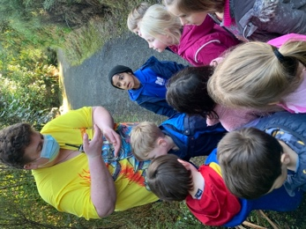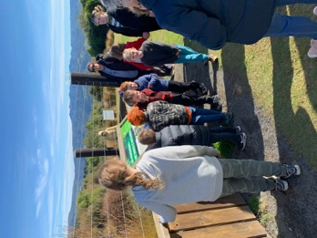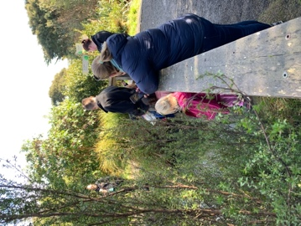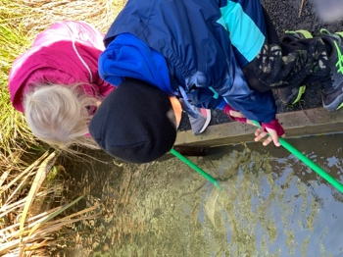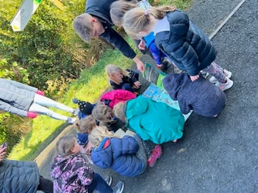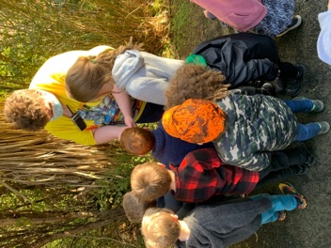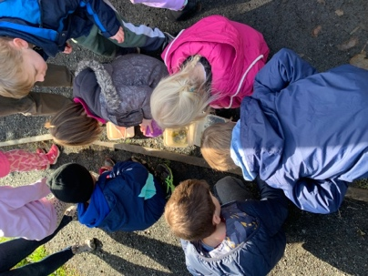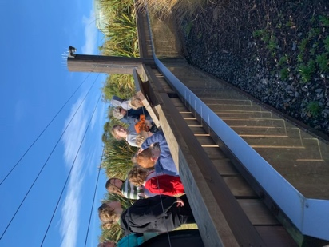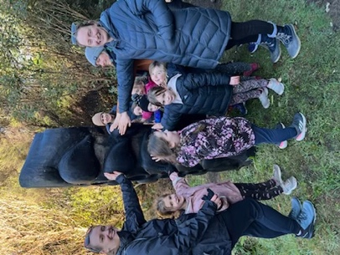
Have a great weekend

David Grant
Principal

