28th February 2025
Welcome
On behalf of everyone in the Big Rock community I would like to welcome Leo de Thierry to Room One. I know he has been keen to start for a while, good news Leo, we are delighted you are finally able to join us and of course your big bro Josh.
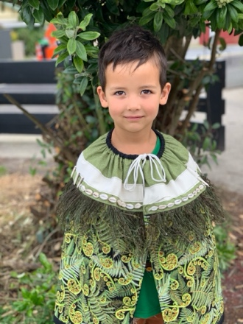
Congratulations
Congratulations to the following players on earning Player of the Day for their respective futsal teams.
Big Rock Dolphins- Evie Hollands and Fletcher Cockburn
Big Rock Stingray- Dion Mooyman
Big Rock Barracuda- Ivar Elliot-Tressler
Big Rock Sharks- Charlie Hughes
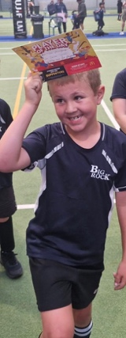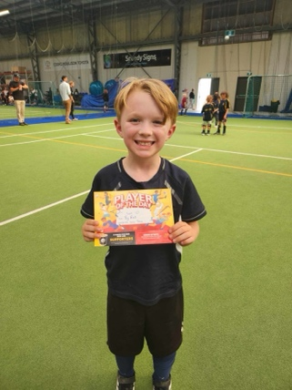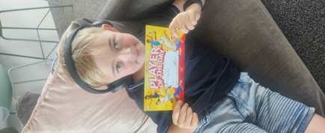
Massive Congratulations
A massive congratulations to Kade Hancock. Earlier in the year (January) Kade was selected to take part in a nation-wide football academy held in Hamilton at St Peter’s Collegiate. The academy players were selected by former professional footballer and former All Whites coach Ricky Herbert. Ricky took the All Whites to the 2010 World Cup, where they were unbeaten, drawing with the mighty Italians. Ricky knows his football. Since that summer academy, Ricky has selected 15 players from across the country to compete in a tournament in Melbourne later in the year. For all intents and purposes this a New Zealand selection team, Ricky Herbert would only choose the best, if the Ricky Herbert name is attached to it. Well done to our very own Kade Hancock on being selected as one of the 15 chosen, an incredible achievement and richly deserved.
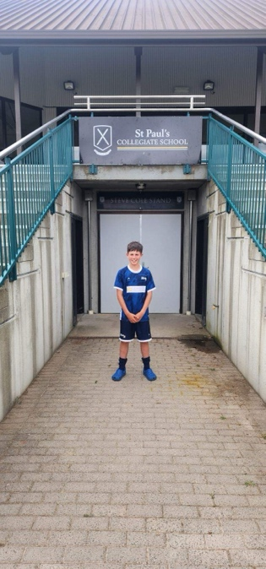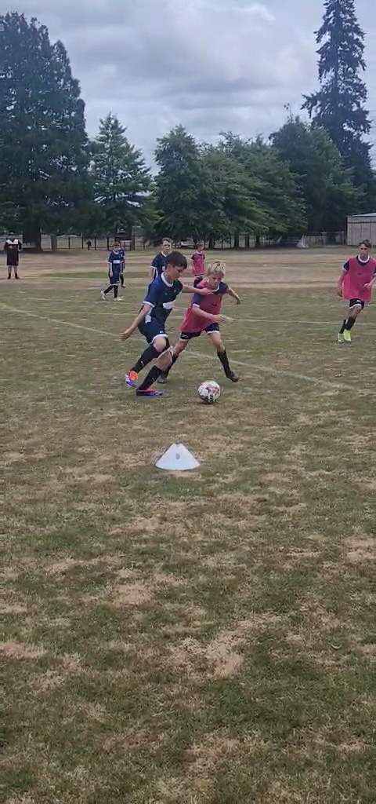
I would also like to offer our congratulations to Billie McNab who finished an excellent 3rd at the recent Southern Region Surf Lifesaving Championships. Excellent stuff Billie.
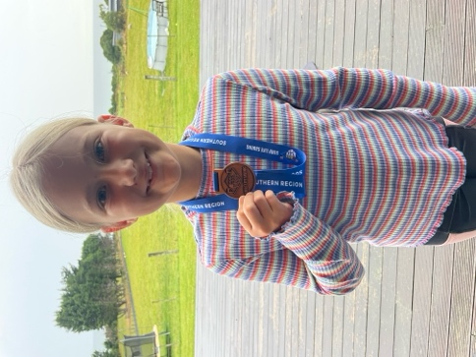
Room Four Bike Adventure
Earlier in the week I had the pleasure of helping on the Room Four Rail Trail Ride. It was a fantastic day, with every child giving it their best and completing far more than we expected. There were a few spills, lots of smiles, mainly of joy and satisfaction, a few of relief when it was over. It was great to see children growing and developing resilience in the great outdoors, the most important place for children to have fun. It is their natural environment.
A big thank you to Sally Scott, Gayle Woodford, Shane Turner, Alex Ramsay, Scott Ashton, Tania McIlroy and Michael Johnston for transporting, riding with and encouraging all the children. Also, a massive thank you to Jude van Aalst for making it happen.
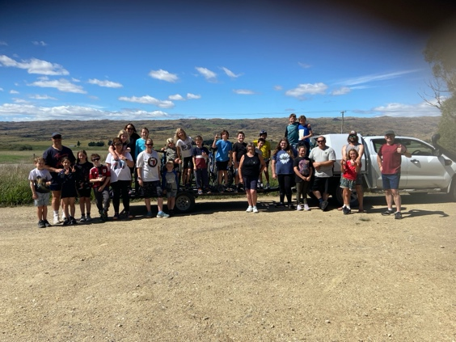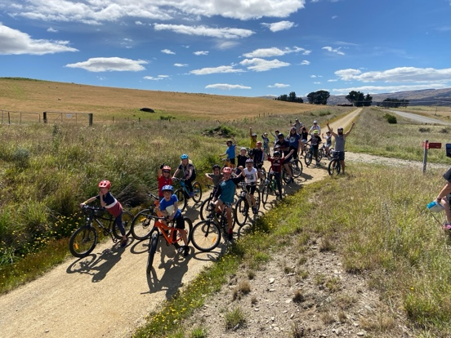
(More photos on Facebook)
Good Luck
Good luck and congratulations (in advance) to all of the children taking part in the Weetbix Tryathlon, especially those who are part of Team Big Rock. Thanks, Shane, for leading the push to get as many on board as possible.
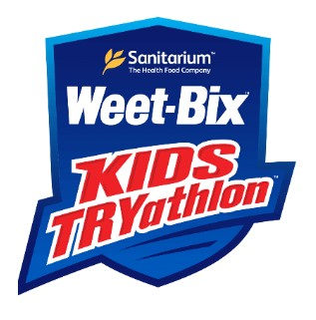
It’s Official
It’s official, GaGa Ball will make its much vaunted and requested debut, on location, at Big Rock this Monday. The final countdown is on.
Have a great weekend.
All the best to Tubby and Sharron of the Taieri Mouth Corner Caravan on their wedding tomorrow.
David Grant
Principal

