29th August 2025
Congratulations
Well done to Maci Kippenberger on winning in the Outram Cowboy Challenge. Maci was immensely proud to share her victory rosette with us.
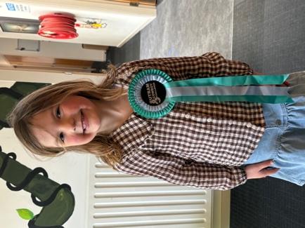
Bravo to Fletcher Cockburn on earning Player of the Day for the Red Gulls and an equally big bravo to Ari Gilbert on earning Player of the Day for the Mini Gulls.
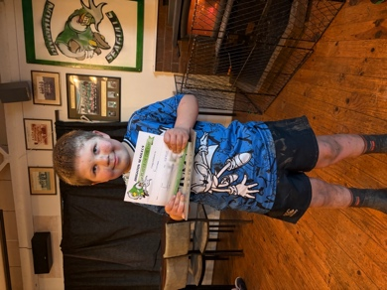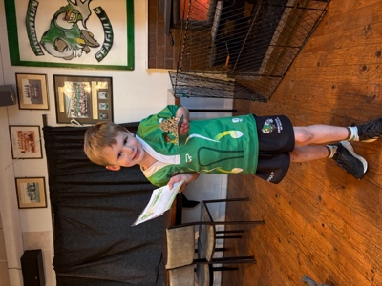
Thank You
I would like to offer a massive thank you to Vaughan Grey for very kindly sourcing and fitting a towbar to the school van. This will make it easier for us to have biking events etc.
Thank you, Vaughan, you are a legend.
Country Music Fans
If there are any country music fans out there, and I am sure that there are, particularly fans of Loretta Lynn, please get in touch with me. I may have something that you would like.
Alice the Musical
Rehearsals are going amazingly well, with some stunning young actors and singers going through their paces.
Thank you to those parents who have been able to come along and help with costumes etc. There is always room for more helpers if you are keen and the times suit.
Please remember to come and collect your tickets from the office. There is a matinee performance for people with toddlers/preschoolers, and for those who are unable to attend the main event. If you have a pre-schooler who is going to be starting school before the end of the year, they are welcome to attend the main event. However, if during the performance they become restless, fidgety or noisy, they will need to leave the hall as it distracts the performers and ruins it for other people and is unfair on everyone. We need the stars on stage to have their opportunity to shine brightly.


Otago Polyfest
As I write this, it is exactly one week (To the minute) where will be on stage at the Otago Polyfest. We are scheduled to perform at 11:00 am and will be very close to that time, if you want to come along and watch the children perform.
All children need to travel to and from the event on the bus. The bus will be leaving school at 9:30 and returning straight after our performance. It is important that all children travel by bus, as it is pretty hectic afterwards with lots of children from lots of schools milling about. If you wish to take your child home, they need to be collected from the bus please, otherwise we may end up with a search party looking for your child. We really appreciate your help with this.
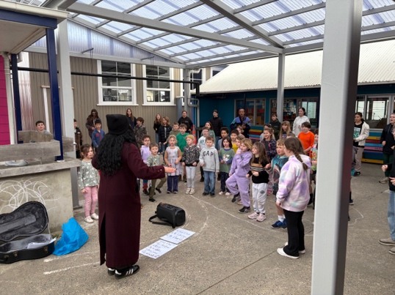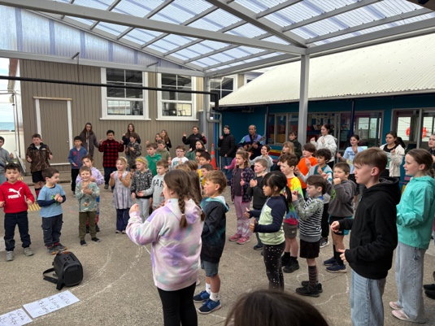
Apology
I would like to apologise to anyone who witnessed the mess at the front of the school this morning. Someone had gotten into the skip, either looking for something (hate to think what) or was just being a nuisance and had decided to try and empty the skip on the driveway. Either way it was disturbing, a real mess and not what you want to see when you pull up in the morning.
Have a great weekend
David Grant

