20th September
Art Extravaganza/Whakanui Toi
In the job that I am lucky to have, every day and every week there are reasons to be proud, proud of the children’s many achievements, big and small, they all matter and they all make me smile. Wednesday was one of the big ones. The work that the children produced, was not just visually stunning but also had a depth to it that should and did stir the heart, as art should. However, that was not what made me proud, what did was the pride in the children’s faces when they were sharing it with their family and friends, and the expressions on the parents, grandparents faces and their pride. Pretty special.
I want to thank all of the children for their hard work and creativity, to the teachers, Lisa Lamb, Richard Murray, Mel Van de Klundert, Jude van Aalst, Su Keen and Teresa Grant for their effort and guidance with the children, knowing when to let them go and when to reign them in, I would also like to acknowledge our ‘Artists in Residence’ Atiana Reihana, Bella Yeoman and Jasmine-Rose MacFarlane-Pearson, 3 incredible young artists among many, but were happy to go about their business with an audience. Thank you, Kara for all the work you did, at the start, during, and at the end with the clean-up. A massive thank you to Teresa Grant who led the whole thing and made sure it stayed on track throughout the term and was set up just so.
While I know professionally it was a great success, the feedback from families and whanau, within the school and the wider community was superb, so thank you.
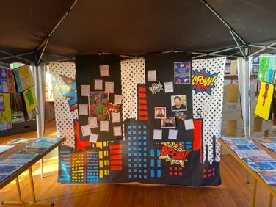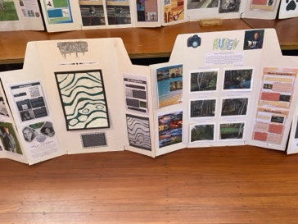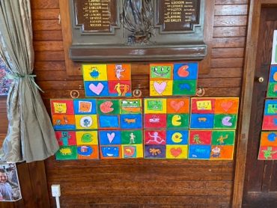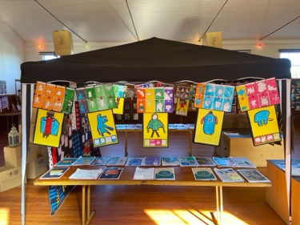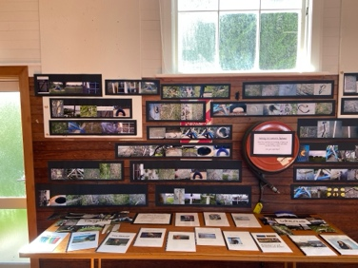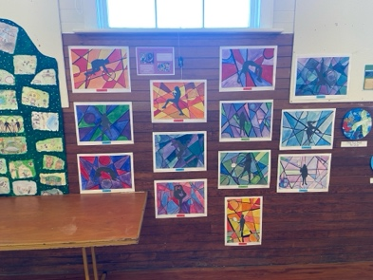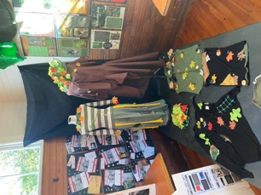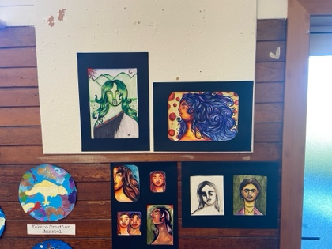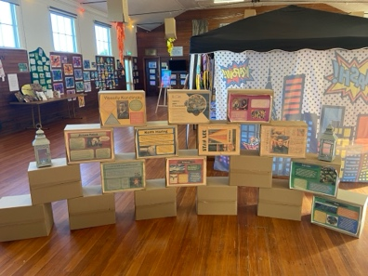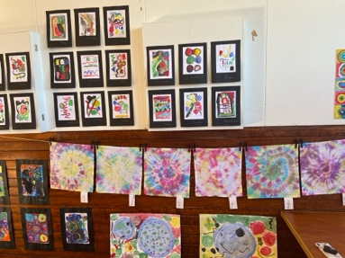

Double Congratulations/ Nga mihi rua
Double congratulations to Ruben Van Tonder who had a busy weekend. Ruben won the Dunedin Pickleball Championships, claiming the gold medal, as well as at his Dunedin Royals Football Club prizegiving claiming the Golden Boot for scoring the most goals for his team. Outstanding Ruben.
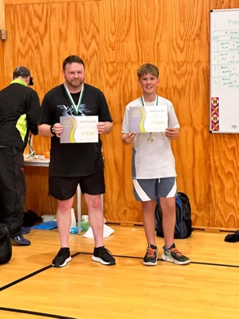
Thank You/ Mauruuru Koe
A massive thank you to the Student Volunteer army who were here last weekend. They painted the front fence, which I think looks excellent, shovelled approximately 15m of bark on to the playground, did a load of sweeping and a bit of weeding. It was really appreciated, and I take my hat off to these young people for their generosity of time and effort.
Term Three Illness/ Te Waa Tuatoru Te Mate
It is no understatement for me to say that the flu or whatever we call it these days, I’m never quite sure, that seemed to be lurking everywhere through winter was easily the worst I have witnessed, even during the dark days of covid, the one that seemed to be at its worst through the term was a tough one. It was tough on children and adults alike, with it sometimes taking weeks to come right. We appreciated people keeping their children home when they were sick, not just so your child could fully recover but also so others may avoid it. We understand how hard it can be with getting time off work etc. Thank you for the courtesy of thinking of others.
Despite the illness and people doing the right thing by keeping their children home, we still maintained, and even improved our attendance rates (We were congratulated by the Ministry), which is incredibly pleasing and is an immense credit to the families and whanau, the children and I think the school itself. We all understand that children stay home when they are crook, or when there might be a family event, as long as we can work together, with a strong relationship between home and school, I’m sure we can continue to manage it sensibly.
Curriculum Update/ Whakahoutanga Marautanga
Any school curriculum needs to be focused on teaching the whole child, that means the core curriculum areas of Reading, Writing and Mathematics (Which should also support Science and the Social Sciences, Te Reo and Tikanga Maori) PE and Swimming, encouraging and providing opportunity for creativity and imagination (the Arts, Reading, Writing), building resilience and independence (All learning programmes, as well as things like mountain biking, class trips, camps etc) as well as having quality resources. It is also valuable, I believe to celebrate the children’s achievements and endeavour with events like our Matariki and Aoteroa New Zealand History celebration and the Art Extravaganza. Not discounting the importance of our Taieri Mouth Adventure and even Pet Day. A school curriculum is a complicated thing, but we must keep the child at the centre of it. I hope you can see how your school’s curriculum all works together and why we do the things we do. It is not just the reason for the high achievement rates but also the high attendance rates. Having great people working together in a great community is also pretty important. Yes, there is always room for improvement, and we will all keep striving to do better.
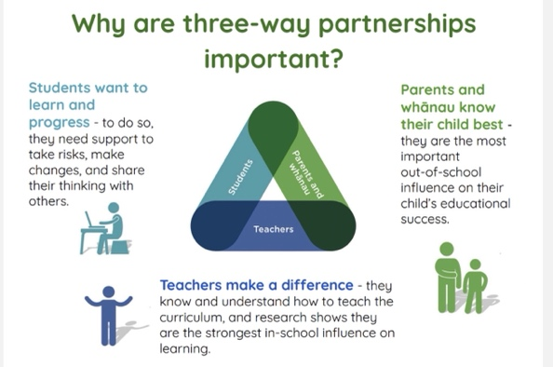
Brighton Backyard Ultra- Running in Paradise/ Rere i roto i te pararaiha
The big event starts tomorrow. If you are running in it, good luck and all the very best. If you are not, I would recommend that you get down and check it out and cheer the athletes on. It is a very impressive event and what many of the runners achieve will blow your mind. Well done, Scott, not just on such a great event but also for helping to raise funds for the senior class camp. Very kind.
Outside Covered Area/ Wāhi Kua Uhia
Earlier in the year the covered outdoor area was finished. However, we have hit a bit of a snag. It doesn’t have a name, we can’t keep calling it the Outdoor covered area, it’s a bit boring. A bit like Flat White for coffee, all those other cool Italian names like mochaccino, and cappuccino or americano, but flat white? A combination of two of the most boring words in the English language. Anyway, we have a competition coming to name the outdoor covered area. It needs to be reasonably short and snappy. Email suggestions to office@bigrock.school.nz.
Term Three Summary/ Wāhanga tuatoru Whakarāpopototanga
Traditionally Term Three can be the toughest for children, with the cold weather, short days, less time outside, as well as flus and bugs etc. The work on show the other night proves to me that they came through well. In general terms it was a very successful one, with lots of bike adventures (More next term), great work in classrooms with Structured Literacy, successful school sports teams, outstanding results for both the senior netball and senior basketball, losing only one game between them, and that was down to illness. The younger players having a ball, there was a ski trip, everyone getting bike lights courtesy of the AA (Thanks Dallas), competing in the Greater Green Island and Otago Championship Cross Country, not just the outcome of the Art Extravaganza but just as importantly the processes and the work in getting there. All in all, like I said at the start of this newsletter, there is something here that makes me proud every day, every week, how about you?
Term Four/ Wāhanga Tuawhā
Hard to believe, but we are heading into the final term of the year. Next term we will have class camps, the Big Day Out, as well as lots of other things happening but I don’t want to let the cat out of the bag just yet. Let’s not forget that on the 21st November there is the Big Rock’s Got Talent event. Please get your entries into Shane Turner as per the school Facebook page. It will be a cracker. We also need to officially open our new sheltered area, and with an ounce of luck will have the symphony orchestra to help us out (Really? Yes!) Not forgetting that the pool will open, and keys will become available to school families first and the wider community a bit later on. We will also be breaking out the pickleball gear, tennis gear, volleyball and croquet equipment that we purchased earlier in the year. It will be busy but great.
I am sure to be asked so here goes:
- The end of year prizegiving is on Thursday 12th December
- School will finish at 1:00pm on Monday 16th December
- After School Care will finish for the year on Friday 13th December
Thank you to everyone who has supported the school this term in anyway, whether it has been going on trips, helping with fundraising, attending school events, encouraging your children with their learning and development or just being positive about your school, it is all much valued and greatly appreciated.
Have a great break and we will see you in term four.
David Grant
Tumuaki/Principal

