27th October 2024
Futsal
Congratulations to the following players on earning Player of the Day for their team.
Big Rock Dolphins- Fletcher Cockburn
Big Rock Stingray – Korbyn Parata-Walters
Big Rock Barracuda – Dion Mooyman (2-6)
Big Rock Orca – Baily Jenkinson (3-1)
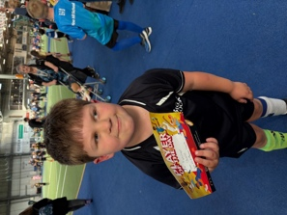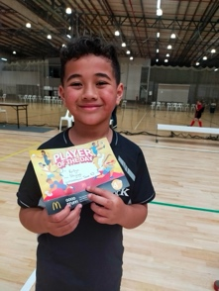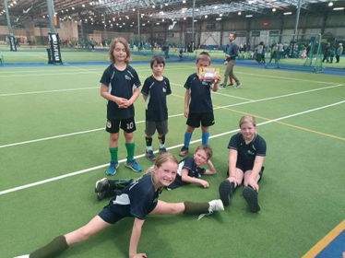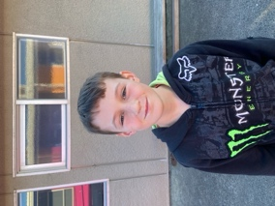

This week’s futsal draw:
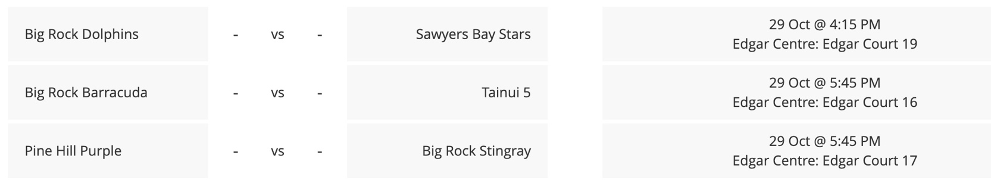
School Photos
A reminder that school photos are on Wednesday 6th November. Information from the photographer will hopefully be available soon.

Dunedin Symphony Orchestra
On Tuesday 5th November we will have a visit and a performance from the Dunedin Symphony Orchestra. The performance will be in the new covered area, that at this stage, does not yet have a name. We will have a prize for the best suggestion. Please drop them in at the office.


School Camps!
Last week I had the pleasure of being on the Room 5 camp to Central Otago. The camp was a mixture of Goldfields history and adventure tourism. The children visited and had tours of the Stewart Town gold workings (Near Bannockburn), Goldfields Mining Village, Chinatown, Arrowtown and the Lakes District Museum. They also went go-karting at Highlands Park as well as their new mini-golf course, Gondola and 6 luge rides, endless games at Kingin, swimming at Frankton etc. It was a great camp to be part of. Thank you Shane, Justine, Rowan, Dallas, Racheal, Laurie, Joe, Edrik and of course Mr Murray for a great few days, without you it wouldn’t have worked, especially the flexibility around the weather. To our Year 7-8s, amazing as always. As I told you at the time, the first time everyone did everything. Resilient, happy children- superb.
A massive thank you to the great people at Highlands Park for their incredible generosity, amazing. If you are in to motor racing and you haven’t been… you need to, soon!
The great people at Southern Lakes Museum and the Goldfields Mining Centre for helping us get around the weather.
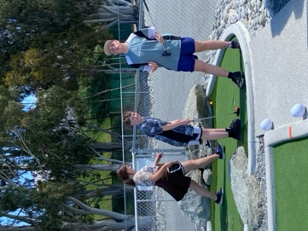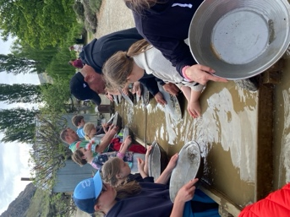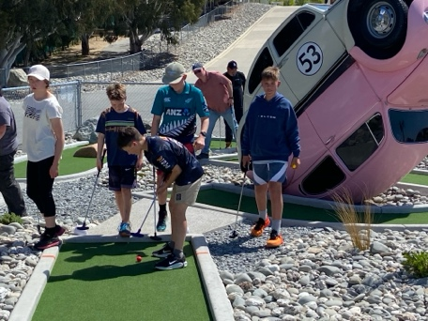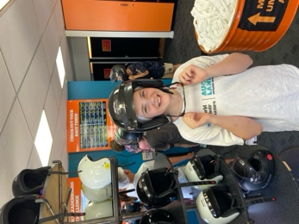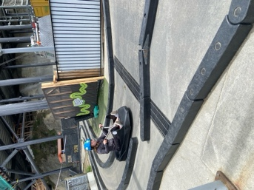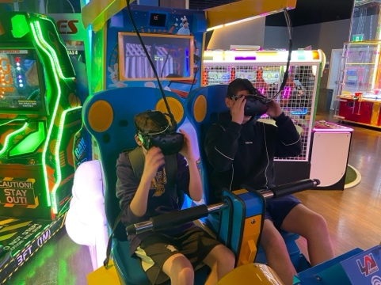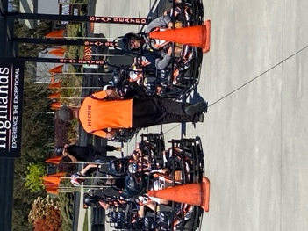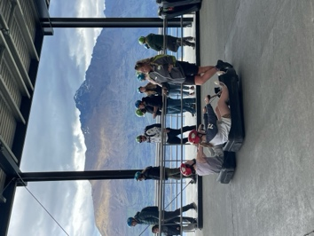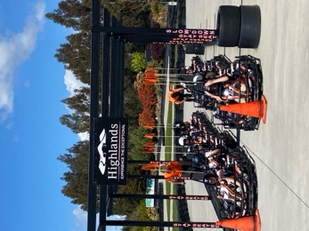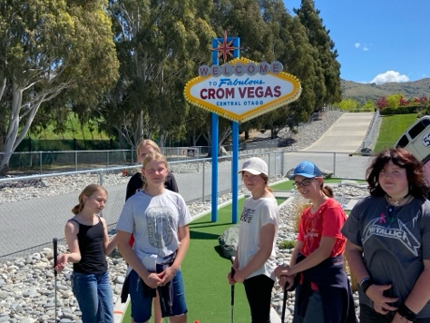
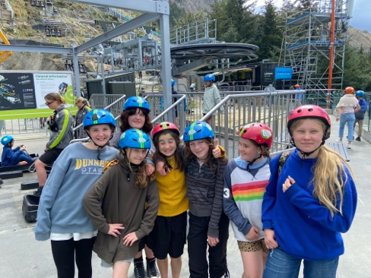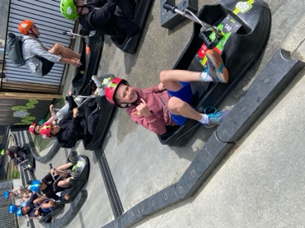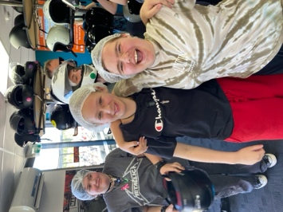
This week coming I will have the pleasure of joining Room 4 on their camp at Waihola. Looking at what Mel and Jude have got planned, it will be a gem. Hopefully the poor weather will have passed through by then. I would love to tell you what is going to be happening but we like to keep it as a bit of a surprise. Needless to say there will be a lot of new and challenging experiences. Thanks in advance to the parents attending, it is much appreciated.
These camps are designed and planned to provide new experiences, social development and build both personal and physical resilience.
Many thanks
David Grant
Principal

