26th October 2023
Congratulations
A big congratulations to the team of children who represented the school with distinction at yesterdays Greater Green Island Athletics. The team consisted of Leith Conway, Jasmine-Rose MacFarlane-Pearson, Malachi Turner, Addison Johnston, Dusty Andrews, Bella Yeoman, Armani Ngaia, Emma Egan, Scarlett Hancock, Kade Hancock, James Patterson, Mikah Reihana and Kiptyn Garner. A special congratulations to Kade Hancock 1st High Jump and 4th 800m, Armani Ngaia 2nd high Jump, James Patterson 3rd Shot Put, Kiptyn Garner 2nd High Jump, Addison Johnston 3rd Long Jump, Jasmine-Rose 2nd high Jump, 3rd Long Jump and Scarlett Hancock 3rd Long Jump and sprints. I wasn’t only impressed with effort and performances, but I was advised later that they were very encouraging towards competitors from other schools, which was very pleasing.
St John First Aid Training
On Wednesday St John visited with Amby. All of the classes learnt age appropriate basic first aid. From being able to dial 111 in an emergency, to putting on bandages and different things in between. This is a difficult thing to do, while it is great and important to teach children about dealing with accidents and injuries, it is also important, especially the younger ones, not to scare them. The balance was spot on, on Wednesday. Many thanks to the team at St John.
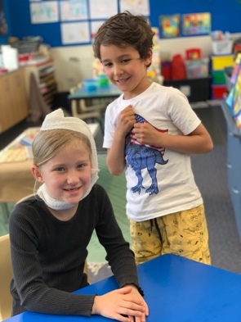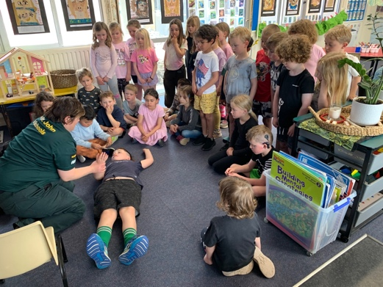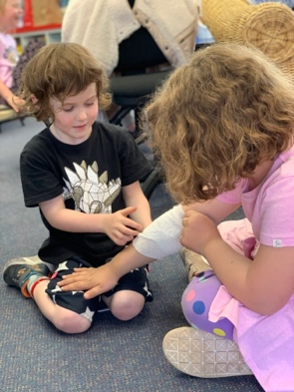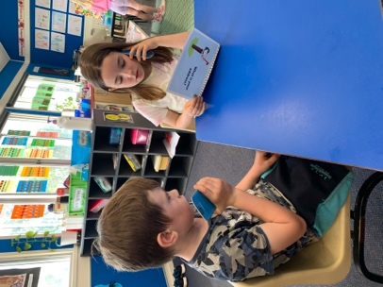
Futsal
Well done to Greyson Farquhar, on earning Player of the Day for the Big Rock Dolphins, top work young man.
Bravo to Quinn Hollands on deservedly earning Player of the Day for the Big Rock Stingray. Keep it up Quinn!
Another great performance from Fin Ramsay saw him earn Player of the Day for the Big Rock Marlin in their hard fought 2 all draw. Excellent stuff.
Good work Courtney McNair on earning Player of the Day for the Big Rock Orca.
(There were no games for the Barracuda or Sharks)
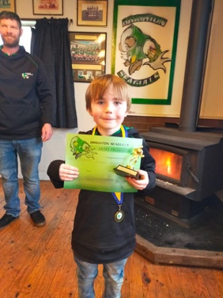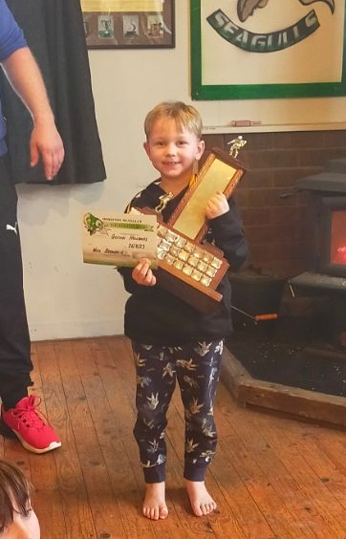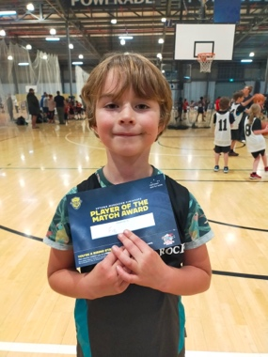
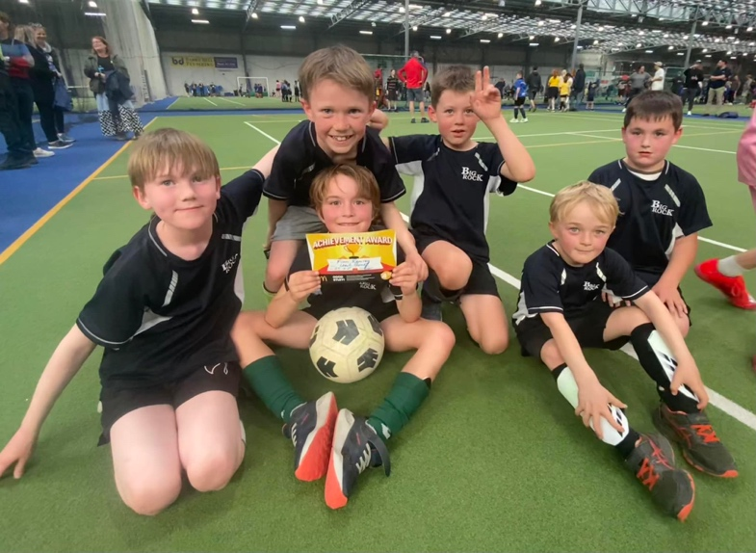
(Photos all from file)
Tuesday Futsal
Big Rock Dolphins v Halfway Bush on court 5 at 4:15
Big Rock Stingray v Columba on court 5 at 4:45
Big Rock Marlin v North East Valley on court 16 at 5:15
Big Rock Barracuda v Halfway Bush on court 17 at 4:45
Wednesday Futsal
Big Rock Orca v Brockville on court 5 at 4:15
Big Rock Sharks v TBC
Planning a Holiday? See Room Four!
During the holiday period we were given a surplus supply of New Zealand maps and guide books by Dallas Hamilton at the AA. Yesterday, Room Four got their hands on them, along with $15,000 (imaginary) to plan a summer holiday.
They must:
- Visit 10 NZ tourist attractions (no more than 2 in any one place)
- Book all accommodation.
- Book all transport (Flights, rental car, fuel, trains, and ferries)
- Allow money for food (per day) and basic spending money.
All costs have to be based on real figures from up to date websites, and the information has to be presented as an itinerary and as a balance sheet. The engagement level was immense. The biggest challenge of course was folding the maps up afterwards!
Once when I was a child and we used paper maps. My Mum was directing dad using a map, and she kept saying ‘Go straight, go straight…) Dad got a bit cross and said ‘The road doesn’t go straight!’ Mum replied ‘Yes it does! Look’ and she held up the map to show him. She was directing dad down a crease in the map Map reading skills are important.
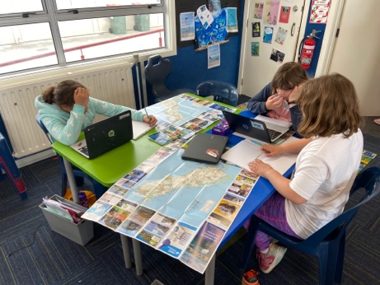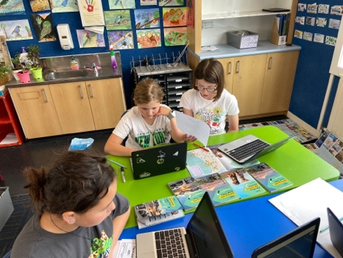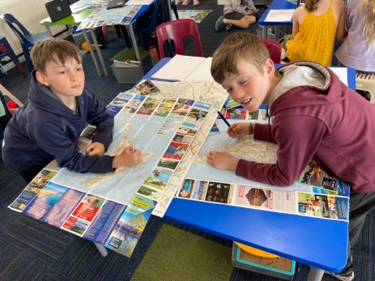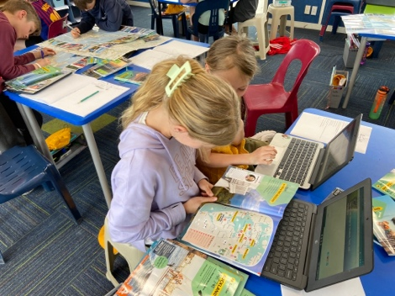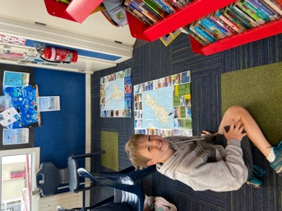
Fern Fever
Earlier today our Year 5-6 girls and some Year 7-8 girls attended Fern Fever. An event put on to celebrate female sport and involving Southern Football, Otago Rugby and Otago Cricket. By all accounts a very cool event. It is great to see three different sporting codes working together to celebrate and promote sport. Well done and thank you to those three organisations.
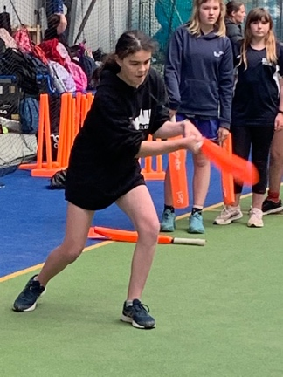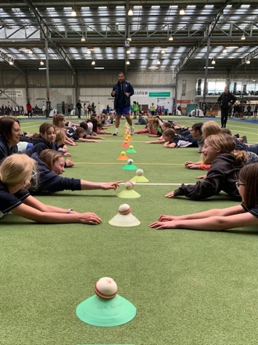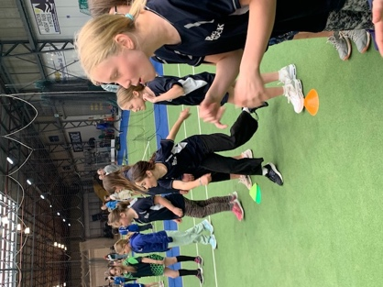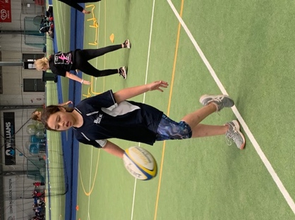

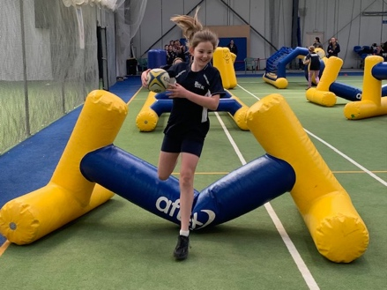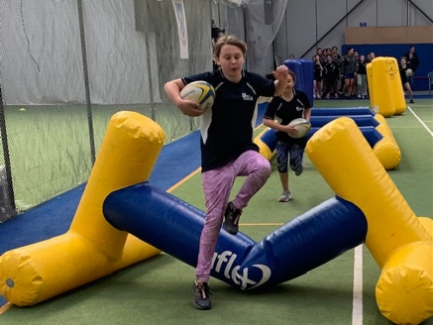

Next week
Monday
On Monday Rooms 1 and 2 have their Bike Day. All children will need to be at school at the normal start time with their bikes (or scooters) and helmets. We will be having a skill session at school first and be heading off to Marlow Park (Dinosaur Park) at a round 10:00.
Many thanks to all the parents who have kindly agreed to help with transportation of bikes and children. We will need you at school by 9:40 please, ready to load and go
Wednesday
On Wednesday the Big Rock Triathlon team will be competing in the Dunedin Triathlon in the Ravensbourne/Port Chalmers area. Good luck to Malachi Turner, Kade Hancock, George Weatherall and Scarlett Hancock.
On Monday 6th November the Introductory Mountain Bike group is scheduled for an adventure either at Redwoods or the new harbour ride (Weather dependent). Can we please have all permission slips in asap. Also, we will need parental support with the transportation of bikes. Thanks.
Have a great weekend and ‘Go Black!’
David Grant
Principal


