27th June 2025
Matariki Celebration
Thank you to everyone who was able to come along on Wednesday to celebrate Matariki, enjoy a broad range of beautiful food, and enjoy each other’s company. These events are so important for a school, especially a school of our size as there is (nearly) room for everyone to come along. Yes, it gets a bit crowded, but that’s a good thing. One of the long time parents I was talking to said ‘Every year we get better at it, everyone knows what to expect and it seems calmer’. I couldn’t agree more. The secret to the success is that takes everyone to make it work, no matter how much organising and preparation goes into it, it’s the people, the whanau and the families and the staff.
I want to pay special thanks to our young Wahine Toa, Atiana Reihana and Hinemoana Jimenez Maxwell for leading the karakia. I also want to thank the new school band, Malachi Turner, Bella Yeoman and Fin Ramsay on their debut performance, which was pretty special. It takes a lot of courage to stand up and perform in a hall full of people, whether it be karakia or music. It needs to be acknowledged and celebrated. Bravo.
Also thank you to a few people who helped us out. Cavan Jenkinson with the lamb, Cass Morton-Lowe for the bread, Micheal Tomlinson for the vegan curry, Shane Turner for carving up, Jo Henderson for cooking the whitebait, Blayr Findlay and Simon Laing for putting the flags up. I want to thank the teachers and support staff for all of their effort in preparation and of course every single child for their hard work.
A special event in a special community.
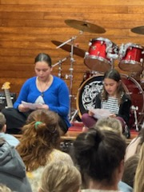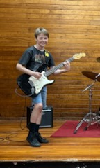

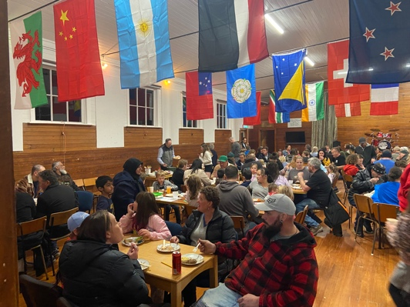
Congratulations
Congratulations to the following players who earned Player of the Day for their respective teams. I would also like to apologise to Paige Ashton who I missed last week. Sorry Paige.
Big Rock Hoopsters – Charlie Rackham
Big Rock Dolphins- Adelaide Conway
Paige Ashton
Big Rock Shooters- Hinemoana Jiminez Maxwell
Big Rock Coasters – Quaye Driver
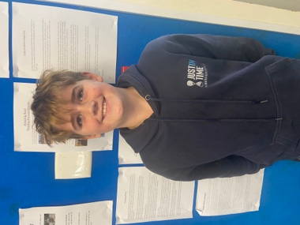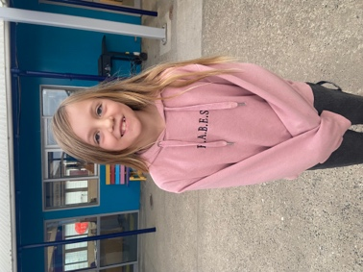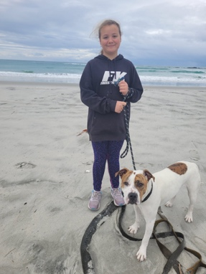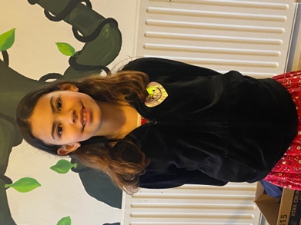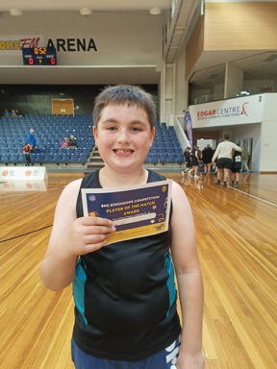
School Accounts
As we are now at the halfway stage of the school year, can we please ask that school accounts are paid in full please before the start of the new term. This includes stationery, sports teams subs and After School Care fees (Which are a bit behind). We do everything we can to keep costs as low as possible and would greatly appreciate accounts being up to date. Thank you.
Playground and Swimming Pool
As you will be aware, we are working on upgrading the pool. This will include a new water heater/heat pump, adding hot water to the shower, repairing the concrete work and repainting the pool itself. At the moment we are gathering quotes, which is taking considerably longer than we expected.
With regard to the playground, we are looking at either upgrading or adding to it. What you may not realise is that school playgrounds are incredibly expensive and we are doing what we can. It is pretty clear from feedback from children and parents that a set of swings would be a good first step.
We are looking at the possibility of a working bee to potentially build a set. We know we have a lot of talented parents in our school community in a broad range of trades and just very skilled people. If anyone thinks that they would be keen to offer their assistance, please get in touch with the office or me directly on 021 213 4316.
The school will pay for all of the resources, as well as providing a top notch barbeque and refreshments during the day, as well as other refreshments at the end.

Ski and Snowboard Trip
We are no longer taking expressions of interest.
I can confirm that the dates will be August 4th and August 5th. Can all forms please be returned by Monday 14th July (Tuesday 15th at the latest). I will remind people on the Sunday before school starts back.
Next Term
Thank you everyone for ensuring that Term Two 2025 was a positive, albeit brief term. The children have worked hard, put up with some awful weather and kept smiling (for the most part) through it all.
Thank you to everyone for their part in ensuring everything stayed positive, parents, Board, staff and of course the children.
Next term promises to be busy and rewarding. As I mentioned last week, we will be performing again at the Otago Polyfest, with a Māori performance and a Pasifika performance, which is very exciting.
Also throughout the term the children will be rehearsing and preparing for our production ‘Alice the Musical’.
A key part of the production will be costumes. If you have an interest or a skill in this area, or are just keen to be involved, please get in touch. Your help and expertise will be much appreciated.
There will of course be many other things happening throughout the term as we charge towards summer. A good example is Room’s Four and Five making their debut on the nationally recognised Science Badges, a science based investigation and presentation programme. Exciting times ahead.
Enjoy the break, stay warm, stay safe and we will see you next term.
David Grant
Principal
Board Elections
Big Rock Primary School
School Board Elections
Parent Election Notice
Nominations are open for the election of five parent representatives to the school board.
All eligible voters will receive a nomination form. Use this form to nominate yourself or someone in your community. You will also receive a nomination cover letter calling for nominations. Information on who is not eligible to be a board member is provided with this notice, and the nomination form. See attached forms and additional information.
If you need more nomination forms, contact the school office.
Nominations close at noon on 6 August 2025. You may provide a signed candidate statement and photograph with your nomination.
The electoral roll is held at the school and can be viewed during normal school hours.
As nominations are received, there will be a list of candidates’ names kept at the school up until election day, which you can view.
Voting closes at 4pm on10 September 2025.
Signed Kelly Adie
Returning Officer



