26th July 2024
Welcome
A massive Big Rock welcome to Mila Parish-Witehira and to Malaika Patton. It is fantastic to have you and your whanau join us.

Congratulations (Get comfortable it is a long list)
In no particular order:
Well done to Bella Yeoman on your immense effort in competing in the World Choir Games in Auckland during the break. Having watched the performances, I can assure you it was pretty spectacular.
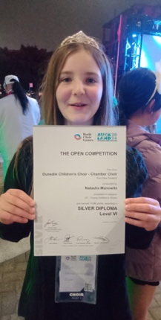
Bravo to Addison Johnston who competed in the New Zealand Dance Awards for Hip Hop, finishing a creditable 4th. I would also like to wish Addison all the best, as this weekend she competes in the South Island Secondary Schools Bowls Championships. From Hip Hop champs to Bowls champs in one week, wow. Normally it’s a hip op to bowls. All the best Addie.


Well done to Lexie Brown, who, in the holidays was selected for the Otago Metro Year 7-8 girls team. A great achievement, top work Lexie. It has been a while since the school had a representative rugby player, and with women’s rugby so popular, really well done.
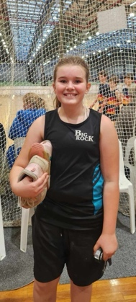
Sports Round-Up
Congratulations to Beau Mansfield who earned Player of the Day in the Big Rock Hoopsters 46-25 victory over Kaikorai Valley College. The whole team played well, but Beau was running hot with the shooting, as they say in basketball, he shot the lights out.
Bravo to Quaye Driver who earned Player of the Day for the Big Rock Shooters in their victory over St Peter Chanel. It sounds like Beau wasn’t alone in shooting the lights out. Great stuff Quaye.
Also, well done to Annabel Free on earning Player of the Day for the Big Rock Coasters in their victory. It was great that Annabel was back playing after a long injury. Outstanding.
Another awesome performance saw Esme Grey earn Player of the Day for the mighty Big Rock Hurricanes 10-2 netball victory on Tuesday. Again, outstanding.
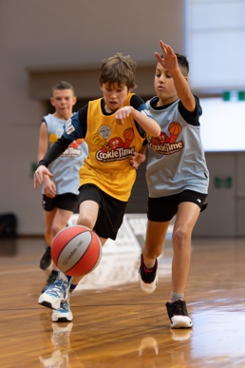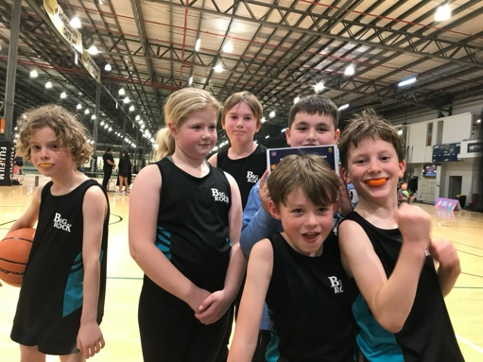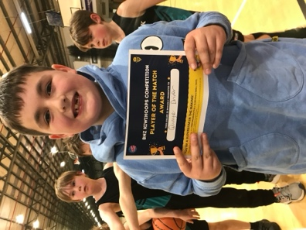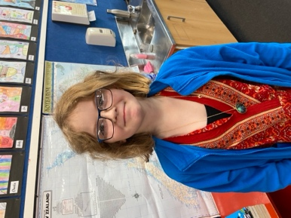
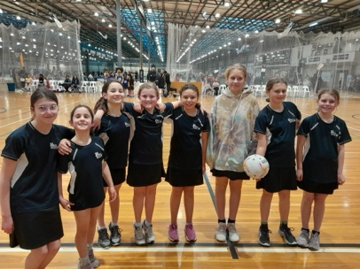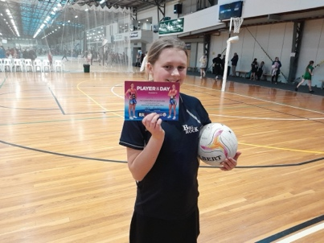
More Players of the Day
Well done to Fletcher Graham for earning Player of the Day for the mighty Brighton Seagulls. Great work Fletcher.
Double trouble saw both Stella and Lexie Brown earn Player of the day for their respective Pirates rugby teams. Excellent work girls.
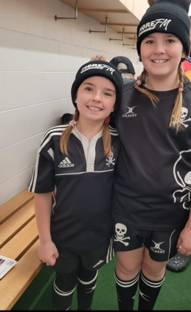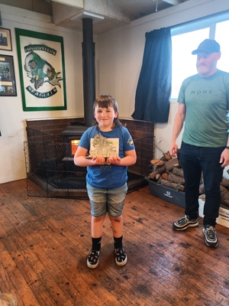
A wonderful experience was had by Emma Egan and Meadow Hamilton, who had the pleasure and privilege of welcoming the players on to the court, seating behind the players and even got to do the coin toss at the last Southern Steel game of the season. Very cool.

Good luck to George Weatherall as he competes in the indoor Surf Lifesaving championships at the weekend at Te Puna o Whakaehu in Mosgiel. You are going to be awesome George.
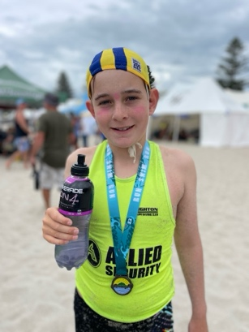
Parent-Teacher Interviews
Thank you to everyone who was able to come and meet with their child’s teacher. These meetings are very beneficial to the teachers and in helping children’s learning and development.
If you were unable to make the interviews and would still like one, please get in touch with your child’s teacher to arrange.

Concerns and Complaints
Schools, like all places with lots of people can be dreadful places for rumour and gossip and can cause a great deal of difficulty later on. Can we please ask that if you have any concerns or complaints, or even clarification on a situation that you contact the school as soon as possible. In the first instance, please contact your child’s teacher, if you believe that that hasn’t be successful, please contact me. We will always listen and try to address your concern or complaint. However, we can not promise to give you the outcome you desire. If you wish to discuss this with me, please arrange a time or contact a member of the Board via the office.
Hot Dogs
Hot dogs will again be available on Wednesday’s for lunch at $4 a pop. Gluten free sausages will also be available.

Art Extravaganza
This term our major Integrated topic is Visual Art. This will have the children exploring and learning about famous artists and famous art pieces as well as creating different art pieces and using techniques and styles from different artists. This will culminate in an exhibition at the Brighton Hall in the last week of the term. The exhibition will be open on Wednesday 25th September from 4:00pm-6:00pm with complimentary wine, orange juice and cheese for Big Rock parents as you peruse the exhibits, and 10:00am – 2:00am on Thursday 25th September for the Brighton/Ocean View and extended areas folk to enjoy.
The term got off to a flying start, and my office was certainly brightened up with a pencil sketch by Atiana Reihana. Thank you Atiana.
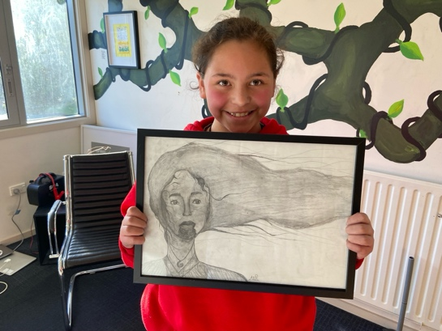
Lastly, I have been given a book of art to look after here at school for a short period of time. It is made up of works by a Brighton artist in the late 1800s-1910. If anyone is interested, please call in, but it can’t leave my office. It pretty stunning.
Have a great weekend

David Grant
Principal

